Describing the X-ray spectrum of a Tungsten tube utilizing the
Monte-Carlo simulation (Geant4)

Report
This effort is intended to understand the energy distribution (photon spectrum) of X-ray beam produced in a Tungsten tube. Photon distribution includes the peaks correspond to the characteristic (discrete) radiation and the peak corresponding to the continuous spectrum described as “braking radiation” or Bremsstrahlung. A Monte Carlo experiment is constructed using Geant4 simulating an electron gun (100 keV) targeting a Tungsten filament. The photon count (intensity) are simulated and plotted vs energy deposit due to the primary and secondary photon particles figure (2) and figure (3). The shape/peak of the continuous spectrum along with the position of discrete lines were considered for comparing the simulated results vs experimental data. This effort demonstrates that the Geant4 platform is an effective method to simulate photons behavior in the range of 0 to 100 keV. In conclusion, utilization of the Geant4 has enhanced the understanding of Monte-Carlo simulation techniques. It has also increased the understanding of the governing mechanism of X ray production in terms of of the “braking radiation” (Bremsstrahlung) spectrum and the discrete radiation spectrum.

Introduction
Roentgen discovered that continuous and characteristic X rays are produced when a beam of electrons is focused on a target (heavy nuclei). The incoming electrons, as a result of a head-on collision with atomic electrons, cause the ionization and excitation of the target atoms. Furthermore, they can also be deflected in the vicinity of the atomic nuclei, releasing their energy via irradiating X ray photons (continuous and discrete spectrum) [1].

Governing Mechanism
A beta particle has little mass, so it can be accelerated easily by elector-magnetic force within an atom and consequently emitting braking radiation (Bremsstrahlung). This occurs when a beta particle is deflected due to the electrical field of heavy nucleus and/or in the field of an atomic electron. In classical consideration of particle physics, the ‘braking radiation’ (Bremsstrahlung) is an electromagnetic radiation produced by the slowing-down of a charged particle (electron beam) when deflected by another charged particle (atomic nucleus). The moving charged particle loses kinetic energy via radiation (X-ray photon).

Bremsstrahlung has a continuous spectrum whose peak intensity shifts toward higher frequency as the energy-loss of the slowing-down particles increases. The deceleration produced by a nucleus of charge Z_{e} (Tungsten) on a particle of charge z_{e} (electron) and mass M is proportional to ( Z z_{e}² / M ). Thus the intensity, which is proportional to the square of the product of the amplitude and the charge z_{e} will vary with ( Z² z⁴ e⁶ / M² ) [2]. Consequently the total Bremsstrahlung per atom is a function of the square of the atomic number of the target material a fact that is well confirmed by experiment. For the particular case of target material (Tungsten). The continuous Bremsstrahlung peaks at about 30 keV as show in figure (1) from the experimental data gathered from an IAEG study [3]

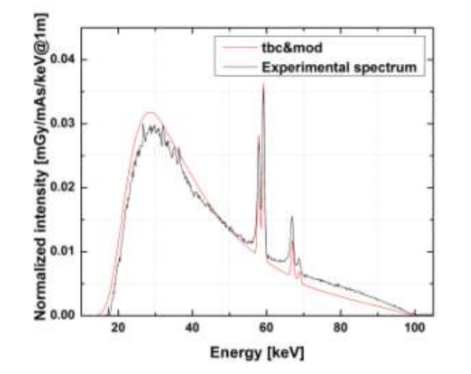Figure 1: Continuous Bremsstrahlung radiation on Tungsten [3].

Characteristic radiation is a discrete energy emission observed in X ray production. These radiations are represented by line spectrum. Since Tungsten has a specific arrangement of the atomic electrons, this energy emission happens when a fast-moving electron collides with a K-shell, L-shell and/or M-shell electron. The electron in these shells are ejected when the incident electron energy is higher than the binding energy in these atomic shell levels leaving behind a ‘hole’. An outer electron will populate these empty holes and release a X ray photon. In the particular case of Tungsten, the K-shell energy = 69.5 keV and L-shell energy is 11.5 keV. Therefore an electron moving from the L-shell to fill a K-shell vacancy will produce a photon with discrete energy of 69.5-11.5 = 58.0 keV. Figure (1) presents experimental data for the the 58.0 keV and with 69.0 keV discrete energy emissions.

Monte-Carlo Simulation
In this effort Geant4 version 11.1 toolkit was constructed to develop two different applications. Either applications will follow the ‘run’ methodology delineated in Geant4 architecture. In every run an object of G4Run is created which is the collection of G4Event(s). A single G4Event object is a collection of G4Track(s). A single G4Track is a collection of many G4Stepping(s).

Continuous Spectrum (Bremsstrahlung)
The first application is a modification to the first step training example provided from Geant4 website. This contains the following classes, configurations, and their registrations:

- Physics list: Selected predefined object ‘FTFP_BERT_EMZ’, ‘QBBC’ and ‘QGSP_BIC_HP_EMZ’
- Detector Construction: Configured world material to be ‘G4_Galeactic’, world geometry to be a box, target material to be ‘G4_W’ and target geometry to be a box.
- Primary Generation Action: The primary particle generator is ‘G4particleGun’ pointing toward negative ‘x’ direction. It kinetic energy is variable and is set with the mac file.
- SteppingAction: UserSteppngAction is implemented in this class; it is responsible for identify the target volume (Tungsten) and adding up the deposit energy in every single stepping action.
- ActionInitialization: This class is responsible for single threaded and multi-threaded handing of the run action. This class registers the primary particle generator, event action, stepping action, and run action.
- Mac file is defined with multiple variables. An example of this file is provided in Table (1).
Table 1: Example of Mac file.
### this is a comment.
/run/initialize
### Add additional physics
# /testem/phys/addPhysics emstandard_opt4
### Set cut
/run/setCut 0.001 mm
### To (de)activate atomic deexcitation
# /process/em/augerCascade true
# /process/em/deexcitationIgnoreCut true
### X-Ray Fluorescence
# /process/em/fluo true
### Set tracking verbose as needed.
# /tracking/verbose 1
### particle
/gun/particle e-
### Kinetic energy.
/gun/energy 100 keV
/run/beamOn 1000000

The working example of this application is provided in the ‘G4FirstStep2023_training‘ directory in it’s entirety.

Discrete Spectrum
The second application is a modification to the TestEm14 training example provided from Geant4 website. This contains the following classes, configurations, and their registrations:
- Physics list: CPhysicListEmStandard class is derived from base class ‘G4VModularPhysicsList’. It uses the ‘GetParticleIterator’ to identify and implement ‘ConstructParticle’, ‘ConstructProcess’ and ‘SetCuts’. The particle properties, the algorithm to process the particles and cuts are user defined.
- Detector Construction: Configured world material to be ‘G4_W’, world geometry to be a box, target material to be ‘G4_W’ and target geometry to be the same box.
- Primary Generation Action: The primary particle generator is ‘G4particleGun’ pointing toward negative ‘x’ direction. The pure virtual function ‘GeneratePrimaries’ is implemented such that the z and y position of the generated particle are a uniform random distribution.
- ActionInitialization: This class is responsible for single threaded and multi-threaded handing of the run action. This class registers the primary particle generator, event action, stepping action, and run action.
- SteppingAction: UserSteppngAction is implemented in this class. The pure virtual function ‘UserSteppingAction’ is implemented such that it identifies and isolates the secondary particles in the current step. The particles without charge (Photons) are singled out and their kinetic energy is added to an one dimensional histogram object.
- Mac file is defined with multiple variables. An example of this file is provided in Table (2).
Table 2: Energy Deposit - Secondary Particles (Simulated by Geant4)
# Macro file for "TungstenCharacteristicRadiation.cc"
#
# to plot atomic deexcitation following an hole
/control/verbose 1
/run/verbose 1
/tracking/verbose 1
#
/testem/det/set_material G4_W
/testem/phys/addPhysics standard
/run/setCut 0.1 um
#
/run/initialize
# create an hole by photoelectric interaction
/process/inactivate compt
/process/inactivate conv
#
# to (de)activate atomic deexcitation
/process/em/augerCascade true
/process/em/deexcitationIgnoreCut true
#
/gun/particle gamma
/gun/energy 100 keV
#
###/analysis/h1/set id=3, xnBins=50000, xvalueMin=0.001, xvalueMax=100.0
/analysis/setFileName xray
# /analysis/h1/set 3 50000 0.001 100. keV #energy of e-
# /analysis/h1/set 5 50000 0.001 100. keV #energy of gamma
/analysis/h1/set 5 100 0.001 100.0 keV #energy of gamma
/run/printProgress 100000
/run/beamOn 1000000

The working example of this application is provided in the ‘TESTeM14‘ directory in it’s entirety.

Simulation Results
“G4FirsStep2023_training” simulation provides the energy deposit of the primary particle simulated for Tungsten when the electron beam has a monotonic energy of 100 (keV). The continuous ‘braking radiation’ (breamsstrahlung) spectrum has a peak at about 20 (keV) which is shifted towards the lower energy as the incident electrons energy lose increases. This is provided in Figure (2). This peak is at about 30 (keV) from the experimental data provided in Figure (1). Please note that this simulation failed to produce the discrete spectrum demonstrated in experimental data in Figure (1).

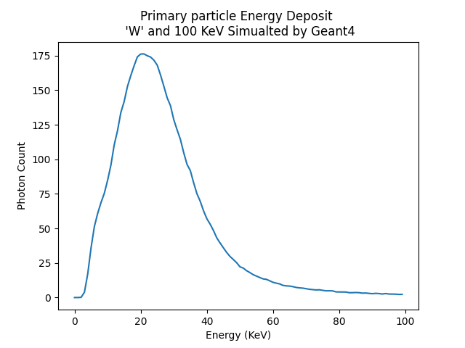Figure 2: Continuous Bremsstrahlung Spectrum (Geant4 Monte-Carlo Simulation)

“TestEm14” simulation provides the energy deposit of the neutral secondary particle simulated for Tungsten when the electron beam has a monotonic energy of 100 (keV). Three discrete spectrum are provided in this simulation representing the 69.0 (keV), 58.0 (keV) and 9.0 (keV). This is provided in Figure (3). These peaks are aligned with the experimental data provided in Figure (1). Please note that this simulation failed to produce the continuous spectrum demonstrated in experimental data in Figure (1). Figure (1) could be easily achieved as a superimposition of figure (2) and figure(3). However, it is not demonstrated in this effort on purpose. This point is caused by selecting two different methods to implement the physics list, selection primary particles for one experiment and selection secondary particles for the other experiment.

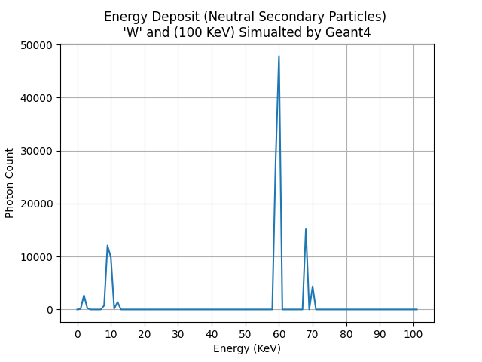Figure 3: Discrete Spectrum (Monte-Carlo Simulation)

Conclusion
Geant4 platform is an exceptionally powerful toolkit to simulate shielding and radiation experiments in the field of Nuclear Engineering. It provided an accurate curvature for the continuous spectrum (Bremsstrahlung) whose peak is eight (keV) apart with experimental data. It provided an accurate spike for the discrete spectrum whose peaks were a match with the experimental data. It provides a methodology to produce a user-defined physicslist and separate data collection for primary particles, secondary particles, charge particles etc. This tool can be configured to provide many fine tuned patterns with high degree of accuracy.

Reference
[1] Turner E. James. Atoms, Radiation, and Radiation Protection. Wiley-VCH, 2007, 3rd edition, page 41.

[2] Robley D. Evans, The Atomic Nucleus. McGraw-Hill, Copyright 1955, page 600

[3] A.H. Lopez Gonzales, Measurement of Characteristic to Total Spectrum Ratio of Tungsten X-Ray Spectrum for The Validatin of the Modified TBC Model. April 13th 2014. Figure 3

Links
https://inis.iaea.org/collection/NCLCollectionStore/_Public/45/099/45099969.pdf
https://geant4.org

