Title:
Understanding Scintillation Counters (NaI Crystal, PM tube) utilizing data collection from nuclear electronic equipment vs Monte Carlo Simulation.

Report:
Gamma Spectroscopy is applied to analyze gamma-rays to identify and quantify radioactive materials. It is used in many fields including nuclear industries, forensics and environmental monitoring.
In this experiment a simple data acquisition system is constructed utilizing a Sodium Iodide crystal coupled to a photo multiplier to describe how to detect gamma radiation, perform counting curve and background noise discrimination, and measure photo-peak resolution for 198Au gammas source. Examination of the electrical pulse observed by Multi-Channel Analyzer spectrum showed that back-scattered (Compton) gammas peak around 0.2 to 0.25 MeV, soft X-ray gammas peak below 0.2 MeV. It was identified that multiple plateau occurs in between high voltage of 0.47 to 0.48 kV and 600 to 700 Volts. Two Monte Carlo experiments were simulated using Geant4 tool sets. The first simulation predicted 198Au’s photon-peak corresponding to gamma line at 411 keV and the second simulation predicted the 198Au’s photon-peak corresponding to gamma line of 600 keV. The hands-on experience with the NaI detectors enhanced the understanding of nuclear electronic tools for Gamma Spectroscopy. The hands-on Monte Carlo simulation enhanced the understanding of the Geant4 tool set.

Introduction:
"NaI scintillation" is a common method for detecting and measuring gamma radiation in nuclear electronics applications. The crystal doped with a small amount of thallium (Tl) to enhance its scintillation efficiency. Sodium Iodide Detectors are widely used in most standard gamma spectroscopy applications because of their high light output and excellent match of their emission spectrum to the sensitivity of photo-multiplier tubes. Figure (1) below provides a simplified blueprint.

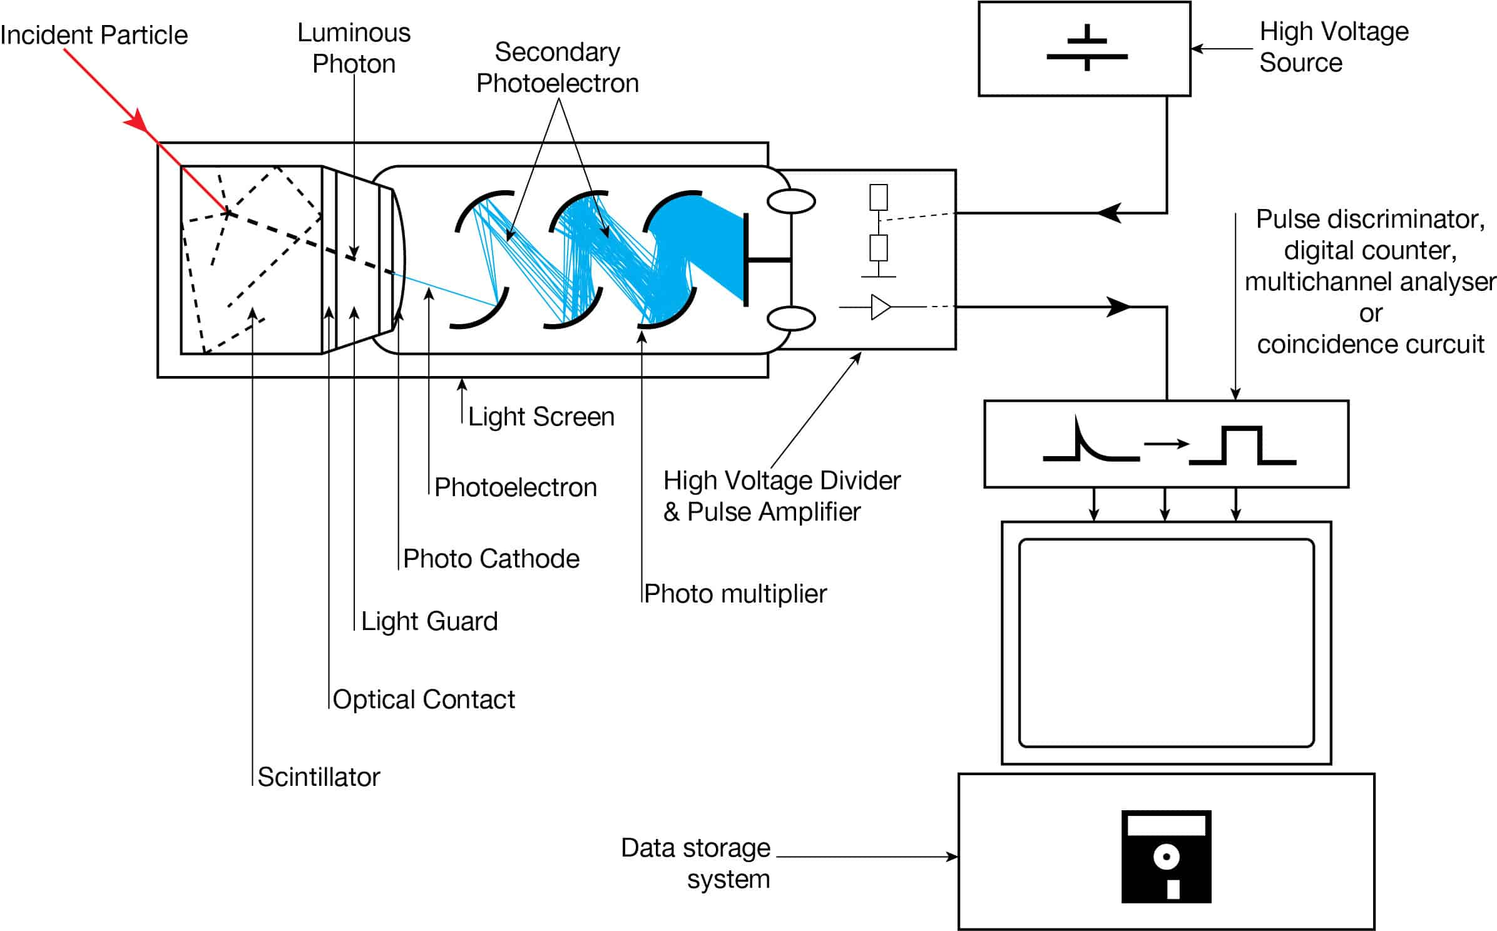Figure 1: NaI(TI) and PM tube [1].

Source (198-Au):
Gold-198 is a radioactive isotope of gold. It undergoes a beta decay to stable 198Hg with a half-life of 2.7 days. The decay properties of 198-Au makes it a candidate for use in medicine since it has 4 mm penetration range in tissue allows it to destroy skin tumors without affecting nearby non-cancerous tissues. The decay scheme of 198-Au to 198-Hg is provided in figure (2).

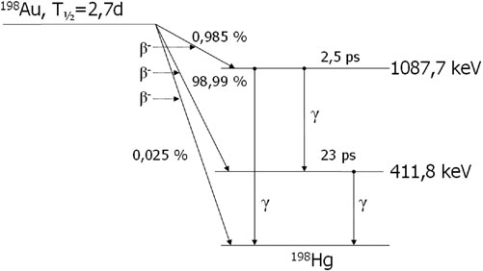Figure 2: Decay Scheme of 198-Au to 198-Hg [2].

Detector Preparation and Setup:
The detector is prepared and configured by placing the NaI(IT) in the lead pig and placing the 198-Au as the source of the gamma ray. Figure (3) represents the configuration for this experiment. The nuclear electronic equipment are as follow : (1) High Voltage Power Supply: Model 323 (2) Amplifier: Ortec 571 (3) MCA: Ortec 551 (4) Oscilloscope: Tektronix 22335A 100MhZ (5) NaI (TI) Crystal.

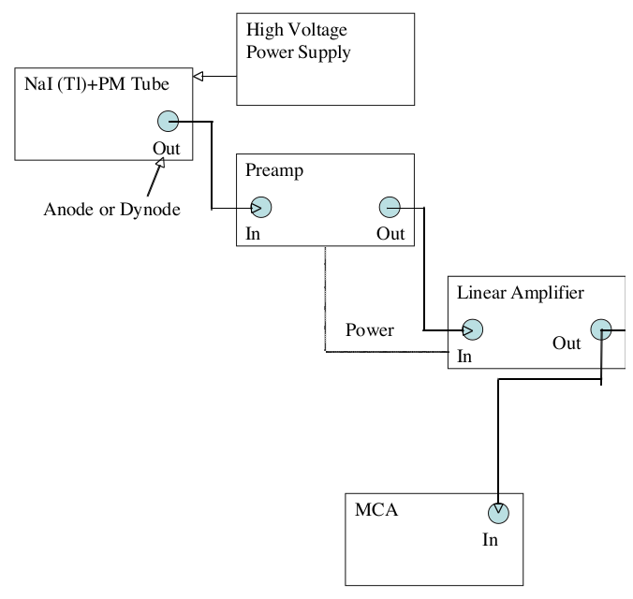Figure 3: MCA, scope, NaI(TI) and 198-Au configuration.

Captured the gamma ray spectrum of 198-Au using a Multi Channel Analyzer (MCA). The measurements where taken when a plateau was observed on the oscilloscope while the detector’s High Voltage supply had been set at a low value 600 volts. The MCA is presented in figure (4) below. It is the pulse height captured representing gamma ray interactions along with the secondary radiation created around the source. The y-axis is the Pulse Height and x-axis is energy in units of MeV. The energy region marked as (1) is the noise which is caused from various sources. The energy region of 100 KeV marked as (2) is the x-ray peak. This is caused by photo-electric absorption. The energy region 250 KeV marked as (3) is the back scattering peak which is caused by Compton scattering. The energy region 600 KeV marked as (4) is the actual photo-peak. The plateau occurred at about 500 KeV which is right after peak (3). This photo-peak corresponds to beta decay of 99 percent which releases a gamma of 411 KeV from figure (2).

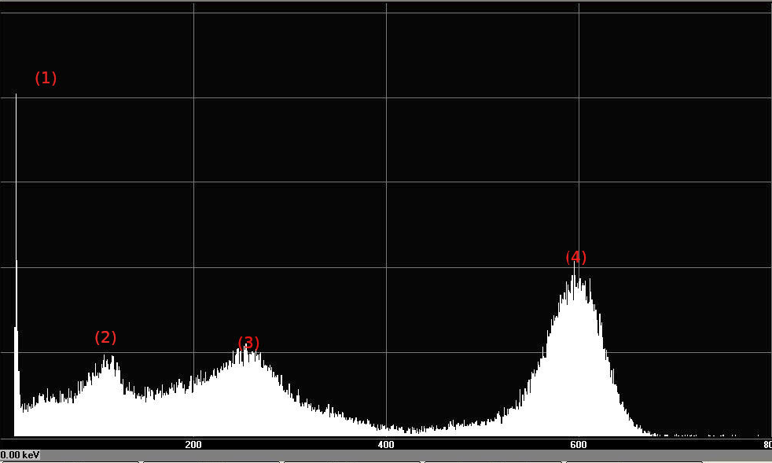Figure 4: MCA output for 198-Au and High Voltage of 600-700 Volts.

Resolution of the NaI Alkali Halide Detector:
Used trial and error to modify the amplifier gain and the High Voltage of the PM tube to place the photo peak in channel 412. This is represented in Figure (5). The PM tube’s High Voltage is at about 470-480 volts.

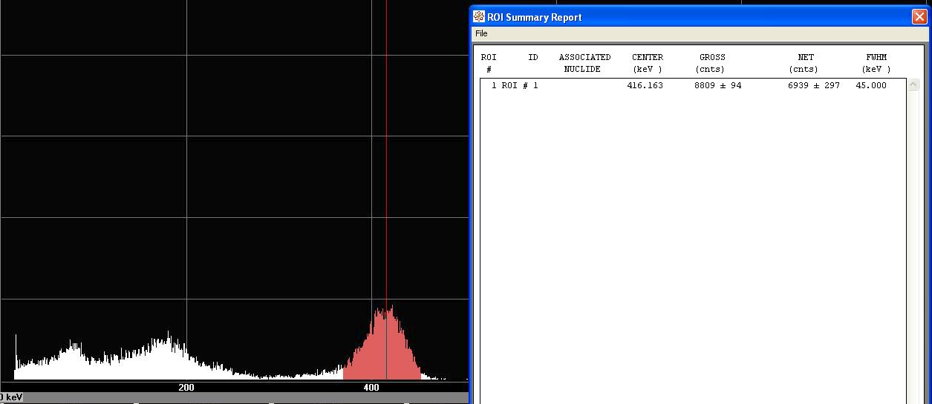Figure 5: MCA output for 198-Au and High Voltage of 0.47-0.48 KV.

Monte Carlo Simulation:
A Geant4 Monte Carlo-based study of this experiment is presented. Goal of this study is to simulate conditions configured in the nuclear electronic set up (Figure 1) and compare the experimental results vs the simulated results.

Scintilator’s Materials and Geometry:
NaI (AI) material is implemented in the “CLab04DetectorConstructor::define_material” method. The G4NistManager and Wikipedia were used to configure this material properties. The NaI’s geometry is defined in “CLab04DetectorConstructor::construct_scintillator”. The NaI’s solid is a “G4Tubs”.

World’s Material and Geometry:
World’s material and geometry is implemented in “CLab04DetectorConstructor::Construct” method. The world solid is a “G4Box” and it’s material is “G4_AIR”.

PM Tubes’s High Voltage:
PM’s high voltage is implemented in “CLab04DetectorConstructor::ConstructSDandField” method. The electrical field is defined to be “G4UniformElectricField” of size 600 Votls/cm. This value was calculated using trial and error.

Primary Particle:
Primary particles were defined in “CLab04PrimaryGenerationAction::GeneratePrimaries” method. 198-Au is of type “G4IonTable”.

Radio Activity Process:
Radio activity process is implemented in “CLab04PhysicsList::CLab04PhysicsList” method. The physics list includes “G4EMStandardPhysics”, “G4DecayPhysics” and “G4RadioActiveDecayPhysics”.
Physics List:

Photon Location:
Photon location was not required in this experiment; however, it was implemented in “CLab04SensitiveDetector::ProcessHits”. Gamma positions and their momentum is evaluated from “GetPosition” and “GetMomentum” function members.

Energy Deposit:
Gamma energy deposited in the scintillation was implemented in “CLab04SteppingAction::UserSteppingAction” method. Additional code was implemented to guarantee the energy deposit were resulted from the scintillation's logical volume.

Figure (6) presents the gamma’s energy deposit of 0.625 MeV in the PM tubes when a uniform electrical field is applied to the scintillation (NaI). This was attempted using trial and error and it is close match to the experimental data.

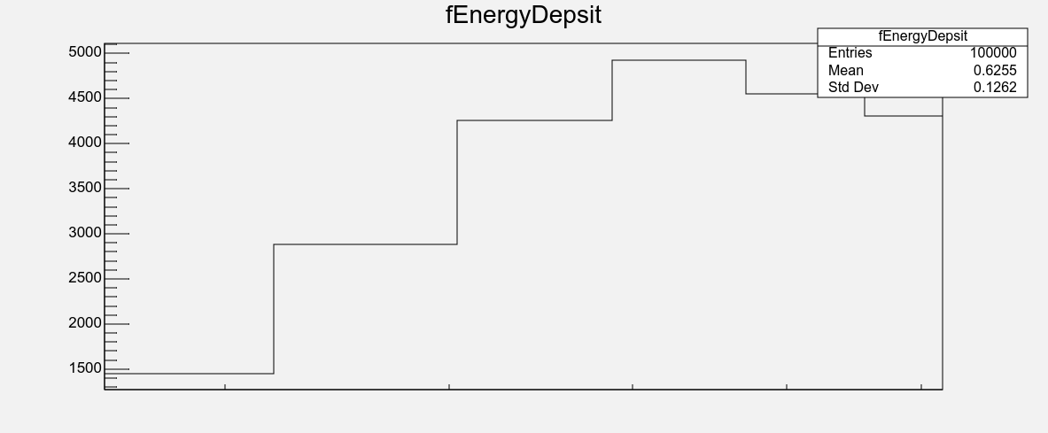Figure 6: Geant4 output for NaI and PM tube are exposed to 600 (KV/cm) electrical Field.

Figure (7) presents the gamma’s energy deposit simulating 198-Au is a very close match to figure (5). The first peak is noise. The second peak is at 100 KeV. The third peak is at 250 KeV and the photo-peak is at 414 KeV.

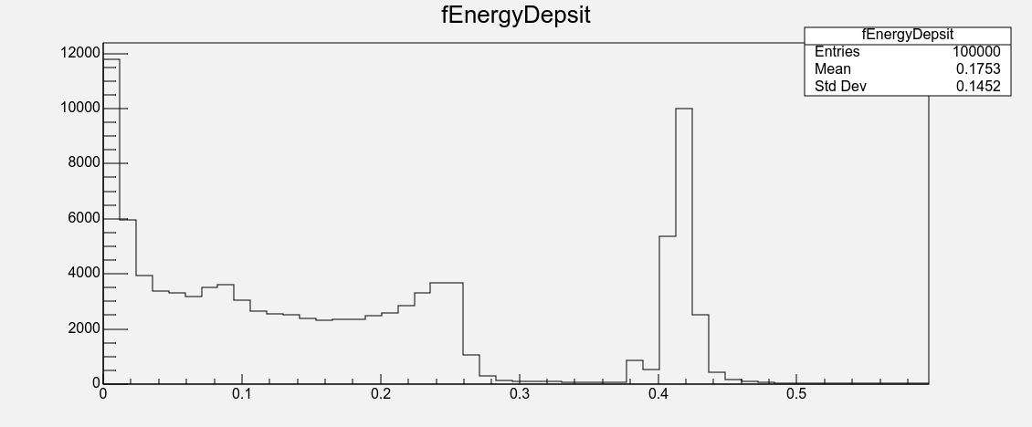Figure 7: Geant4 Simulation of 198-Au in the lead pig.

Next:
The “G4UniformElectricField” was used to generate a uniform electrical field across the entire world. Additional code is used to generate the same field in the scintillation volume only. The code snippet below is copied from the user manual (version 11.3).

#include "G4EqMagElectricField.hh"
#include "G4UniformElectricField.hh"
#include "G4DormandPrince745.hh"

const G4int nvar = 8;

auto pEMfield = new G4UniformElectricField(
G4ThreeVector(0.0,100000.0*kilovolt/cm,0.0));

auto pEquation = new G4EqMagElectricField(pEMfield);

auto stepper = new G4DormandPrince745( pEquation, nvar );
// Create the Runge-Kutta 'stepper' using the efficient 'DoPri5' method

auto fieldManager= G4TransportationManager::GetTransportationManager()->
GetFieldManager();
// Set this field to the global field manager
fieldManager->SetDetectorField( pEMfield );

G4double minStep = 0.010*mm ; // minimal step of 10 microns

// Create a driver to control that integration is within acceptable errors
auto pIntgrationDriver =
new G4IntegrationDriver<G4DormandPrince745>(minStep, stepper, nvar);

fieldManager->SetChordFinder( new G4ChordFinder(pIntgrationDriver) );
Furthermore, Geant4 can be used to simulate the photon meter tube in Figure (1). This tool has the capacity to simulate many scenarios/pattern in nature.
Conclusion:
Geant4 is grate tool set to simulate many pattern in physics with accurate results. In addition, it has a large set of libraries which are used to simulate particular scenarios like Electrical Fields. Simulated data were a close match to experimental data for the decay scheme of 198-Au. Electrical Field was developed with a little bit of code added.

Reference
[1] TBD
[2] TBD
[3] TBD

