The Q-value is measured and is distributed between the Beta particle anti-neutrino and daughter particle. If there is no anti-neutrino, the kinetic energy must be divided between the beta particle (an electron) and the daughter, furthermore, since the daughter is much heavier than the electron. The Q-value must be discrete and accounted for by the electron. However, experiment showed the energy distribution of the negative beta decay is continuous and is not discrete. Number of electrons as a function of the energy (measured in MeV).

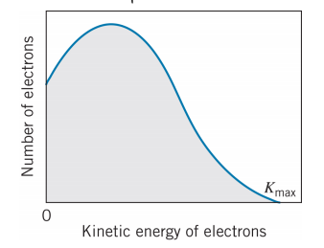
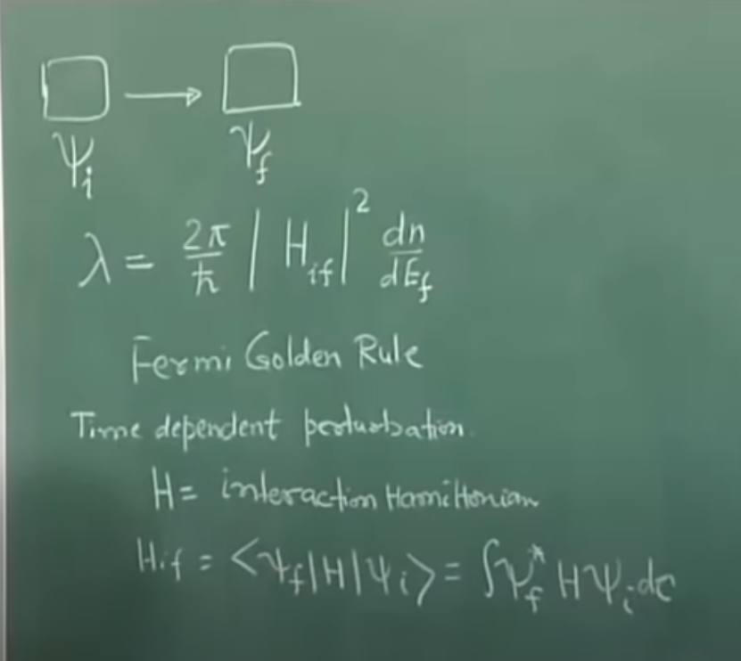

The shape or the functional form of the spectrum explained as Fermi’s Golden Rule of Beta decay (time dependent perturbation theory). The wave form of the initial state is psi sub script-i and the wave form of the final state psi sub script-f. The interaction Hamiltonian is H.
psi sub script-i is ψ_{i}
and psi sub script-f is ψ_{f}
H sub script-i-f is < _{ψi} _{| H | ψf} > = ∫ _{ψf*} _{H ψi dτ}

dn/dE_{f} decided the shape of the energy spectrum (density of the state at the final energy Ef).

ψ_{i} = ψ_{p} | ψ_{f} = ψ_{d} ψ_{e} ψ_{ν}
Where the psi sub script-i is wave function of the input, psi sub-script-d is the wave function of the daughter, electron and neutrino.

∫ _{ψf*} H ψi dτ = ∫ ψd* ψe* ψν* H ψp dτ

* represents the complex conjugate.
Neutrino is considered (approximated) a free particle.
Ψe = (1/v)^(1/2) exp ( i Pe . r / h)
Ψv = (1/v)^(1/2) exp ( i Pv . r / h)
Where v is volume, i is the imaginary value Pe is the momentum of electron dot product with r divided by h-bar.

Kinetic energy is the total energy of electron (considered to be relativistic) minus the rest energy.
is ( Pe^2 C^2 + me^2 C^4 ) ^ (½) - me0 C^2
Where Pe is the linear momentum of electron, C is the speed of light, me is the mass of electron nd the me0 is the rest mass of electron.
(1/v)^(1/2) exp ( i Pe . r / h) = (1/v)^(1/2) {1 + _{i} P . r / h}

approximated to _{(1/v)^(1/2)}
∫ ψd* ψe* ψν* H ψp dτ = (1/v) ∫ ψd* H ψp dτ = (1/v) Mif

Where Mif is the Nuclear Matrix Element. This is a constant, so the shape of the energy distribution is impacted by the dn/dEf or the density of the states at the final energy. The final energy is a system and there are some energy level available for the states of final energy. The term dn is number of quantum states around the available energy. The dn confined in volume V for the electron and the neutrino.

One-dimensional deep square well potential (QM).
E = n^2 h^2 pi^2 / (2*m*L^2)
Where n=1,2,3 and …
E is quantum energy level,
h-bar and Pi are constants.

Pn = n h pi / L =
where n = 1,2 and 3…
quantified momentum.
H-bar and pi are constants
L is angular momentum.

Three-dimensional deep square well potential
E = (n1^2 + n2&2 + n3^2) h^2 pi^2 / (2*m*L^2)

[1] https://www.youtube.com/watch?v=AB5JFmMvtGw
[2] https://www.youtube.com/watch?v=Oq9sdWQc4gg&t=549s

