LAB Logbook

Lab 1
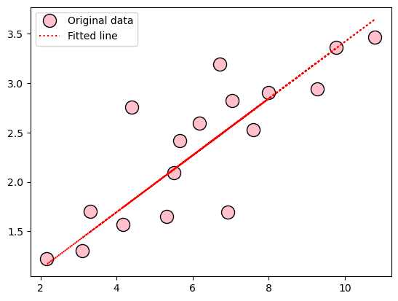
Lab 2
Accuracy = 0.974
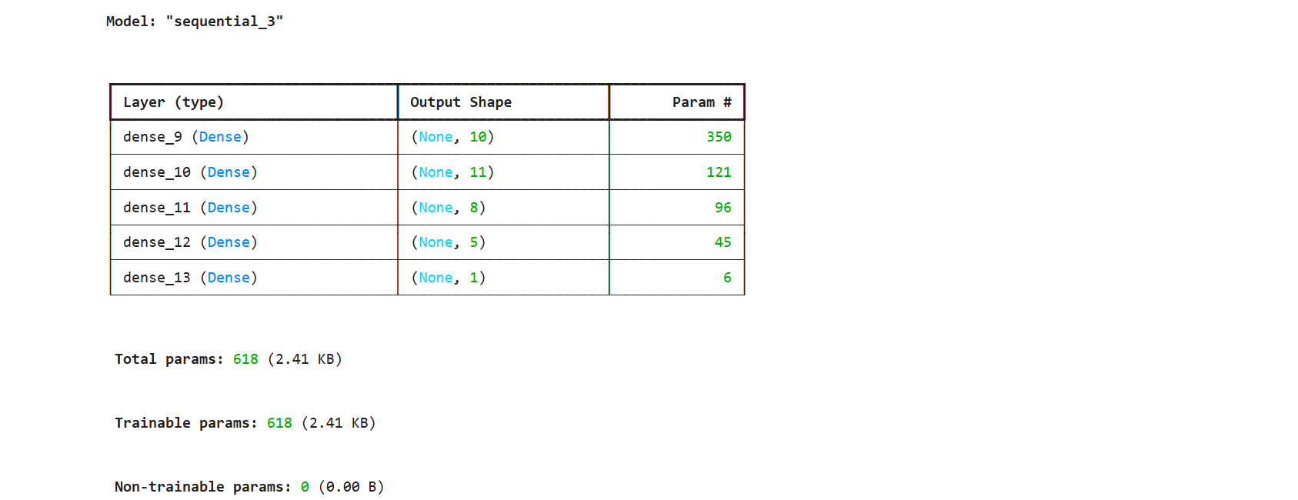
Task2 = 0.823​

Lab 3
Test accuracy: 0.8833000063896179
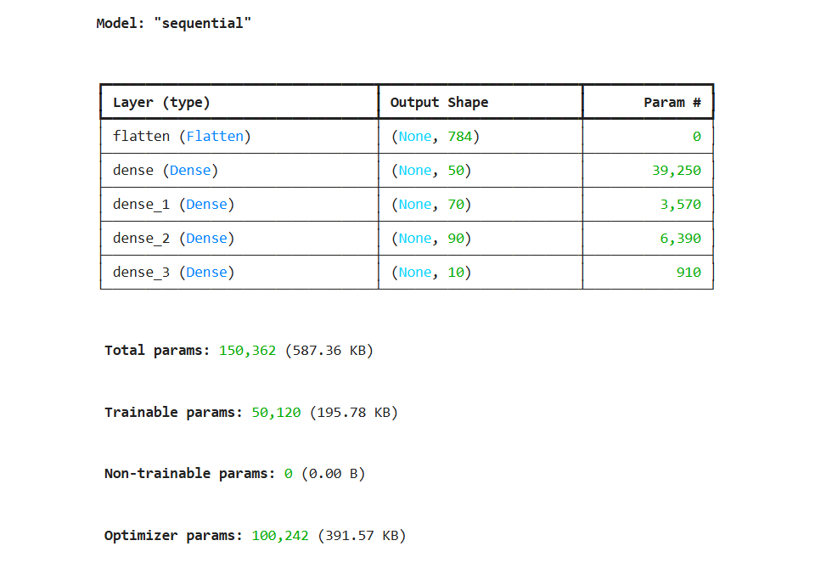

Lab 4

Lab 5

Lab 6

Lab 7

Lab 8

Lab 9

Lab 10

Lab 11

Lab 12

