Subject: Motor Procurement Update – Reactor Cooling System
Facility: North River Nuclear Power Station
Department: Mechanical Systems Engineering
Date: 12 March 2026
Prepared by: Operations & Maintenance Division

1. Overview
This document provides an update regarding the procurement and installation of replacement motors for the secondary reactor cooling system pumps. The motors currently installed in Units 2 and 3 have reached their scheduled operational lifetime and require replacement during the upcoming maintenance window.
The replacement motors have been sourced from ThermoDrive Industrial Systems, with updated specifications to improve efficiency and reduce vibration under high-load conditions.
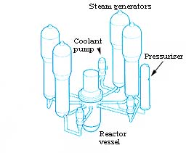
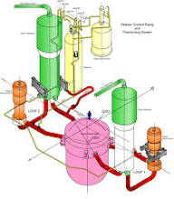

2. Motor Specifications
Parameter | Current Unit | Replacement Unit
Rated Power | 450 kW | 450 kW
Operating Voltage | 6.6 kV | 6.6 kV
Cooling Method | Air-cooled | Enhanced air-cooled
RPM | 1480 RPM | 1480 RPM
Manufacturer | Legacy Systems Ltd. | ThermoDrive Industrial Systems

3. Installation Schedule
The motor replacement procedure will take place during the planned maintenance shutdown scheduled for April 2026.
Proposed timeline:
- Isolation of pump assembly
- Removal of existing motor housing
- Installation of replacement motor unit
- Alignment calibration and vibration testing
- Operational verification
Estimated downtime per unit: 6–8 hours

4. Safety and Compliance
All installation procedures must comply with:
- Nuclear Regulatory Commission (NRC) operational standards
- Facility mechanical safety protocols
- Electrical isolation procedures
Personnel performing the installation must ensure all lockout–tagout procedures are followed.

5. Final Notes
Engineering teams are requested to review the attached documentation and confirm compatibility with existing pump assemblies before the scheduled maintenance window.
Any discrepancies or procurement concerns should be reported to the Mechanical Systems Engineering Office before March 20, 2026

