**Name : Aradhya Sakalley**

**Sapid : 60004210253**

**Batch : C3-2**

**Branch : Computer Engineering**

**Experiment 1**

**Aim :** To implement Booth’s multiplication algorithm.

**Theory:**

Booth's Algorithm is a binary multiplication technique that optimizes the multiplication of signed binary numbers by efficiently recognizing patterns in the multiplier. By examining pairs of adjacent bits in the multiplier and applying addition, subtraction, or shifting operations accordingly, Booth's Algorithm significantly reduces the number of arithmetic operations required, making it a more efficient method, particularly for large binary numbers.

**Code :**

def twosComplement(num):

    onesComp=""

    for i in num:

        if i == "0":

            onesComp += "1"

        else:

            onesComp +="0"

    return bin(int(onesComp,2) + int("1",2)).replace('0b',"")

num1 = int(input('Enter number: '))

num2 = int(input('Enter 2nd number: '))

binNum1 = bin(abs(num1)).replace("0b",'')

binNum2 = bin(abs(num2)).replace("0b",'')

if len(binNum1) >= len(binNum2):

    maxlen = len(binNum1)

else:

    maxlen = len(binNum2)

maxlen +=1

binNum1 = binNum1.zfill(maxlen)

binNum2 = binNum2.zfill(maxlen)

if num2 < 0:

    binNum2 = twosComplement(binNum2)

if num1 < 0:

    binNum1 = twosComplement(binNum1)

binCompNum1 = twosComplement(binNum1)

binCompNum1 = binCompNum1.zfill(maxlen)

print(binNum1)

print(binNum2)

print(binCompNum1)

count = maxlen

m = binNum1

minusm = binCompNum1

q = binNum2

q1 = '0'

a = "0"

a = a.zfill(maxlen)

rightshift=""

while count > 0:

    if q1 == '1' and q[maxlen-1] == '0':

        a = bin(int(a,2) + int(m,2)).replace('0b','')

        if(len(a) > maxlen):

            a = a[1:]

        a = a.zfill(maxlen)

    elif q1=='0' and q[maxlen-1] == '1':

        a = bin(int(a,2) + int(minusm,2)).replace('0b','')

        if(len(a) > maxlen):

            a = a[1:]

        a = a.zfill(maxlen)

    merged = a+q+q1

    rightshift = merged[0]

    for i in range(len(merged)-1):

        rightshift += merged[i]

    a = rightshift[:maxlen]

    q = rightshift[maxlen:maxlen*2]

    q1 = rightshift[-1]

    count -=1

ans = a+q

minus = False

if ans[0] == '1':

    ans = twosComplement(ans)

    minus = True

print(ans)

if minus:

    print(int(ans,2) * -1)

else:

    print(int(ans,2))

**Output :**

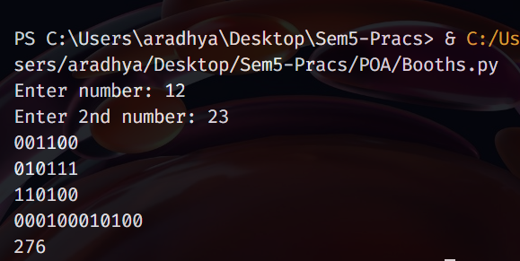

**Solved Example :**

Solve using Booth’s algorithm 7 x -3 (4 bit)

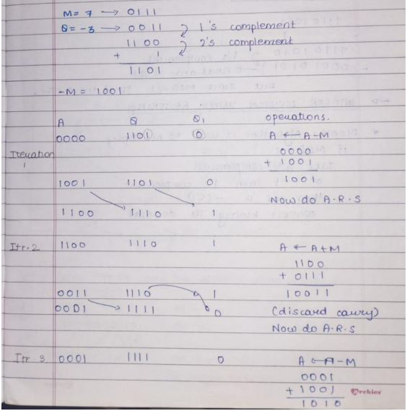

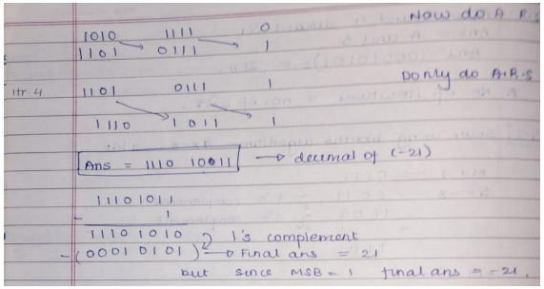

**Conclusion : Thus we have implemented Booth’s algorithm**