BUSINESS STRATEGY & INVESTMENT REPORT
AI Resume & Interview Coach
Sustainability & Growth Assessment — Based on the Day 23 Customer & MVP Blueprint
PREPARED FOR FOUNDER REVIEW | PRE-SEED / IDEA STAGE
Market: India (Phase 1) → English-speaking global markets (Phase 2)
Prepared by: AI Co-Founder / Growth Strategy Desk
Date: July 2026

Table of Contents

Executive Summary

Startup Summary (from the Day 23 Blueprint)
- AI Resume & Interview Coach: an AI-powered platform helping India's tier-2/3 college students and fresh graduates build ATS-ready resumes and prepare for interviews.
- Targets a real, well-documented structural problem: ~5M Indian graduates enter the job market yearly against ~2.8M graduate-level jobs, and 60%+ of resumes fail ATS screening.
- ICP: final-year students / fresh grads within 18 months of graduation, tier-2/3 cities, highly price-sensitive, mobile-first, active on WhatsApp/Telegram/YouTube.
- MVP is deliberately narrow: manual or semi-automated resume review + mock-interview feedback for ONE niche segment, delivered via chat (WhatsApp/Telegram), no native app.
- Monetization tested as a one-time ₹99–₹299 UPI unlock, not a subscription, with a free ATS-check as the acquisition hook.
- Distribution plan leans on community channels (placement WhatsApp groups, referrals, college micro-partnerships) rather than paid acquisition.
- Operating in a crowded field: 8+ funded or traction-proven competitors already serve this wedge in India (PrepFree, Resumeera.xyz, ResumeGyani, Dovira AI, Jobcopy, Internshala, Kickresume, Novoresume).
- As of the blueprint, there is zero direct evidence — no interviews conducted, no landing page tested, no payments collected.
- Founder is solo, side-project stage, moderate technical ability, and currently has no college/placement-cell network.

Extracted Assumptions
Dimension | Assumption
Customer | Tier-2/3 Indian final-year students & fresh grads; price-sensitive; discover products via community/social channels, not search or ads
MVP | A manually-delivered resume review + structured mock-interview feedback, chat-based, scoped to one niche segment
Value proposition | Depth of feedback and India-specific recruiter norms, not speed or breadth of features — differentiation from commodity AI resume builders
Pricing | ₹99–₹299 one-time purchase, free ATS check as top-of-funnel hook, no subscription at launch
Revenue | Primarily transactional/per-use in Year 1; B2B2C college licensing modeled as a future, unvalidated revenue layer
GTM | Organic, community-led distribution (WhatsApp/Telegram groups, referrals, one college pilot) — no paid-acquisition budget assumed

1. Business Reality Check
This section stress-tests the blueprint's core assumptions against revenue, distribution, and evidence — not features or vanity metrics.

Who pays?
The individual student pays directly (₹99–₹299 one-time), not a college or employer, at least in the MVP phase. This is a consumer-transactional model, not B2B — meaning revenue is only as strong as thousands of small, individually-won purchase decisions, not a handful of institutional contracts.

Why do they pay?
Not for the resume document itself — free tools already produce that. They pay for a credible signal that the output will actually improve their odds of getting an interview call, typically after seeing a free ATS score, a peer's success story, or a testimonial. The purchase trigger is proof, not product features.

How will they discover the product?
Primarily through informal, high-trust community channels: WhatsApp/Telegram placement groups, peer referral, and (eventually) YouTube/Instagram short-form content. There is no paid-acquisition budget assumed, and no SEO or app-store presence to lean on early — discovery is entirely dependent on manual, founder-led community seeding.

Biggest growth risks
- Community-led distribution (WhatsApp/Telegram groups) is high-touch, unscalable without dedicated effort, and easy for group admins/incumbents to block or crowd out.
- Internshala and PrepFree already own large-scale institutional and student distribution channels that a solo founder cannot replicate quickly.
- No paid-acquisition fallback if organic/community channels underperform — growth is capped by founder bandwidth (side-project status).

Biggest monetization risks
- Price anchoring is already set low by competitors (free tiers, ₹299 "Pro" plans) — thin margin per transaction, requiring high volume to matter.
- One-time purchase model caps lifetime value; without a retention or upsell layer, each user is a single, small transaction.
- No evidence yet that free-to-paid conversion (ATS check → ₹99–₹299 unlock) will actually happen at a workable rate.

Weak assumptions to validate first
Assumption | Why It's Risky
Users will pay ₹99–₹299 upfront, before deep trust is established | No payment test has been run; stated willingness-to-pay is not the same as real money changing hands
WhatsApp/Telegram groups are a scalable acquisition channel | Effective for a first cohort, but unproven beyond a handful of manually-seeded groups
Colleges/placement cells will eventually license or partner | Zero relationships exist today; institutional sales cycles are typically slow and relationship-driven
"India-specific feedback depth" is a strong enough differentiator | Currently a hypothesis, not a tested or proven advantage over funded incumbents already localizing for India

2. Business Strategy Report
A practical, execution-first strategy for turning the validated problem into a sustainable business — prioritizing revenue and distribution over feature-building.

2.1 Business Model Canvas
Customer Segments | Tier-2/3 Indian final-year students & fresh grads (0–18 months post-graduation); price-sensitive, mobile-first.
Value Propositions | India-specific, depth-focused resume + interview feedback that gets you an actual interview call — not another generic AI resume template.
Channels | WhatsApp/Telegram placement groups, peer referral, YouTube/Instagram short-form content, one college micro-partnership.
Customer Relationships | High-touch/manual in MVP (founder personally reviews resumes); community-driven trust; referral-based growth.
Revenue Streams | One-time ₹99–₹299 per-use unlock; future add-on mock-interview rounds; future B2B2C college licensing (unvalidated).
Key Resources | Founder's time & domain empathy; a proprietary feedback rubric (to be built); early testimonials/social proof.
Key Activities | Manual resume/interview review delivery; community seeding; testimonial collection; iterative rubric refinement.
Key Partners | College placement cells (pilot stage); student ambassadors/micro-influencers in target niche.
Cost Structure | Near-zero fixed costs at MVP stage — founder time, AI/LLM API usage, basic landing page/chat tooling.

2.2 Revenue & Pricing Strategy
Revenue should be tested, not assumed. The strategy below prioritizes proving real willingness-to-pay before adding pricing complexity.
Tier | Price | Rationale
Free hook | ₹0 — ATS score check | Low-friction top-of-funnel; builds trust before asking for payment
Core offer | ₹99–₹299 one-time | Matches proven price sensitivity of niche; low enough to reduce purchase friction
Add-on | ₹49–₹99 per extra mock round | Tests upsell/LTV expansion once core offer converts
Future B2B2C | Flat per-cohort licensing fee | Only pursued after 1+ college pilot validates institutional interest

Pricing risk flag
Competitors have already anchored the market at free-to-₹299. A new entrant cannot win on price alone — pricing strategy must be paired with visible proof of outcome (before/after ATS score, real interview-call stories) to justify any payment at all.

2.3 Go-To-Market Strategy
Phase | Focus | Actions
Phase 0  (Wk 1–2) | Manual validation | Wizard-of-Oz delivery to 15–20 users in one niche; confirm pain points & pricing signal
Phase 1  (Wk 3–4) | Community-led growth | Seed 3–5 WhatsApp/Telegram groups; referral incentive; collect testimonials
Phase 2  (Mo 2–3) | Institutional pilot | 1–2 college placement-cell pilots; test B2B2C interest with zero/low-cost pilot terms
Phase 3  (Mo 3–6) | Content & organic reach | YouTube/Instagram short-form content once product-market signal is real, not before
Phase 4  (Mo 6+) | Paid acquisition (conditional) | Only introduce paid ads after unit economics (CAC < LTV) are proven organically

2.4 Customer Acquisition Strategy
Channel | Cost | Notes
WhatsApp/Telegram placement groups | Free (time) | Primary channel; highest trust, lowest cost, but manual and hard to scale
Referral from paying users | Free / small discount | Cheapest channel once initial trust is established; compounds over cohorts
College placement-cell partnerships | Free (relationship-building time) | Slow to establish, but high-leverage — reaches many students per relationship
YouTube/Instagram short-form content | Free (time) / low | Builds long-term organic reach; not a Day 1 priority
Paid social/search ads | ₹ (budget required) | Deprioritized until organic CAC and conversion are proven

2.5 First 100 Users Plan
Source | Target Users | How
Founder's own network | 10–15 | Direct outreach to classmates/juniors in final-year cohorts
WhatsApp/Telegram placement groups | 30–35 | Post free ATS-check offer in 3–5 relevant groups
College micro-partnership | 20–25 | One placement-cell pilot promoting to a specific batch/branch
Referral loop | 15–20 | Each paying user refers 1 peer for a small discount/bonus
Content (YouTube/Instagram) | 10–15 | Short before/after resume or mock-interview clips from founder

2.6 Competitive Position & Moat
No inherent technology moat exists — wrapping an LLM into a resume/interview tool is now commoditized, and multiple funded competitors already do it well. Any durable advantage must come from distribution and trust, not raw AI capability.
Potential Moat | Current Status
Hyper-local trust in tier-2/3 colleges | Aspirational — not yet built; requires deliberate, sustained community presence
Proprietary India-specific feedback rubric | Not yet built — would compound with more real user/recruiter data over time
Placement-cell relationships (B2B2C lock-in) | Zero relationships today — biggest gap vs. PrepFree
High-touch coaching depth vs. speed-focused incumbents | Plausible differentiator, but unproven against user preference for speed

2.7 Reverse SWOT Analysis
Reverse SWOT starts from what could kill the business, then asks what would have to be true to flip each threat into an advantage.
Threat | Feeding Weakness | Opportunity to Flip It | Strength to Build
Funded incumbents crush a solo side-project head-on | No capital, no distribution network yet | Incumbents largely ignore deep, tier-2/3-specific niches | Community-led local trust the incumbents can't easily replicate
AI feature parity is commoditized | No proprietary technology | Build a proprietary rubric from real recruiter/user data over time | A compounding data/quality moat if executed consistently
Users won't pay upfront | Unproven pricing, low trust | Free ATS-check hook + peer proof funnel lowers the barrier to a first purchase | Low price point reduces friction once trust is established
Founder bandwidth limits execution speed | Side-project, limited time/capital | A tight 30-day sprint forces fast, cheap validation before overcommitting | Low burn rate means the founder can pivot cheaply if signal is weak

2.8 Investor One-Liner
One-liner
An AI-powered, India-first interview coach helping tier-2/3 college students turn weak resumes into real interview calls — starting in the underserved niches funded incumbents don't bother to go deep on.

2.9 30-Second Founder Pitch
Spoken pitch
"Every year, India produces 5 million graduates for 2.8 million graduate jobs — and 6 in 10 resumes never even reach a human because they fail ATS screening. We help tier-2/3 college students fix that: real, India-specific resume feedback and interview coaching for a price they can actually afford — starting at ₹99. We're not building another generic AI resume tool; we're going deep on the students the big platforms overlook."

3. Investment Scorecard
Dimension | Score | Reasoning
Business Viability | 42 / 100 | Real, data-backed problem and clear customer, but thin differentiation and unproven pricing model
Revenue Potential | 38 / 100 | Low ARPU, one-time purchase model, modest realistic SOM ($150K–$400K ARR at Year 1–2 pace)
GTM Strength | 45 / 100 | Plausible, low-cost community-led channel, but unproven at scale with no paid-acquisition fallback
Competitive Strength | 30 / 100 | No moat yet; entering a crowded field against 8+ funded, traction-proven incumbents
Investor Readiness | 20 / 100 | Solo side-project, zero users/interviews/revenue as of this report — pre-seed idea stage only

35 / 100 AVERAGE SCORE — VALIDATE STAGE

5. Visual Dashboard
A single-view snapshot of the business model, revenue streams, GTM flow, first-100-users plan, competitive moat strength, key risks, and investment scorecard.
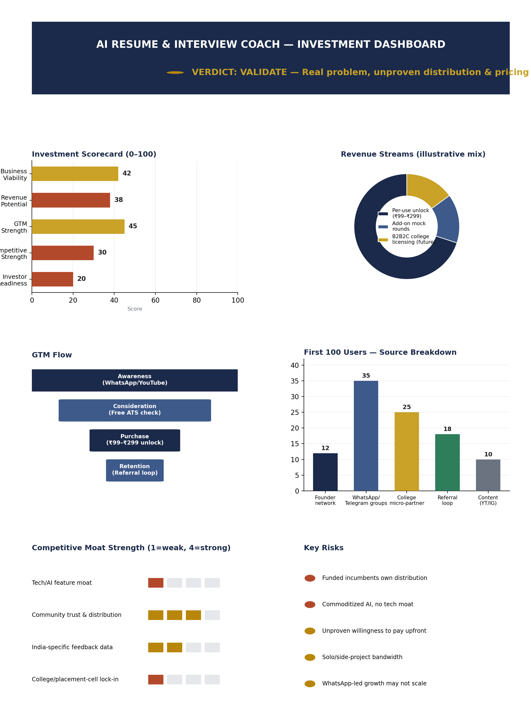

4. Founder Action Sheet — Top 10 Actions
# | Action
1 | Commit to one tier-2/3 niche segment this week — write it down, don't hedge
2 | Interview 15–20 target users about their last rejection and real willingness to pay
3 | Build a 1-page landing page with a clear ₹99–₹299 offer and a free ATS-check hook
4 | Seed 3–5 relevant WhatsApp/Telegram placement groups with the free offer
5 | Manually deliver the service to the first 20 signups — charge real money, not free trials
6 | Open 1 pilot conversation with a college placement cell
7 | Launch a referral incentive for paying users
8 | Publish 3–5 short-form videos (YouTube/Instagram) showing real before/after resumes
9 | Track CAC, conversion rate, and repeat usage weekly in a simple spreadsheet
10 | Review unit economics & distribution signal on Day 30 — decide to scale, pivot, or kill

Sustainability Verdict
VERDICT: VALIDATE
This is not yet a sustainable business — it is a well-documented problem paired with an unvalidated solution in a crowded, funded competitive field. Sustainability hinges entirely on evidence the founder does not yet have: real payments, a repeatable distribution channel, and a defensible niche beyond "another AI resume tool." Run the 30-day validation sprint, prioritize a narrow tier-2/3 niche and one paying-user cohort over any further feature-building, and revisit this scorecard with real revenue and usage data before considering it investable.

