STARTUP VALIDATION REPORT
AI Resume & Interview Coach
AI-powered career readiness platform for students & fresh graduates
PREPARED FOR FOUNDER REVIEW | IDEA-VALIDATION STAGE
Market: India (Phase 1) → English-speaking global markets (Phase 2)
Prepared by: Startup Advisory & Market Research Desk
Date: July 2026

Table of Contents

1. Executive Summary
AI Resume & Interview Coach is an early-stage (idea-validation) concept targeting one of India's most acute and well-documented labour-market frictions: a widening gap between the number of graduates produced each year and the number of graduate-level jobs created. The founder proposes an AI-powered platform that builds ATS-friendly resumes and coaches students and fresh graduates through interview preparation, priced affordably for a price-sensitive, high-volume market.
Bottom line
The problem is real, large, and worsening — but the solution category is crowded with well-funded, fast-moving competitors already serving the exact same wedge (resume + AI interview prep) in India. This is a Conditional-Go: proceed, but only with a sharply differentiated niche, not a general-purpose resume builder.

Founder-Market Fit | Market Opportunity | Competitive Intensity | Overall Verdict
5.7 / 10 — Moderate | 8 / 10 — Large & growing | 9 / 10 — Very High | CONDITIONAL GO

Key findings from this report:
- The underlying problem is validated by national labour data, not just anecdote — India adds roughly 5 million graduates a year against ~2.8 million graduate-level jobs, and two-thirds of unemployed 20–29 year-olds now hold a degree.
- At least 8 direct or adjacent competitors already operate in this exact space in India (Resumod, ResumeGyani, Resumeera.xyz, Dovira AI, Jobcopy, Internshala, PrepFree, plus global players like Kickresume and Novoresume). Several already report 100K–200K+ monthly active users.
- The most defensible open space is not "resume + interview prep" in general — it is a tightly-scoped niche (a specific student segment, region, or career vertical) combined with genuinely superior AI feedback quality and a distribution channel competitors haven't locked up.
- No existing validation (users, waitlist, interviews) has been done yet. This is the single highest-priority gap to close before writing more code.
- As a side project with long-term startup ambitions, the recommended path is a 30-day scrappy validation sprint before any further product investment.

2. Problem Validation

2.1 Is the problem real?
Yes — and it is more severe than most first-time founders assume. This is not a niche annoyance; it is a structural, national-scale mismatch between education output and job creation in India.
Data Point | Figure | Source
Graduates added per year in India | ~5 million | State of Working India 2026 (Azim Premji University)
Graduate-level jobs created per year | ~2.8 million | State of Working India 2026
Share of unemployed youth (20–29) who are graduates | 67% | State of Working India 2026
Youth unemployment rate (15–29) | ~15.2% (Mar 2026) | India labour market data
Unemployment rate, ages 15–25 | ~40% | State of Working India 2026
New resumes created monthly in India | ~12 million | Industry press, 2026
Resumes that fail ATS screening | >60% | Industry press, 2026

2.2 What this means for the startup
- The pain point (poor resumes + weak interview readiness → fewer offers) is grounded in real structural conditions, not a founder assumption.
- The addressable behaviour (12M resumes/month) proves people are already actively taking action to solve this themselves — the market is not dormant, it is underserved by quality.
- However, a large, well-documented problem also means the opportunity has already attracted well-funded competitors (Section 5) — the problem being validated is not the same as the solution being differentiated.

2.3 Validation status
Current stage: Unvalidated by direct evidence
No interviews, no waitlist, no landing page tests, and no paying or free users exist yet. Everything above validates the market problem using third-party data — it does not yet validate that your specific product, positioning, or pricing will win users away from incumbents. Closing this gap is priority #1 (see the 30-Day Action Plan).

3. Founder-Market Fit Score
Founder-market fit measures how well-positioned you personally are to win in this specific market — not how good the idea is in the abstract. Scored 0–10 on six dimensions based on what you've shared.
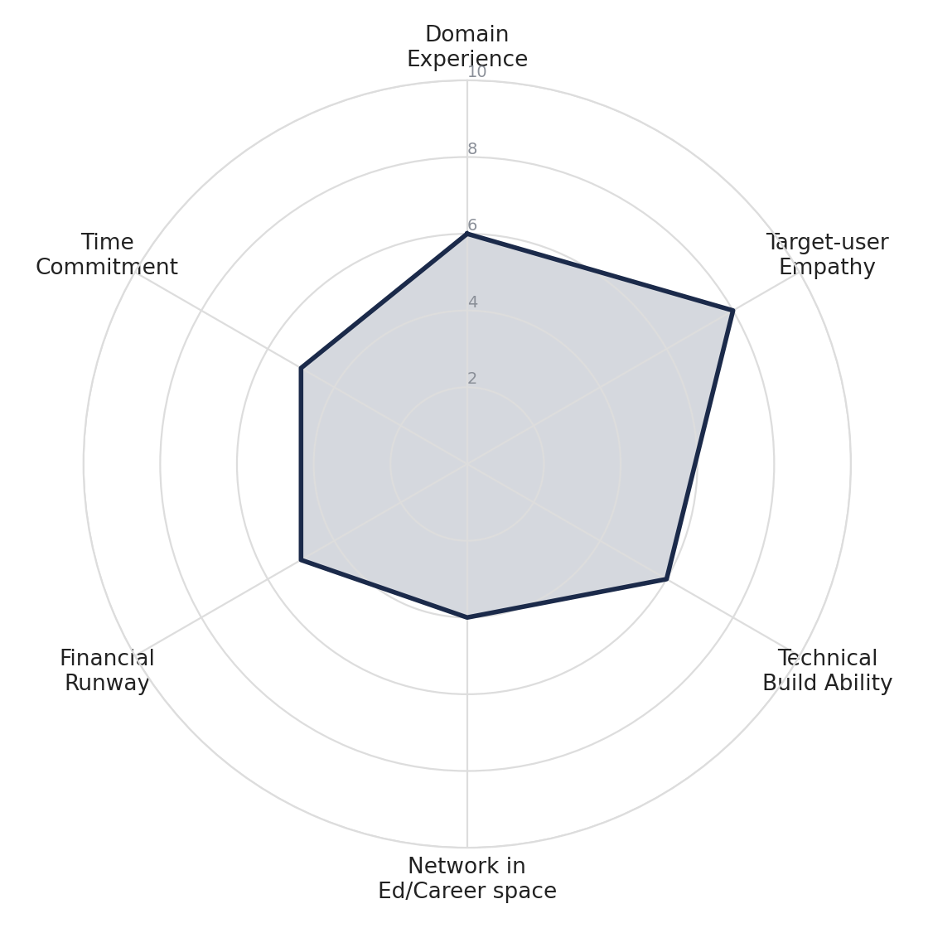
Dimension | Score | Why
Domain experience | 6 / 10 | You clearly understand the student/job-seeker pain point, but no stated background in recruiting, HR, or career coaching yet.
Target-user empathy | 8 / 10 | You're building for a life-stage you likely just lived through or are close to — strong intuitive empathy for the user.
Technical build ability | 6 / 10 | AI-powered products are buildable with modern no-code/LLM tooling; assumed moderate technical capability at side-project stage.
Network in ed/career space | 4 / 10 | No mentioned relationships with colleges, placement cells, HR communities, or career influencers — this is currently a gap.
Financial runway | 5 / 10 | Side-project status implies limited dedicated capital; assumed self-funded/bootstrapped.
Time commitment | 5 / 10 | Side-project (not full-time) — realistic given stated intent, but will cap execution speed against funded competitors.

5.7 / 10 MODERATE FIT
Interpretation: You have genuine empathy for the problem, which is a real asset — but you are entering a category with entrenched, funded competitors while under-indexed on distribution network and full-time bandwidth. Fit improves fast if you build a placement-cell/college network before scaling product.

4. TAM, SAM, SOM Analysis
Sized two ways — as a revenue opportunity and as a user-count opportunity — using published market data plus bottom-up estimates from India labour statistics.
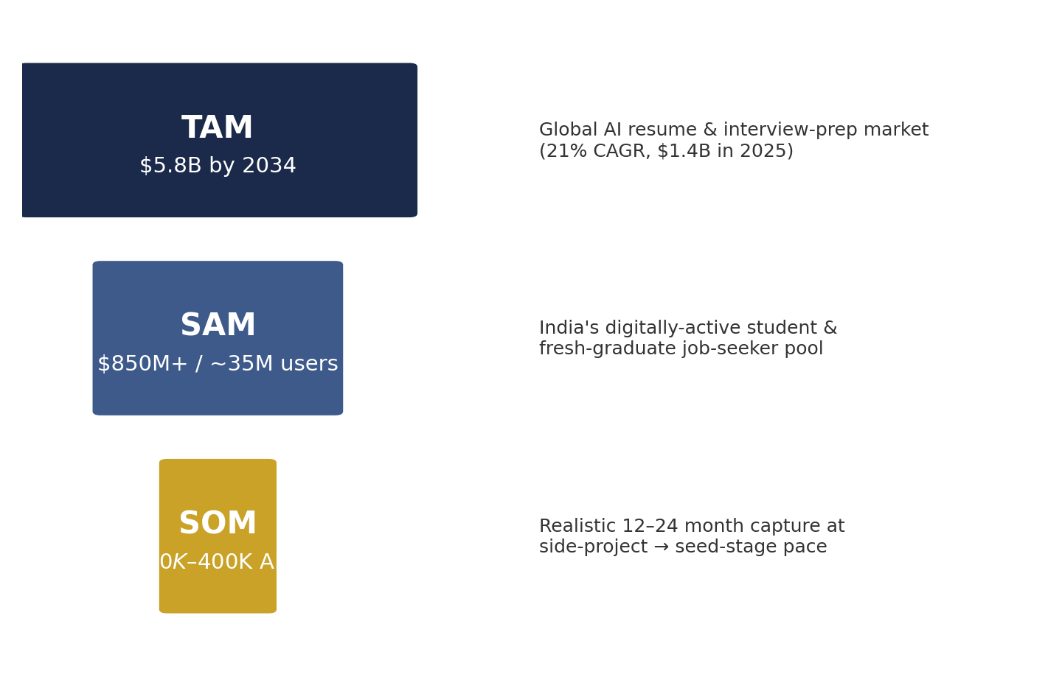
Layer | Size | Basis
TAM | $1.4B (2025) → $5.8B by 2034  (~17–21% CAGR) | Global AI resume-builder / career-prep app market, all English-speaking geographies
SAM | ~$850M+ opportunity /  ~30–35M active users | India's digitally-active college students + fresh graduates (within ~3 years of graduation) who create resumes and search for jobs online; Asia-Pacific is the fastest-growing regional segment
SOM | $150K–$400K ARR /  15,000–75,000 users | Realistic 12–24 month capture as a bootstrapped/side-project entrant focusing on 1–2 niches (e.g., tier-2/3 college students, or one professional vertical) rather than competing broadly

4.1 How these numbers were derived
- TAM: Global resume-building and AI resume-builder app market sizing from industry market research (2025–2034 forecasts).
- SAM: India creates ~12 million new resumes a month; even assuming heavy repeat usage, this implies a unique active-user base in the tens of millions annually, concentrated among the ~5 million new graduates/year plus the multi-year backlog of job-seeking graduates.
- SOM: Modelled conservatively against comparable early-stage players — Resumeera.xyz reached ~180,000 monthly active users before its most recent feature launch; a new, resource-constrained entrant should target a fraction of that in Year 1, concentrated in a defensible niche.
Caveat
These are directional, not audited, figures. Before fundraising or making resourcing decisions, validate SAM/SOM with primary research (surveys, pilot conversion rates) rather than relying on top-down market sizing alone.

5. Competitor Analysis
This is the most important section in this report: the India AI-resume-and-interview-prep space is already active and, in places, well-capitalized. Treat this as a crowded market, not a greenfield.
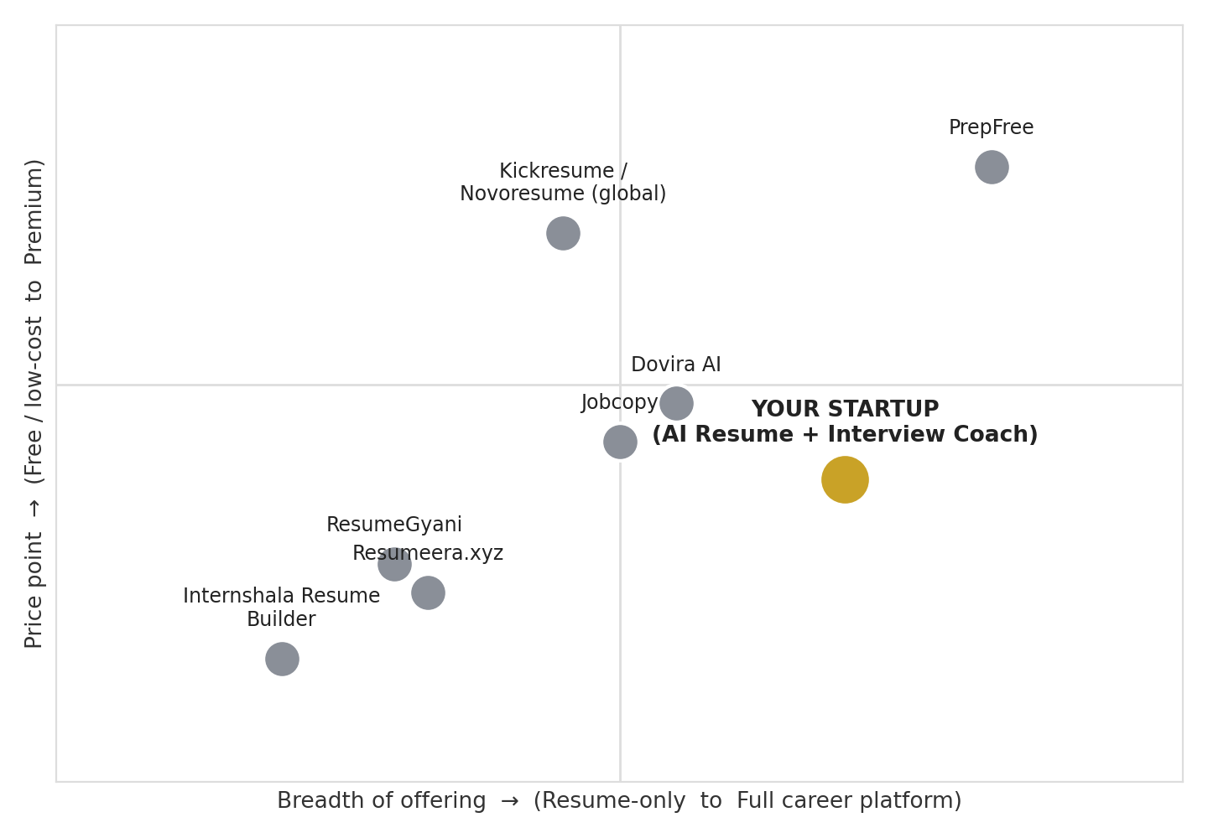
Competitor | Focus | Traction Signal | Gap vs. Them
PrepFree | Full career-readiness platform: AI mock interviews, resume intelligence, assessments, job matching | 130+ university partnerships, 180+ hiring partners | They own institutional/B2B2C distribution — hard to out-compete head-on without a channel edge
Resumeera.xyz | Resume + interview prep, India-focused, SEO content | ~180,000 monthly active users pre-latest launch | Strong SEO/content moat; differentiate on product depth, not search traffic
ResumeGyani | AI resume builder + ATS checker + AI mock interviews | Claims 100,000+ Indian users; freemium, ₹299 Pro plans | Low price anchor already set in the market — hard to charge a premium without clear extra value
Dovira AI / Jobcopy | AI resume + cover letter + interview Q&A generation | Positioned as ATS pass-rate boosters (claims up to 80%) | Generic, global positioning — room to out-localize for Indian recruiters/ATS norms
Internshala Resume Builder | Free AI resume builder for students/freshers | Backed by Internshala's large existing student user base | Cannot compete on distribution — Internshala already owns the internship-seeking student funnel
Kickresume / Novoresume / Zety (global) | Global resume builders, some AI + interview features | Established global brands, large template libraries | Not India-first — pricing in USD/EUR and generic formatting are weak fits for Indian resume norms (biodata fields, objective statements)

5.1 What incumbents have already solved
- Core resume generation and ATS scoring are now commodity features — multiple free tools already do this well.
- AI mock interviews with voice/video and live feedback already exist (PrepFree, Dovira AI, Jobcopy).
- Price anchoring is already set low (free tiers, ₹299 Pro plans) — a new entrant cannot win on "cheaper AI resume builder" alone.

6. Market Gap Analysis
The generic "AI resume + interview prep" wedge is saturated. The genuine open space is narrower and requires a specific choice of who you serve and how deeply.
Potential Gap | Why It's Still Open
Tier-2/3 city & regional-language students | Most incumbents optimize for English-fluent, metro, top-college users; PrepFree's university partnerships likely skew toward larger institutions
Vertical specialization (e.g., core engineering, government-exam aspirants, non-tech commerce/arts grads) | Generic tools give generic advice; a coach tuned to specific industries' resume/interview norms is a defensible niche
Placement-cell / college B2B2C distribution not already locked up by PrepFree | Thousands of tier-2/3 colleges still lack any structured career-readiness partner
Depth of feedback over breadth of features | Most tools optimize for speed ("resume in 2 minutes"); a slower, coaching-style product that genuinely improves interview performance is a different value proposition, not a faster competitor to the same thing

Recommended wedge
Don't compete as "another AI resume builder." Pick one narrow, underserved student segment (e.g., tier-2/3 engineering colleges, or a specific non-tech vertical) and become the depth-focused interview coach for that segment first — then expand.

7. Ideal Customer Profile (ICP)
Attribute | Profile
Life stage | Final-year college student or graduate within 0–18 months of graduation
Education | Undergraduate degree (engineering, commerce, or general Bachelor's) from a tier-2/tier-3 Indian institution
Location | Non-metro India (tier-2/3 cities) with reliable smartphone internet access
Income sensitivity | High — household income moderate; willing to pay small amounts (₹99–₹499) for a clear, provable outcome, not for subscriptions with vague value
Digital behaviour | Active on YouTube, Instagram, WhatsApp groups, and placement-cell communications; searches in Hinglish/regional-English mix
Core motivation | Get *any* interview call — starting from underconfidence about resume quality and interview performance, not from career optimization

8. Buyer Persona
"Ankit, the Anxious Final-Year Applicant"
Age 21 · B.Tech, Mechanical Engineering, tier-3 college, Uttar Pradesh · First-generation college graduate
Goals
Land any campus-placement or off-campus interview call before final semester ends; prove to family that the degree was worth it.
Frustrations
Doesn't know if his resume format is "correct"; freezes up in mock interviews; can't afford ₹5,000+ coaching institutes; gets generic, one-size-fits-all advice from free tools.
Where he spends time
YouTube (placement prep channels), WhatsApp/Telegram placement groups, college career-cell notices, Instagram reels about interview tips.
Willingness to pay
Low absolute amount, high sensitivity to proof of ROI — will pay ₹99–₹299 for something a peer has already vouched for, resists blind subscriptions.

9. Customer Pain Points
Pain Point | Underlying Cause
Resume gets rejected before a human ever sees it | Lack of awareness of ATS keyword-matching and formatting rules
Freezes or rambles in interviews | No safe, repeatable way to practice under realistic pressure
Doesn't know what recruiters actually want | Educational institutions teach subject knowledge, not job-search skills
Can't afford professional resume writers or coaching institutes | Coaching institutes price for urban, higher-income families
Generic AI tools give generic, Western-style advice | Most AI tools are trained/tuned for global (US/UK) resume norms, not Indian recruiter expectations
Overwhelmed by conflicting advice online | No single trusted source; every YouTube channel says something different

10. Buying Triggers & Objections

10.1 Buying Triggers
- Placement season / campus drive announcements (highest-intent moment)
- Just received a rejection email or ghosting after an application
- A friend/senior got an interview call after using a similar tool
- College career cell recommends or mandates resume review before drive registration

10.2 Objections & How to Address Them
Objection | Response Strategy
"There are already free tools (Internshala, Canva) — why pay?" | Lead with outcome proof (interview-call uplift, ATS score before/after) rather than feature lists
"I don't trust AI feedback on something this important" | Show sample outputs, use social proof from peers/seniors, offer a free trial before payment
"I'll just ask ChatGPT for free" | Differentiate on India-specific ATS/recruiter tuning, structured practice flow, and progress tracking — not raw text generation
"My college already has a placement cell" | Position as a supplement, not a replacement — most placement cells are overloaded and generic

11. Customer Journey
Stage | Trigger / Action | Customer State | Your Opportunity
Awareness | Sees a placement-drive notice or gets rejected | Anxious, searching for quick fixes on YouTube/Google | Show up in placement-cell WhatsApp groups, YouTube shorts, college partnerships
Consideration | Compares free tools vs. paid options | Price-sensitive, skeptical of AI quality | Free ATS score check as a hook; visible peer testimonials
Trial | Tries resume builder or one mock interview | Evaluating whether feedback feels "real" and India-relevant | Make first output genuinely useful in under 5 minutes — no paywall on core value
Conversion | Needs unlimited downloads or more mock rounds | Has seen enough value to consider a small payment | Low-friction ₹99–₹299 one-time or short-term unlock, not a recurring subscription upfront
Retention / Advocacy | Gets an interview call or offer | Grateful, likely to share with juniors/peers | Referral loop into next year's cohort and placement-cell relationship

12. Risk Assessment
Risk | Likelihood | Impact | Mitigation
Competing against funded, distribution-rich players (PrepFree, Resumeera) | High | High | Avoid head-on positioning; win a narrow niche and college channel first
Commoditized AI features (anyone can wrap an LLM into a resume tool) | High | Medium | Moat via curated India-specific data, proprietary feedback rubrics, and community/trust, not raw AI capability
Low willingness-to-pay in target segment | Medium | High | Validate pricing early via a real payment test, not survey answers; consider freemium + B2B2C (colleges pay) model
Side-project bandwidth limits execution speed | High | Medium | Timebox validation sprint (30 days); decide go/no-go on full-time commitment based on early signal, not sunk cost
AI-generated advice quality/accuracy for Indian recruiter norms | Medium | High | Human-in-the-loop review during early cohorts; build feedback rubric from real recruiter input, not generic LLM output
Regulatory/data-privacy handling of resumes & personal data | Low | Medium | Basic data-protection hygiene from day one (consent, storage limits) given personal data involved

13. Pivot Opportunities
If direct-to-student consumer traction proves difficult, these adjacent models use the same core AI capability with different distribution or monetization:
Pivot Direction | Rationale
B2B2C: sell to college placement cells / training institutes | Colleges already need to demonstrate placement outcomes; one institutional sale reaches hundreds of students at once — sidesteps individual price sensitivity
Vertical specialization (govt-exam aspirants, non-tech commerce/arts, or a specific industry) | Escapes direct competition with generalist tools; deeper, more defensible expertise
B2B recruiter-side tool (pre-screening / candidate readiness scoring for SMB hiring) | Employers, especially SMBs, also struggle to evaluate volume applications — flips the buyer to one with higher willingness-to-pay
Content/community-led model (YouTube/Instagram authority) monetized via tools | Lower-cost distribution than paid acquisition in a market where trust and peer proof drive conversion

14. Go / No-Go Recommendation
CONDITIONAL GO
Proceed to validation — do not proceed to full product build yet

The underlying problem is real and well-documented, and you have genuine personal empathy for the target user. But the specific solution category — AI resume building plus interview coaching for Indian students — is already served by multiple funded, traction-proven competitors. Proceeding straight to a full build of a general-purpose version of this product carries high risk of building something the market doesn't need a ninth version of.

Proceed if...
- You commit to a narrow, specific niche (segment, region, or vertical) rather than a general resume-and-interview tool
- You can secure at least 2–3 college/placement-cell relationships or a clear community distribution channel within 30 days
- Early validation (Section 15) shows real people will take a concrete action — not just say "this is a good idea"

Do not proceed (or pivot) if...
- You cannot find any distribution edge beyond "better AI" — commoditized AI quality is not a durable moat
- 30-day validation shows lukewarm interest even from your warmest, most accessible audience (your own college/network)
- You're unwilling to narrow scope — competing broadly against PrepFree, Resumeera, and ResumeGyani head-on as a solo side-project is a low-odds fight

15. 30-Day Action Plan
Goal: replace assumptions with evidence before writing more product code. Every week ends with a go/kill decision point for that week's hypothesis.
Week | Focus | Concrete Actions
Week 1 | Talk to the market | Conduct 15–20 structured interviews with final-year students/fresh grads (not surveys). Ask about their last resume rejection or interview failure, not hypothetical opinions. Map their current tools and spend.
Week 2 | Narrow the niche & test demand | Pick one specific segment (e.g., one college, one branch, one region) from Week 1 learnings. Build a simple landing page describing the specific promise. Drive traffic via personal network, WhatsApp groups, and one placement-cell contact. Track signups, not just visits.
Week 3 | Ship a manual/Wizard-of-Oz MVP | Deliver the core value manually or semi-manually (e.g., you + an AI tool review resumes 1:1 for 15–20 signups) before building automated product. Charge a small real fee (₹99–₹299) to test willingness-to-pay, even if the process isn't automated yet.
Week 4 | Decide & plan | Review conversion, payment, and qualitative feedback against the Go/No-Go criteria above. If positive: scope a lean v1 automated product and pursue 2–3 college partnerships. If negative: revisit Section 13 (Pivot Opportunities) before further investment.

Success metrics to track from Day 1
- Interview-to-insight ratio: are the same 2–3 pain points repeating across conversations?
- Landing page → signup conversion rate (aim for a clear signal, not vanity traffic)
- Willingness to pay: real money collected, not stated intent
- At least one institutional (college/placement-cell) conversation opened
Final note
This report validates that the problem is real and the market is large — it does not yet validate that you will win it. The next 30 days should be spent generating evidence, not more features.

