POLYNOMIAL REGRESSION: THEORY, IMPLEMENTATION,
AND A MACHINE LEARNING PROJECT WORKFLOW
Aradhya Jain | Department of Computer Science and Engineering | Manipal Institute of Technology

Abstract—Polynomial regression is a supervised learning technique used to model nonlinear relationships between input features and a continuous target. It extends linear regression by transforming input variables into polynomial terms while retaining a model that is linear in its coefficients. This report explains the mathematical foundation, end-to-end project workflow, preprocessing, model training, evaluation, implementation, and practical limitations. A small synthetic example illustrates how a quadratic model can capture curvature. The workflow is intended as a reusable blueprint for a beginner machine learning project.
Index Terms—Polynomial regression, supervised learning, feature engineering, least squares, overfitting, model evaluation, scikit-learn.

I. INTRODUCTION
Machine learning (ML) develops models that learn patterns from data and use them to make predictions. Polynomial regression is appropriate when the relationship between a numerical input and a continuous output is curved rather than adequately represented by a straight line. Example applications include estimating energy consumption from temperature, predicting material response under load, and modelling growth trends. The objective of a project is not merely to fit a curve, but to build a reproducible pipeline that generalises to unseen observations.

II. MATHEMATICAL FOUNDATION
For one input variable x, a polynomial model of degree d is:
ŷ = β₀ + β₁x + β₂x² + … + β_d xᵈ
Here, ŷ is the predicted target; β₀ is the intercept; β₁,…,β_d are learned coefficients; d is the polynomial degree; and xᵏ is the kth-power feature. Although the curve is nonlinear in x, the model is linear in the coefficients β. Therefore, ordinary least squares can estimate the coefficients.
For n observations, the model chooses coefficients that minimise the sum of squared residuals:
SSE = Σᵢ₌₁ⁿ (yᵢ − ŷᵢ)²

III. END-TO-END PROJECT WORKFLOW
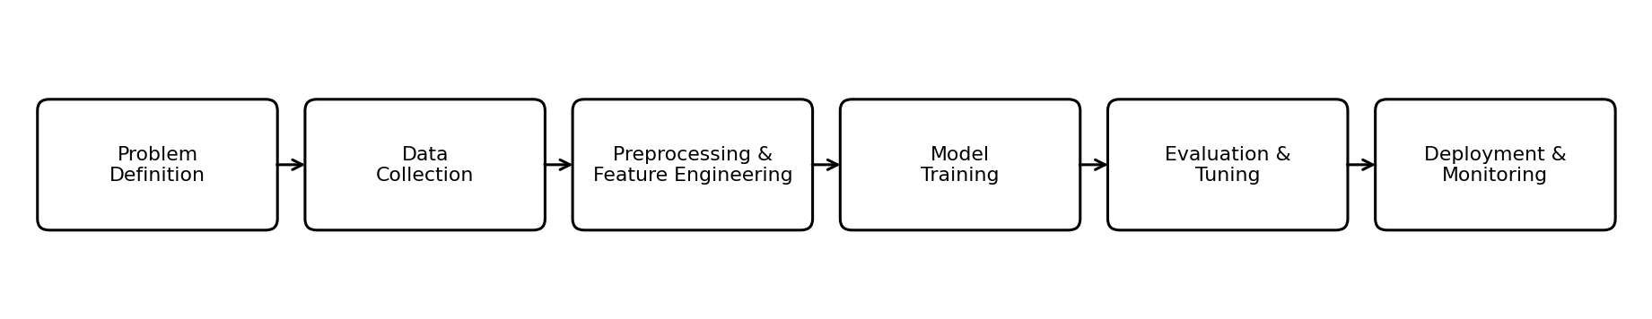
Fig. 1. Typical lifecycle of a supervised ML project.
A sound project follows these stages:
• Problem definition: specify the prediction objective, target variable, intended users, constraints, and success measure.
• Data collection and understanding: obtain a relevant dataset; inspect dimensions, data types, units, target distribution, duplicates, missing values, and possible data leakage.
• Preprocessing: correct data types, handle missing values, remove or justify duplicates, investigate outliers, and encode categorical variables when present. Fit preprocessing steps on training data only.
• Feature engineering: select useful predictors and create polynomial terms. For multiple inputs, terms may include x₁², x₂², and interactions such as x₁x₂. Avoid adding unnecessary high-degree terms.
• Training and validation: split data into training and test sets. Use cross-validation on the training set to compare degrees and tune hyperparameters; reserve the test set for final evaluation.
• Evaluation and deployment: report metrics, inspect residuals, document limitations, save the full preprocessing-model pipeline, and monitor performance when new data arrives.

IV. DATA PREPROCESSING AND FEATURE ENGINEERING
Exploratory data analysis (EDA) uses summary statistics and plots to understand distributions, relationships, missingness, and outliers. A scatter plot of each important feature against the target can reveal curvature. Missing values may be imputed using a training-set mean, median, or a domain-specific method. Categorical features require suitable encoding; identifiers that do not carry predictive meaning should generally be excluded.
Polynomial expansion creates powers and, optionally, interaction terms. With p input features and degree d, the number of generated terms can grow rapidly. Standardisation can help when feature scales differ, especially for regularised models. The scaler and feature transformer must be fitted within each training fold to prevent information leakage.

V. MODEL TRAINING AND SELECTION
A baseline linear regression model should be fitted first. Polynomial regression is then created by applying a polynomial feature transformation followed by linear regression. The degree is a hyperparameter: a low degree may underfit, while a high degree may fit noise and overfit. Select degree using cross-validation and a metric aligned with the task. Ridge or Lasso regularisation can reduce large coefficients and improve stability when polynomial features are numerous or correlated.
For multiple predictors, polynomial regression can model curvature and interactions, but the project must control feature growth. Keep a record of the random seed, split strategy, selected features, degree, preprocessing choices, and software versions for reproducibility.

VI. IMPLEMENTATION USING PYTHON
The following example shows the core scikit-learn pipeline. Replace X and y with the project's feature matrix and continuous target after loading and inspecting the dataset.
from sklearn.model_selection import train_test_split, GridSearchCV
from sklearn.pipeline import make_pipeline
from sklearn.preprocessing import PolynomialFeatures, StandardScaler
from sklearn.linear_model import LinearRegression, Ridge
from sklearn.metrics import mean_absolute_error, mean_squared_error, r2_score
X_train, X_test, y_train, y_test = train_test_split(
X, y, test_size=0.2, random_state=42
)
pipe = make_pipeline(
PolynomialFeatures(include_bias=False),
StandardScaler(),
Ridge()
)
search = GridSearchCV(
pipe, {"polynomialfeatures__degree": [1, 2, 3, 4]},
cv=5, scoring="neg_mean_squared_error"
)
search.fit(X_train, y_train)
pred = search.predict(X_test)
print("Degree:", search.best_params_)
print("MAE:", mean_absolute_error(y_test, pred))
print("RMSE:", mean_squared_error(y_test, pred)**0.5)
print("R2:", r2_score(y_test, pred))
This pipeline performs polynomial expansion, scaling, and Ridge regression. GridSearchCV tests candidate degrees using five-fold cross-validation. The test set is not used for model selection. For a basic unregularised model, replace Ridge() with LinearRegression().

VII. PERFORMANCE EVALUATION
Evaluate predictions on data not used for fitting. Common regression metrics are:
• MAE = (1/n)Σ|yᵢ−ŷᵢ|: average absolute error, in the target's units; lower is better.
• MSE = (1/n)Σ(yᵢ−ŷᵢ)²: penalises large errors more strongly; its units are squared.
• RMSE = √MSE: gives error in the target's units and is sensitive to large residuals.
• R² = 1 − SSE/SST: measures improvement over predicting the target mean. It can be negative on test data; a higher value is not automatically proof of a better model.

VIII. ILLUSTRATIVE EXAMPLE, LIMITATIONS AND CONCLUSION
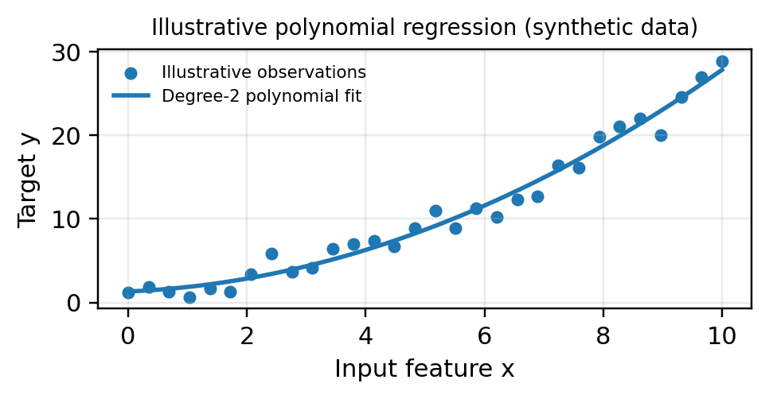
Suppose the relationship between an input x and target y bends upward. A straight-line model may systematically underpredict at larger x, whereas a degree-2 model can represent the curvature through x². The plotted data are synthetic and demonstrate the idea only; they do not establish model accuracy for any real application.
Polynomial regression is interpretable for small degrees and easy to implement, but it is sensitive to outliers, extrapolation, multicollinearity, and degree selection. High-degree curves can oscillate and behave unrealistically outside the training range. Regularisation, cross-validation, sensible feature selection, and domain knowledge help mitigate these risks.
In conclusion, polynomial regression is a practical extension of linear regression for continuous targets with nonlinear patterns. A reliable ML project combines problem definition, data understanding, leakage-safe preprocessing, feature engineering, model selection, evaluation, reproducibility, and monitoring. The best model is the one that performs reliably on unseen data and meets the project's real objective—not simply the one with the most complex curve.

