From Messy Data to Meaningful Insight
  - Digital Survey Response Integrity
Research audit | 13 October 2026 | Exploratory — not a confirmatory publication

Executive overview
A survey export can report zero missing values and still contain hundreds of thousands of negative response codes. Looking beyond blank cells exposes the problem.
There are 4,771 unique case numbers and 289 fields. Literal-null checks alone would call the export complete, but its negative codes and blank strings tell a more complicated story.

Dataset provenance and privacy
Uploaded file: datafile(4).csv | Rows: 4,771 | Columns: 289 | Source: Source DOI not verified; original survey codebook not supplied
The uploaded participant-level CSV is deliberately withheld from all public artifacts. This report contains only aggregate, non-row-level results. Source dataset license and original codebook status must be rechecked before public publication.

Phase 1 — Audit
- 4,771 recorded rows, 289 fields; 0.00% literal missing cells.
- 0 whole-row duplicates; structure: 4771 unique case numbers (one record per case).
Null cells: 0 (0.000% of all cells); blank-string cells: 14,793. Whole-row duplicate count: 0. Numeric columns: 257; other: 32.

Missingness and coding patterns
- case_num: 0.00% literal nulls
- weight_raking: 0.00% literal nulls
- status: 0.00% literal nulls
- device_type: 0.00% literal nulls
- device_type_dich: 0.00% literal nulls
- OS_Apple: 0.00% literal nulls
Observed negative codes: -1→3,871, -2→188,420, -3→77,221, -5→55,552, -96→10,452, -97→58,698, -98→1,780. These are NOT automatically classified as missing. Consult source coding manual.

Observed integrity flags
- breakoff_flagged: 713
- status_not6: 713
- blank_personality_scores: 710
- blank_device_dich: 127
- negative_code_cells: 395994
- negative_code_rows: 4771
- n_negative_columns: 248

Phase 2 — Analyses and reproducibility
Exploratory associations use Spearman rank correlation with pairwise available cases. Group comparisons use Welch t-tests and pooled-SD Cohen d, but group meanings must be verified. Reliability uses complete cases only and is diagnostic in the absence of confirmed scale keying.
Personality variables are stored as numeric text or blanks. Numeric conversions were used for analysis only; the original file was not changed.
- Extraversion_mean: n=4061, M=2.993, SD=0.745
- Agreeableness_mean: n=4061, M=3.514, SD=0.605
- Conscientionusness_mean: n=4053, M=3.77, SD=0.614
- Neuroticism_mean: n=4053, M=2.845, SD=0.671
- Imagination_mean: n=4055, M=3.302, SD=0.683
Provisional device-code group effect, unweighted and not population-representative: {"device_codes": "0 versus 1; meanings unverified", "n0": 2238, "n1": 1716, "mean0": 2.962, "mean1": 3.038, "difference": -0.077, "cohen_d": -0.103, "p": 0.0013496314956990886, "exploratory": true}
Diagnostic reverse-coded O1 comparison: {"n": 4533, "matches_7_minus_O1": 4533}
No alpha or omega is reported for the named personality means because the original questionnaire item-to-scale and reverse-key mapping is unverified. Reliability across five different personality constructs would be methodologically invalid.

Selected Spearman associations
- Extraversion / Neuroticism: rho=-0.2069, n=4,035, p=2.95e-40 (exploratory)
- Agreeableness / Conscientionusness: rho=+0.1516, n=4,036, p=3.63e-22 (exploratory)
- Neuroticism / Conscientionusness: rho=-0.2024, n=4,027, p=1.77e-38 (exploratory)
- Extraversion / Imagination: rho=+0.1820, n=4,034, p=2.19e-31 (exploratory)
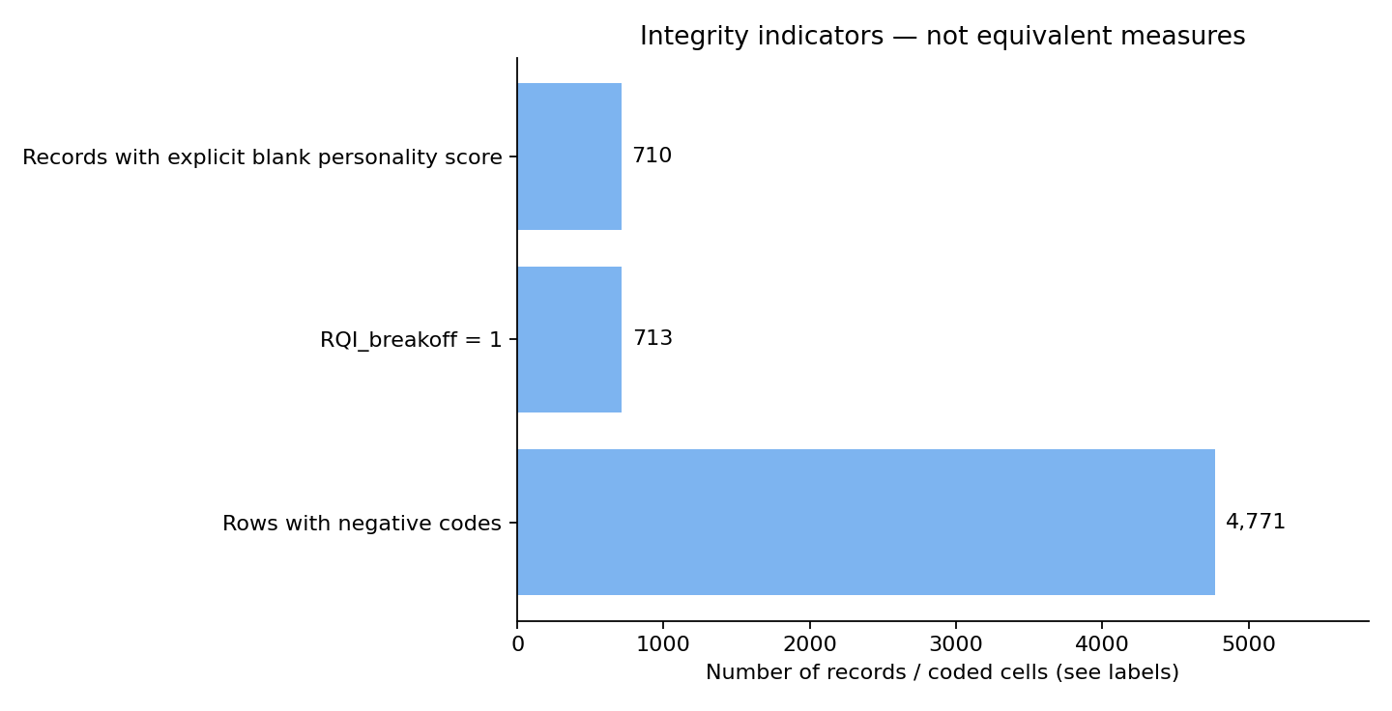
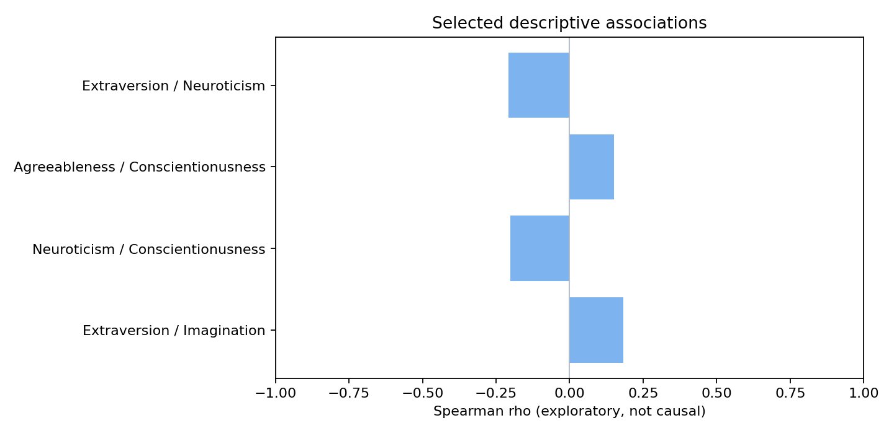

From findings to action

Zero nulls does not mean complete
What we found — The table has no literal CSV null cells, while 395,994 numeric cells carry one of the observed negative codes.
Why it matters / What to do — Audit coding conventions, skip patterns and blank text separately from ordinary NA checks.

Completion is a measurable issue
What we found — RQI_breakoff is 1 for 713 records, the same number as cases whose status differs from 6.
Why it matters / What to do — Reconcile process-quality metadata before choosing an analytic population.

Personality scores are not always populated
What we found — 710 Extraversion_mean entries are blank strings even though the CSV has zero nulls.
Why it matters / What to do — Convert blanks explicitly for score-specific analyses and report resulting sample sizes.

An apparent device difference is exploratory
What we found — The reported device-code group comparison needs a codebook to interpret groups 0 and 1 correctly.
Why it matters / What to do — Do not describe demographic or device effects until coding and sampling weights are verified.

Data limitations — retained, not silently fixed
- The exported CSV contains no literal nulls but uses blank strings and negative response codes extensively. Treating all these as valid survey answers is unsafe.
- Meaning of codes -1, -2, -3, -5, -96, -97, -98 is unverified without the survey codebook; negative-coded cells were counted, not silently recoded.
- A raking-weight variable exists, but its target population, weighting strata and intended inference are undocumented here. No population estimates claimed.
- Device-type codes and all personality scoring keys need the source instrument. The device group comparison is diagnostic only.
- The status and RQI_breakoff flags align numerically but the codebook must confirm their operational meaning.
The exact meanings of -1, -2, -3, -5, -96, -97, and -98 are not supplied. The published sample frame, raking calibration and codebook need verification.

Reproducibility and citations
This bundle contains aggregate-results.csv, variable-dictionary.csv, two figures in PNG and SVG, a Python script, and references.bib. Original participant-level files are withheld. See REPRODUCIBILITY.md for exact command lines. This report is exploratory. Original source licenses are not established for the first two uploads.
Core methods: Spearman (1904), Cronbach (1951), McDonald (1999), Welch (1947), Cohen (1988), statsmodels MixedLM, scikit-learn FactorAnalysis. DOI/URL in references.bib.

