STATISTICAL AUDIT · EXPLORATORY RESEARCH
Psychological Survey Dataset
Comprehensive Statistical Analysis
SPSS source: فایل خام.sav
Date: 12 October 2026
240 recorded rows · 89 original fields · 2 coded groups
RESEARCH INTEGRITY ALERT: 119 of 120 aligned questionnaire pairs have identical responses on all 76 items. Group p-values do not meet defensible independent-observation assumptions.
Publication note: The SPSS variable-name compatibility fix has been inserted into the appendix. The latest standalone analysis script is included separately; its R execution is still unverified.
Purpose: explain every construct, quantify quality problems, document diagnostic statistics, and describe what must be validated before scientific claims.

Executive summary / key findings
- The file contains 240 rows and 89 variables; group `fire` and group `non` each have 120 recorded rows. The literal meaning of those codes is not provided.
- There are 76 questionnaire item variables: 13 ambiguity-tolerance (A), 33 emotion self-regulation (EM), 15 mentalization (H), and 15 death-anxiety (D), plus demographics and stored scale/subscale scores.
- Only 86 different 76-item response patterns exist across 240 rows. In all, 239 rows share a questionnaire pattern with another row. This could be repeated forms, pairing, data copying or a processing fault; provenance must be established.
- Exactly 119 of 120 same-position pairs from `fire` and `non` are identical on all 76 questionnaire item answers. Age-band and education distributions are exactly the same in both groups.
- No SPSS system-missing values were found. However, 31 values in D1–D15 are outside the permitted codes 1 or 2, affecting five case rows.
- Stored TOTALA, TOTALEM and MZQ disagree with their simple raw item sums in 84, 32 and 26 rows respectively. Differences are not necessarily wrong until official reverse-scoring rules are checked.
- Stored ambiguity-tolerance TOTALA differs by 4.63 points between groups (40.45 versus 35.83), yet the direct item sum differs by only 0.08; this is the central sensitivity finding.
- P-values, confidence intervals and effect sizes are calculated transparently but labeled diagnostic only. No evidence supports an independent-groups causal claim or a reliable death-anxiety total score.

What this dataset can and cannot answer
Can answer: what variables exist, category frequencies, observed score distributions, exact profile overlap, problematic cases, and mathematical sensitivity to score definitions. Cannot yet answer: whether fire/non are psychologically different populations; whether stored totals implement correct scoring; or how death anxiety relates to other validated constructs.

Variable dictionary and what the constructs mean
SPSS contains labels for constructs and response options, but **not the wording of the individual psychological questions**. Therefore we can describe the general domains, not infer the exact thought or symptom each item measures. Several SPSS item measurement settings say “scale” even when a single five-category Likert response is substantively ordinal.
Code | Accessible meaning | Type | Interpretation / limitation
GROUP | Group code | Nominal/binary | 1=fire, 2=non; group meaning unknown
NUMBER | Original case number | Identifier | 121 distinct across 240; repeated across groups
AGE | Age band | Ordinal | 4 categories; source labels 1:<30, 2:30–40, 3:40–50, 4:50–60
AGEE | Age in years | Scale | Observed 22–58 years
MARRIAGE | Marital status | Nominal | 1=single, 2=married; 3=divorced is labeled but not observed
EDUCATIO | Education level | Ordinal | 1 diploma, 2 associate, 3 bachelor, 4 master, 5 doctorate
A1–A13 | Ambiguity tolerance items | Ordinal 1–5 | Five-level agree/disagree options; item wording unavailable
EM1–EM33 | Emotion self-regulation items | Ordinal 1–5 | Five-level truthfulness response options; individual questions unavailable
H1–H15 | Mentalization items | Ordinal 1–5 | Five-level agreement scale; reverse coding unknown
D1–D15 | Death anxiety items | Binary 1/2 | 1=true, 2=false; 31 codes violate allowed values
TOTALA | Stored A total | Scale (unverified) | 84 mismatches with direct A sum
TOTALEM | Stored EM total | Scale (unverified) | 32 mismatches with direct EM sum
OPTIMISM | Optimism score | Scale (unverified) | Potential emotional subscale; scoring manual absent
EVALUATI | Emotion appraisal score | Scale (unverified) | Subscale; overlap with overall emotion score possible
SOCIALSK | Social skills score | Scale (unverified) | Subscale; component–total correlations not independent
EMOTIONA | Emotion utilization score | Scale (unverified) | Subscale; direction unverified
MZQ | Stored mentalization total | Scale (unverified) | 26 mismatches with direct H sum

Plain-language psychological interpretation
Ambiguity tolerance — How comfortable someone feels when there is no certain answer; the raw A response choices concern agreement with statements, but item texts and score direction are unknown.
Emotional self-regulation — Skills or tendencies involved in handling feelings, reacting to emotional situations, and staying effective under emotional demands; no clinical diagnosis follows from this score.
Mentalization — Thinking about one’s own and other people’s thoughts, intentions and feelings; the total alone cannot establish whether someone has a clinical mentalizing difficulty.
Death anxiety — Agreement/disagreement with death-related statements. D-items must first be verified; a total must not be invented from invalid and potentially reversely keyed responses.
Emotional subdomains — Optimism, emotion appraisal, social skills and emotion utilization are separately stored, but may share items with the overall emotion score; their correlations can be partly a mathematical consequence of overlap.

Methods and analysis plan

Design and objective
No research question, study protocol, primary endpoint or sampling design is given. The work is a comprehensive exploratory audit. `fire` and `non` are preserved as literal source codes; their substantive meaning cannot be assumed.

Import and preservation
The `.sav` file was read from its SPSS binary structures and labels into Python for numerical validation. The companion R script uses `haven::read_sav()` to reproduce import from the original file. Raw values are preserved separately; code-invalid D answers are flagged rather than silently assigned a score.

Data completeness and range checking
All 89 original fields were checked for system missing, allowed response categories, constant columns, duplicated IDs and repeated 76-item response profiles. `NUMBER` is only unique *within* dataset group; 121 distinct NUMBER values occur in 240 rows.

Description and assumptions
Categorical counts, numerical score distributions, median, skewness, IQR outliers, Shapiro–Wilk, Brown–Forsythe, score-profile overlap and provisional scale reliability were examined. The independence assumption is not supported, overriding other inference diagnostics.

Group comparisons
As transparent diagnostics, Welch independent-sample t-tests, Mann–Whitney rank tests, Hedges g with bootstrap intervals, rank-biserial effects and BH q-values were computed for seven stored scores. The tests are displayed specifically to reveal their fragility, not to accept the independent-sample model as true.

Association and regression
Spearman/Pearson correlations were screened on full rows and a one-per-unique-item-profile sensitivity view; 21 score pairs were corrected with BH separately. Descriptive HC3-variance regressions related each score to group, age, marriage and education; residual shape, Breusch–Pagan, VIF, fit and AIC/BIC were recorded.

Excluded analyses
No validated death-anxiety total exists; logistic modeling would lack a justified binary endpoint; there are only two coded main groups, so an ANOVA/post-hoc family adds no scientific value. Confirmatory testing awaits corrected source data and a real design.

Results — direct audit findings
Audit metric | Observed value
Recorded rows | 240
Original variables | 89
Rows in each group | 120 / 120
System missing cells | 0
Unique complete item-response patterns | 86
Rows in repeated complete patterns | 239
Identical matched 76-item pairs across groups | 119 / 120
Distinct case numbers | 121
Invalid D item cells | 31
Rows with invalid D | 5
TOTALA vs raw A-sum mismatch | 84
TOTALEM vs raw EM-sum mismatch | 32
MZQ vs raw H-sum mismatch | 26

A mismatch with the arithmetic sum is a check, not proof that the stored total is incorrect; item reversal could be legitimate. Conversely, identical item responses plus different stored totals make unverified group comparisons vulnerable to scoring or data-assembly differences.
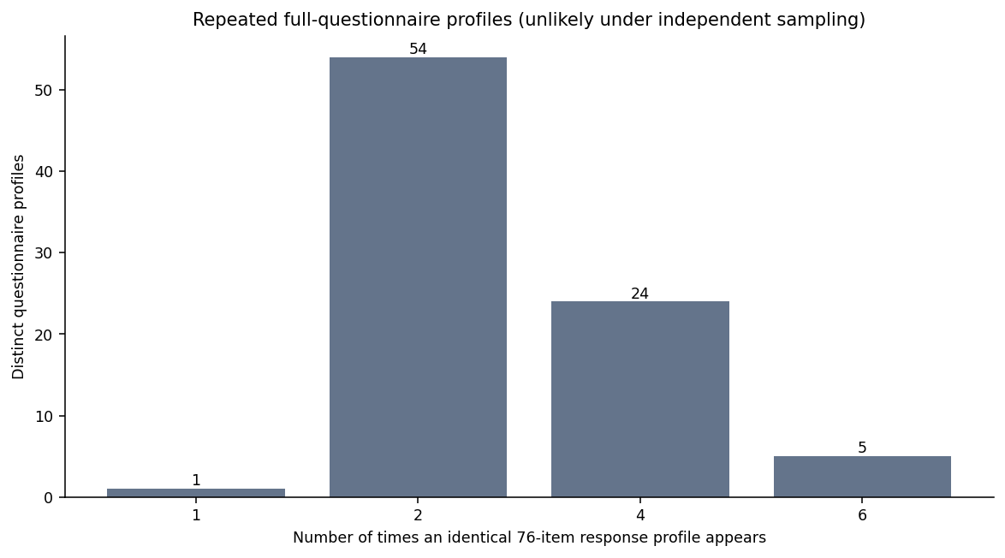
Figure 1. Repeated questionnaire profiles (76 items): only 86 unique profiles remain.
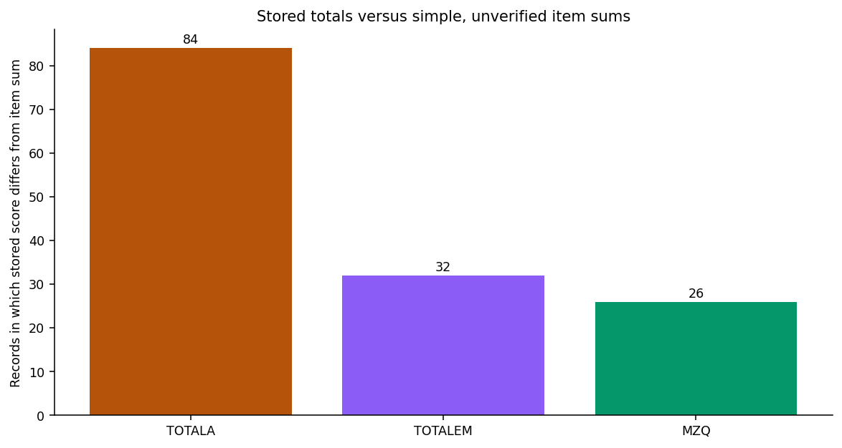
Figure 2. Number of source scores differing from unadjusted item sums.

Demographic structure
Category | fire | non
Under 30 / کمتر از ۳۰ | 10 | 10
30–40 / ۳۰ تا ۴۰ | 62 | 62
40–50 / ۴۰ تا ۵۰ | 41 | 41
50–60 / ۵۰ تا ۶۰ | 7 | 7
Single / مجرد | 26 | 25
Married / متأهل | 94 | 95
Diploma / دیپلم | 15 | 15
Associate / فوق‌دیپلم | 26 | 26
Bachelor / کارشناسی | 63 | 63
Master / ارشد | 15 | 15
Doctorate / دکتری | 1 | 1

Age bands and education categories are numerically identical across groups; marital counts differ by one. Mean recorded exact age is 40.38 in fire and 38.44 in non. This apparent balancing cannot be interpreted as successful study matching until the repeated questionnaire responses and respondent identifiers are explained.

Observed stored-score distributions
Stored score | Mean fire | Mean non | Difference | Hedges g | Welch p*
TOTALA | 40.45 | 35.83 | 4.62 | 0.74 | 2.75e-08
TOTALEM | 109.10 | 105.75 | 3.35 | 0.15 | 0.2555
MZQ | 41.08 | 40.13 | 0.95 | 0.12 | 0.3514
OPTIMISM | 43.30 | 42.88 | 0.42 | 0.04 | 0.7530
EVALUATI | 29.88 | 29.65 | 0.23 | 0.04 | 0.7815
SOCIALSK | 36.17 | 35.87 | 0.30 | 0.03 | 0.7955
EMOTIONA | 19.65 | 19.36 | 0.29 | 0.06 | 0.6460

*Calculated p-values and g are shown only to diagnose inconsistency. Independent-sample assumptions and scoring rules are unverified. Example: TOTALA gives Welch p≈2.75×10⁻⁸ and Hedges g≈0.74; these are NOT valid grounds for claiming a genuine psychological group difference.
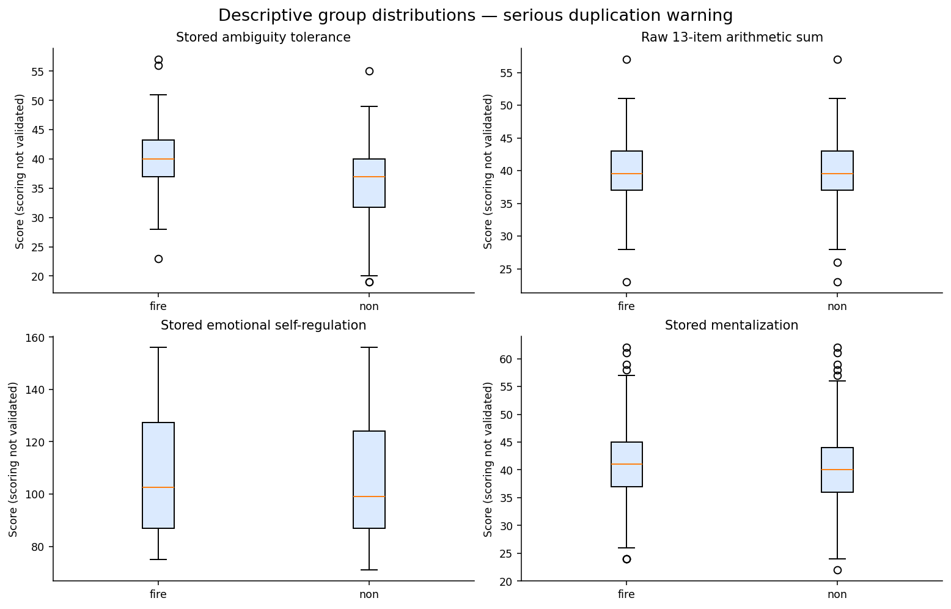
Figure 3. Recorded score distributions by group; diagnostic only.

Scoring sensitivity: the central contradiction
Score definition | fire mean | non mean | Difference
TOTALA stored | 40.45 | 35.83 | 4.62
A1–A13 raw sum | 39.74 | 39.67 | 0.07
TOTALEM stored | 109.10 | 105.75 | 3.35
EM1–EM33 raw sum | 109.10 | 109.00 | 0.10
MZQ stored | 41.08 | 40.13 | 0.95
H1–H15 raw sum | 41.08 | 41.08 | 0.00

Because virtually all aligned item vectors across groups coincide, a statistical comparison based on the raw A item sum is near zero, whereas the stored source TOTALA shows a substantial contrast. The possible explanations include legitimate reverse scoring, changed source scores, import/alignment error, or processing errors. **Without the questionnaire scoring manual, the correct explanation is unknown.**

Reliability diagnostics and detailed psychometric caveat
Construct | Items | Raw alpha | Bootstrap interval*
Ambiguity tolerance / تحمل ابهام | 13 | 0.328 | 0.152–0.455
Emotion self-regulation / خودگردانی | 33 | 0.926 | 0.914–0.935
Mentalization / ذهنی‌سازی | 15 | 0.660 | 0.573–0.728

The raw A alpha of 0.328 is low, EM 0.926 is high, and H 0.660 is intermediate. These are *not validated reliability estimates* because item direction, source independence and instrument scoring remain unresolved. An impressive total–subscale correlation can also be tautological if item content is shared.

Correlation screening
Score A | Score B | Spearman ρ | Bootstrapped interval | BH q*
TOTALEM | SOCIALSK | 0.922 | 0.875 to 0.949 | 4.98e-35
TOTALEM | OPTIMISM | 0.915 | 0.847 to 0.954 | 6.99e-34
TOTALEM | EVALUATI | 0.876 | 0.804 to 0.918 | 1.68e-27
OPTIMISM | EMOTIONA | 0.860 | 0.777 to 0.907 | 1.17e-25
TOTALEM | EMOTIONA | 0.860 | 0.782 to 0.902 | 1.17e-25
OPTIMISM | SOCIALSK | 0.817 | 0.709 to 0.875 | 2.92e-21
EVALUATI | EMOTIONA | 0.784 | 0.709 to 0.853 | 1.26e-18
SOCIALSK | EMOTIONA | 0.759 | 0.657 to 0.825 | 6.44e-17
OPTIMISM | EVALUATI | 0.752 | 0.633 to 0.839 | 1.63e-16
EVALUATI | SOCIALSK | 0.737 | 0.620 to 0.822 | 1.23e-15
OPTIMISM | MZQ | 0.312 | 0.090 to 0.536 | 0.0065
TOTALEM | MZQ | 0.295 | 0.057 to 0.504 | 0.0103

The `TOTALEM`–`SOCIALSK` Spearman coefficient is about +0.922 on a one-per-unique-profile sensitivity view. The extremely high correlation likely reflects related emotional-domain measurements and possible component/total overlap; it is not proof that social skills cause self-regulation. Treat 86 patterns as distinct *answer vectors*, not 86 certified people.
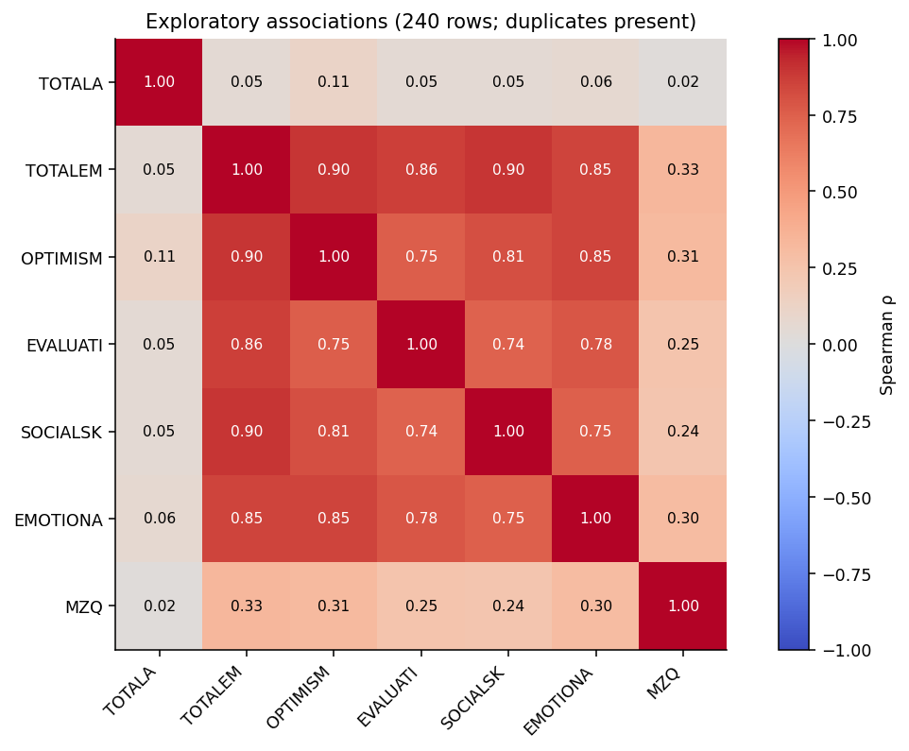
Figure 4. Correlations among stored scores; repeated cases and shared components can inflate apparent precision.

Model diagnostics and why robustness is not enough
Outcome | Group coefficient (HC3) | 95% interval* | R² | Diagnostic p
TOTALA | 4.80 | 3.22 – 6.39 | 0.144 | 3.00e-09
TOTALEM | 3.65 | -2.10 – 9.40 | 0.104 | 0.2130
OPTIMISM | 0.56 | -2.05 – 3.17 | 0.103 | 0.6726
EVALUATI | 0.15 | -1.40 – 1.70 | 0.128 | 0.8500
SOCIALSK | 0.70 | -1.55 – 2.94 | 0.099 | 0.5447
EMOTIONA | 0.30 | -0.94 – 1.55 | 0.073 | 0.6317
MZQ | 0.99 | -0.98 – 2.97 | 0.097 | 0.3240

The HC3-adjusted group coefficient on `TOTALA` is about +4.80, controlling recorded age, marital status and education; 95% diagnostic interval 3.22–6.39. Breusch–Pagan tests detect heteroscedasticity in several outcomes, and adjusted predictor VIF is approximately 1.63. HC3 corrects variance-model sensitivity, **not duplication, data provenance, invalid scoring or unmeasured confounding**.

Discussion: what these findings mean

What we can say confidently
The file demonstrably contains two blocks of 120 labeled records and a highly repeated set of questionnaire answers. We can characterize the distribution of recorded responses and identify exact arithmetic/range mismatches. That is an important, substantive finding about *the dataset*.

What we cannot say
We cannot yet say whether a member of one independent population truly has higher ambiguity tolerance, emotional regulation or mentalization than someone in the other. The numerical difference in stored TOTALA is sharply contradicted by the near-identical raw A item response sums. The direction of individual questionnaire items and actual population composition are unverified.

Why several strong correlations are not independent discoveries
Optimism, emotion appraisal, social skills and emotion utilization likely measure interrelated aspects of emotional functioning. If these subscales contribute to TOTALEM, correlating the total and a component is partly circular. Structural duplication may also make intervals and p-values artificially precise.

Unexpected pattern in demographics
Both groups have 10 people below 30, 62 in the second age band, 41 in the third and seven in the fourth; education counts are also exactly the same category by category. In isolation that could reflect matching, but together with 119 identical questionnaires it needs source validation.

Research limitations
Unknown research objectives; unknown sampling and subject identifiers; missing item wording/manuals; no verified death-anxiety score; possible copying/matching ambiguity; self-report measurement; unknown representativeness; no dates/time variables; and no independent external validation.

Practical implications
Treat the current work as a quality audit and descriptive exploration. The most valuable next research step is to reconcile records and rescoring rules—not to seek more sophisticated significance tests. The bilingual dashboard makes the audit accessible to nontechnical stakeholders.

Verification checklist before a thesis/article
- Confirm the intended research question, hypothesis, target outcome(s), study population, recruitment and analysis unit.
- Explain exactly what `fire` and `non` represent, and whether rows form real matched pairs, repeated measures or independent subjects.
- Match questionnaire rows and original participant IDs against paper/online forms and the data-export history. Resolve the 119 identical cross-group forms.
- Obtain all 76 item wordings and official scale manuals, including reverse-scoring and subscale composition; recompute and independently audit totals.
- Verify and correct the five rows with invalid D answers against source forms; never impute 1/2 by guesswork.
- Distinguish corrected score variables from originals and retain an immutable audit trail and restricted-access source file.
- Prespecify a primary analysis, sample unit, assumptions, effect sizes and multiple-testing plan; rerun robust/paired/clustered methods only if the design justifies them.
- Present the current descriptive dashboard with a permanent “unverified / exploratory” caption; do not circulate participant-level records publicly.

Interpretation of reported statistical quantities
A p-value depends on a correct null model and independent sampling; g is a standardized descriptive difference; Spearman ρ is a monotonic association; alpha is raw-item internal consistency; R² measures variance explained *in these rows*; and HC3 is robust against variance heterogeneity, not against duplicated respondents. Confidence intervals throughout are nominal and diagnostic, not validated coverage statements for an unknown population.

Appendix A — all 89 original SPSS variables
Every original SPSS field is listed below with its actual Persian label and measurement level. The detailed CSV additionally preserves response codes, range and quality flags.
Original variable | English description | Original Persian label
GROUP | Group (fire/non; meaning unverified) | گروه
NUMBER | Original case number (not globally unique) | شماره افراد
AGE | Age category | سن افراد
MARRIAGE | Marital status | تأهل
AGEE | Age in years | سن افراد
EDUCATIO | Education level | میزان تحصیلات
A1 | Ambiguity-tolerance item | تحمل ابهام
A2 | Ambiguity-tolerance item | تحمل ابهام
A3 | Ambiguity-tolerance item | تحمل ابهام
A4 | Ambiguity-tolerance item | تحمل ابهام
A5 | Ambiguity-tolerance item | تحمل ابهام
A6 | Ambiguity-tolerance item | تحمل ابهام
A7 | Ambiguity-tolerance item | تحمل ابهام
A8 | Ambiguity-tolerance item | تحمل ابهام
A9 | Ambiguity-tolerance item | تحمل ابهام
A10 | Ambiguity-tolerance item | تحمل ابهام
A11 | Ambiguity-tolerance item | تحمل ابهام
A12 | Ambiguity-tolerance item | تحمل ابهام
A13 | Ambiguity-tolerance item | تحمل ابهام
EM1 | Emotional-self-regulation item | خودگردانی هیجانی
EM2 | Emotional-self-regulation item | خودگردانی هیجانی
EM3 | Emotional-self-regulation item | خودگردانی هیجانی
EM4 | Emotional-self-regulation item | خودگردانی هیجانی
EM5 | Emotional-self-regulation item | خودگردانی هیجانی
EM6 | Emotional-self-regulation item | خودگردانی هیجانی
EM7 | Emotional-self-regulation item | خودگردانی هیجانی
EM8 | Emotional-self-regulation item | خودگردانی هیجانی
EM9 | Emotional-self-regulation item | خودگردانی هیجانی
EM10 | Emotional-self-regulation item | خودگردانی هیجانی
EM11 | Emotional-self-regulation item | خودگردانی هیجانی
EM12 | Emotional-self-regulation item | خودگردانی هیجانی
EM13 | Emotional-self-regulation item | خودگردانی هیجانی
EM14 | Emotional-self-regulation item | خودگردانی هیجانی
EM15 | Emotional-self-regulation item | خودگردانی هیجانی
EM16 | Emotional-self-regulation item | خودگردانی هیجانی
EM17 | Emotional-self-regulation item | خودگردانی هیجانی
EM18 | Emotional-self-regulation item | خودگردانی هیجانی
EM19 | Emotional-self-regulation item | خودگردانی هیجانی
EM20 | Emotional-self-regulation item | خودگردانی هیجانی
EM21 | Emotional-self-regulation item | خودگردانی هیجانی
EM22 | Emotional-self-regulation item | خودگردانی هیجانی
EM23 | Emotional-self-regulation item | خودگردانی هیجانی
EM24 | Emotional-self-regulation item | خودگردانی هیجانی
EM25 | Emotional-self-regulation item | خودگردانی هیجانی
EM26 | Emotional-self-regulation item | خودگردانی هیجانی
EM27 | Emotional-self-regulation item | خودگردانی هیجانی
EM28 | Emotional-self-regulation item | خودگردانی هیجانی
EM29 | Emotional-self-regulation item | خودگردانی هیجانی
EM30 | Emotional-self-regulation item | خودگردانی هیجانی
EM31 | Emotional-self-regulation item | خودگردانی هیجانی
EM32 | Emotional-self-regulation item | خودگردانی هیجانی
EM33 | Emotional-self-regulation item | خودگردانی هیجانی
H1 | Mentalization item | ذهنی سازی
H2 | Mentalization item | ذهنی سازی
H3 | Mentalization item | ذهنی سازی
H4 | Mentalization item | ذهنی سازی
H5 | Mentalization item | ذهنی سازی
H6 | Mentalization item | ذهنی سازی
H7 | Mentalization item | ذهنی سازی
H8 | Mentalization item | ذهنی سازی
H9 | Mentalization item | ذهنی سازی
H10 | Mentalization item | ذهنی سازی
H11 | Mentalization item | ذهنی سازی
H12 | Mentalization item | ذهنی سازی
H13 | Mentalization item | ذهنی سازی
H14 | Mentalization item | ذهنی سازی
H15 | Mentalization item | ذهنی سازی
D1 | Death-anxiety item | اضطراب مرگ
D2 | Death-anxiety item | اضطراب مرگ
D3 | Death-anxiety item | اضطراب مرگ
D4 | Death-anxiety item | اضطراب مرگ
D5 | Death-anxiety item | اضطراب مرگ
D6 | Death-anxiety item | اضطراب مرگ
D7 | Death-anxiety item | اضطراب مرگ
D8 | Death-anxiety item | اضطراب مرگ
D9 | Death-anxiety item | اضطراب مرگ
D10 | Death-anxiety item | اضطراب مرگ
D11 | Death-anxiety item | اضطراب مرگ
D12 | Death-anxiety item | اضطراب مرگ
D13 | Death-anxiety item | اضطراب مرگ
D14 | Death-anxiety item | اضطراب مرگ
D15 | Death-anxiety item | اضطراب مرگ
TOTALA | Ambiguity tolerance (stored total) | نمره کلی تحمل ابهام
TOTALEM | Emotional self-regulation (stored total) | نمره کل خودگردانی
OPTIMISM | Optimism subscale (stored) | خوشبینی
EVALUATI | Emotion appraisal subscale (stored) | ارزیابی هیجانات
SOCIALSK | Social skills subscale (stored) | مهارت اجتماعی
EMOTIONA | Emotion utilization subscale (stored) | کاربرد هیجانات
MZQ | Mentalization (stored total) | ذهنی سازی

Appendix B — full self-contained R code
The exact companion `full_reproducible_analysis.R` is reproduced below. Run Rscript full_reproducible_analysis.R "فایل خام.sav" "r_results" on a computer with R and the listed packages. This environment does not contain an R runtime, so the R script has not been executed here; Python calculated the accompanying CSV results independently.
#!/usr/bin/env Rscript
# SPSS PSYCHOLOGICAL DATA — full reproducible exploratory audit, diagnostics, and exports
# Input: "فایل خام.sav" (or pass its path as the first command-line argument).
# Run: Rscript full_reproducible_analysis.R "فایل خام.sav" "r_results"
# R >=4.2; no variables are anonymized or silently dropped.
# IMPORTANT: A=13, EM=33, H=15, D=15 items. No questionnaire scoring manuals provided.
# IMPORTANT: Nearly all records duplicate another complete questionnaire response profile.
# Consequently, p-values from group-comparison models are NOT valid inferential evidence.

options(stringsAsFactors = FALSE)
args <- commandArgs(trailingOnly = TRUE)
input <- if (length(args) >= 1) args[1] else "فایل خام.sav"
out_dir <- if (length(args) >= 2) args[2] else "r_results"
if (!file.exists(input)) stop("SPSS input file not found: ", input)
dir.create(out_dir, recursive = TRUE, showWarnings = FALSE)
packages <- c("haven", "ggplot2", "sandwich", "lmtest", "car")
missing_packages <- packages[!vapply(packages, requireNamespace, logical(1), quietly = TRUE)]
if (length(missing_packages)) {
message("Install with: install.packages(c(", paste(sprintf('"%s"', missing_packages), collapse=", "), "))")
stop("Missing required R packages. Install them once, then run again.")
}
set.seed(20261012)

# 1. Read the SAV; retain exact short variable names, data codes and value labels.
spss <- haven::read_sav(input, user_na = TRUE)
names(spss) <- toupper(names(spss))
for (old in c("EDUCATION", "EVALUATION", "SOCIALSKILLS", "EMOTIONAP")) {
new <- c(EDUCATION="EDUCATIO", EVALUATION="EVALUATI",
SOCIALSKILLS="SOCIALSK", EMOTIONAP="EMOTIONA")[[old]]
names(spss)[names(spss) == old] <- new
}
raw <- as.data.frame(lapply(spss, as.numeric), check.names = FALSE)
names(raw) <- names(spss)
A <- paste0("A", 1:13)
EM <- paste0("EM", 1:33)
H <- paste0("H", 1:15)
D <- paste0("D", 1:15)
ITEMS <- c(A, EM, H, D)
SCORES <- c("TOTALA", "TOTALEM", "OPTIMISM", "EVALUATI", "SOCIALSK", "EMOTIONA", "MZQ")
required <- c("GROUP", "NUMBER", "AGE", "AGEE", "MARRIAGE", "EDUCATIO", ITEMS, SCORES)
stopifnot(all(required %in% names(raw)))
stopifnot(nrow(raw) == 240L, ncol(raw) == 89L, all(raw$GROUP %in% c(1,2)))

# 2. Labels, category validation, IDs, exact questionnaire-profile duplication.
data <- raw
data$CASE_ID <- seq_len(nrow(data)) # always unique; NUMBER repeats between groups

data$GROUP_LABEL <- factor(data$GROUP, levels=c(1,2), labels=c("fire","non"))
data$AGE_LABEL <- factor(data$AGE, levels=1:4,
labels=c("Under 30","30-39","40-49","50-59"), ordered=TRUE)
data$MARRIAGE_LABEL <- factor(data$MARRIAGE, levels=1:3,
labels=c("single","married","divorced"))
data$EDUCATION_LABEL <- factor(data$EDUCATIO, levels=1:5,
labels=c("Diploma","Associate","Bachelor","Master","Doctorate"), ordered=TRUE)
data$EDUC_BAND <- factor(ifelse(data$EDUCATIO >= 4, "Postgraduate",
c("Diploma","Associate","Bachelor")[pmin(data$EDUCATIO,3)]),
levels=c("Bachelor","Associate","Diploma","Postgraduate"))
profile_key <- do.call(paste, c(as.list(raw[,ITEMS,drop=FALSE]), sep="|"))
data$QUESTIONNAIRE_PROFILE_ID <- match(profile_key,unique(profile_key))
data$PROFILE_REPEAT_COUNT <- as.integer(table(data$QUESTIONNAIRE_PROFILE_ID)[
as.character(data$QUESTIONNAIRE_PROFILE_ID)])
data$PROFILE_IS_REPEATED <- as.integer(data$PROFILE_REPEAT_COUNT > 1)
for (i in 1:15) {
col <- D[i]
invalid <- !is.na(raw[[col]]) & !(raw[[col]] %in% c(1,2))
data[[col]][invalid] <- NA_real_ # do NOT overwrite raw saved separately
}
data$D_INVALID_COUNT <- rowSums(sapply(D, function(n) {
!is.na(raw[[n]]) & !(raw[[n]] %in% c(1,2))
}))
data$FLAG_ANY_D_INVALID <- as.integer(data$D_INVALID_COUNT > 0)

for (z in list(c("A","TOTALA"), c("EM","TOTALEM"), c("H","MZQ"))) {
prefix <- z[1]; total <- z[2]
items <- switch(prefix, A=A, EM=EM, H=H)
raw_sum <- rowSums(raw[,items,drop=FALSE],na.rm=FALSE)
data[[paste0(prefix,"_ITEM_SUM_RAW")]] <- raw_sum
data[[paste0("FLAG_",total,"_DISAGREE")]] <- as.integer(raw_sum != raw[[total]])
data[[paste0(total,"_MINUS_RAW_SUM")]] <- raw[[total]] - raw_sum
}
# Original scores are preserved, but are NOT labeled 'corrected'.
write.csv(raw,file.path(out_dir,"raw_numeric.csv"),row.names=FALSE,fileEncoding="UTF-8")
write.csv(data,file.path(out_dir,"cleaned_powerbi.csv"),row.names=FALSE,na="",fileEncoding="UTF-8")

# 3. Variable dictionary: exact Persian SPSS labels and response-category mappings.
classification <- function(n) {
if (n == "NUMBER") return("identifier (not globally unique)")
if (n == "GROUP") return("nominal/binary")
if (n %in% c("AGE","EDUCATIO")) return("ordinal")
if (n == "MARRIAGE") return("nominal")
if (n == "AGEE" || n %in% SCORES) return("scale")
if (n %in% D) return("binary response item")
if (n %in% c(A,EM,H)) return("ordinal Likert item")
return("unspecified")
}
plain <- c(GROUP="Group (fire versus non; semantics unknown)",
NUMBER="Original case number; not unique across groups",AGE="Age band",
MARRIAGE="Marital status",AGEE="Exact age in years",EDUCATIO="Education",
TOTALA="Ambiguity tolerance score (stored)",
TOTALEM="Emotional self-regulation score (stored)",
OPTIMISM="Optimism subscale (stored)",EVALUATI="Emotional appraisal (stored)",
SOCIALSK="Social skills (stored)",EMOTIONA="Use of emotions (stored)",
MZQ="Mentalization score (stored)")
variable_dictionary <- do.call(rbind,lapply(names(raw),function(n) {
lab <- attr(spss[[n]],"label")
codes <- attr(spss[[n]],"labels")
codes_text <- if(is.null(codes)) "" else paste(paste0(as.numeric(codes),"=",names(codes)),collapse="; ")
English <- if(n %in% names(plain)) plain[n] else if(n %in% A) "Ambiguity-tolerance questionnaire item" else if(n %in% EM) "Emotional-self-regulation questionnaire item" else if(n %in% H) "Mentalization questionnaire item" else "Death-anxiety questionnaire item"
issues <- c()
if(n %in% D && any(!raw[[n]] %in% c(1,2))) issues <- c(issues,"Unlabelled invalid response codes")
if(n %in% SCORES) issues <- c(issues,"Stored score; original scoring rules not supplied")
if(n %in% c(A,EM,H,D)) issues <- c(issues,"Actual individual question text not contained in SAV labels")
if(n == "NUMBER") issues <- c(issues,"Repeated case numbers")
data.frame(variable=n,spss_label_persian=if(length(lab)) lab else "",
plain_english=as.character(English),substantive_type=classification(n),
value_labels=codes_text,distinct_values=length(unique(raw[[n]][!is.na(raw[[n]])])),
missing_system=sum(is.na(raw[[n]])), min=min(raw[[n]],na.rm=TRUE),
max=max(raw[[n]],na.rm=TRUE),issue=paste(issues,collapse="; "))
}))
write.csv(variable_dictionary,file.path(out_dir,"variable_dictionary.csv"),row.names=FALSE,fileEncoding="UTF-8")

# 4. Full audit: category violations, exact profile matches and 120+120 row structure.
stopifnot(sum(raw$GROUP==1)==120, sum(raw$GROUP==2)==120)
fire <- raw[raw$GROUP==1,,drop=FALSE]
non <- raw[raw$GROUP==2,,drop=FALSE]
stopifnot(nrow(fire)==nrow(non))
pair_audit <- data.frame(row_in_each_group=1:120,
fire_number=fire$NUMBER,non_number=non$NUMBER,
identical_76_items=vapply(1:120,function(i) identical(unname(unlist(fire[i,ITEMS])),unname(unlist(non[i,ITEMS]))), logical(1)),
identical_AGE=fire$AGE==non$AGE,
identical_EDUCATIO=fire$EDUCATIO==non$EDUCATIO,
identical_MARRIAGE=fire$MARRIAGE==non$MARRIAGE)
for (s in SCORES) pair_audit[[paste0(s,"_fire_minus_non")]] <- fire[[s]]-non[[s]]
write.csv(pair_audit,file.path(out_dir,"cross_group_pair_audit.csv"),row.names=FALSE)
audit <- data.frame(metric=c("rows","raw_columns","groups_fire","groups_non",
"system_missing_cells","entire_row_duplicates_including_group_and_number",
"unique_questionnaire_profiles","rows_belonging_to_repeated_profiles",
"identical_76_item_pairs_in_aligned_group_rows","unique_original_case_numbers",
"out_of_range_D_cells","rows_with_bad_D_values","TOTALA_vs_raw_sum_disagreements",
"TOTALEM_vs_raw_sum_disagreements","MZQ_vs_raw_sum_disagreements"),
value=c(nrow(raw),ncol(raw),sum(raw$GROUP==1),sum(raw$GROUP==2),
sum(is.na(raw)),sum(duplicated(raw)),length(unique(profile_key)),sum(data$PROFILE_IS_REPEATED),
sum(pair_audit$identical_76_items),length(unique(raw$NUMBER)),sum(data$D_INVALID_COUNT),
sum(data$FLAG_ANY_D_INVALID),sum(data$FLAG_TOTALA_DISAGREE),
sum(data$FLAG_TOTALEM_DISAGREE),sum(data$FLAG_MZQ_DISAGREE)))
write.csv(audit,file.path(out_dir,"audit_summary.csv"),row.names=FALSE)
write.csv(data[,c("CASE_ID","GROUP","NUMBER","QUESTIONNAIRE_PROFILE_ID",
"PROFILE_REPEAT_COUNT","PROFILE_IS_REPEATED","FLAG_ANY_D_INVALID","D_INVALID_COUNT",
"FLAG_TOTALA_DISAGREE","FLAG_TOTALEM_DISAGREE","FLAG_MZQ_DISAGREE")],
file.path(out_dir,"case_level_quality_flags.csv"),row.names=FALSE)

# 5. Frequencies (coded respondent answers; not seven competing tests per item).
frequencies <- do.call(rbind,lapply(c("GROUP","AGE","MARRIAGE","EDUCATIO",ITEMS), function(n) {
vals <- sort(unique(raw[[n]])); t <- table(raw[[n]])
data.frame(variable=n,code=as.numeric(names(t)),n=as.integer(t),pct=100*as.integer(t)/nrow(raw))
}))
write.csv(frequencies,file.path(out_dir,"frequencies_all_categorical_items.csv"),row.names=FALSE)

# 6. Score summary with normality checks, skewness, outlier counts.
skew <- function(v) {
v <- v[is.finite(v)]; n <- length(v); if(n<3||sd(v)==0) return(NA_real_)
n/((n-1)*(n-2))*sum(((v-mean(v))/sd(v))^3)
}
desc <- function(v) {
q <- quantile(v,c(.25,.75),na.rm=TRUE); b <- 1.5*(q[2]-q[1]);
data.frame(n=sum(!is.na(v)),mean=mean(v,na.rm=TRUE),sd=sd(v,na.rm=TRUE),
median=median(v,na.rm=TRUE),min=min(v,na.rm=TRUE),max=max(v,na.rm=TRUE),
skewness=skew(v),iqr_outliers=sum(v<q[1]-b|v>q[2]+b,na.rm=TRUE),
shapiro_p=if(length(v)>=3 && length(v)<=5000) shapiro.test(v)$p.value else NA_real_)
}
score_descriptives <- do.call(rbind,lapply(SCORES,function(s) {
do.call(rbind,lapply(c("all","fire","non"),function(k) {
v <- if(k=="all") raw[[s]] else raw[raw$GROUP==if(k=="fire") 1 else 2,s]
data.frame(score=s,group=k,desc(v))
}))
}))
write.csv(score_descriptives,file.path(out_dir,"score_descriptives.csv"),row.names=FALSE)
descriptive_all <- do.call(rbind,lapply(names(raw),function(s) {
data.frame(variable=s,desc(raw[[s]]))
}))
write.csv(descriptive_all,file.path(out_dir,"descriptive_all_variables.csv"),row.names=FALSE)

# 7. Internal consistency on RAW item coding only (not validated scoring).
cronbach_alpha <- function(x) {
x <- as.matrix(x); k <- ncol(x); total <- rowSums(x)
if(k<=1 || var(total)==0) return(NA_real_)
k/(k-1)*(1-sum(apply(x,2,var))/var(total))
}
alpha_rows <- list(); item_rows <- list()
for (name in c("A","EM","H")) {
cols <- switch(name,A=A,EM=EM,H=H); x <- raw[,cols,drop=FALSE]
bs <- replicate(400,cronbach_alpha(x[sample(nrow(x),replace=TRUE),,drop=FALSE]))
ci <- quantile(bs,c(.025,.975),na.rm=TRUE)
alpha_rows[[name]] <- data.frame(construct=name,n_items=ncol(x),alpha_raw=cronbach_alpha(x),
ci_low=ci[1],ci_high=ci[2],note="Raw coding only; unknown reverse-key directions; repeated records")
for (s in cols) item_rows[[s]] <- data.frame(construct=name,item=s,
corrected_item_total_r=cor(raw[[s]],rowSums(x)-raw[[s]]),
alpha_if_deleted=cronbach_alpha(x[,setdiff(cols,s),drop=FALSE]))
}
write.csv(do.call(rbind,alpha_rows),file.path(out_dir,"reliability_raw_provisional.csv"),row.names=FALSE)
write.csv(do.call(rbind,item_rows),file.path(out_dir,"item_reliability_diagnostics.csv"),row.names=FALSE)

# 8. Diagnostic independent-sample contrasts: calculation shown despite broken independence.
hedges_g <- function(x,y) {
nx<-length(x); ny<-length(y)
sp <- sqrt(((nx-1)*var(x)+(ny-1)*var(y))/(nx+ny-2))
(mean(x)-mean(y))/sp*(1-3/(4*(nx+ny)-9))
}
welch_row <- function(s) {
x <- data[data$GROUP==1,s]; y <- data[data$GROUP==2,s]
tt <- t.test(x,y,var.equal=FALSE)
# 600-iteration bootstrap CI for standardized difference is descriptive only.
bs <- replicate(600,hedges_g(sample(x,replace=TRUE),sample(y,replace=TRUE)))
u <- suppressWarnings(wilcox.test(x,y,exact=FALSE))
# rank-biserial correlation uses U statistic, not W directly; ties use average ranks.
nx <- length(x);ny <- length(y)
ranks <- rank(c(x,y),ties.method="average")
U <- sum(ranks[seq_along(x)]) - nx*(nx+1)/2
data.frame(score=s,fire_mean=mean(x),non_mean=mean(y),
mean_difference_fire_minus_non=mean(x)-mean(y),
welch_t=unname(tt$statistic),welch_df=unname(tt$parameter),welch_p=tt$p.value,
diff_ci_low=tt$conf.int[1],diff_ci_high=tt$conf.int[2],hedges_g=hedges_g(x,y),
g_boot_ci_low=quantile(bs,.025),g_boot_ci_high=quantile(bs,.975),
brown_forsythe_p=car::leveneTest(c(x,y), factor(rep(c("fire","non"),c(nx,ny))),center=median)[1,"Pr(>F)"],
shapiro_fire_p=shapiro.test(x)$p.value,shapiro_non_p=shapiro.test(y)$p.value,
mann_whitney_p=u$p.value,rank_biserial=(2*U/(nx*ny)-1))
}
contrasts <- do.call(rbind,lapply(c(SCORES,"A_ITEM_SUM_RAW","EM_ITEM_SUM_RAW","H_ITEM_SUM_RAW"),welch_row))
contrasts$welch_BH_q <- NA_real_
idx <- which(contrasts$score %in% SCORES)
contrasts$welch_BH_q[idx] <- p.adjust(contrasts$welch_p[idx],"BH")
contrasts$interpretation <- "DIAGNOSTIC ONLY; extreme overlap/duplication breaks independent-case inference"
write.csv(contrasts,file.path(out_dir,"group_differences_unreliable_diagnostic.csv"),row.names=FALSE)

# 9. Group-demographic association diagnostics (independence is violated).
demo_tests <- do.call(rbind,lapply(c("AGE","MARRIAGE","EDUCATIO"),function(s){
tab <- table(raw$GROUP,raw[[s]])
chi <- suppressWarnings(chisq.test(tab,correct=FALSE))
n <- sum(tab);v <- sqrt(as.numeric(chi$statistic)/(n*min(dim(tab)-1)))
p <- if(any(chi$expected<5)) suppressWarnings(chisq.test(tab,simulate.p.value=TRUE,B=4999)$p.value) else chi$p.value
data.frame(variable=s,chi2=unname(chi$statistic),p=p,dof=unname(chi$parameter),
cramers_v=v,min_expected=min(chi$expected),p_method=if(any(chi$expected<5)) "permutation under independent rows" else "asymptotic chi-square")
}))
write.csv(demo_tests,file.path(out_dir,"demographic_group_associations_diagnostic.csv"),row.names=FALSE)

# 10. Exploratory correlations with both 240 rows and 1 row per unique 76-item pattern.
# Neither automatically recovers true independent respondents; unique-case reduction is sensitivity only.
cor_rows <- list()
for (sample_name in c("full_240","unique_profiles")) {
ix <- if (sample_name=="full_240") seq_len(nrow(data)) else !duplicated(data$QUESTIONNAIRE_PROFILE_ID)
sub <- data[ix,,drop=FALSE]
pairs <- combn(SCORES,2,simplify=FALSE)
for (k in seq_along(pairs)) {
pair <- pairs[[k]];x<-sub[[pair[1]]];y<-sub[[pair[2]]]
rho <- suppressWarnings(cor.test(x,y,method="spearman",exact=FALSE))
pearson <- cor.test(x,y,method="pearson")
# Fisher transform interval for Pearson r, bootstrap for Spearman rho.
n<-length(x);z<-atanh(unname(pearson$estimate));ci<-tanh(z+c(-1,1)*qnorm(.975)/sqrt(n-3))
boot <- replicate(300,{j<-sample.int(n,n,replace=TRUE);cor(x[j],y[j],method="spearman")})
cor_rows[[paste0(sample_name,"_",k)]] <- data.frame(sample=sample_name,x=pair[1],y=pair[2],n=n,
spearman_rho=unname(rho$estimate),spearman_p=rho$p.value,
spearman_ci_low=quantile(boot,.025),spearman_ci_high=quantile(boot,.975),
pearson_r=unname(pearson$estimate),pearson_p=pearson$p.value,
pearson_fisher_ci_low=ci[1],pearson_fisher_ci_high=ci[2])
}
}
correlations <- do.call(rbind,cor_rows)
correlations$spearman_BH_q <- ave(correlations$spearman_p,correlations$sample,
FUN=function(p) p.adjust(p,"BH"))
write.csv(correlations,file.path(out_dir,"score_correlations_exploratory.csv"),row.names=FALSE)

# 11. HC3 OLS regressions for education/marriage/age-adjusted DESCRIPTIVE diagnostics.
model_results <- list(); diagnostics <- list()
for (s in SCORES) {
dd <- data; dd$FIRE <- as.integer(dd$GROUP==1)
dd$MARRIAGE_F <- as.integer(dd$MARRIAGE==2)
fit <- lm(reformulate(c("FIRE","AGEE","MARRIAGE_F","EDUC_BAND"),response=s),data=dd)
vv <- sandwich::vcovHC(fit,type="HC3"); cc <- coef(fit); ss <- sqrt(diag(vv));
residual_p <- shapiro.test(resid(fit))$p.value
bp_p <- lmtest::bptest(fit)$p.value
vif_obj <- car::vif(fit)
max_vif <- if(is.matrix(vif_obj)) max(vif_obj[,"GVIF"]^(1/(2*vif_obj[,"Df"]))) else max(vif_obj)
diagnostics[[s]] <- data.frame(score=s,n=nobs(fit),r2=summary(fit)$r.squared,
adjusted_r2=summary(fit)$adj.r.squared,AIC=AIC(fit),BIC=BIC(fit),
residual_shapiro_p=residual_p,breusch_pagan_p=bp_p,max_vif=max_vif)
for (term in c("FIRE","AGEE","MARRIAGE_F")) {
val <- cc[term];se <- ss[term];p <- 2*pnorm(-abs(val/se))
model_results[[paste(s,term)]] <- data.frame(score=s,term=term,coef=unname(val),
se_HC3=unname(se),ci_low=unname(val-1.96*se),ci_high=unname(val+1.96*se),
p=unname(p),r2=summary(fit)$r.squared,adjusted_r2=summary(fit)$adj.r.squared,
AIC=AIC(fit),BIC=BIC(fit),residual_shapiro_p=residual_p,
breusch_pagan_p=bp_p,max_vif=max_vif)
}
}
models <- do.call(rbind,model_results)
models$group_term_BH_q <- NA_real_
sel <- models$term == "FIRE";models$group_term_BH_q[sel] <- p.adjust(models$p[sel],method="BH")
models$interpretation <- "Diagnostic only: robust SE does not cure replicated cases"
write.csv(models,file.path(out_dir,"adjusted_regressions_unreliable_diagnostic.csv"),row.names=FALSE)
write.csv(do.call(rbind,diagnostics),file.path(out_dir,"model_diagnostics.csv"),row.names=FALSE)

# 12. Reproducible figures: all titles explicitly warn against inferential use.
p <- ggplot2::ggplot(data,ggplot2::aes(x=GROUP_LABEL,y=TOTALA,fill=GROUP_LABEL))+
ggplot2::geom_boxplot(width=.55,alpha=.65,outlier.size=1)+
ggplot2::labs(title="Stored ambiguity-tolerance score by dataset group (UNVERIFIED)",
subtitle="119/120 aligned pairs have identical original questionnaire responses",
x="SPSS group code",y="Stored TOTALA score")+ggplot2::theme_minimal()+
ggplot2::theme(legend.position="none")
ggplot2::ggsave(file.path(out_dir,"stored_TOTALA_group.png"),p,width=8,height=5,dpi=180)
p <- ggplot2::ggplot(data,ggplot2::aes(x=GROUP_LABEL,y=A_ITEM_SUM_RAW,fill=GROUP_LABEL))+
ggplot2::geom_boxplot(width=.55,alpha=.65,outlier.size=1)+
ggplot2::labs(title="Simple arithmetic sum of A1–A13 (NOT a validated scale score)",
x="SPSS group code",y="Unreversed/raw item sum")+ggplot2::theme_minimal()+
ggplot2::theme(legend.position="none")
ggplot2::ggsave(file.path(out_dir,"raw_A_item_sum_group.png"),p,width=8,height=5,dpi=180)
m <- cor(data[,SCORES],method="spearman",use="pairwise.complete.obs")
cor_plot <- as.data.frame(as.table(m));names(cor_plot) <- c("Var1","Var2","rho")
p <- ggplot2::ggplot(cor_plot,ggplot2::aes(x=Var1,y=Var2,fill=rho))+
ggplot2::geom_tile(color="white")+
ggplot2::geom_text(ggplot2::aes(label=sprintf("%.2f",rho)),size=3)+
ggplot2::scale_fill_gradient2(low="#2563eb",mid="#ffffff",high="#dc2626",midpoint=0,limits=c(-1,1))+
ggplot2::labs(title="Exploratory score correlations — repeated records present",x="",y="")+
ggplot2::theme_minimal()+ggplot2::theme(axis.text.x=ggplot2::element_text(angle=45,hjust=1))
ggplot2::ggsave(file.path(out_dir,"score_correlation_heatmap.png"),p,width=9,height=7,dpi=180)
plot_profiles <- as.data.frame(table(data$PROFILE_REPEAT_COUNT))
names(plot_profiles) <- c("repeats","num_rows")
p <- ggplot2::ggplot(plot_profiles,ggplot2::aes(x=repeats,y=num_rows))+
ggplot2::geom_col(fill="#475569")+
ggplot2::labs(title="How many rows share an identical 76-item questionnaire profile?",
x="Times a profile repeats",y="Rows associated with repeat count")+ggplot2::theme_minimal()
ggplot2::ggsave(file.path(out_dir,"questionnaire_duplication.png"),p,width=8,height=5,dpi=180)

# 13. Bilingual Power BI case export — readable English + Persian dimension captions.
# This file retains case-level rows; protect it and never publish it publicly by default.
data$GROUP_EN <- ifelse(data$GROUP==1,"fire","non")
data$GROUP_FA <- ifelse(data$GROUP==1,"گروه fire","گروه non")
data$AGE_BAND_EN <- c("Under 30","30–40 (SPSS code)","40–50 (SPSS code)","50–60 (SPSS code)")[data$AGE]
data$AGE_BAND_FA <- c("کمتر از ۳۰ سال","۳۰ تا ۴۰ سال","۴۰ تا ۵۰ سال","۵۰ تا ۶۰ سال")[data$AGE]
data$MARRIAGE_EN <- c("Single","Married","Divorced")[data$MARRIAGE]
data$MARRIAGE_FA <- c("مجرد","متأهل","مطلقه")[data$MARRIAGE]
data$EDUCATION_EN <- c("High-school diploma","Associate degree","Bachelor degree","Master degree","Doctorate")[data$EDUCATIO]
data$EDUCATION_FA <- c("دیپلم","فوق‌دیپلم","کارشناسی","کارشناسی ارشد","دکتری")[data$EDUCATIO]
data$IS_FIRE <- as.integer(data$GROUP==1)
data$IS_REPEATED_PROFILE <- as.integer(data$PROFILE_REPEAT_COUNT>1)
data$IS_D_INVALID <- data$FLAG_ANY_D_INVALID
data$IS_TOTALA_MISMATCH_RAW <- data$FLAG_TOTALA_DISAGREE
data$IS_TOTALEM_MISMATCH_RAW <- data$FLAG_TOTALEM_DISAGREE
data$IS_MZQ_MISMATCH_RAW <- data$FLAG_MZQ_DISAGREE
data$IS_PROFILE_FIRST <- as.integer(!duplicated(data$QUESTIONNAIRE_PROFILE_ID))
# Aliases matching the original bilingual Power BI export and DAX field names.
data$A_RAW_SUM <- data$A_ITEM_SUM_RAW
data$EM_RAW_SUM <- data$EM_ITEM_SUM_RAW
data$H_RAW_SUM <- data$H_ITEM_SUM_RAW
data$A_SUM_DISCREPANCY <- data$TOTALA_MINUS_RAW_SUM
data$EM_SUM_DISCREPANCY <- data$TOTALEM_MINUS_RAW_SUM
data$H_SUM_DISCREPANCY <- data$MZQ_MINUS_RAW_SUM
data$D_INVALID_ITEM_COUNT <- data$D_INVALID_COUNT
data$PROFILE_MULTIPLICITY <- data$PROFILE_REPEAT_COUNT
data$IS_FIRST_PROFILE_OCCURRENCE <- data$IS_PROFILE_FIRST
# Original D codes are preserved separately; use validated D columns for careful item analysis.
for (c in D) data[[paste0(c,"_VALIDATED")]] <- data[[c]]
for (c in D) data[[c]] <- raw[[c]]
# D1:D15 original columns contain raw data for audit; Dn_VALIDATED invalid items are NA.
data$D_INVALID_STATUS_EN <- ifelse(data$IS_D_INVALID==1,"Out-of-range responses","All D responses valid")
data$D_INVALID_STATUS_FA <- ifelse(data$IS_D_INVALID==1,"پاسخ نامعتبر در سؤال‌های اضطراب مرگ","پاسخ‌های اضطراب مرگ معتبر")
write.csv(data,file.path(out_dir,"powerbi_cases_bilingual_INTERNAL.csv"),row.names=FALSE,
fileEncoding="UTF-8",na="")
score_names_en <- c("Stored ambiguity-tolerance score","Stored emotion self-regulation score",
"Stored mentalization score","Optimism","Emotional appraisal","Social skills",
"Emotion utilization","Arithmetic A sum (not validated)","Arithmetic EM sum (not validated)",
"Arithmetic H sum (not validated)")
score_names_fa <- c("نمره ثبت‌شده تحمل ابهام","نمره ثبت‌شده خودگردانی هیجانی",
"نمره ثبت‌شده ذهنی‌سازی","خوش‌بینی","ارزیابی هیجانات","مهارت اجتماعی",
"کاربرد هیجانات","جمع حسابی A (تأییدنشده)","جمع حسابی EM (تأییدنشده)",
"جمع حسابی H (تأییدنشده)")
score_codes <- c(SCORES,"A_ITEM_SUM_RAW","EM_ITEM_SUM_RAW","H_ITEM_SUM_RAW")
summary_rows <- list()
for (i in seq_along(score_codes)) for (g in c(1,2)) {
x <- data[data$GROUP==g,score_codes[i]]
summary_rows[[length(summary_rows)+1]] <- data.frame(
Score_code=score_codes[i], Score_EN=score_names_en[i], Score_FA=score_names_fa[i],
Group_EN=if(g==1) "fire" else "non",Group_FA=if(g==1) "گروه fire" else "گروه non",
N=sum(!is.na(x)),Mean=mean(x,na.rm=TRUE),SD=sd(x,na.rm=TRUE),
Median=median(x,na.rm=TRUE),Minimum=min(x,na.rm=TRUE),Maximum=max(x,na.rm=TRUE),
Evidence_status_EN="Unverified score / diagnostic only",
Evidence_status_FA="نمره تأییدنشده / صرفاً تشخیصی")
}
write.csv(do.call(rbind,summary_rows),file.path(out_dir,"powerbi_group_summary_bilingual.csv"),
row.names=FALSE,fileEncoding="UTF-8")

# 14. Diagnostic bootstrap intervals for two-group rank and contingency effect sizes.
# These intervals assume the observed rows are independent. This assumption is NOT established;
# record them only as nominal computational/sensitivity outputs, not valid population coverage.
rank_biserial_fun <- function(x,y) {
n <- length(x);m <- length(y)
U <- sum(rank(c(x,y),ties.method="average")[seq_len(n)]) - n*(n+1)/2
2*U/(n*m)-1
}
cramers_fun <- function(g,catval) {
tab <- table(g,catval)
if(min(dim(tab))<2) return(0)
z <- suppressWarnings(chisq.test(tab,correct=FALSE)$statistic)
sqrt(as.numeric(z)/(sum(tab)*min(dim(tab)-1)))
}
extra_effects <- list()
for (s in c(SCORES,"A_ITEM_SUM_RAW","EM_ITEM_SUM_RAW","H_ITEM_SUM_RAW")) {
x <- data[data$GROUP==1,s];y <- data[data$GROUP==2,s]
bs <- replicate(600,rank_biserial_fun(sample(x,replace=TRUE),sample(y,replace=TRUE)))
extra_effects[[length(extra_effects)+1]] <- data.frame(test="Mann-Whitney",variable=s,
effect="Rank-biserial",effect_estimate=rank_biserial_fun(x,y),
bootstrap_ci_low=unname(quantile(bs,.025)),bootstrap_ci_high=unname(quantile(bs,.975)),
interval_coverage_warning="Diagnostic only: respondent independence unknown")
}
for (s in c("AGE","MARRIAGE","EDUCATIO")) {
x<-data[data$GROUP==1,s]; y<-data[data$GROUP==2,s]
bs<-replicate(600,{xx<-sample(x,replace=TRUE);yy<-sample(y,replace=TRUE);
cramers_fun(c(rep(1,length(xx)),rep(2,length(yy))),c(xx,yy))})
extra_effects[[length(extra_effects)+1]] <- data.frame(test="Chi-square diagnostic",variable=s,
effect="Cramer V",effect_estimate=cramers_fun(data$GROUP,data[[s]]),
bootstrap_ci_low=unname(quantile(bs,.025)),bootstrap_ci_high=unname(quantile(bs,.975)),
interval_coverage_warning="Diagnostic only: independence unverified; bias near V=0")
}
write.csv(do.call(rbind,extra_effects),file.path(out_dir,"additional_effect_size_CIs_DIAGNOSTIC.csv"),
row.names=FALSE,fileEncoding="UTF-8")

writeLines(capture.output(sessionInfo()),file.path(out_dir,"R_session_info.txt"))
cat("Completed exports at:",normalizePath(out_dir),"\n")
cat("CRITICAL: 119/120 aligned cross-group questionnaires identical; only",
length(unique(profile_key)),"unique full questionnaire profiles across",nrow(raw),"rows.\n")
cat("Interpret any inferential p-values as diagnostic calculations only.\n")

