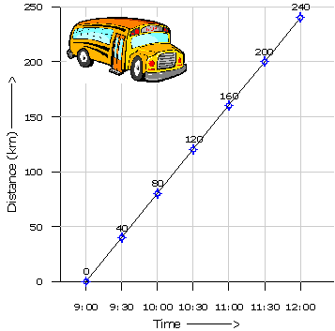

***10.1. Distance-Time Graphs***

1. 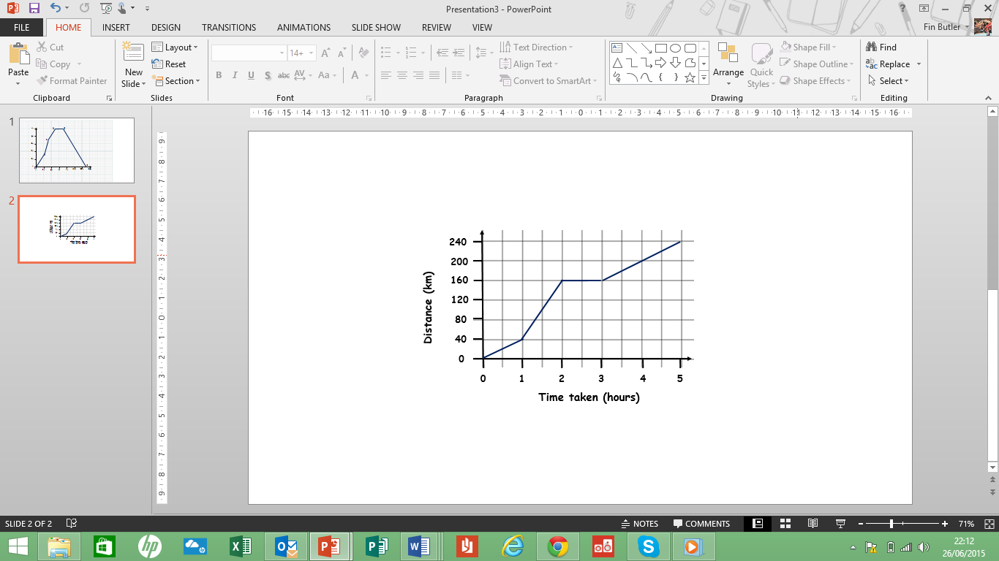Paul was travelling in his car to a meeting. This distance-time graph illustrates his journey.
2. **How long after he set off did he:**
3. **Stop for his break**
4. **Set off after this break**
5. **Get to his meeting place?**
6. 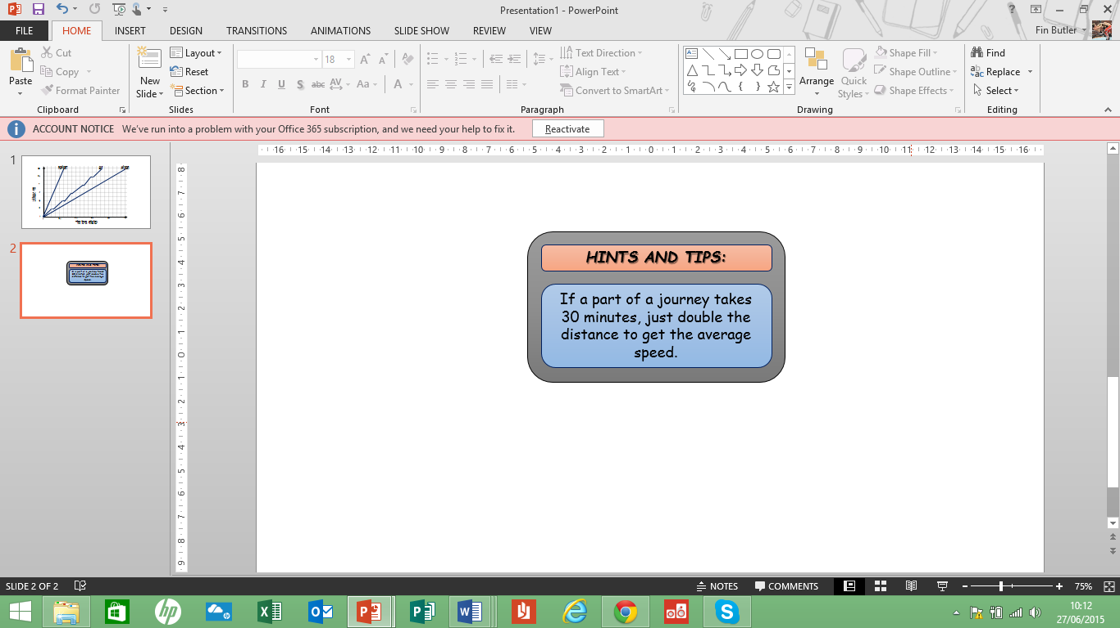**At what average speed was he travelling:**
7. **Over the first hour**
8. **Over the second hour**
9. **For the last part of his journey?**
10. **The meeting was scheduled to start at 10.30am. What is the latest time he should have left home?**
11. James was travelling to Cornwall on his holiday. This distance-time graph illustrates his journey.
12. 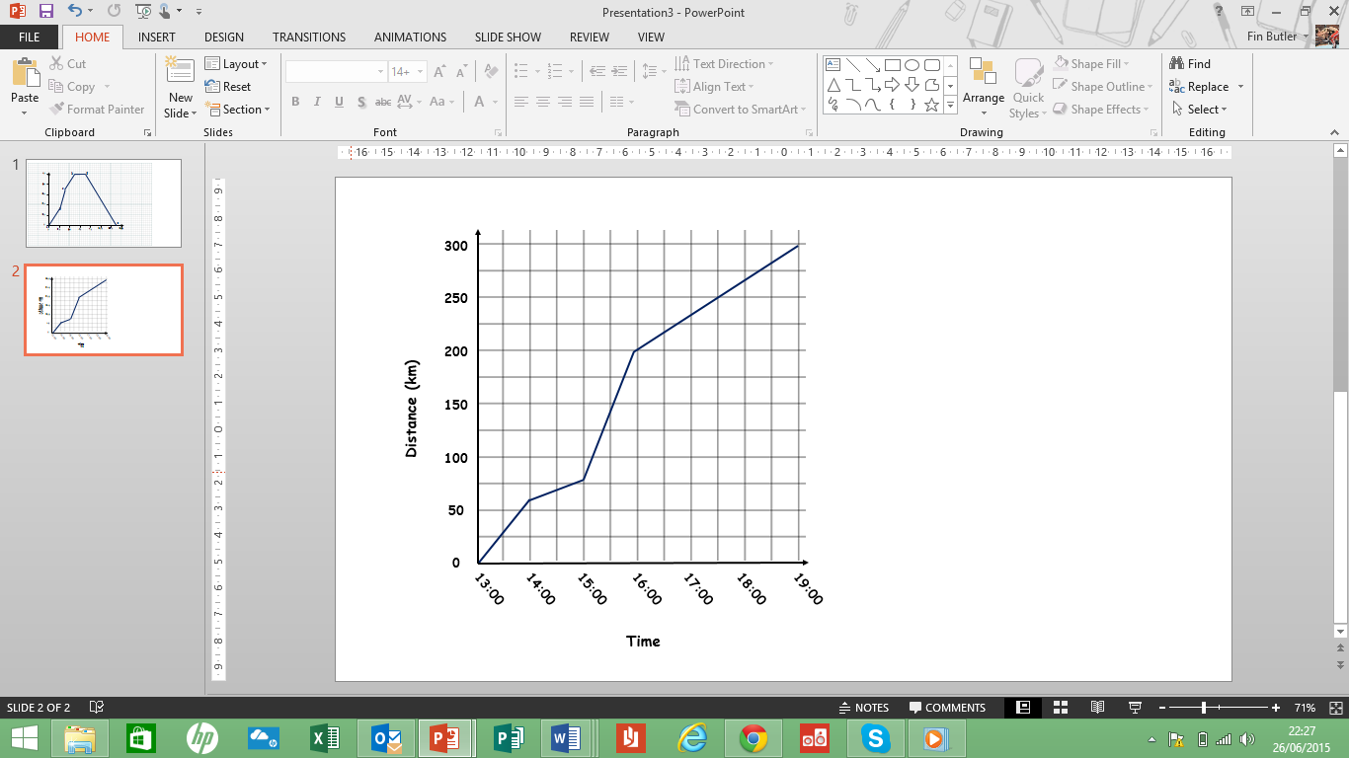**His greatest speed was on the motorway.**
13. **How far did he travel on the motorway?**
14. **What was his average speed on the motorway?**
15. **When did he travel the most slowly?**
16. **What was his lowest average speed?**



***10.1. Distance-Time Graphs***

1. A small bus set off from Leeds to pick up Mike and his family. It then went on to pick up Mike’s parents and grandparents. It then travelled further, dropping them all off at a hotel. The bus then went on a further 10km to pick up another party and it took them back to Leeds. This distance-time graph illustrates the journey.

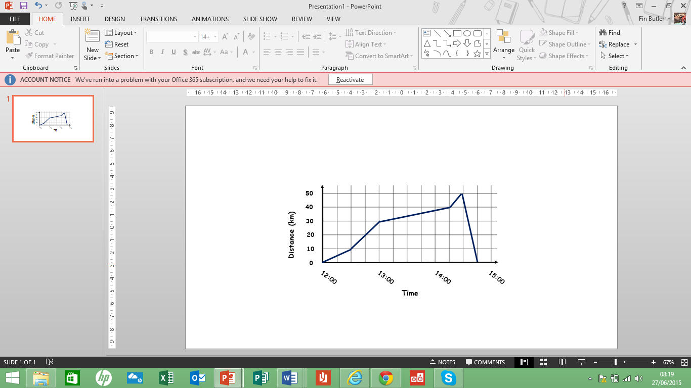

1. **How far from Leeds did Mike’s parents and grandparents live?**
2. **How far from Leeds is the hotel at which they all stayed?**
3. **What was the average speed of the bus on its way back to Leeds?**
4. Three friends, Patrick, Araf and Sean, ran a 1000m race. The race is illustrated on the distance-time graph shown here:

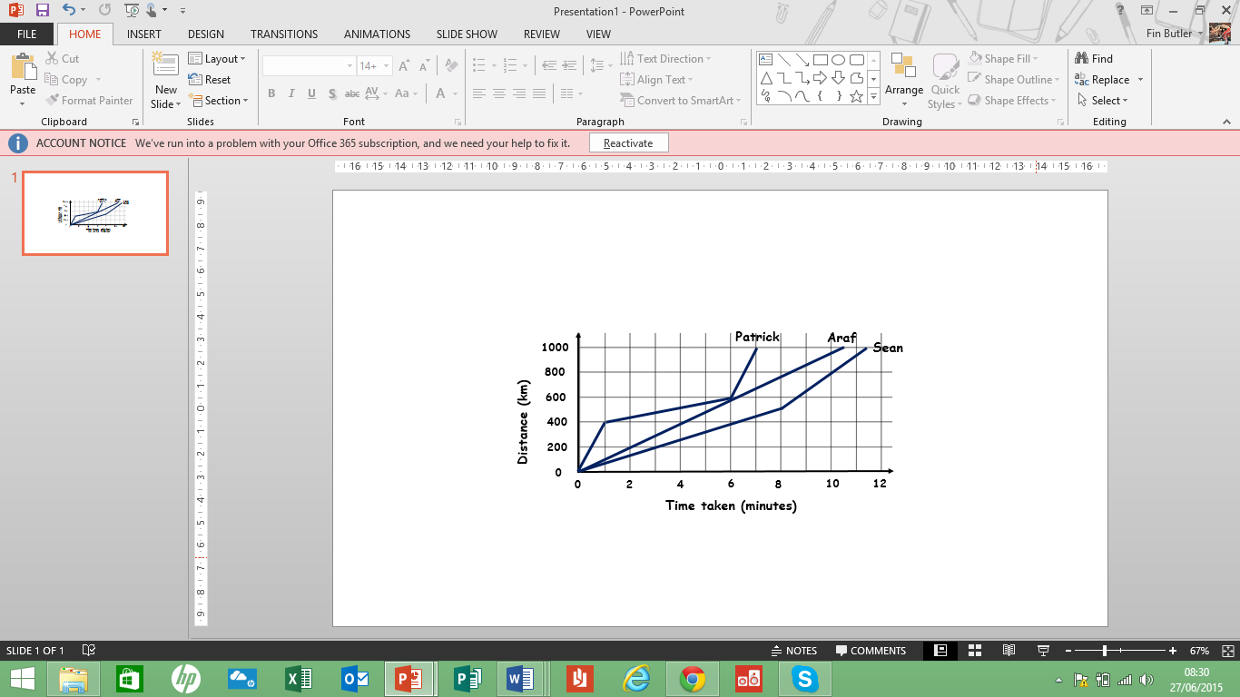

1. **Describe how each of them completed the race.**
2. **What is Araf’s average speed in m/s?**
3. **What is this speed in km/h?**



***10.1. Distance-Time Graphs***

1. Richard and Paul took part in a 5000m race. It is illustrated in this graph.

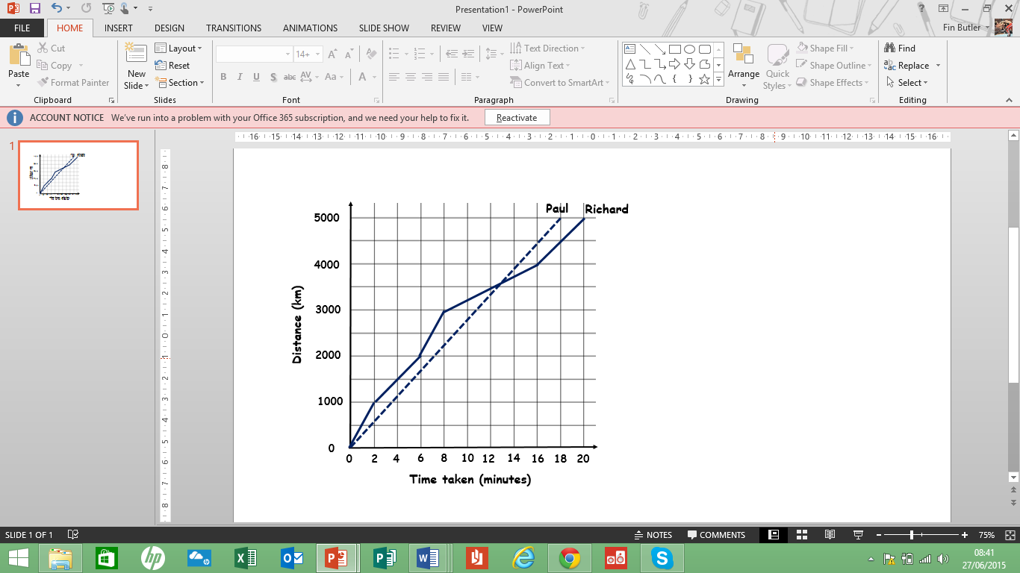

1. **Paul ran a steady race. What is his average speed in:**
2. **Metres per minute.**
3. **Kilometres per hour?**
4. **Richard ran in spurts. What was his highest average speed?**
5. **Who won the race and by how much?**
6. 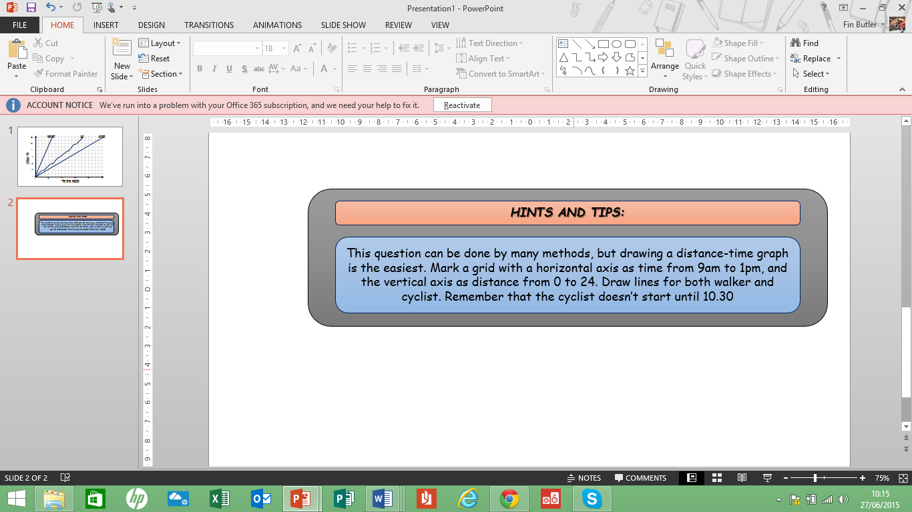A walker sets off at 9.00am from point P to walk along a trail at a steady pace of 6km per hour. 90 minutes later, a cyclist sets off from P on the same trail at a steady pace of 15km per hour. At what time did the cyclist overtake the walker? You may use a graph to help you solve this question.

***10.1. Distance-Time Graphs***

1. Three school friends set off from school at the same time, 3.45pm. They all lived 12km away from the school. The distance-time graph illustrates their journeys:

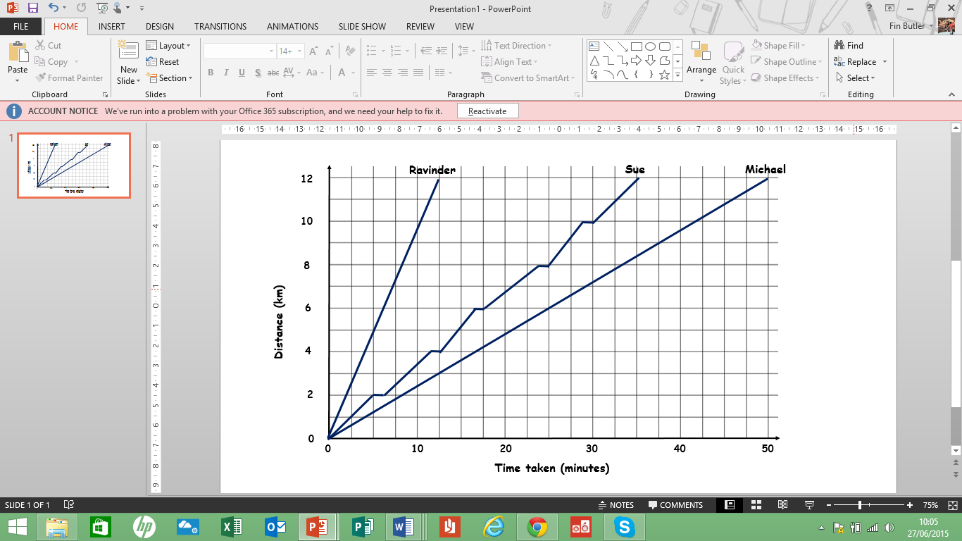

One of them went by bus, one cycled and one was taken by car.

2. **Explain how you know that Sue used the bus.**
3. **Who went by car?**
4. **At what times did each of them get home?**
5. **When the bus was moving, it covered 2km in 5minutes. What is this speed in kilometres per hour?**
6. **Overall, the bus covered 12km in 35minutes. What is this speed, in kilometres per hour?**
7. **How many stops did the bus make before Sue got off?**