1. 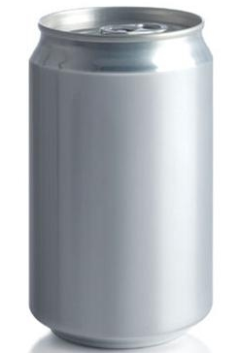When put under an increased amount of pressure an aluminium can will be crushed. If a weight of 15kg is applied to a can it will be crushed to 32% of its original height.

I have a can that is 13cm tall and apply 15kg of weight to it. What will be the height of the can now?

1. The diameter of a circular piece of steel is 7cm. When heated the diameter increases in size by 11%. Find the area of the piece of steel after it has been heated.

What is the difference between the two areas, before and after it has been heated?

1. An elastic band of length 15cm can be stretched without breaking by increasing its length by between 58% and 62%. Once stretched the elastic band will not return to its original length, it will have increased by 10% of the length it was stretched by.

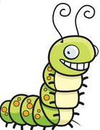 I have stretched the elastic band to 24cm. Does it break and if not what is its length when relaxed?

1. A Population of caterpillars have been taking over a vegetable patch. Overnight they have been eating 3% of all the vegetation available to them. After 4 days how much of the original vegetation is left?
2. A new drug being developed by a company is said to be 70% effective at wiping out certain bacteria. After using the drug if there are over 100,000 bacteria still left the patient is said to still be infected. The new drug will be 40% more expensive to produce than what is currently available.

a) A patient has 421,000 bacteria in their blood and starts the new drug. How many will be left after taking the new drug? Is the patient still infected? Would taking the drug again be enough to cure them?

1. The original drug cost £31.50. How much will the new drug cost? If the company produces them with an £11 profit how much does the drug cost to make? How many drugs does the company need to produce to make a £2m profit?