**GCSE – Data Collection and Sampling**

**A. Critiquing questions and designing better questions.**

1. Ben wants to find out what food people like to eat in restaurants, so asks his family:  
   *“Do you agree that pizza is better than pasta?”*List two things that are wrong with his survey? (2)  
     
     
     
     
     
     
   _________________________________________________
2. Naomi wants to find out how often people go to the cinema. She uses this question on a questionnaire.  
   “How many times do you go to the cinema?”  
     
   □ Not very often □ Sometimes □ A lot  
     
   a) Write down two things wrong with this question. (2)   
     
     
     
     
     
   b) Design a better question for her questionnaire to find out how often adults go to the cinema. You should include some response boxes. (2)
3. “How many texts have you sent on your mobile phone?  
   □ 0-10 □ 10-20 □ 20-30 □ 30 or more”

List two things wrong with this question. (2)

1. Valerie is the manager of a supermarket. She wants to find out how often people shop at her supermarket. She will use a questionnaire.  
   Design a suitable question for Valerie to use on her questionnaire.  
   You must include some response boxes. (2 marks)

**B. Tally Charts**

1. Phillip is going to carry out a survey of the football teams supported by each of his friends. In the space below, draw a suitable data collection sheet that Phillip could use. (3 marks)

**C. Sample Bias**

1. Melanie wants to find out how often people go to the cinema. She gives a questionnaire to all the women leaving a cinema. Her sample is biased.   
   Give **two** possible reasons why.

**D. Random Sampling**

A random sample is ______________________________________________________________

“You want to take a random sample a student’s favourite TV programmes at school. Describe how you could achieve a random sample.”

“Dave wants to determine the spending habits of the UK population. He stands outside HSBC bank’s headquarters and asks the first 10 people he sees. Suggest two reasons why his sample will likely be poor.”

**E. Stratified Sampling**

What is it?

______________________________________________________________________________

**Test Your Understanding:**

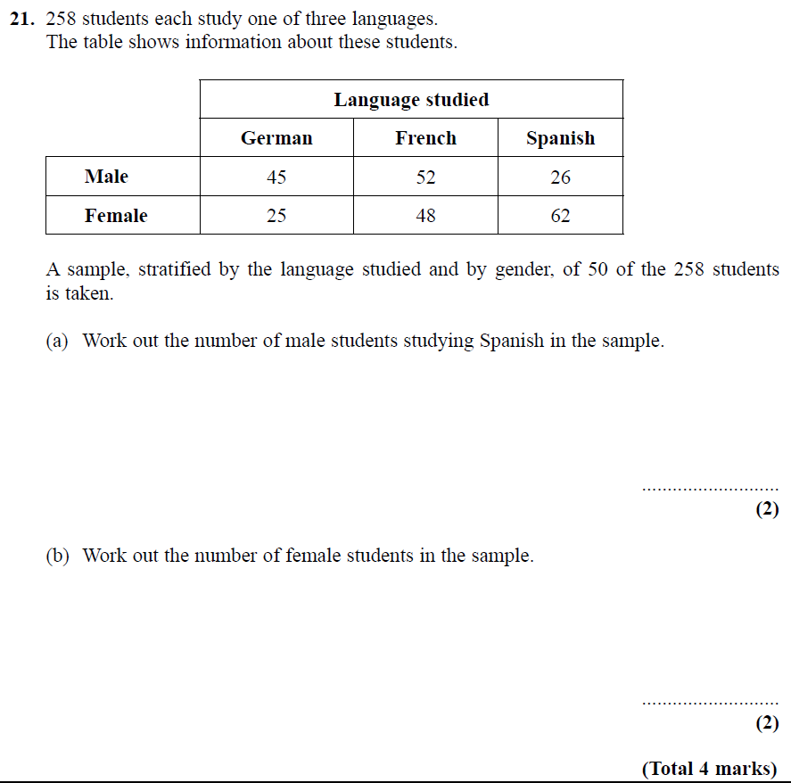  
**Exercises**

1. Here is a table showing how many students there are at Geometry High

|  |  |  |  |  |  |
| --- | --- | --- | --- | --- | --- |
| Year | 7 | 8 | 9 | 10 | 11 |
| No students | 100 | 120 | 115 | 130 | 126 |

I want to take stratified sample of 150 people from the school. How many year 11’s should I include in my sample.

1. Debbie is carrying out a survey to see how much people spend on groceries. She has the following information about which people shop at which supermarket in her town.

|  |  |  |  |  |  |
| --- | --- | --- | --- | --- | --- |
| Supermarket | Sainsbury’s | Tesco | Aldi | Waitrose | M&S |
| No of shoppers | 6400 | 5100 | 4500 | 2000 | 1350 |

She wants to conduct a stratified sample of 200 people, how many people should she survey from Tesco?

1. The table gives information about the number of 564 students doing extracurricular clubs at a secondary school to see how much time they spend on homework.

|  |  |  |  |  |  |  |
| --- | --- | --- | --- | --- | --- | --- |
| Club | Chess | Sports | Art | Music | Debating | Drama |
| Boys | 24 | 85 | 43 | 36 | 25 | 54 |
| Girls | 16 | 80 | 50 | 41 | 28 | 82 |

A stratified sample is to be carried out of size 60.

1. How many boys from chess club should be sampled?
2. How many girls from Drama should be sampled?
3. How many boys should be sampled?

1. In a teenage professional football club of 340 players, 18 are aged between 11 and 12. If a stratified sample of size 100 were to be carried out, how many 11-12 year olds should be included in the sample?

1. The table shows the number of male and female students attending an after school arts programme.

|  |  |  |
| --- | --- | --- |
| Age (years) | Number of male students | Number of female students |
| 16 | 50 | 30 |
| 17 | 60 | 40 |
| 18 | 76 | 54 |
| 19 | 13 | 24 |

How many students from each category should be included in a stratified sample of size 40?