**QQQ – Year 7 Transformations**

Name Score ________ / 9 Award ___________

1. Using the diagram below, describe the single transformation from.
2. A to B ________________________________________________________ (1)
3. B to C ________________________________________________________ (1)
4. C to D ________________________________________________________ (1)
5. A to D (note that decimal coordinates are permitted)  
     
    ________________________________________________________ (1)

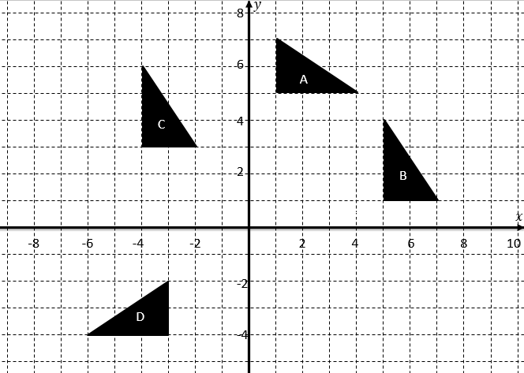

1. Carry out the following transformations:
   1. Rotate the shape A $180°$ about the point $\left(0,-2\right)$. Label it B. (1)
   2. Rotate the shape A $90°$ anticlockwise about the origin. Label it C. (1)
   3. Reflect the shape in the line $y=2$. Label it D. (1)

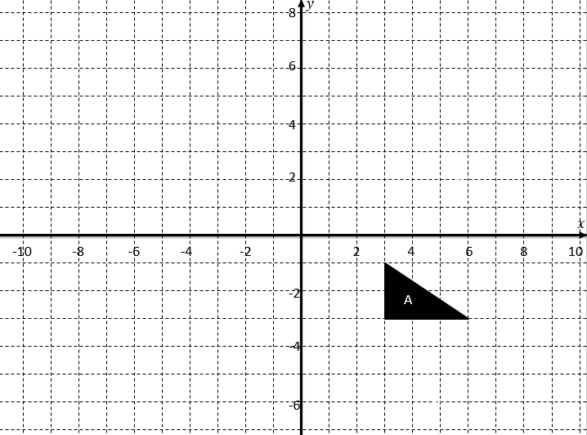

1. Identify the centre of rotation as A is rotated to give B. (1)  
     
   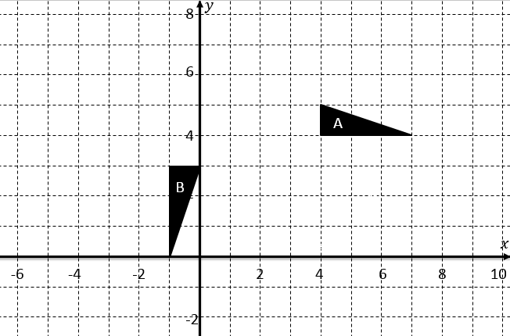

  Centre of rotation: ( , ) 

1. An object is rotated $180°$ about the point $\left(3,3\right)$ followed by $180°$ about the point $\left(1,1\right)$. Describe the **single** transformation that has the same effect as this combined transformation. (1)  
     
     
   ____________________________________________________________________________  
     
     
   ____________________________________________________________________________  
     
     
     
   *(Awards: 5+ Bronze, 6+ Silver, 8+ Gold, 9 Platinum)*

Solutions

1. A) Reflection in the line $y=x$  
   B) A translation by $\left(\begin{matrix}-9 \\ 2\end{matrix}\right)$  
   C) A rotation $90°$ anticlockwise about/around the origin (or (0,0)).

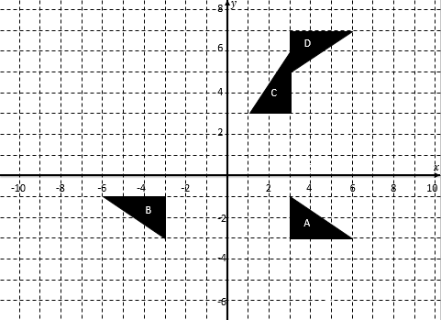

1. (1,6)
2. Translation by $\left(\begin{matrix}-4 \\ -4\end{matrix}\right)$.