**Year 7 Transformations**

**Section A: Translation**

**Test Your Understanding**

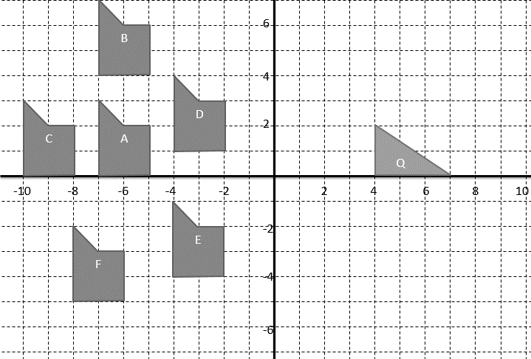

1. Describe (fully) the transformation from:  
   1. A to B ___________________________________________
   2. A to C ___________________________________________
   3. A to D ___________________________________________
   4. A to E ___________________________________________
   5. A to F ___________________________________________
2. Translate shape Q by the vector $\left(\begin{matrix}-1 \\ 3\end{matrix}\right)$. Label it R.

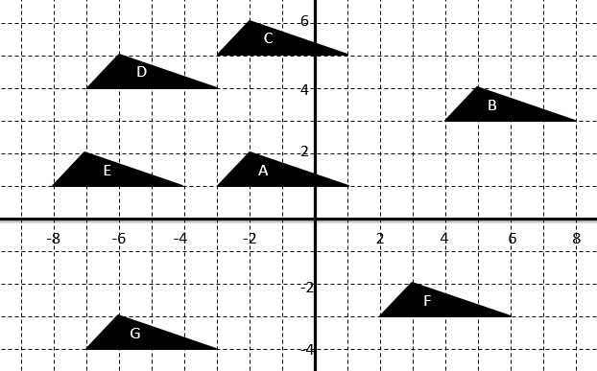**Exercise 1** Question 1 : Describe each of the following transformations.

a) A to B  
  
  
_____________________  
b) A to C  
  
  
_____________________  
c) A to D  
  
  
_____________________  
  
d) A to E e) A to F  
___________________________________ ____________________________________  
  
f) A to G  
  
  
___________________________________

Question 2:

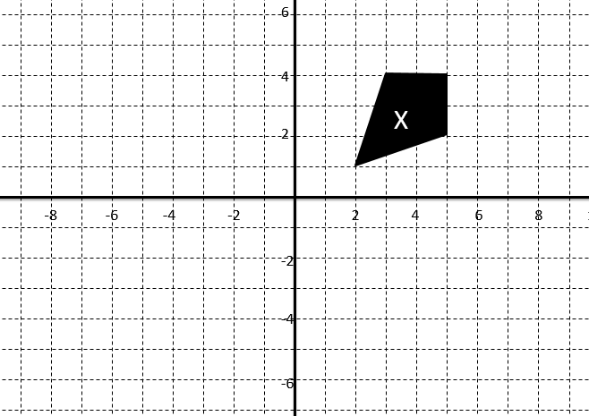

1. Translate X by $\left(\begin{matrix}-7 \\ 0\end{matrix}\right)$. Label it A.
2. Translate X by $\left(\begin{matrix}2 \\ -4\end{matrix}\right)$. Label it B.
3. Translate X by $\left(\begin{matrix}-3 \\ 2\end{matrix}\right)$. Label it C.

Question 3: A point $\left(3,1\right)$ is translated by $\left(\begin{matrix}4 \\ -2\end{matrix}\right)$. What is the image of the point after the transformation?  
  
 ________________________

Question 4: Give a single vector that would be required to translate a point in the way described:

1. Up 3 units. _____________
2. Left 2 units. _____________
3. Down 7 units and right 6 units. ___________
4. Up 1 unit, right 2 units, down 3 units, left 4 units: _________________

* Give a single vector that would be required to translate a point in the way described. Give your vector in terms of the integer $n$.  
  *Up 1 unit, right 2 units, down 3 units, left 4 units, up 5 units, right 6 units, …   
  … down $4n-1$ units, left $4n$ units, up $4n+1$ units.*  
    
  _______________

**Section 2 – Reflection**

**Mini-Exercise**

By considering points on each line and observing any pattern, determine the equation the represents the line.

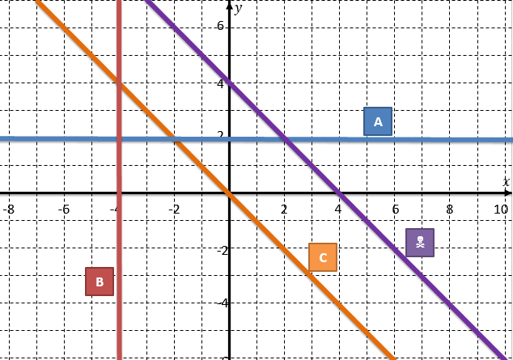

A _______________________________ B ___________________________________  
  
C _______________________________  ___________________________________

**Test Your Understanding**

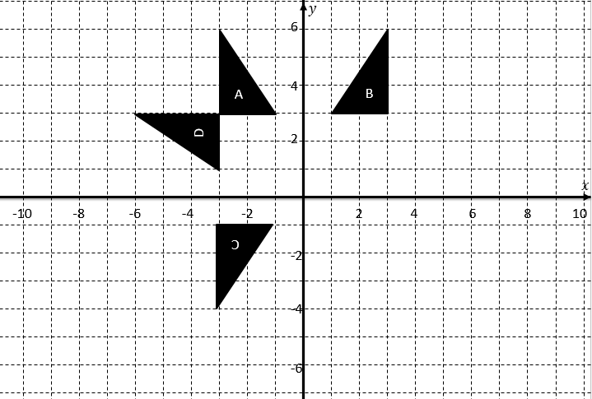

Describe the transformation from:

1. A to B _____________________________________________________________________
2. A to C ______________________________________________________________________
3. A to D ______________________________________________________________________

**Test Your Understanding**

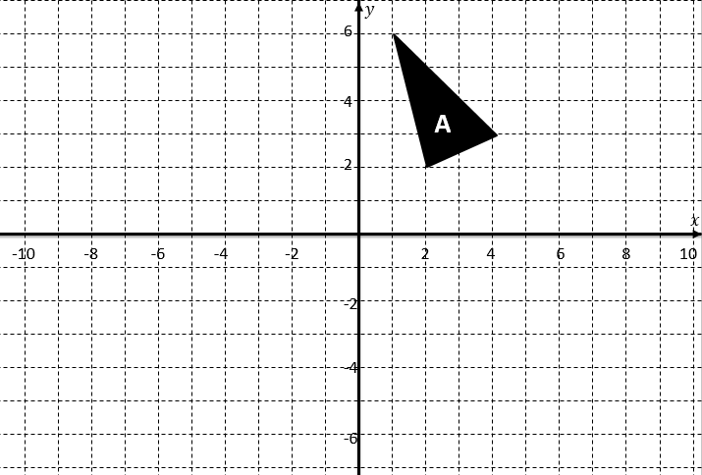

1. Reflect the shape in the line $y=1$. Label it B.
2. Reflect the shape in the line $y=-x$. Label it C.

**Main Exercise**

**Question 1**

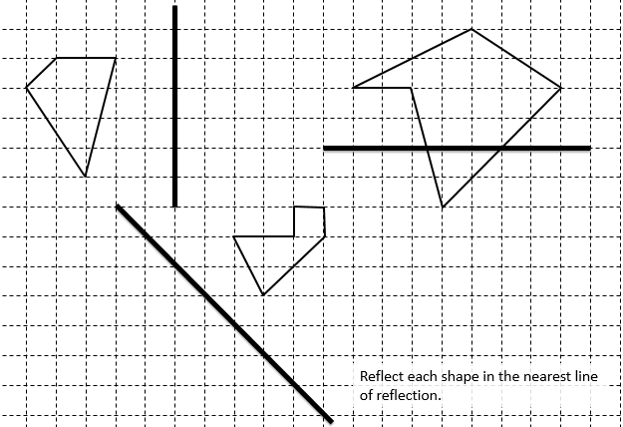

**Question 2**

Reflect the shape A in:

a) The $y$-axis. Label it B. b) The line $y=1$. Label it C.  
c) The line $y=x$. Label it D. d) The line $y=-x$. Label it E.

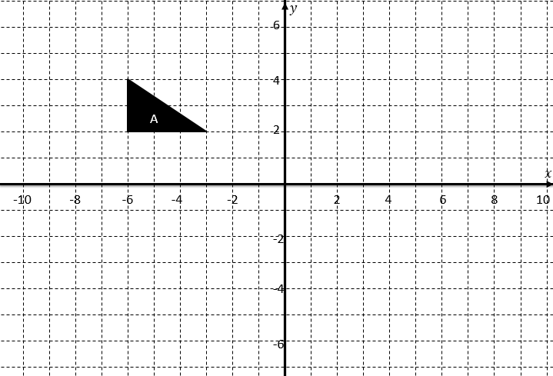

**Question 3**

Describe the transformation from:

a) A to B: ___________________________________________________________________  
b) A to C: ___________________________________________________________________   
c) A to D: ___________________________________________________________________

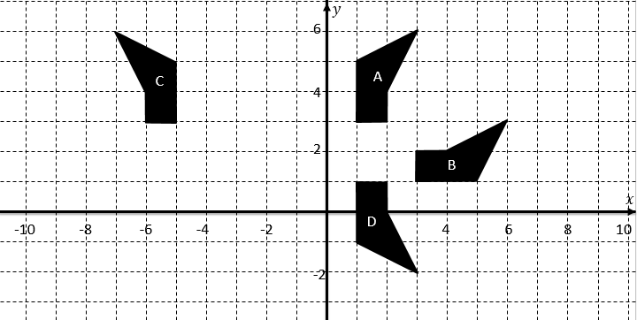

**Question 4**

1. Plot the points (3,0), (4,0), (7,1), (2,3). Label it Bob.
2. Reflect your shape in the line $y=-x$. Label it Steve.

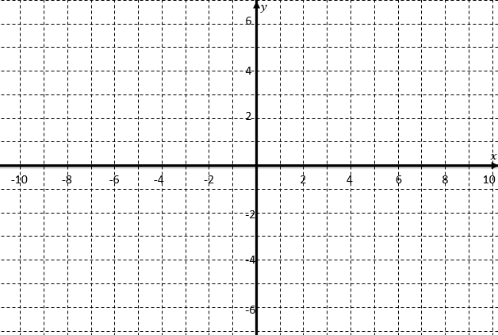

**Question 5**

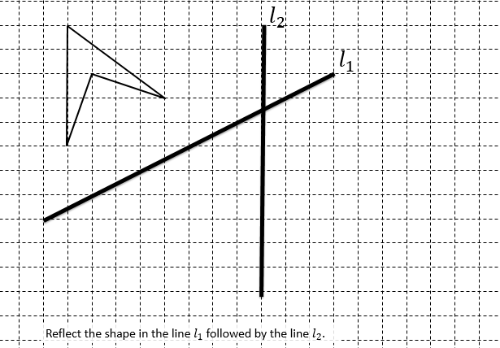

**Question 6**

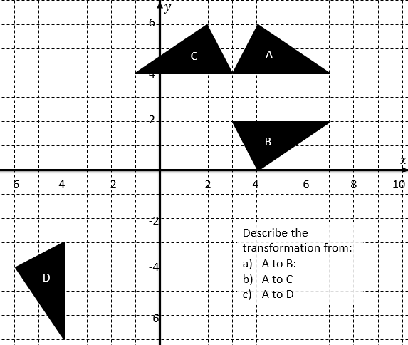

1. ____________________________________________________________
2. ____________________________________________________________
3. ____________________________________________________________

**Question 7**

Find the image of each transformation on the point (3, 4) (i.e. give the coordinate of the new point).

1. (3,4) is reflected in the $y$-axis. ( , )
2. (3,4) is reflected in the $x$-axis. ( , )
3. (3,4) is reflected in the line $y=x$. ( , )
4. (3,4) is reflected in the line $x=3$ ( , )
5. (3,4) is reflected in the line $y=-1$ ( , )

Question 

Find the image of each transformation on the point $(3,a)$, giving your coordinates in terms of $a$ and $b$.

1. $(3,a)$ is reflected in the line $y=a$. ( , )
2. $(3,a)$ is reflected in the line $x=a$. ( , )
3. $(3,a)$ is reflected in the line $y=-x$. ( , )
4. $(3,a)$ is reflected in the line $y=x$ followed by $y=b+1$. ( , )

**Exercise 3**

**Test Your Understanding**

Rotate the object 180° about the point (1,1).

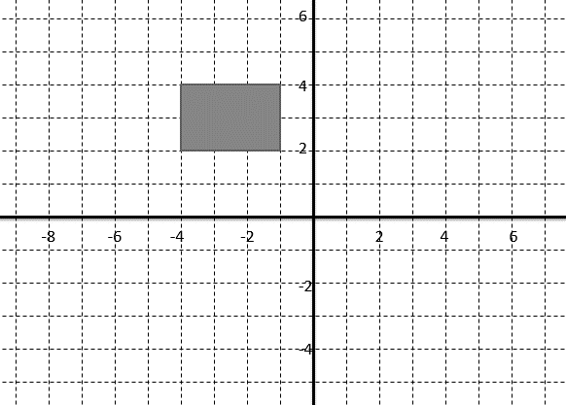

Rotate the object 90° anticlockwise about the point (2,2).

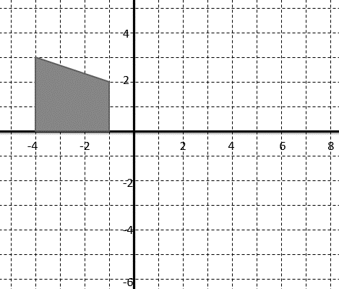

Rotate the object 90° clockwise about the origin.

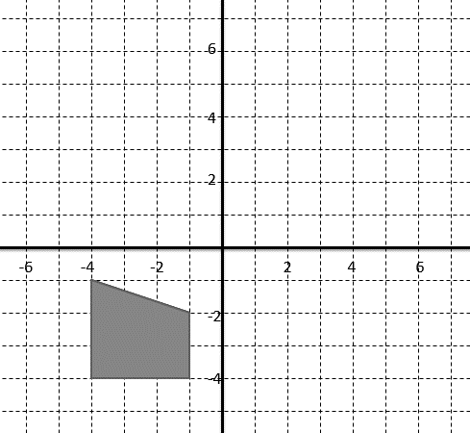

**Test Your Understanding**

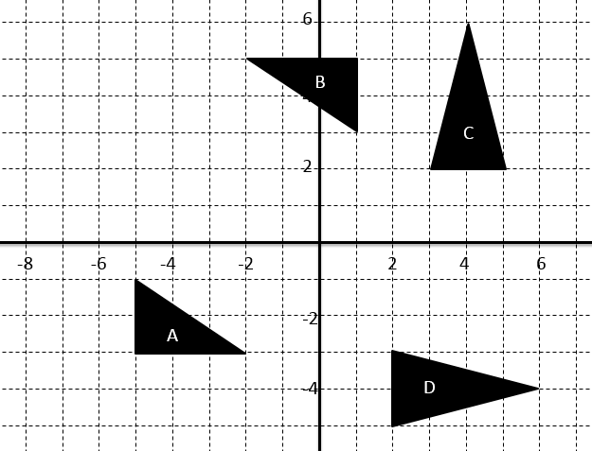 Describe the following transformations.

**A $→$ B**

**_______________________  
  
_______________________  
  
_______________________**

**C $→$ D  
  
_______________________  
  
_______________________  
  
_______________________**

**Main Exercises**

**Question 1**

Carry out the following transformations:

a) Rotate the shape A $180°$ about the point $\left(0,1\right)$. Label it B.  
b) Rotate the shape A $90°$ anticlockwise about the origin. Label it C.

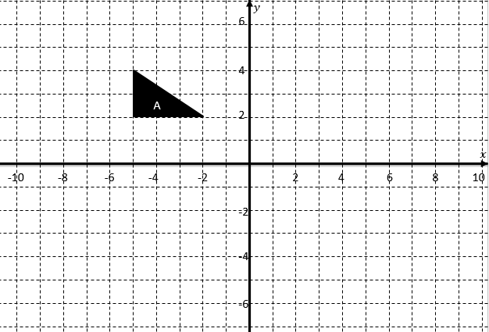

**Question 2**

Describe the following transformations:

A $→$ B ___________________________________________________________________________  
  
B $→$ C ___________________________________________________________________________

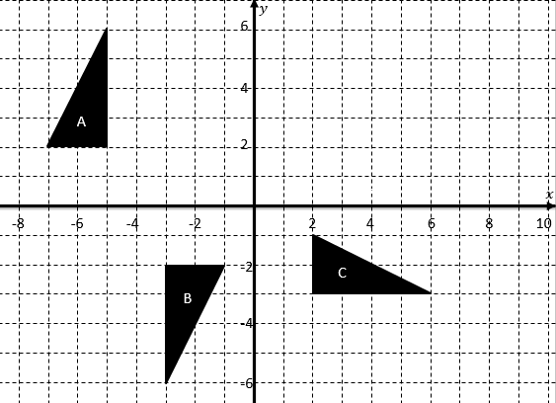

**Question 3**

Carry out the following transformations:

a) Rotate the shape A $90°$ clockwise about the point $\left(-3,0\right)$. Label it B.  
b) Rotate the shape A $180°$ about the point $\left(-1,2\right)$. Label it C.  
c) Rotate the shape A $90°$ anticlockwise about the point $(0,2)$. Label it D.

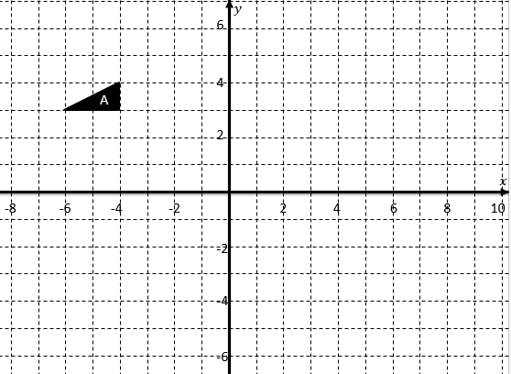

**Question 4**

Describe the following transformations:

1. A $→$ B ______________________________________________________________
2. A $→$ C ______________________________________________________________
3. A $→$ D ______________________________________________________________

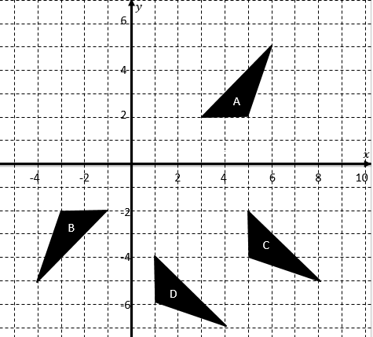

**Question 5**

Describe the following transformations:

1. A $→$ B ______________________________________________________________
2. B $→$ C ______________________________________________________________
3. C $→$ D ______________________________________________________________
4. A $→$ C ______________________________________________________________

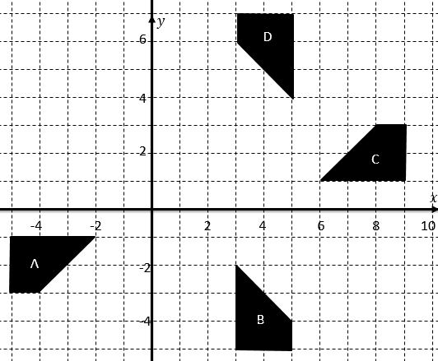

**Question 6**

Find the effect of the rotation on each of the following points.

1. Rotate $\left(3,2\right)$ $180°$ about the origin. ________________
2. Rotate $\left(3,2\right)$ $90°$ clockwise about the origin. ________________
3. Rotate $\left(3,2\right)$ $90°$ anticlockwise about the origin. ________________

**Question **

Given that $a>2$ and $b>3$, rotate the point $\left(a,b\right)$ $90°$ clockwise about the point $\left(2,3\right)$. Give your coordinates in terms of $a$ and $b$.

____________________