Answers:

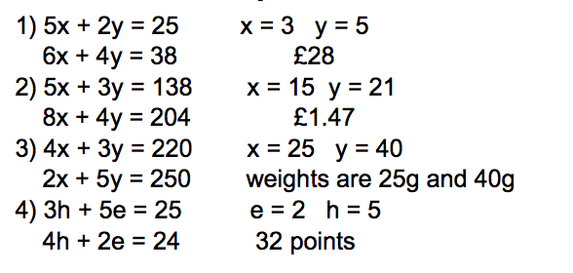

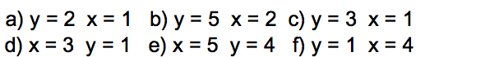

4) 72, 60 and 48

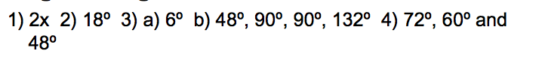

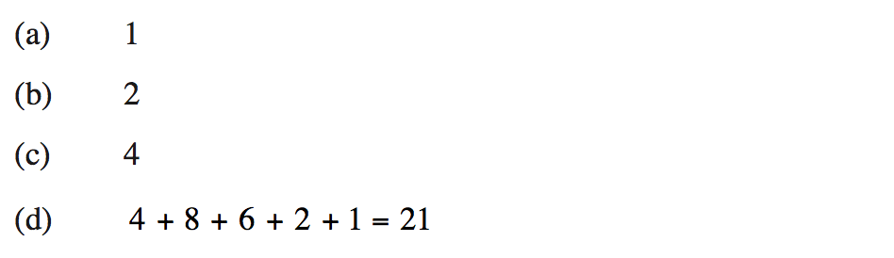

1/9, 4

/Users/lynn/Desktop/Screen Shot 2018-02-16 at 21.48.49.png





/Users/lynn/Desktop/Screen Shot 2018-02-16 at 21.50.06.png

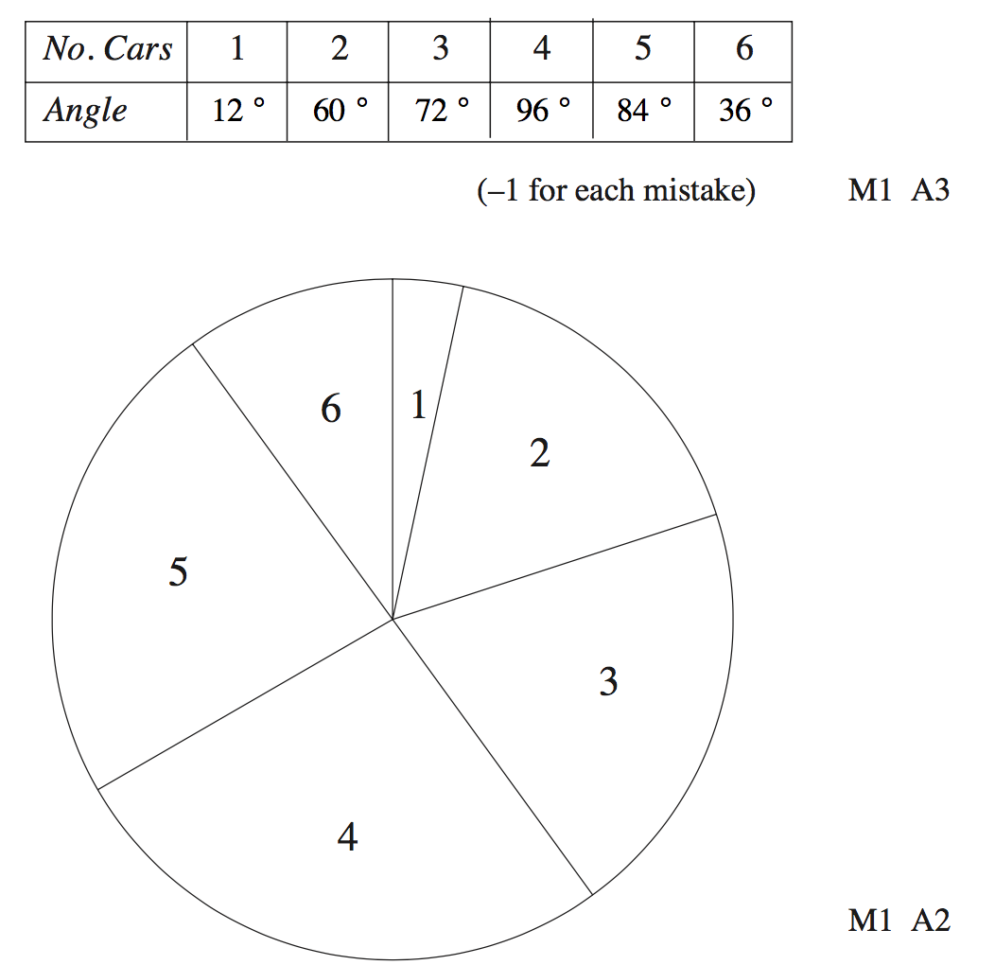

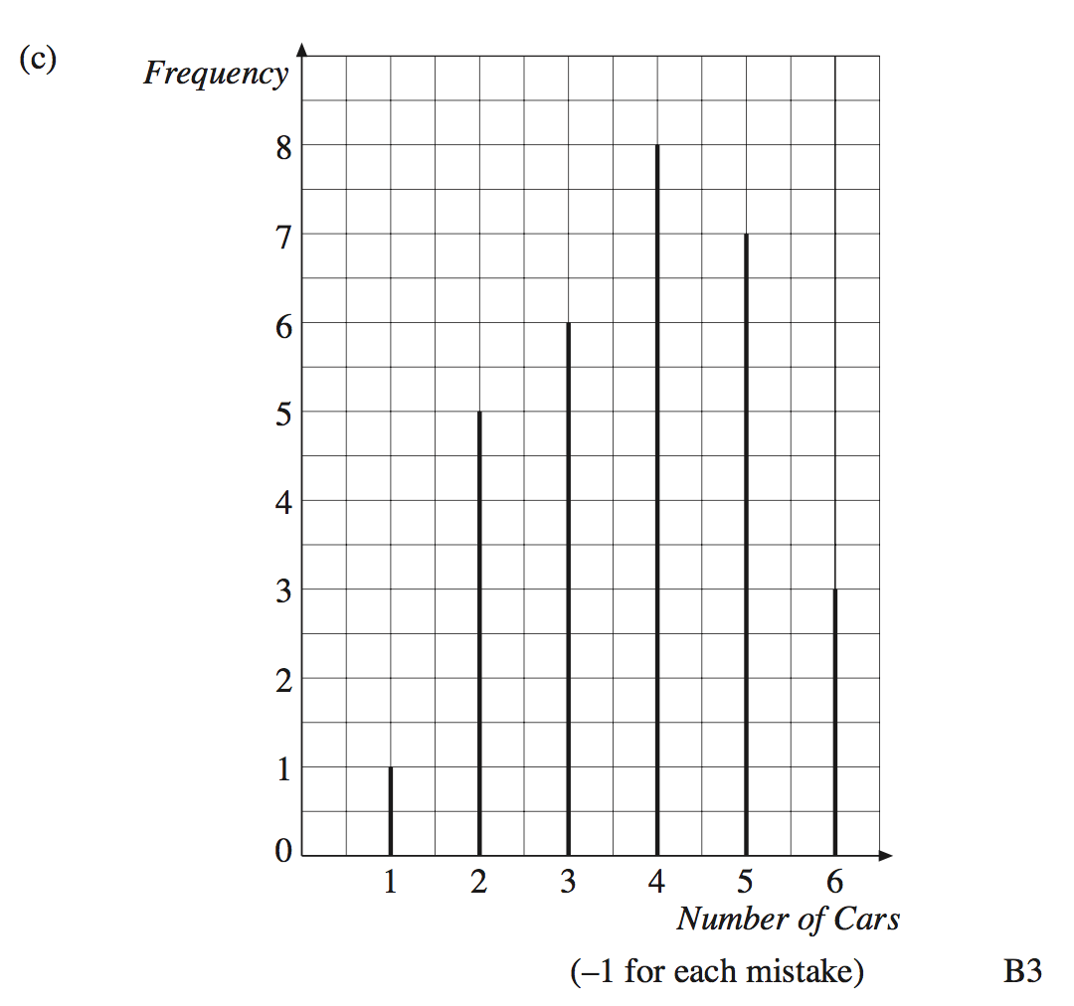



6, 105, 16

10, No, Need to know the number of medals for Russian Federation