Ven diagram

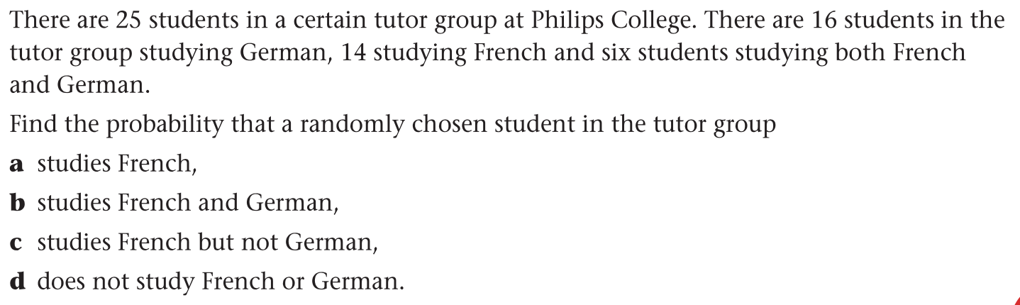

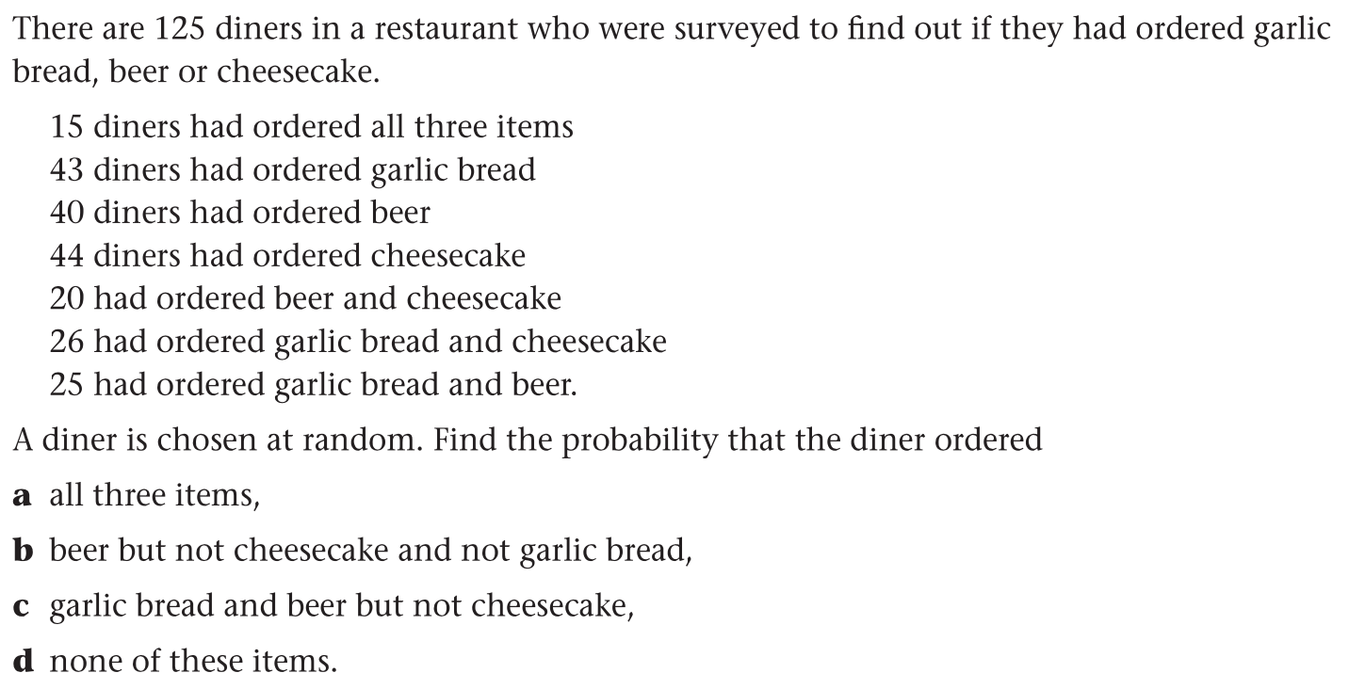

Additional Rule

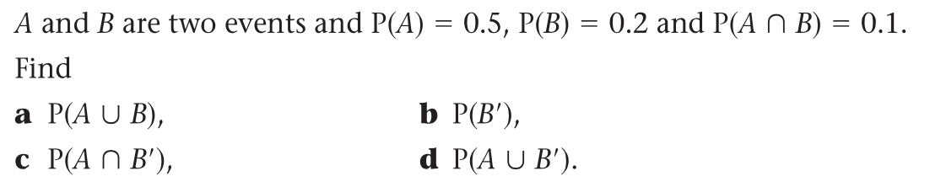

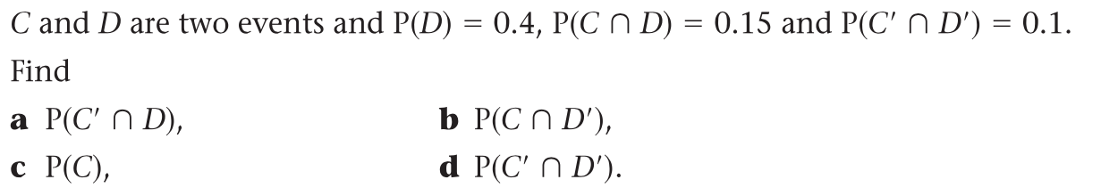

Mutually exclusive event & Independent event

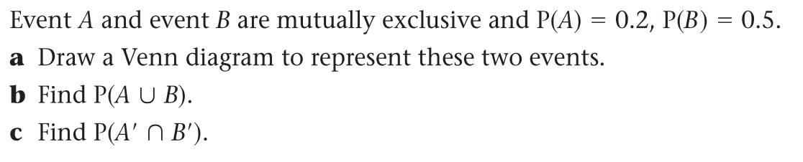

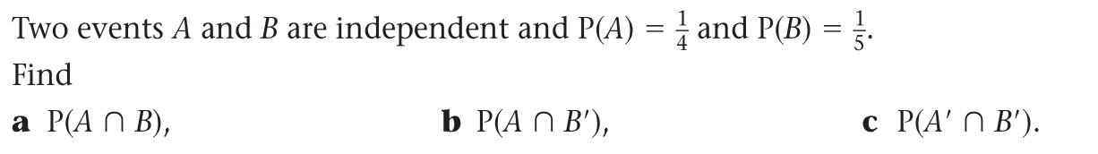

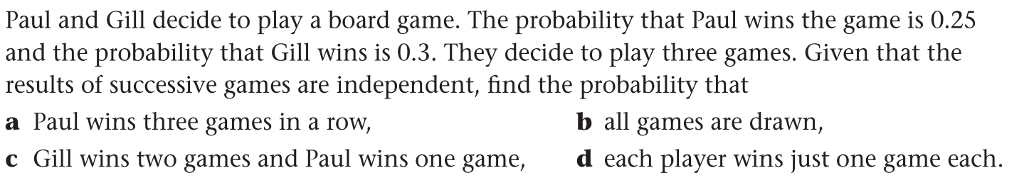

Conditional probabilities

