Test 1

Below are set of numbers! One of the numbers is missing. I also want the data set to have the given mean/median/mode/range. Write the complete data set

1. Median 12 - 3, 6, 12, 15, ? - ______, ______, ______, ______, _______
2. Range 10 – 3, 4, 2, 8, ? - ______, ______, ______, ______, _______

Write a data set of 5 numbers with the following:

1. Median 6, Mode 3, Range 12 - ______, ______, ______, ______, _______
2. Median 10, Mode 10, Range 20 -______, ______, ______, ______, _______

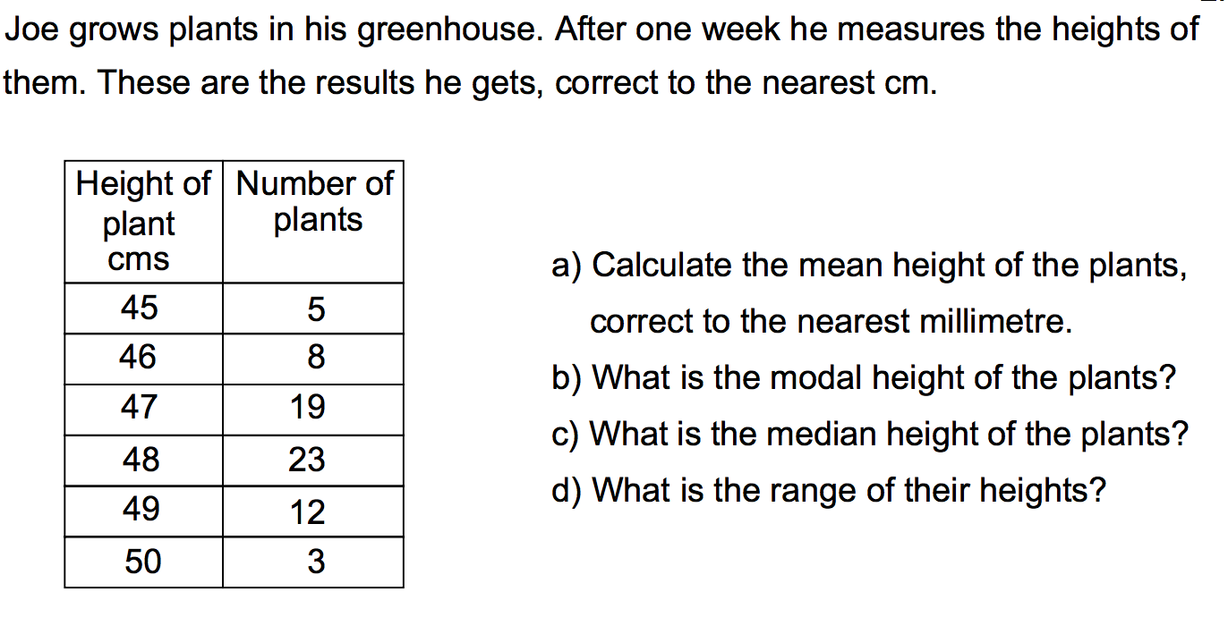

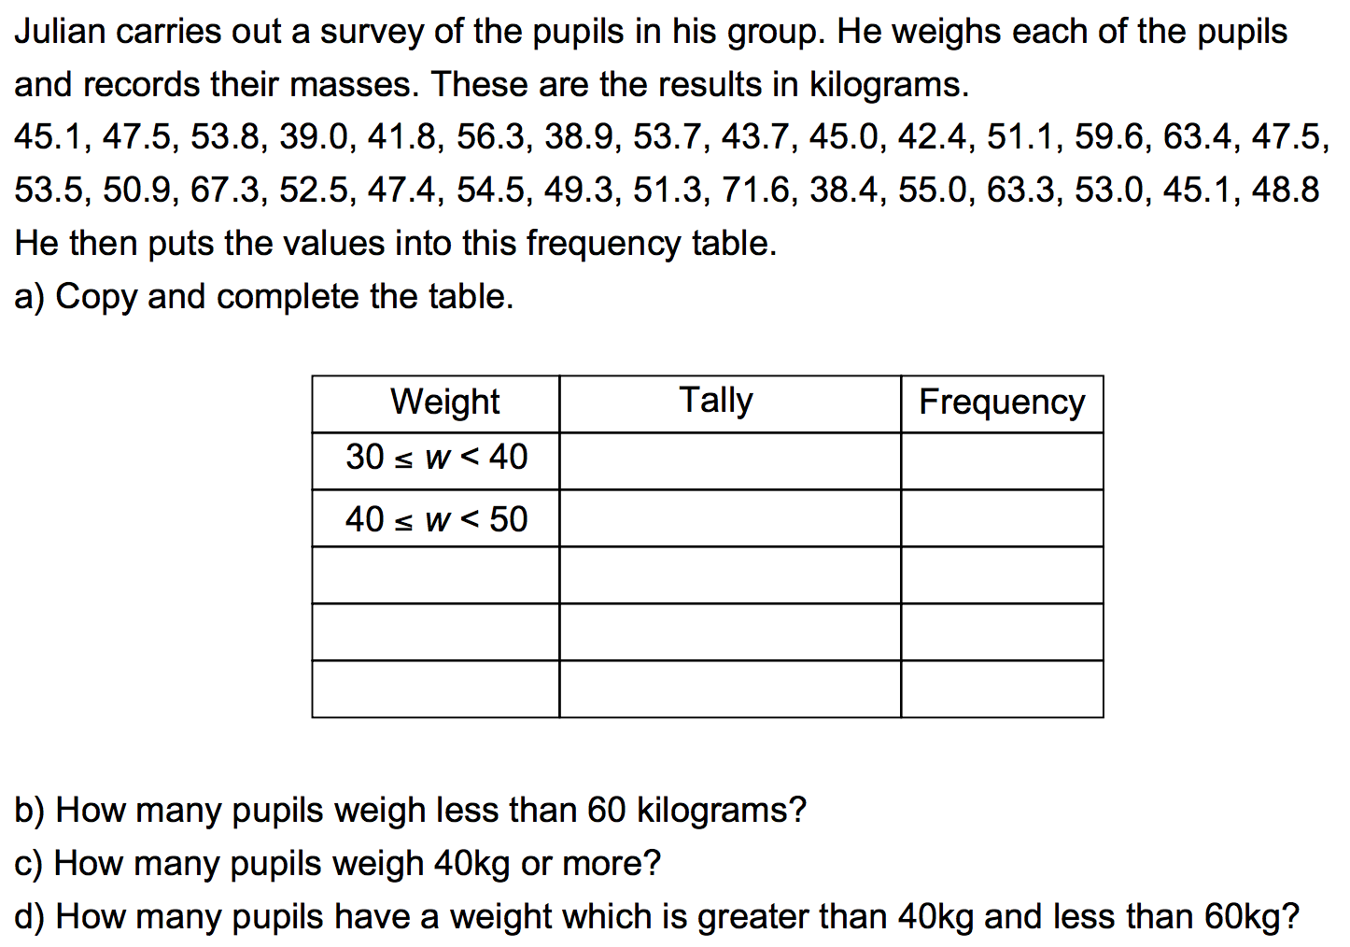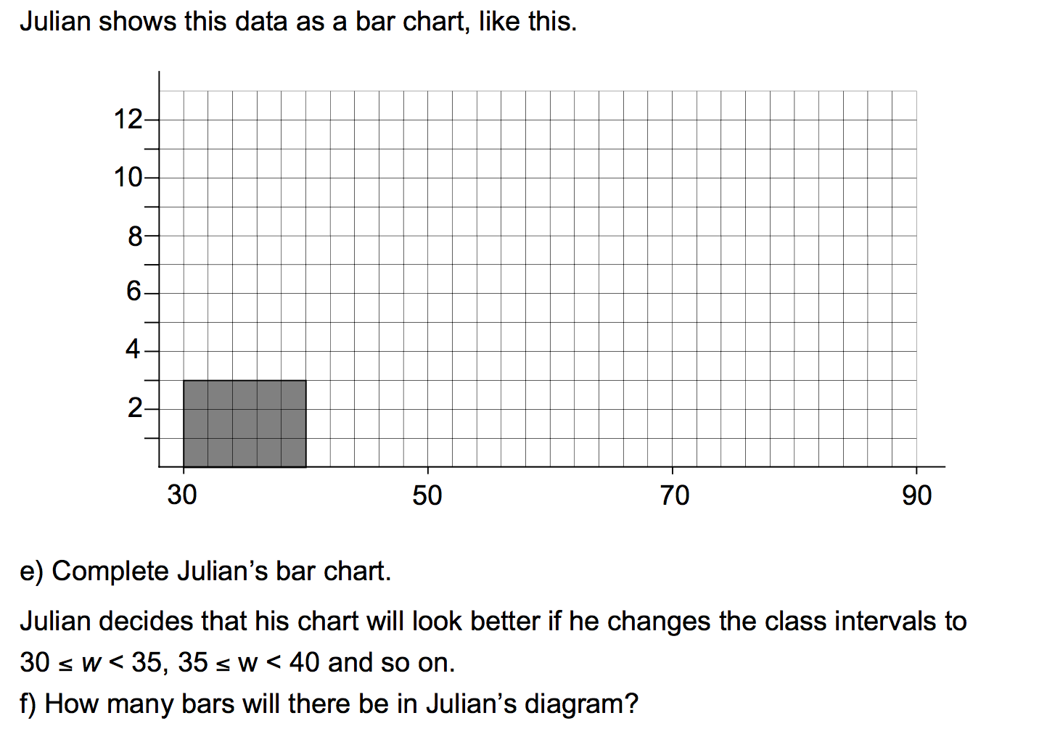

g) What is the mean?

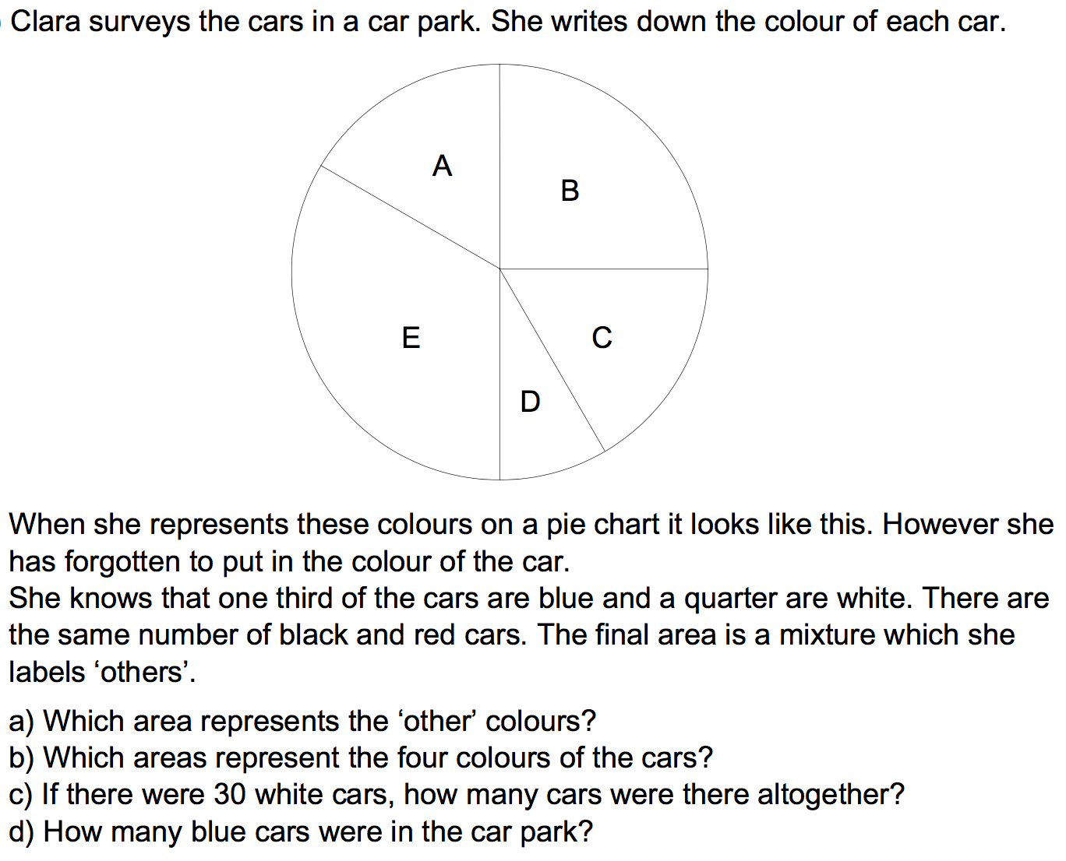

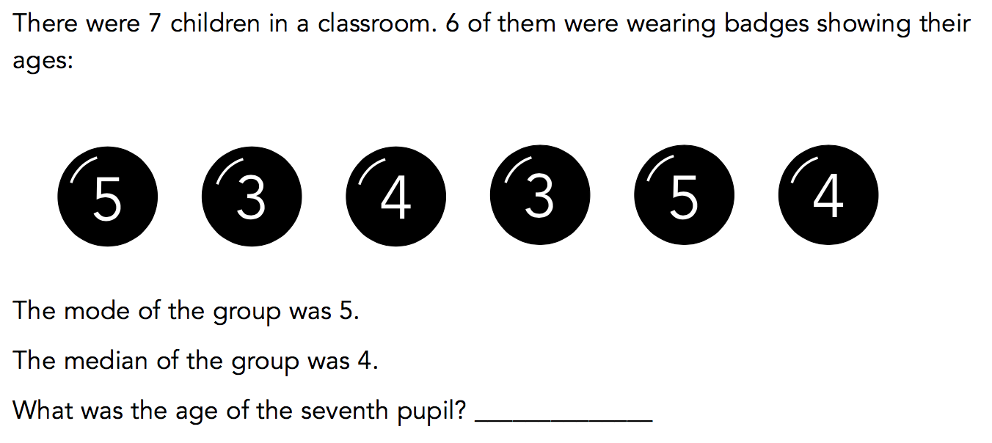

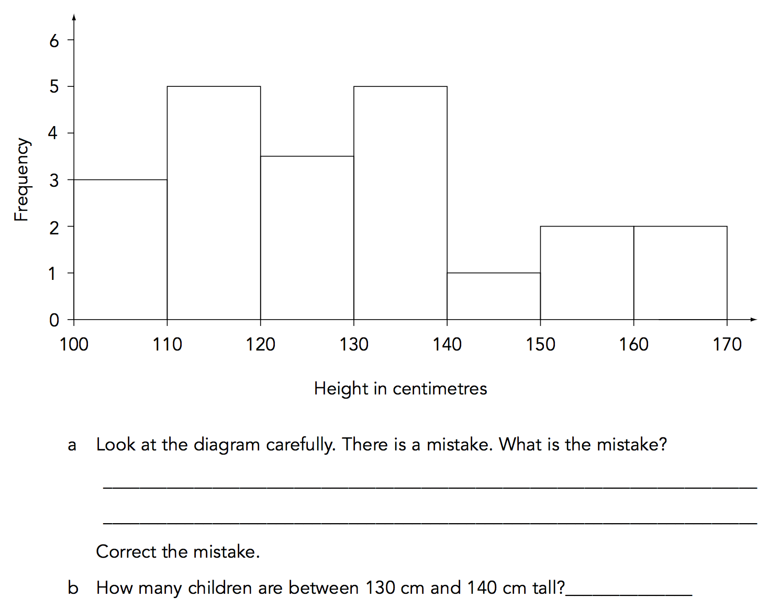

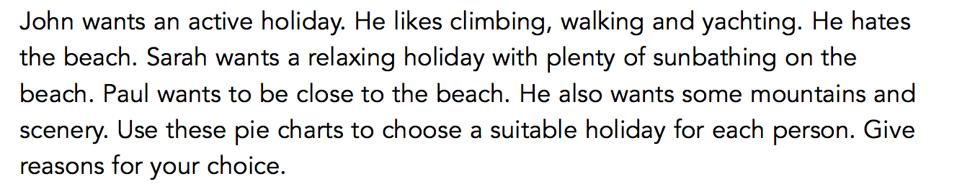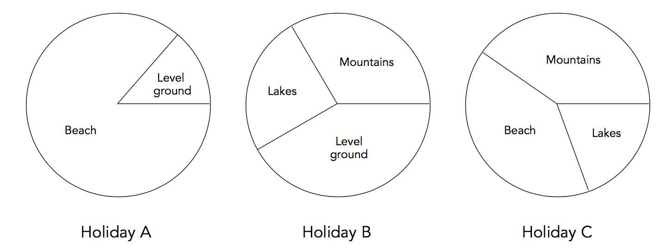

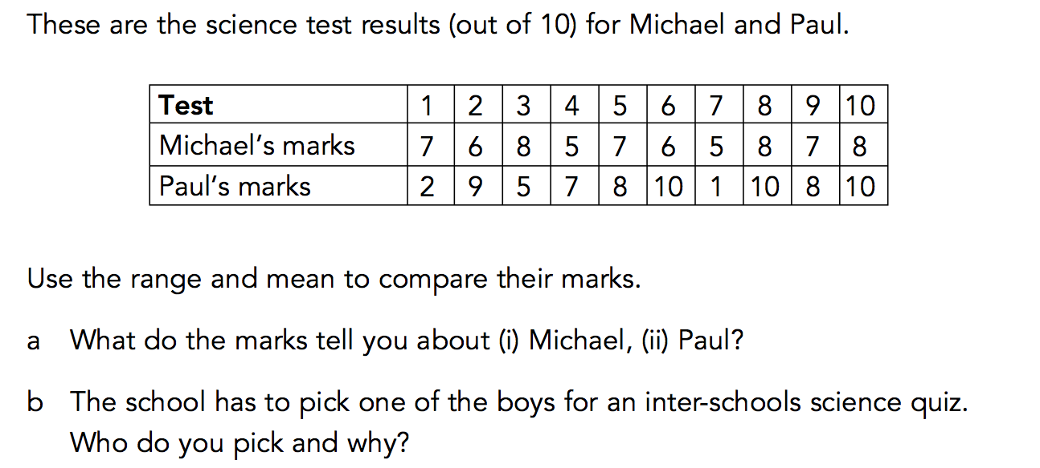

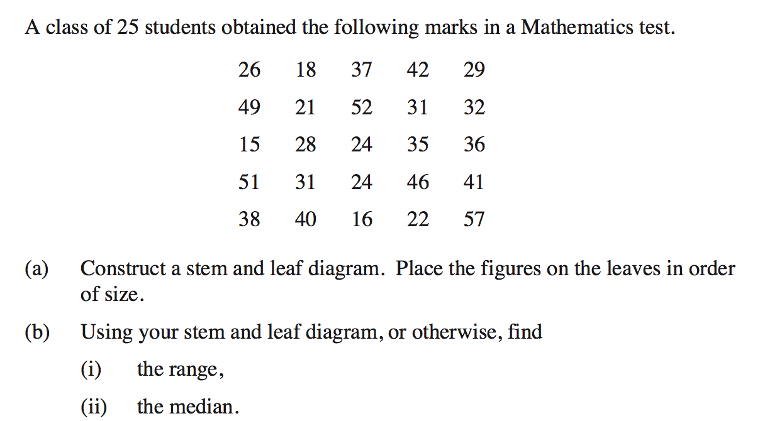

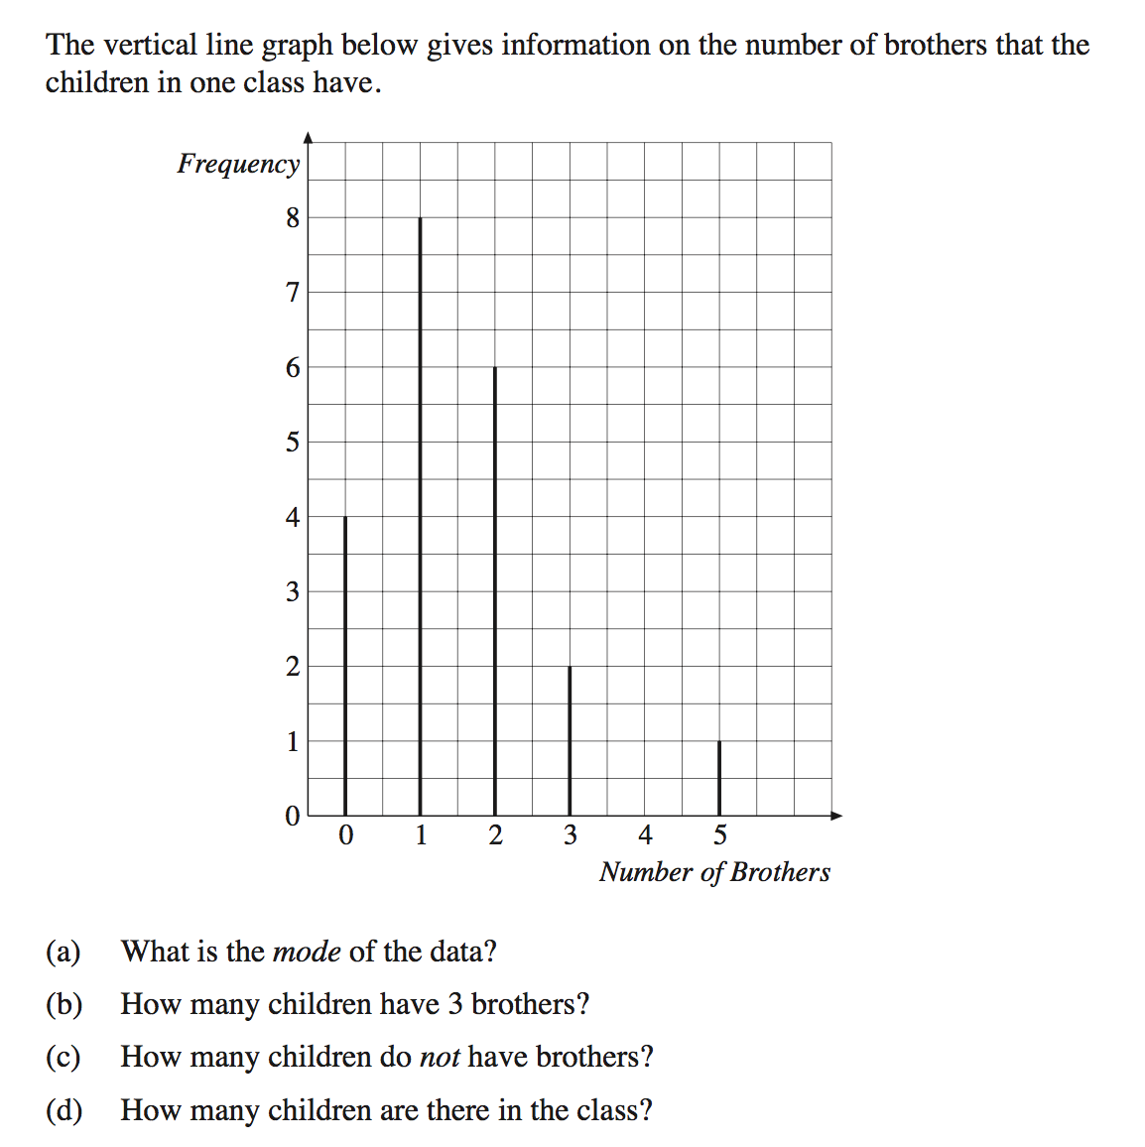

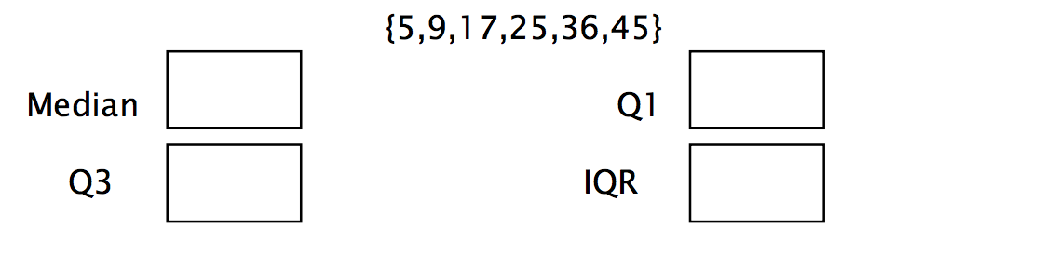

{11,5,9,17,25,36,45}

