

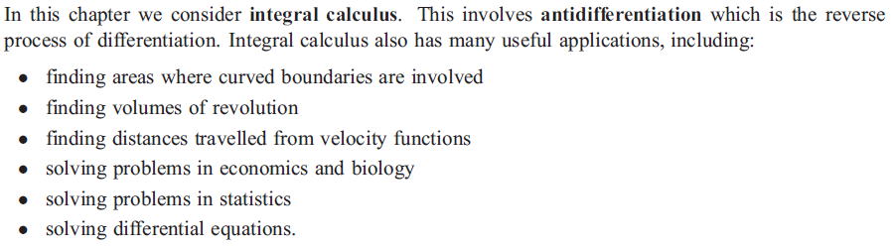

C:\Users\amanda.bixler\Desktop\2_001.png

C:\Users\amanda.bixler\Desktop\6.png

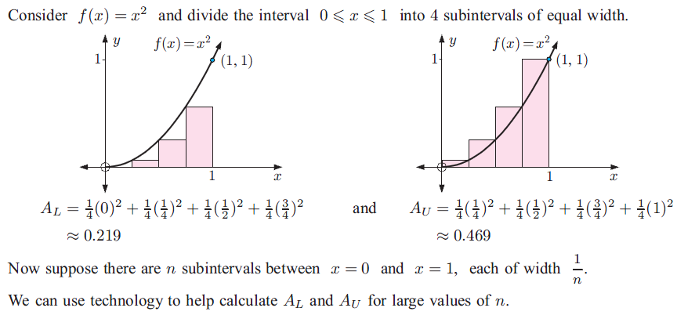

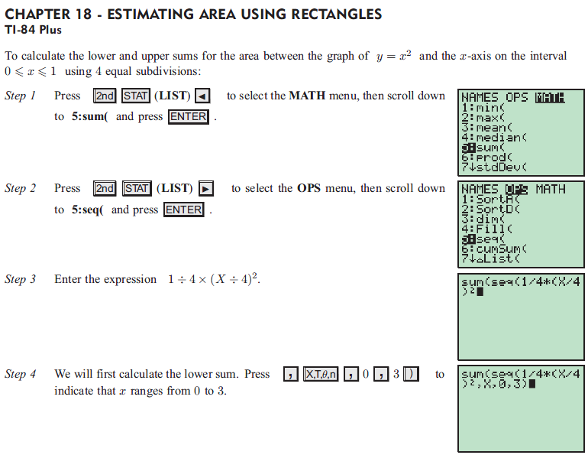



C:\Users\amanda.bixler\Desktop\9.png



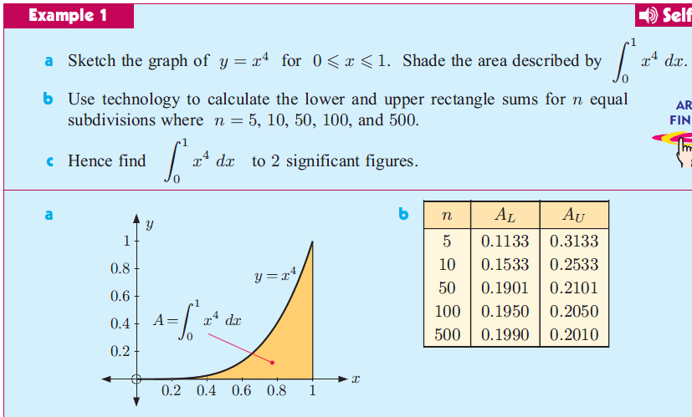



C:\Users\amanda.bixler\Desktop\13.png

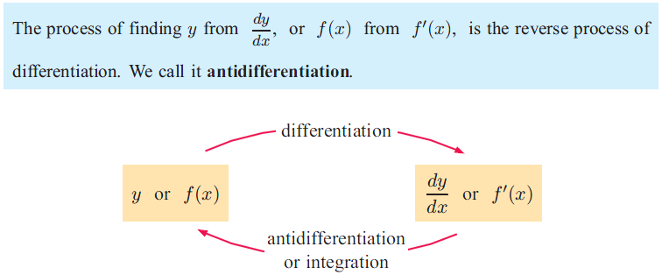





C:\Users\amanda.bixler\Desktop\17.png









C:\Users\amanda.bixler\Desktop\23.png



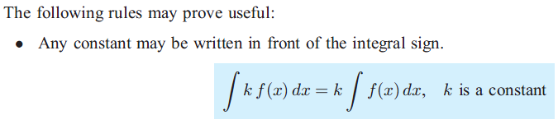







C:\Users\amanda.bixler\Desktop\29.png

C:\Users\amanda.bixler\Desktop\61.png

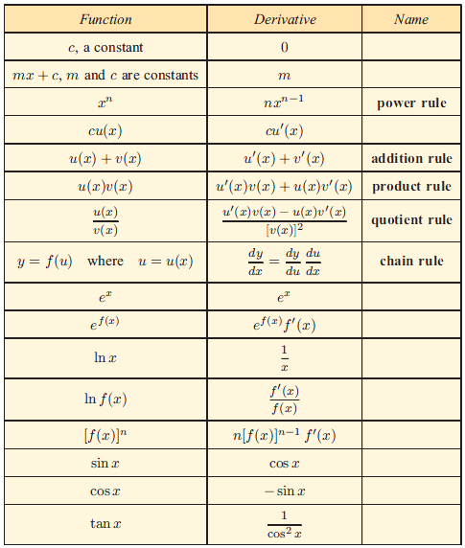

C:\Users\amanda.bixler\Desktop\62.png

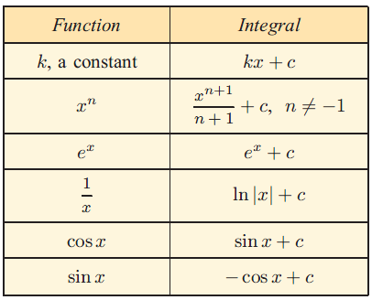





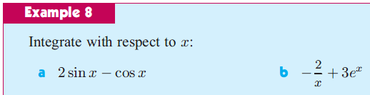

C:\Users\amanda.bixler\Desktop\35.png









C:\Users\amanda.bixler\Desktop\40.png





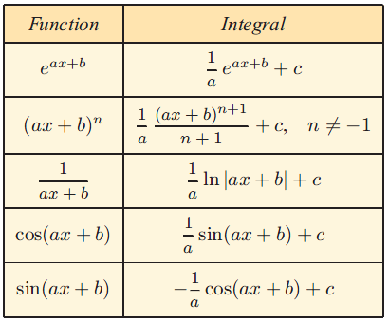





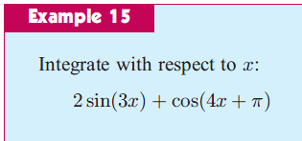

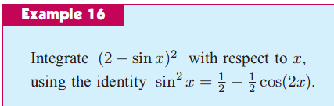

C:\Users\amanda.bixler\Desktop\48.png











C:\Users\amanda.bixler\Desktop\54.png

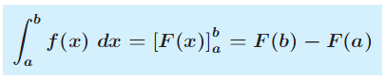





C:\Users\amanda.bixler\Desktop\58.png

