





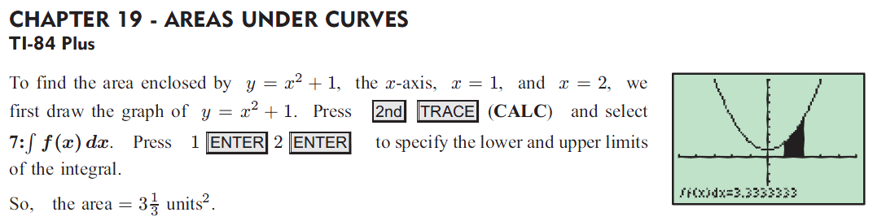



C:\Users\amanda.bixler\Desktop\5.png

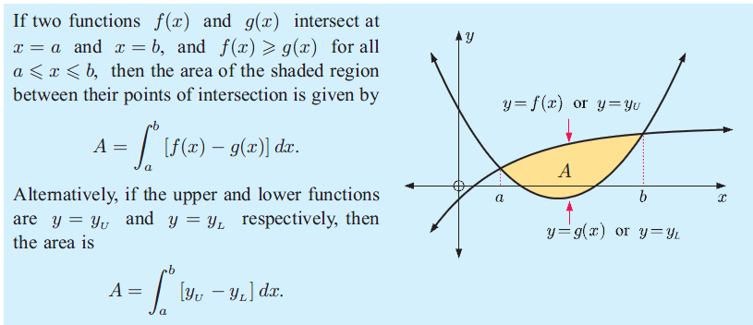

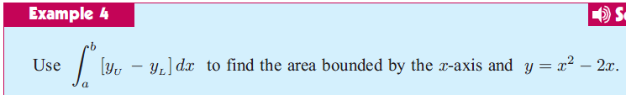

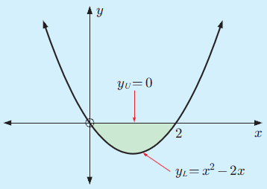



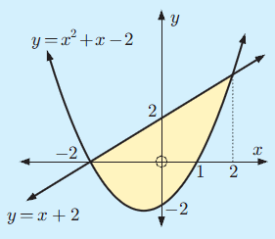



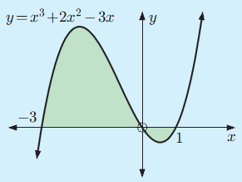

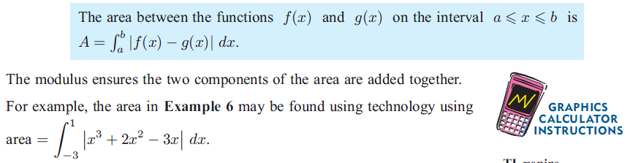

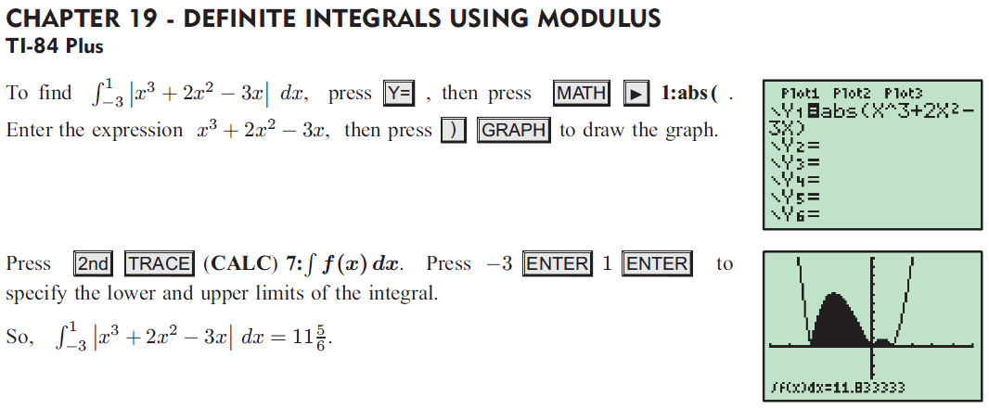



C:\Users\amanda.bixler\Desktop\16.png

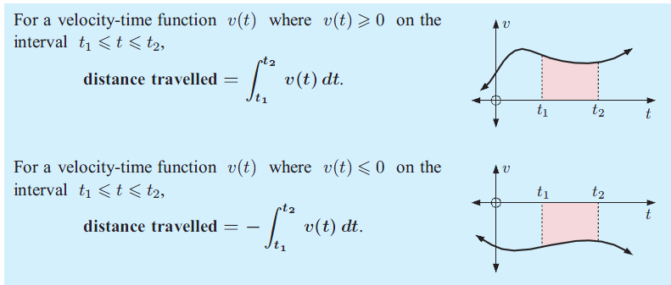

C:\Users\amanda.bixler\Desktop\18.png

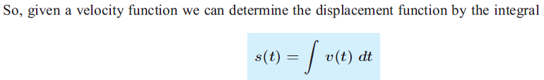

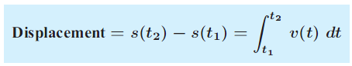

C:\Users\amanda.bixler\Desktop\21.png

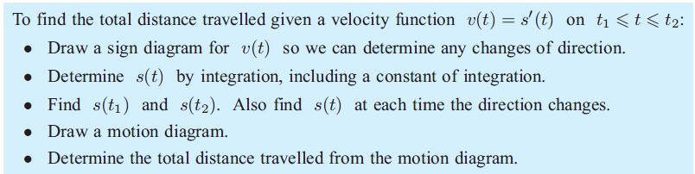

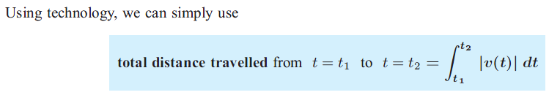

C:\Users\amanda.bixler\Desktop\24.png

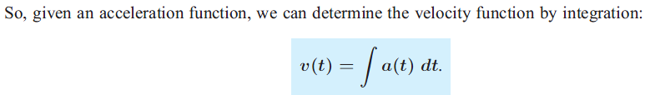

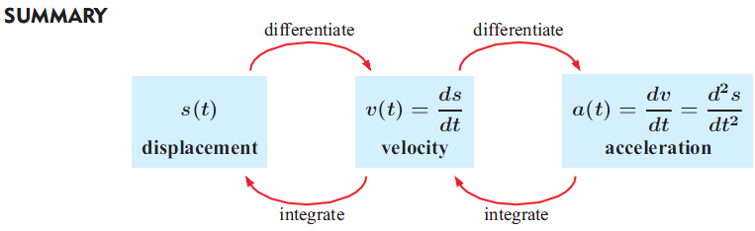

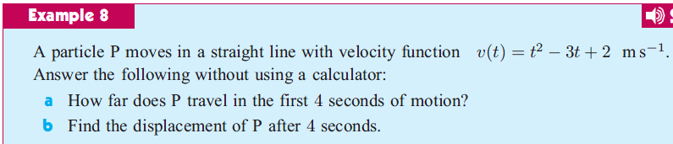

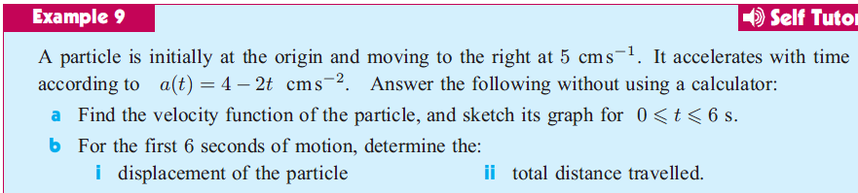

C:\Users\amanda.bixler\Desktop\29.png

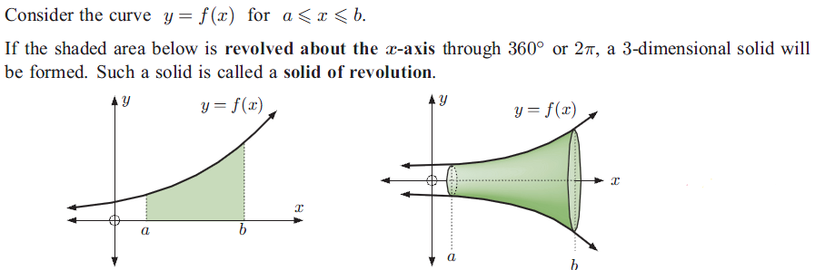

C:\Users\amanda.bixler\Desktop\31.png

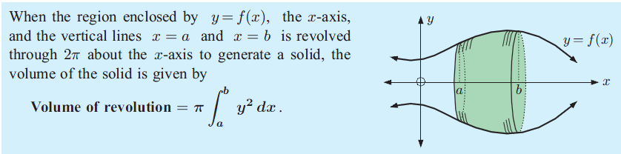

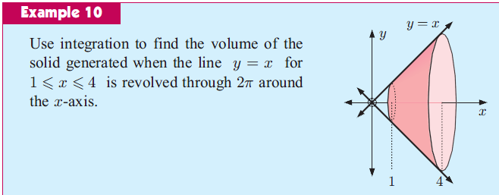



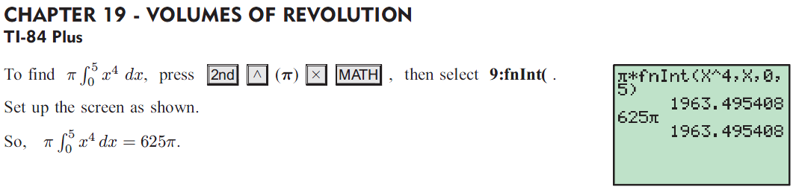

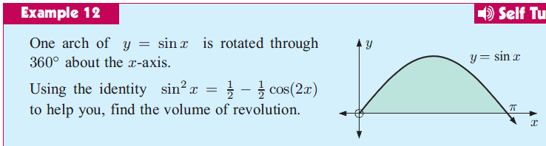

C:\Users\amanda.bixler\Desktop\39.png

