Revised

Jacob answered 80% of the questions in a test correctly.

He answered 32 of the questions correctly.

Work out the total number of questions in the test

At the end of the season a garden centre reduced the prices of all its spring plants by 40%. If a plant now costs £7.50, what was its price before the sale?

The table below shows the population of two towns, Greystock and Thrusham in 1980 and 2000.

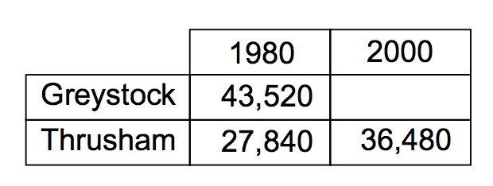

1. In Greystock the population fell by 15.4% between 1980 and 2000. What was the population in Greystock in 2000?
2. In Thrusham the population increased between 1980 and 2000. Calculate the percentage increase to 1 decimal place.