Reflections.
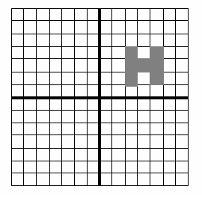

1. a) Copy the shape onto a set of axis
and label them
b) Reflect the shape in the x-axis
c) Reflect the new shape in the y-axis

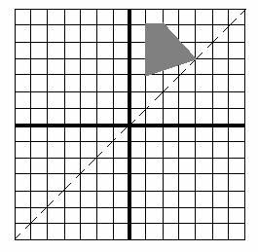
2. a) Reflect the shape in the dotted line.
b) Reflect the new shape in the x-axis
c) Write the co-ordinates of the four
corners of the shape you have at
this stage.
d) Reflect this shape in the dotted line
e) What is the special name for this dotted
line?

3. Draw a grid running from -6 to +6 in the y direction, and -10 to 10 in the x direction. Plot the following shapes on your grid, joining up the points in order to spell a word.

Shape A: (0,1), (0,3), (0,2), (1,2), (1,3), (1,1)
Shape B: (3,1), (2,1), (2,2), (3,2), (2,2), (2,3), (3,3)
Shape C: (4,3), (4,1), (5,1)
Shape D: (6,3), (6,1), (7,1)
Shape E: (8,1), (8,3), (9,3), (9,1), (8,1)

- Draw a line from (0, -1) to (10, -1). Use this as a mirror line and reflect all of the message. What do you notice about the letters?
- Draw a line from (0,-6) to (0,6). Use this as a mirror line to reflect both the messages again. What do you notice about the letters?
- Plot your name on a set of axis and reflect it using the same lines as above.
- What happens if you reflect your name in the same line twice?

