Transformations with Rotations
Copy each diagram into your books and answer the question onto it.
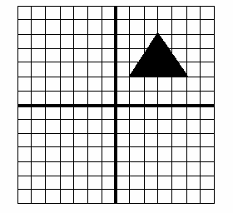
- a) Label the three corners of your triangle as A,B,C

b) Rotate the triangle 90° clockwise
about the point (0,0) –

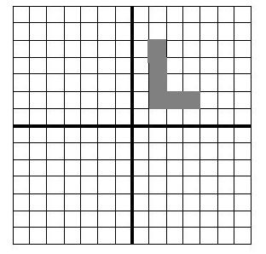

2. Using the diagram above,

- a) Label the point nearest to the origin (0,0) as A
- b) Reflect the shape in the x-axis,
- c) Reflect the new shape in the
- y-axis,
- d) Rotate your shape 90° clockwise about the origin.
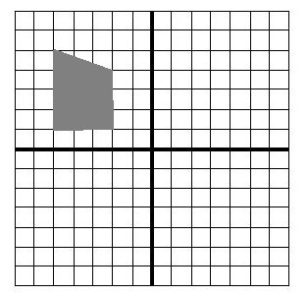
3. Using the diagram above,
- Label the corners of the shape
A B C D
b) Rotate the new shape by 180° anticlockwise and label the corners A’ B’ C’ D’
d) Reflect the shape in the y-axis.

4. Draw a grid running from -6 to +6 in the y direction, and -10 to 10 in the x direction. Plot the following shapes on your grid, joining up the points in order to spell a word.

Shape A: (0,1), (0,3), (0,2), (1,2), (1,3), (1,1)
Shape B: (3,1), (2,1), (2,2), (3,2), (2,2), (2,3), (3,3)
Shape C: (4,3), (4,1), (5,1)
Shape D: (6,3), (6,1), (7,1)
Shape E: (8,1), (8,3), (9,3), (9,1), (8,1)
- Draw a line from (0, -1) to (10, -1). Use this as a mirror line and reflect all of the message. What do you notice about the letters?
- Draw a line from (0,-6) to (0,6). Use this as a mirror line to reflect both the messages again. What do you notice about the letters?
- Plot your name on a set of axis and reflect it using the same lines as above.
- What happens if you reflect your name in the same line twice?

