Exam Review Calculus
1. The curve y = f (x) passes through the point (2, 6).
Given that = 3x2 – 5, find y in terms of x.
(Total 6 marks)
2. Let f (x) = .
(a) Write down the equation of the vertical asymptote of y = f (x).
(1)
(b) Find f ′ (x). Give your answer in the form where a and b ∈ .
(4)
(Total 5 marks)

3. The following diagram shows the graphs of f (x) = ln (3x – 2) + 1 and g (x) = – 4 cos (0.5x) + 2, for 1 ≤ x ≤ 10.
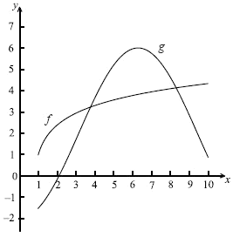
(a) Let A be the area of the region enclosed by the curves of f and g.
(i) Find an expression for A.
(ii) Calculate the value of A.
(6)
(b) (i) Find f ′ (x).
(ii) Find g′ (x).
(4)
(c) There are two values of x for which the gradient of f is equal to the gradient of g. Find both these values of x.
(4)
(Total 14 marks)

4. The diagram below shows part of the graph of the gradient function, y = f ′ (x).
(a) On the grid below, sketch a graph of y = f ″ (x), clearly indicating the x-intercept.
(2)
(b) Complete the table, for the graph of y = f (x).
x-coordinate
(i) Maximum point on f
(ii) Inflexion point on f
(2)
(c) Justify your answer to part (b) (ii).
(2)
(Total 6 marks)
5. Let
(a) Show that
(2)
(b) Find the value of
(5)
(Total 7 marks)
6. Consider f (x) = x3 + 2x2 – 5x. Part of the graph of f is shown below. There is a maximum point at M, and a point of inflexion at N.
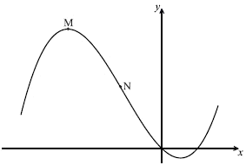
(a) Find f ′ (x).
(3)
(b) Find the x-coordinate of M.
(4)
(c) Find the x-coordinate of N.
(3)
(d) The line L is the tangent to the curve of f at (3, 12). Find the equation of L in the form y = ax + b.
(4)
(Total 14 marks)
7. On the axes below, sketch a curve y = f (x) which satisfies the following conditions.
x | f (x) | f ′ (x) | f ′′ (x)
−2 ≤ x < 0 |  | negative | positive
0 | –1 | 0 | positive
0 < x <1 |  | positive | positive
1 | 2 | positive | 0
1 < x ≤ 2 |  | positive | negative
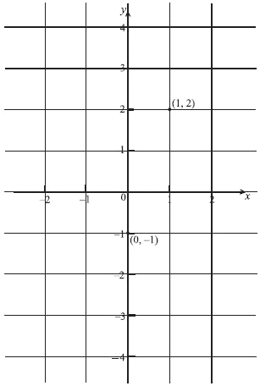
(Total 6 marks)
8. Differentiate each of the following with respect to x.
(a) y = sin 3x
(1)
(b) y = x tan x
(2)
(c) y =
(3)
(Total 6 marks)
9. The function f (x) is defined as f (x) = 3 + , x .
(a) Sketch the curve of f for −5 ≤ x ≤ 5, showing the asymptotes.
(3)
(b) Using your sketch, write down
(i) the equation of each asymptote;
(ii) the value of the x-intercept;
(iii) the value of the y-intercept.
(4)
(c) The region enclosed by the curve of f, the x-axis, and the lines x = 3 and x = a, is revolved through 360° about the x-axis. Let V be the volume of the solid formed.
(i) Find dx.
(ii) Hence, given that V = , find the value of a.
(10)
(Total 17 marks)
10. Consider the function f (x) = 4x3 + 2x. Find the equation of the normal to the curve of f at the point where x =1.
(Total 6 marks)
11. The following diagram shows part of the graph of a quadratic function, with equation in the form y = (x − p)(x − q), where p, q ∈ .
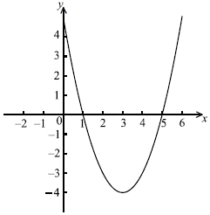
(a) Write down
(i) the value of p and of q;
(ii) the equation of the axis of symmetry of the curve.
(3)
(b) Find the equation of the function in the form y = (x − h)2 + k, where h, k ∈ .
(3)

(c) Find .
(2)
(d) Let T be the tangent to the curve at the point (0, 5). Find the equation of T.
(2)
(Total 10 marks)

12. The velocity, v, in m s−1 of a particle moving in a straight line is given by v = e3t−2, where t is the time in seconds.
(a) Find the acceleration of the particle at t =1.
(b) At what value of t does the particle have a velocity of 22.3 m s−1?
(c) Find the distance travelled in the first second.
(Total 6 marks)

13. Let f (x) = x3 − 3x2 − 24x +1.
The tangents to the curve of f at the points P and Q are parallel to the x-axis, where P is to the left of Q.
(a) Calculate the coordinates of P and of Q.
Let N1 and N2 be the normals to the curve at P and Q respectively.
(b) Write down the coordinates of the points where
(i) the tangent at P intersects N2;
(ii) the tangent at Q intersects N1.
(Total 6 marks)

14. The shaded region in the diagram below is bounded by f (x) = , x = a, and the x-axis. The shaded region is revolved around the x-axis through 360°. The volume of the solid formed is 0.845π.
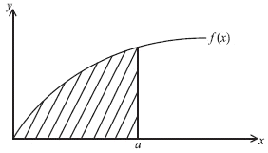
Find the value of a.
(Total 6 marks)

