IB SL Even More Vector Practice
1. Two lines L1 and L2 have these vector equations.
L1 : r = 2i + 3j + t(i– 3j)
L2 : r = i + 2j + s(i – j)
The angle between L1 and L2 is θ. Find the cosine of the angle θ.
(Total 6 marks)
2. The line L1 is represented by r1 = and the line L2 by r2 =
The lines L1 and L2 intersect at point T. Find the coordinates of T.
(Total 6 marks)
3. The point O has coordinates (0, 0, 0), point A has coordinates (1, –2, 3) and point B has coordinates (–3, 4, 2).
(a) (i) Show that =
(ii) Find .
(8)
(b) The line L1 has equation
Write down the coordinates of two points on L1.
(2)
(c) The line L2 passes through A and is parallel to.
(i) Find a vector equation for L2, giving your answer in the form r = a + tb.
(ii) Point C (k, –k, –5)is on L2. Find the coordinates of C.
(6)
(d) The line L3 has equation and passes through the point C.
Find the value of p at C.
(2)
(Total 18 marks)
4. Let v = 3i + 4 j + k and w = i + 2 j – 3k. The vector v + pw is perpendicular to w.
Find the value of p.
(Total 7 marks)

5. Consider the points A (1, 5, 4), B (3, 1, 2) and D (3, k, 2), with (AD) perpendicular to (AB).
(a) Find
(i)
(ii) , giving your answer in terms of k.
(3)
(b) Show that k = 7.
(3)
The point C is such that =
(c) Find the position vector of C.
(4)
(d) Find cos .
(3)
(Total 13 marks)
6. The diagram below shows a cuboid (rectangular solid) OJKLMNPQ. The vertex O is (0, 0, 0), J is (6, 0, 0), K is (6, 0, 10), M is (0, 7, 0) and Q is (0, 7, 10).
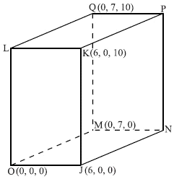
(a) (i) Show that = .
(ii) Find .
(2)
(b) An equation for the line (MK) is r = + s.
(i) Write down an equation for the line (JQ) in the form r = a + tb.
(ii) Find the acute angle between (JQ) and (MK).
(9)

(c) The lines (JQ) and (MK) intersect at D. Find the position vector of D.
(5)
(Total 16 marks)
7. Consider the point D with coordinates (4, 5), and the point E, with coordinates (12, 11).
(a) Find .
(2)
(b) Find .
(2)
(c) The point D is the centre of a circle and E is on the circumference as shown in the following diagram.
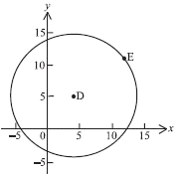
The point G is also on the circumference. is perpendicular to . Find the possible coordinates of G.
(8)
(Total 12 marks)
8. A boat B moves with constant velocity along a straight line. Its velocity vector is given by
v = .
At time t = 0 it is at the point (−2, 1).
(a) Find the magnitude of v.
(b) Find the coordinates of B when t = 2.
(c) Write down a vector equation representing the position of B, giving your answer in the form r = a + tb.

(Total 6 marks)

