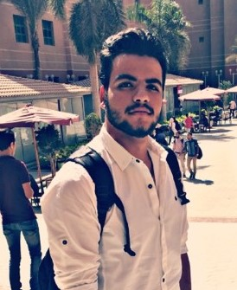

I wish to accept me to your internship and work with your great teams benefits from them knowledge, be helpful for them, work under stress and make some awesome, smart projects.

Greatings



Arafaarafa19101998@gmail.com

01015625739

01158596439

Cairo

Contacts

Some Words

NICE SCROLL

BOOTSTRAP

JQUERY

PHP

REACT.JS

JS

HTML 5

CSS 3

Solve prop

CSS

HTML

Proficiency

I‘m Arafa Arafa from Cairo my age 20 years study at MTI university computer science, fond of thing call computer I were studied everything at short time with good understanding, skills smart, creative, good searcher, learn everything at short time and I want to have position in the world of computer, I have a dream and I want to achieve it and Overcome obstacles

**About Me**

I were learnt C++, C#, java, learnt some basics about game development, CCNA networks, server administrator (REDHAT), but now learning front end developing and back end to become full stack developer, active at university my GPA 3.5 for that my instructor choose me and 5 students to do project about solar energy , in the future learning machine learning

Facebook/prognour.nour

twitter/@arafa82251937

LinkedIn/in/arafa-arafa-56b382156

WEB DEVELOPER

Arafa Arafa Abd El-Mawgod

Work Experiences

Education

Profile

Level 2 (2017-2019)

Computer Science

CS

University of MTI

**Self Study (2017-????)**