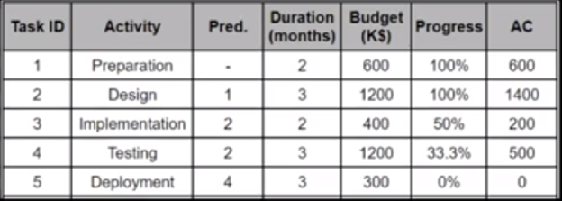

|  |  |
| --- | --- |
| **1** | **How Much is it Over/Under Budget?**  **->It’s over budget, 600.000$ more than expected budget.** |
| **2** | **How many days is it ahead/behind the schedule?**  **->It’s behind the schedule and it evaluated with 5 months**. |
| **3** | **By the end of the project by how much will it be over/under budget?**  **->Over budget with 600000$.** |

Pv at 7 months:

When task 3 is planned early PV =3000K$

When task 3 is planned lase PV = 2600K$

Average case PV =2800K$

|  |  |  |
| --- | --- | --- |
|  | **Formula** | **Result(K$)** |
| **Actual Cost (Ac)** | **The summation of AC** | **600+1400+200+500=2700** |
| **Earned Value (EV)** | **The summation of (budget * progress precent)** | **600 +200+400*50%+1200*33.3%+300*0% = 2396** |
| **Cost Variance (CV)** | **EV-AC** | **2396-2700= -304** |
| **Schedule Variance (SV)** | **EV-PV**  **PV = [max, min, aver]** | **2396-3000 = -604**  **2396-2600 = -204**  **2396-2800 = -404** |
| **Cost Performance Index (CPI)** | **EV/AC** | **2396/2700=0.887** |
| **Estimate At Completion (EAC)** | **BAC/CPI** | **3700/0.889=4160** |