**Experiment No. 07**

**Experiment Name: Experiment with Java interfaces**

*Course title: Programming Language II(Java) Lab*

*Course code:*

*Spring 2025*

**Date of Submission**:



**Submitted to-**

###### **Md. Rafsan Jani**

*Assistant Professor*

*Department of Computer Science and Engineering*

|  |  |  |
| --- | --- | --- |
| **Sl** | Class Roll | Name |
| 01 | 2023000010034 | Md Arafat Rahman |
|  |  |  |

Screenshot:

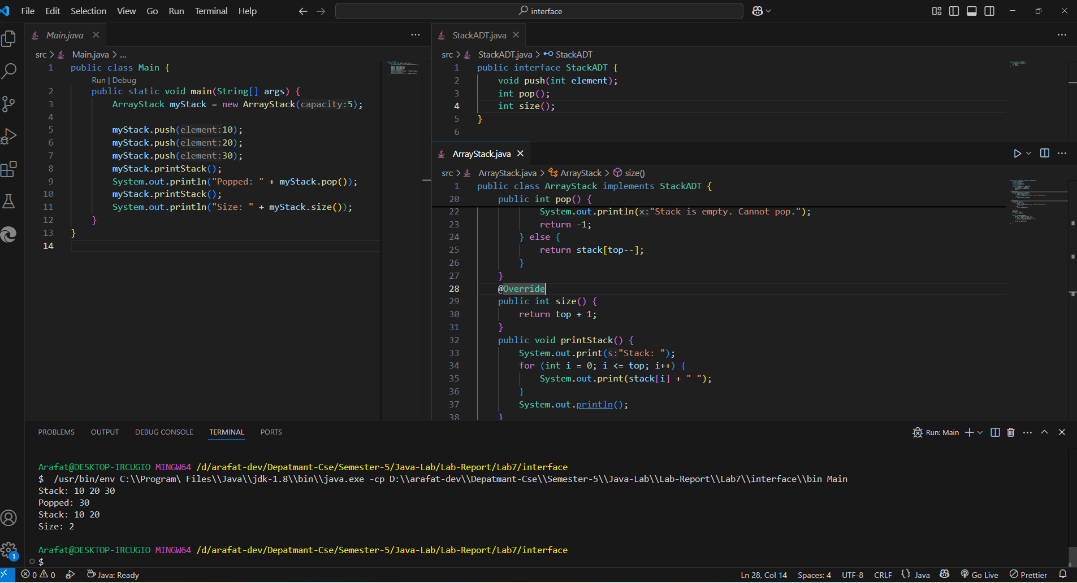

Main.java

public class Main {

    public static void main(String[] args) {

        ArrayStack myStack = new ArrayStack(5);

        myStack.push(10);

        myStack.push(20);

        myStack.push(30);

        myStack.printStack();

        System.out.println("Popped: " + myStack.pop());

        myStack.printStack();

        System.out.println("Size: " + myStack.size());

    }

}

StackADT.java

public interface StackADT {

    void push(int element);

    int pop();

    int size();

}

ArrayStack.java

public class ArrayStack implements StackADT {

    private int[] stack;

    private int top;

    private int capacity;

    // Constructor

    public ArrayStack(int capacity) {

        this.capacity = capacity;

        stack = new int[capacity];

        top = -1;

    }

    @Override

    public void push(int element) {

        if (top == capacity - 1) {

            System.out.println("Stack is full. Cannot push.");

        } else {

            stack[++top] = element;

        }

    }

    @Override

    public int pop() {

        if (top == -1) {

            System.out.println("Stack is empty. Cannot pop.");

            return -1;

        } else {

            return stack[top--];

        }

    }

    @Override

    public int size() {

        return top + 1;

    }

    public void printStack() {

        System.out.print("Stack: ");

        for (int i = 0; i <= top; i++) {

            System.out.print(stack[i] + " ");

        }

        System.out.println();

    }

}