**Experiment No. 02**

**Experiment Name: Implementation of Variables and Conditional Statements**

*Course title: Programming Language II(Java) Lab*

*Course code:*

*Spring 2025*

**Date of Submission**:



**Submitted to-**

###### **Md. Rafsan Jani**

*Assistant Professor*

*Department of Computer Science and Engineering*

|  |  |  |
| --- | --- | --- |
| **Sl** | Class Roll | Name |
| 01 | 2023000010034 | Md Arafat Rahman |

**Hw- 1: Write a java program to check the room temperature, if it is greater than 30 degree print the turn on the air conditioner.**

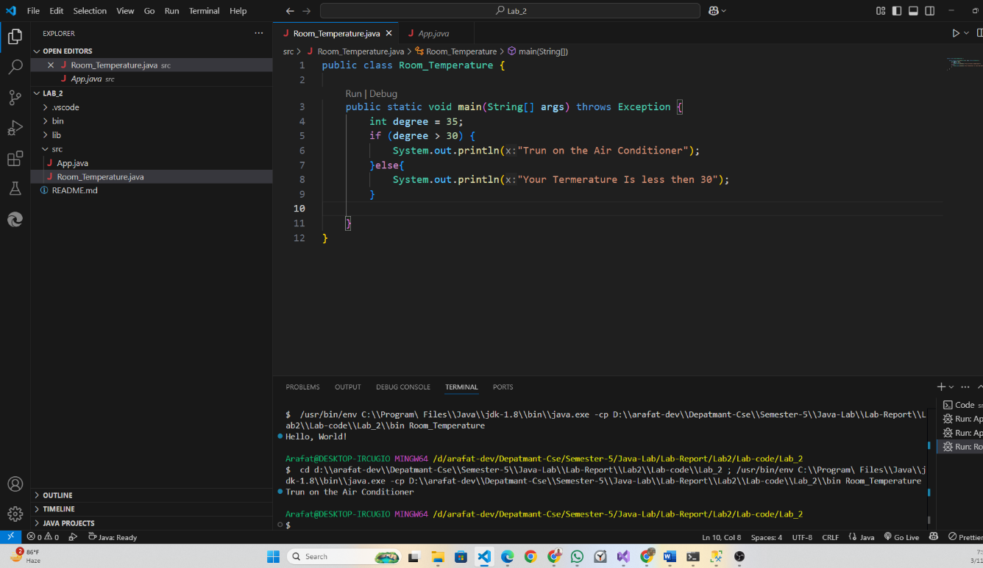

**Hw- 2: Write a java program to check a given year is leap year or not.**

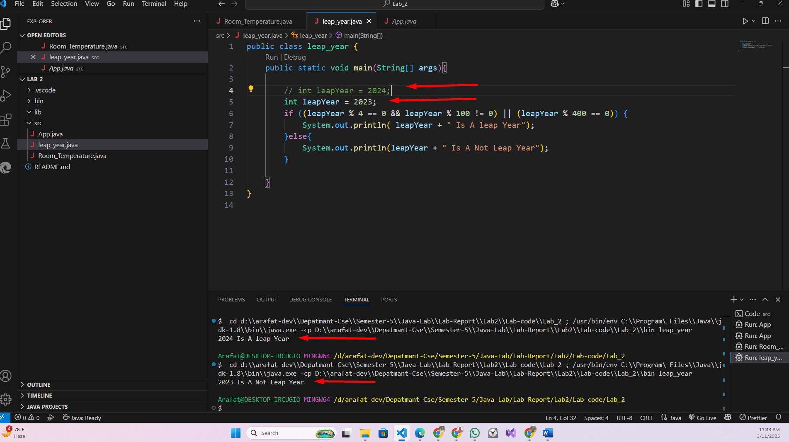

**Ternary Operator**

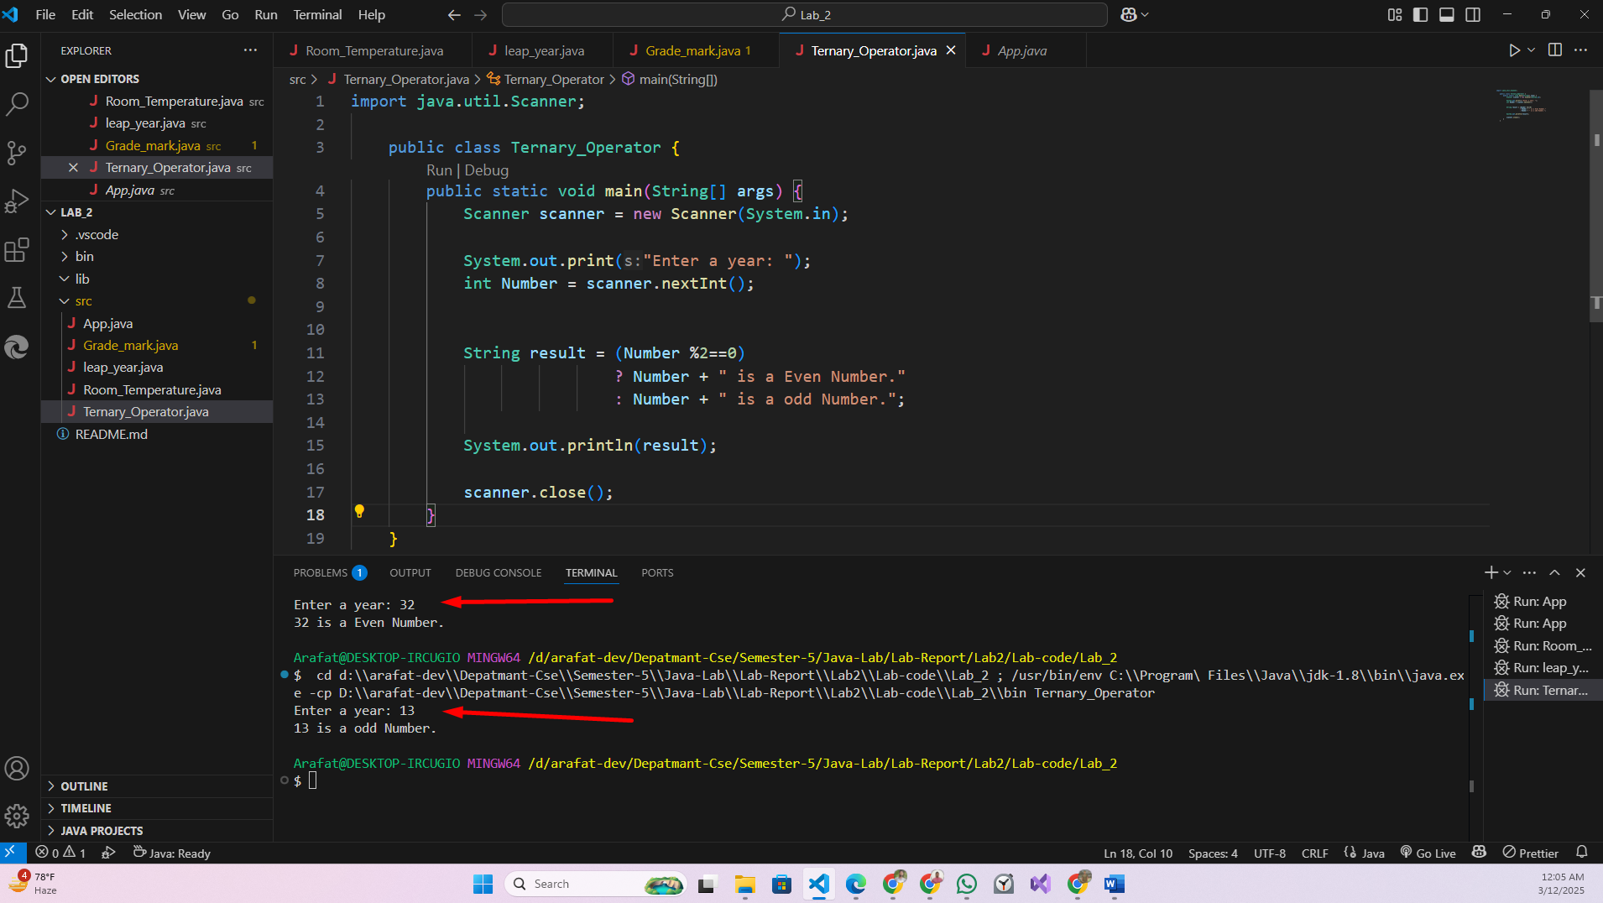

**Hw- 3: Write a java program to demonstrate the Letter Grade for a given mark.**

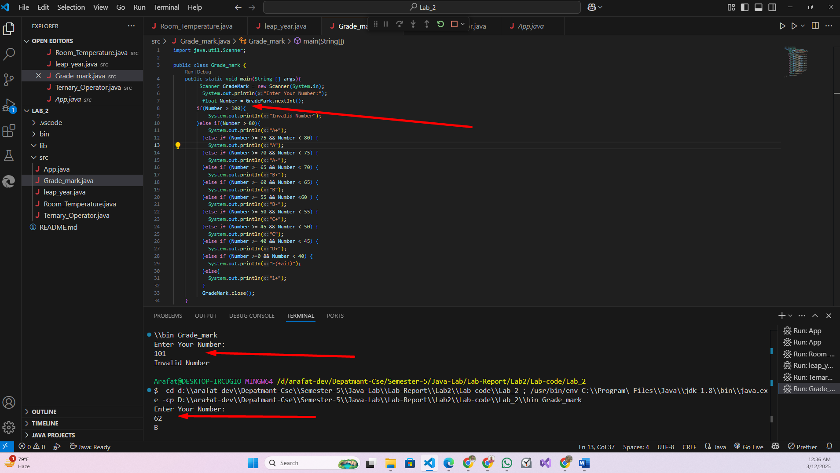

**Hw-4: Write a Java Program to check whether a char is vowel or Consonant using Switch Case.**

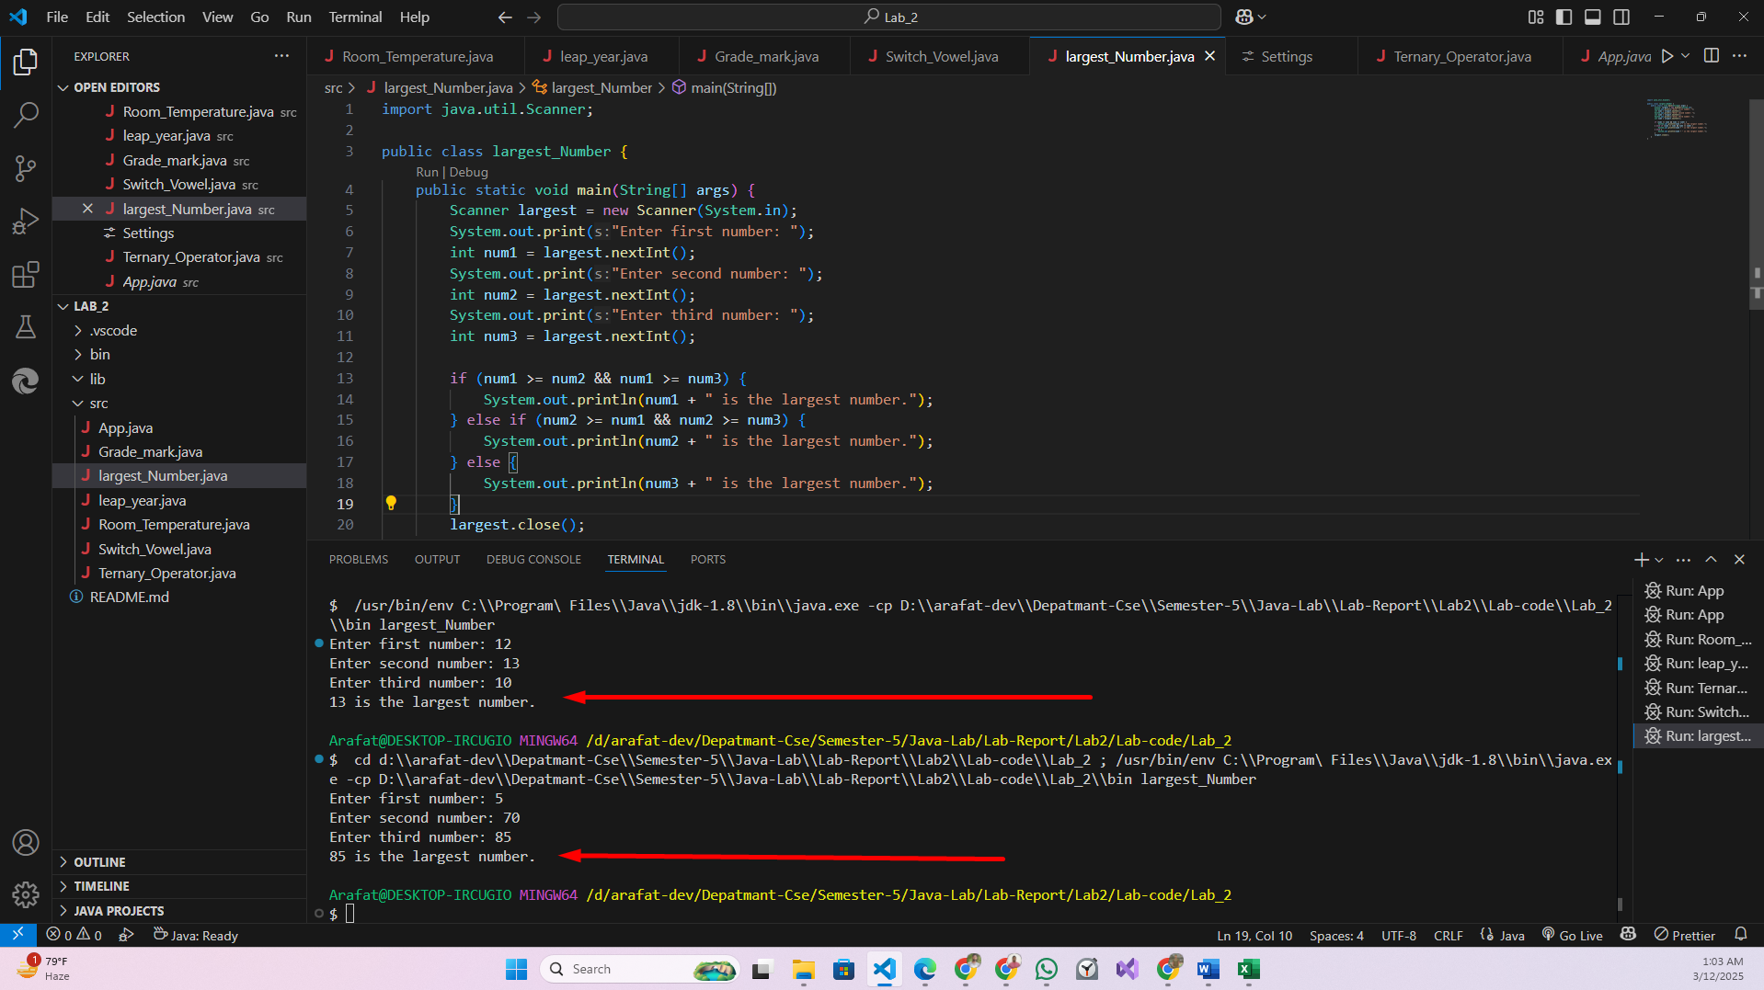

**Hw-5: Write a Java Program to check whether a char is vowel or Consonant using Switch Case.**

