**Experiment No. 04**

**Experiment Name: Array And String**

*Course title: Programming Language II(Java) Lab*

*Course code:*

*Spring 2025*

**Date of Submission**:



**Submitted to-**

###### **Md. Rafsan Jani**

*Assistant Professor*

*Department of Computer Science and Engineering*

|  |  |  |
| --- | --- | --- |
| **Sl** | Class Roll | Name |
| 01 | 2023000010001 | Md Samaul Islam |
|  |  |  |

**Hw 1:** Write a Java program that accepts a stringfrom the user and counts how many vowels (a, e,i, o, u)are present in the given string.

Code:

import java.util.Scanner;

public class CountVowels {

    public static void main(String[] args){

        Scanner scanner = new Scanner(System.in);

        System.out.print("Enter a string: ");

        String inputVowels = scanner.nextLine().toLowerCase();

        int count = 0;

        for( int i = 0; i <inputVowels.length(); i++){

            char ch = inputVowels.charAt(i);

            if(ch=='a'||ch=='e'||ch=='i'||ch=='o'||ch=='u'){

                count++;

            }

        }

        System.out.println("Number of vowels: " + count);

    }

}

Screenshot:

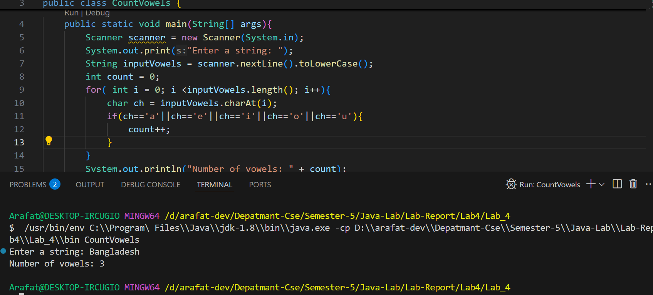

**Hw 2:** Write a Java program that accepts an array of integers from the user and prints the maximum number with its index.

Code:

import java.util.Scanner;

public class MaxNumberWithIndex {

    public static void main (String [] args){

        Scanner scanner = new Scanner(System.in);

        System.out.print("Enter The Number of element: ");

        int n = scanner.nextInt();

        int arr[] = new int[n];

        System.out.println("Enter " + n + " Integers: ");

        for(int i = 0; i<n; i++){

            arr[i] = scanner.nextInt();

        }

        int max = arr[0];

        int index = 0;

        for(int i =1; i < n; i++){

            if(arr[i] > max){

                max = arr[i];

                index = i;

            }

        }

        System.out.println("Maximum number: " + max);

        System.out.println("Index of maximum number: " + index);

    }

}

Screenshot:

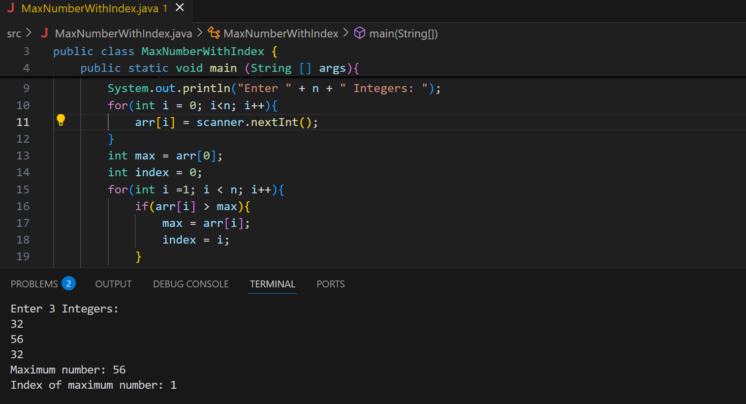

**Hw 3:** Write a Java program that accepts a string from the user and checks if it is a palindrome (reads the

same forward and backward, ignoring case).

Code:

import java.util.Scanner;

public class PalindromeCheck {

    public static void main(String[] args) {

        Scanner scanner = new Scanner(System.in);

        System.out.print("Enter a string: ");

        String original = scanner.nextLine();

        String input = original.toLowerCase();

        String reversed = "";

        for (int i = input.length() - 1; i >= 0; i--) {

            reversed += input.charAt(i);

        }

        if (input.equals(reversed)) {

            System.out.println(original + " is a palindrome.");

        } else {

            System.out.println(original + " is not a palindrome.");

        }

    }

}

***Screenshot:***

