**Experiment No. 05**

**Experiment Name: Experiment with Basic Class**

*Course title: Programming Language II(Java) Lab*

*Course code:*

*Spring 2025*

**Date of Submission**:



**Submitted to-**

###### **Md. Rafsan Jani**

*Assistant Professor*

*Department of Computer Science and Engineering*

|  |  |  |
| --- | --- | --- |
| **Sl** | Class Roll | Name |
| 01 | 2023000010034 | Md Arafat Rahman |
|  |  |  |

Hw 1: Create a console-based application to manage student records using Java. The system should allow the user to:

* Add student records
* Display all students
* Search for a student by roll number
* Exit the program

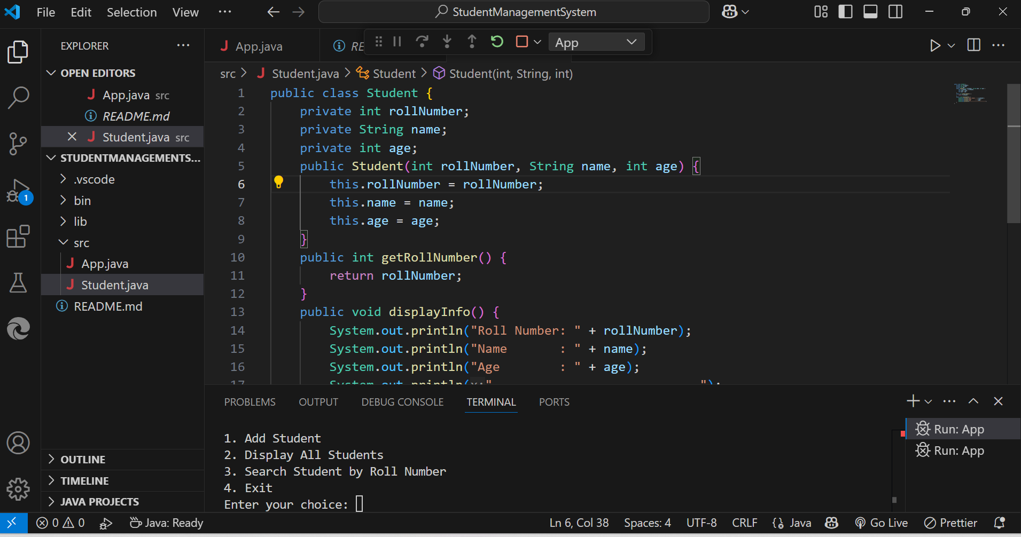

**Main.java**

import java.util.ArrayList;

import java.util.Scanner;

public class App {

    private static ArrayList<Student> students = new ArrayList<>();

    private static Scanner scanner = new Scanner(System.in);

    public static void main(String[] args) throws Exception {

        int choice;

        do {

            System.out.println("\n====== Student Management System ======");

            System.out.println("1. Add Student");

            System.out.println("2. Display All Students");

            System.out.println("3. Search Student by Roll Number");

            System.out.println("4. Exit");

            System.out.print("Enter your choice: ");

            choice = scanner.nextInt();

            scanner.nextLine();

            switch (choice) {

                case 1:

                    addStudent();

                    break;

                case 2:

                    displayAllStudents();

                    break;

                case 3:

                    searchStudent();

                    break;

                case 4:

                    System.out.println("Exiting program... Goodbye!");

                    break;

                default:

                    System.out.println("Invalid choice! Please try again.");

            }

        } while (choice != 4);

    }

    private static void addStudent() {

        System.out.print("Enter Roll Number: ");

        int rollNumber = scanner.nextInt();

        scanner.nextLine();

        System.out.print("Enter Name: ");

        String name = scanner.nextLine();

        System.out.print("Enter Age: ");

        int age = scanner.nextInt();

        scanner.nextLine();

        students.add(new Student(rollNumber, name, age));

        System.out.println("Student added successfully!");

    }

    private static void displayAllStudents() {

        if (students.isEmpty()) {

            System.out.println("No student records found.");

        } else {

            System.out.println("\n--- Student Records ---");

            for (Student student : students) {

                student.displayInfo();

            }

        }

    }

    private static void searchStudent() {

        System.out.print("Enter Roll Number to search: ");

        int rollNumber = scanner.nextInt();

        scanner.nextLine();

        boolean found = false;

        for (Student student : students) {

            if (student.getRollNumber() == rollNumber) {

                System.out.println("\n--- Student Found ---");

                student.displayInfo();

                found = true;

                break;

            }

        }

        if (!found) {

            System.out.println("Student with roll number " + rollNumber + " not found.");

        }

    }

}

**Student.java**

public class Student {

    private int rollNumber;

    private String name;

    private int age;

    public Student(int rollNumber, String name, int age) {

        this.rollNumber = rollNumber;

        this.name = name;

        this.age = age;

    }

    public int getRollNumber() {

        return rollNumber;

    }

    public void displayInfo() {

        System.out.println("Roll Number: " + rollNumber);

        System.out.println("Name       : " + name);

        System.out.println("Age        : " + age);

        System.out.println("----------------------------");

    }

}

**Hw 2:**

**Features to Implement:**

**Class Student**

* Fields: rollNo, name, marks
* Constructor to initialize values
* Method displayInfo() to show details

**Class StudentManagerList**

* to store Student objects
* Methods:
* addStudent()
* displayAllStudents()
* searchStudent(int rollNo)

**Class Main (with main method)**

* Menu-driven program
* Use of Scanner for input

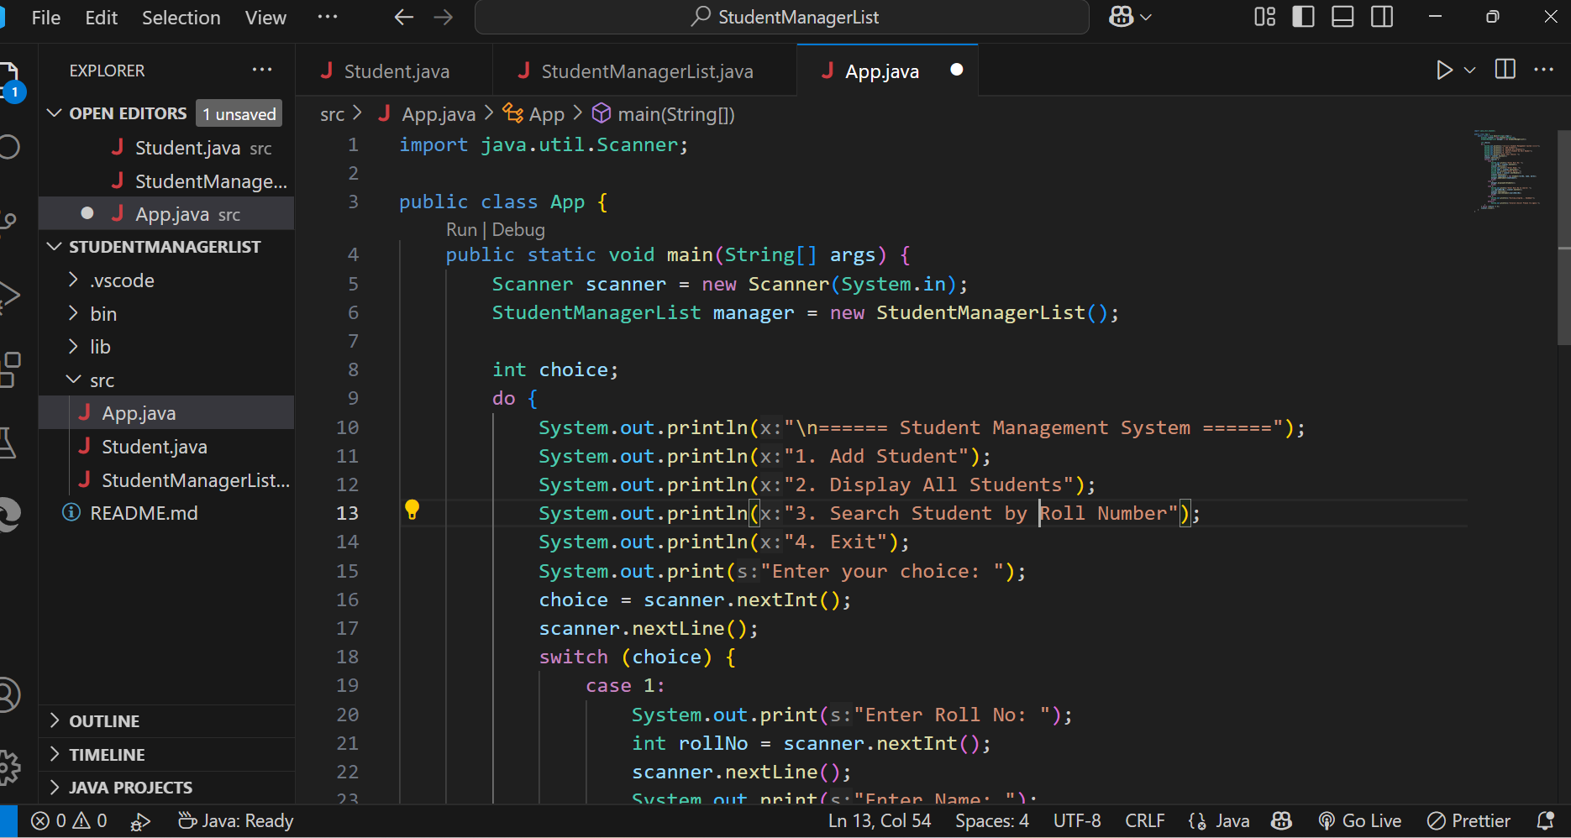

**App.java**

import java.util.Scanner;

public class App {

    public static void main(String[] args) {

        Scanner scanner = new Scanner(System.in);

        StudentManagerList manager = new StudentManagerList();

        int choice;

        do {

            System.out.println("\n====== Student Management System ======");

            System.out.println("1. Add Student");

            System.out.println("2. Display All Students");

            System.out.println("3. Search Student by Roll Number");

            System.out.println("4. Exit");

            System.out.print("Enter your choice: ");

            choice = scanner.nextInt();

            scanner.nextLine();

            switch (choice) {

                case 1:

                    System.out.print("Enter Roll No: ");

                    int rollNo = scanner.nextInt();

                    scanner.nextLine();

                    System.out.print("Enter Name: ");

                    String name = scanner.nextLine();

                    System.out.print("Enter Marks: ");

                    double marks = scanner.nextDouble();

                    scanner.nextLine();

                    Student newStudent = new Student(rollNo, name, marks);

                    manager.addStudent(newStudent);

                    break;

                case 2:

                    manager.displayAllStudents();

                    break;

                case 3:

                    System.out.print("Enter Roll No to search: ");

                    int searchRollNo = scanner.nextInt();

                    scanner.nextLine();

                    manager.searchStudent(searchRollNo);

                    break;

                case 4:

                    System.out.println("Exiting program... Goodbye!");

                    break;

                default:

                    System.out.println("Invalid choice! Please try again.");

            }

        } while (choice != 4);

        scanner.close();

    }

}

**Student.java**

public class Student {

    private int rollNo;

    private String name;

    private double marks;

    public Student(int rollNo, String name, double marks) {

        this.rollNo = rollNo;

        this.name = name;

        this.marks = marks;

    }

    public void displayInfo() {

        System.out.println("Roll No : " + rollNo);

        System.out.println("Name    : " + name);

        System.out.println("Marks   : " + marks);

        System.out.println("-----------------------------");

    }

    public int getRollNo() {

        return rollNo;

    }

}

**StudentManagerList.java**

import java.util.ArrayList;

public class StudentManagerList {

    private ArrayList<Student> students = new ArrayList<>();

    public void addStudent(Student student) {

        students.add(student);

        System.out.println("Student added successfully!\n");

    }

    public void displayAllStudents() {

        if (students.isEmpty()) {

            System.out.println("No student records available.\n");

        } else {

            System.out.println("=== All Student Records ===");

            for (Student student : students) {

                student.displayInfo();

            }

        }

    }

    public void searchStudent(int rollNo) {

        boolean found = false;

        for (Student student : students) {

            if (student.getRollNo() == rollNo) {

                System.out.println("=== Student Found ===");

                student.displayInfo();

                found = true;

                break;

            }

        }

        if (!found) {

            System.out.println("Student with Roll No " + rollNo + " not found.\n");

        }

    }

}