**Experiment No. 09**

**Experiment Name: Experiment with Collections Framework**

*Course title: Programming Language II(Java) Lab*

*Course code:*

*Spring 2025*

**Date of Submission**:



**Submitted to-**

###### **Md. Rafsan Jani**

*Assistant Professor*

*Department of Computer Science and Engineering*

|  |  |  |
| --- | --- | --- |
| **Sl** | Class Roll | Name |
| 01 | 2023000010001 | Md Samaul Islam |
|  |  |  |

**1. Homework**

Exercise 1: Student Name List

Create a List<String> to store student names.

Add at least 5 names.

Sort the list alphabetically.

Print the sorted list.

import java.util.ArrayList;

import java.util.Collections;

import java.util.List;

public class StudentNameList {

    public static void main(String[] args) {

        List<String> studentNames = new ArrayList<>();

        studentNames.add("Samaul");

        studentNames.add("Karim");

        studentNames.add("Arafat");

        studentNames.add("Tania");

        studentNames.add("Bashir");

        Collections.sort(studentNames);

        System.out.println("Sorted Student Names:");

        for (String name : studentNames) {

            System.out.println(name);

        }

    }

}

**2. Homework**

Exercise 2: Unique Student ID Collector

Use a Set<String> to store ID.

Try adding duplicate IDs.

Print the list of unique IDs.

import java.util.HashSet;

import java.util.Set;

public class UniqueStudentIDCollector {

    public static void main(String[] args) {

        Set<String> studentIDs = new HashSet<>();

        studentIDs.add("Seu101");

        studentIDs.add("Seu102");

        studentIDs.add("Seu103");

        studentIDs.add("Seu101");

        studentIDs.add("Seu104");

        studentIDs.add("Seu102");

        System.out.println("Unique Student IDs:");

        for (String id : studentIDs) {

            System.out.println(id);

        }

    }

}

**3. Homework**

Exercise 3: Word Frequency Counter

Input a sentence from user.

Split the words and count the frequencies.

Use a Map<String, Integer> to count occurrences of each word.

Print the word-frequency pairs.

Example:

Input: She sells sea shells in the sea shore.

Output:

She 1

sea 2

sells 1

shells 1

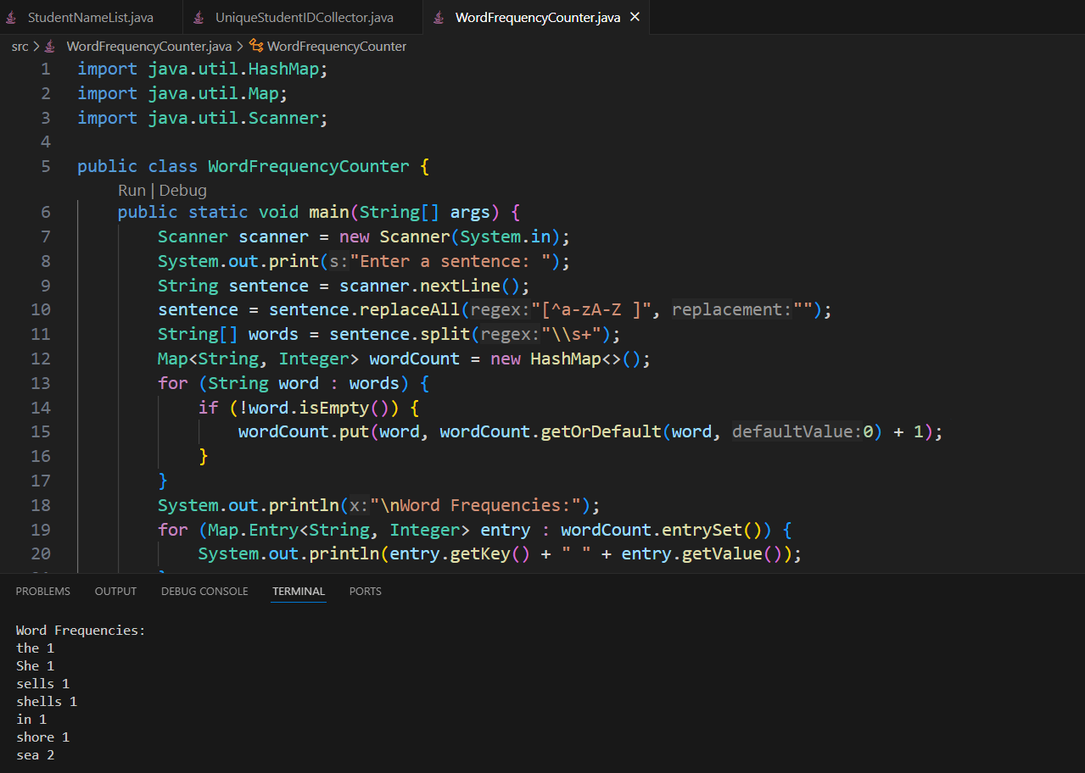

import java.util.HashMap;

import java.util.Map;

import java.util.Scanner;

public class WordFrequencyCounter {

    public static void main(String[] args) {

        Scanner scanner = new Scanner(System.in);

        System.out.print("Enter a sentence: ");

        String sentence = scanner.nextLine();

        sentence = sentence.replaceAll("[^a-zA-Z ]", "");

        String[] words = sentence.split("\\s+");

        Map<String, Integer> wordCount = new HashMap<>();

        for (String word : words) {

            if (!word.isEmpty()) {

                wordCount.put(word, wordCount.getOrDefault(word, 0) + 1);

            }

        }

        System.out.println("\nWord Frequencies:");

        for (Map.Entry<String, Integer> entry : wordCount.entrySet()) {

            System.out.println(entry.getKey() + " " + entry.getValue());

        }

        scanner.close();

    }

}