**Lab Report No: 02**

**Lab Report on: Socket Program with python.**

**Name : MD ARAFAT ISLAM**

**IT_ 17008**

**Objective:** Socket programming shows how to use socket APIs to establish communication links between remote and local processes. The processes that use a socket can reside on the same system or different systems on different networks. Sockets are useful for both stand-alone and network applications.

The processes that use a socket can reside on the same system or different systems on different networks. Sockets are useful for both stand-alone and network applications. Sockets allow you to exchange information between processes on the same machine or across a network, distribute work to the most efficient machine, and they easily allow access to centralized data. Socket application program interfaces (APIs) are the network standard for TCP/IP. A wide range of operating systems support socket APIs. i5/OS™ sockets support multiple transport and networking protocols. Socket system functions and the socket network functions are threadsafe.

**Server side** : Server-side network programming involves designing and implementing programs to be run on a server. Server-side applications run as processes on a dedicated physical machine, virtual machine, or cloud infrastructure. Server-side applications receive requests from the clients and perform tasks as requested by the clients.

**Server side code:**

import socket # for socket import sys try:

s = socket.socket(socket.AF_INET, socket.SOCK_STREAM) print "Socket successfully created"

except socket.error as err:

print "socket creation failed with error %s" %(err)

port = 80

try: host_ip = socket.gethostbyname('www.google.com') except socket.gaierror:

print "there was an error resolving the host"

sys.exit()

s.connect((host_ip, port))

print "the socket has successfully connected to google \on port == %s" %(host_ip)

Client side: In a client environment, each computer still holds (or can still hold) its (or some) resources and files. Other computers can also access the resources stored in a computer, as in a peer-to-peer scenario. One of the particularities of a client/server network is that the files and resources are centralized. This means that a computer, the server, can hold them and other computers can access them. Since the server is always ON, the client machines can access the files and resources without caring whether a certain computer is ON.

Client side code:

# standard Python sio = socketio.Client()

# asyncio

sio = socketio.AsyncClient() sio.connect('http://localhost:127.0.0.1') await sio.connect('http://localhost:127.0.0.1') sio.event(namespace='/chat') def my_custom_event(sid, data): pass

@sio.on('connect', namespace='/chat')

def on_connect():

tracert( 172.18.4.1)

**Output :** Socket successfully created the socket has successfully connected to google on port == [80](http://173.194.224.15/?fbclid=IwAR0f3PQGQ-sIm0xm9AzPa2TE5GUwYPMyrYplvumYV2Tvm34S0p07Tdc5AuY) to IP 172.18.4.1

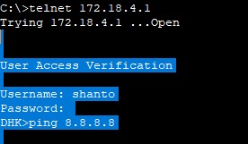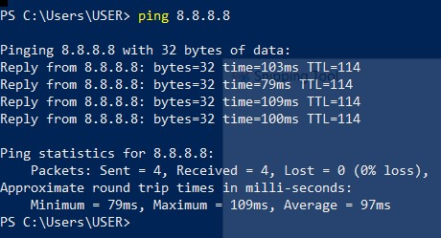

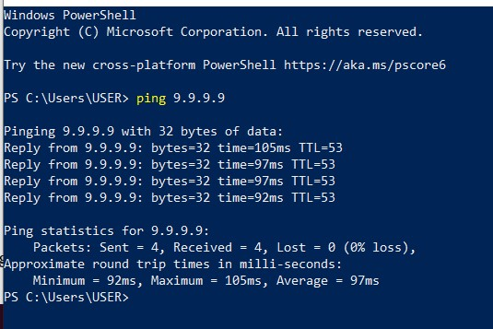

**Conclusion:** Sockets are the endpoints of a bidirectional communications channel. Sockets may communicate within a process, between processes on the same machine, or between processes on different continents.

Sockets may be implemented over a number of different channel types: Unix domain sockets, TCP, UDP, and so on. The socket library provides specific classes for handling the common transports as well as a generic interface for handling the rest.