**RESUME**

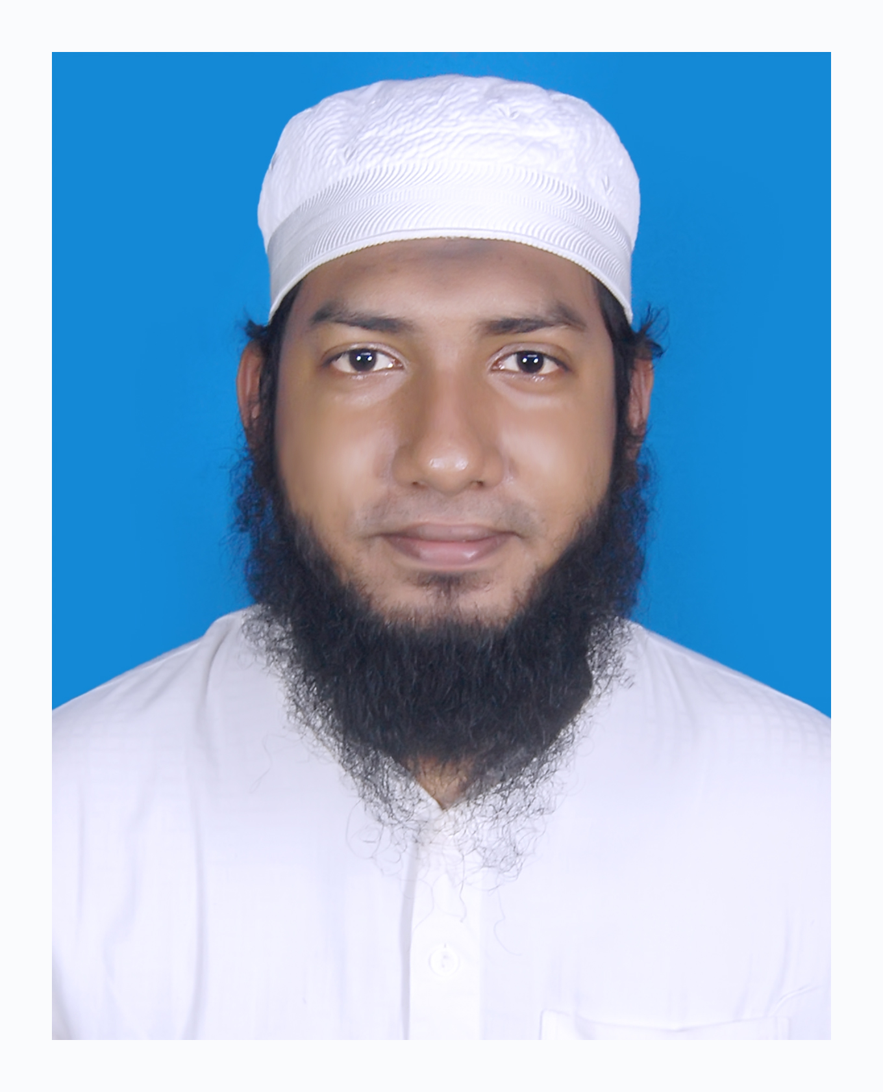

**Salman Mohammad Sultan**

**Address: 116, South Goran, Khilgaon, Dhaka-1219**

**Mobile number: +88 - 01913248844**

**E-mail id:** [salmanmdsultan@gmail.com](mailto:salmanmdsultan@gmail.com)

**Linkedin :** <https://salman-mohammad-sultan-88b70a104>

**Github:** <https://github.com/Salman13201016>

**OBJECTIVES:**

To build a challenging career with a Educational Institute and also with research field where my merit, sincerity, skill will contribute the best to achieve desirable goals through a team-based management approach.

**ACADEMIC QUALIFICATION**

|  |  |  |  |  |  |  |
| --- | --- | --- | --- | --- | --- | --- |
| **SL** | **Degree** | **Institute** | **Group/Dept.** | **Year of Appearing** | **Year Passing** | **CGPA** |
| 1 | B.Sc. | University of Asia Pacific | CSE | 2013 | 2017 | 3.75 out of 4.00 |
| 2 | H.S.C | Govt. Laboratory High School | Science | 2011 | 2013 | 4.40 out of 5.00 |
| 3 | S.S.C | Govt. Laboratory High School | Science | 2000 | 2011 | 4.69 out of 5.00 |

**Undergraduate Thesis:**

**Automated Body Cell Counting System using Convolutional Neural Network from Microscopy Cell image.**

Our thesis represents a system which can count number of cell from an image automatically. We use density estimation technique using Convolutional Neural Network.

**Research-Interest**

* Software Engineering, Pattern Recognition, Artificial Intelligent, Social Awareness

**Skills:**

* Programming Language: C, C++, PHP, Python, C# (Unity 3D), MATLAB
* Framework: Laravel
* Front-end Framework: Bootstrap
* Proficiency: Critical Thinking, Good Knowledge in Database Design, Data Communication, Networking, Data Structure, Artificial Intelligent, Pattern Recognition and good in people management.
* Database Management System: MySQL, Oracle.
* Operating System: Window (XP, 7, 8.1, 10), Linux

**Significant Achievement/ Experience:**

* **Educational**:
  + VC Award (4 times with 1st position)
  + DC Award (2 times with 5th position)
* **Hackathon**:
  + Ring Id SUST 6th CSE Carnival, 2017
  + Inter University CSE Carnival, UAP, 2017 (4th Position)
* **Project Exhibition**:
  + Inter University CSE Carnival, UAP, 2017 (3rd Position)
  + Intra University CSE Fest, UAP, 2016
* **Idea Exhibition**:
  + Intra University Software Fest, UAP, 2016 (Idea on WIFI Pen drive, 4th Position)
* **Programming Contest**:
  + Intra University Programming Contest, UAP, 2013 (12th Position)
  + ACM ICPC Preliminary Programming Contest, 2016
* **Problem Solved**:
  + 10 + problem Solved in UVA online judge (<https://uhunt.onlinejudge.org/id/664012>)
  + 20 + in Light OJ online judge and URI online judge
* **Extra-Curricular Activities**:
  + Technical Support in ACM ICPC and NCPC, 2016
  + Co-Founder in Voboghure Thikana | Pothik (<https://www.facebook.com/groups/voboghure.pothik/>)
  + Former Sales Manager at T-Shirt in 2010
  + Former Lens Corporal in Bangladesh National Cadet Corps

**Projects**

* **UAP Online Course Registration System** (Website)
  + Student can register on a particular semester course.
  + Programming Language: PHP (Raw)
  + Database Management System: MySQL
* **Admin Panel for E-commerce System** (Website)
  + Admin can add, delete, update, select new products with categories and brands.
  + Programming Language: PHP (PDO)
  + Database Management System: MySQL
* **Online Restaurant Service for the tourist** (Website, Partially Completed)
  + Tourist can choose, order in online from a particular restaurant.
  + Programming Language: PHP
  + Database Management System: MySQL
* **LPG Gas Leakage Detector** (Hardware)
  + The system can detect any kind of gas leakage and give notification with alarm.
  + Programming Language: C++
  + Tools: Arduino
* **ZigZag Game** (Game)
  + Desktop Game.
  + Programming Language: C#
  + Tools: Unity 3D
* **Ball Molatile** (Game)
  + Desktop Game.
  + Programming Language: C++
  + Library: graphics.h

**Training/ Workshop/Trainer**

* Trainer at Hardware and Software Development Club, CSE, UAP
* LICT Top Up It Training on Web Development, 2016
* BPO Summit Big Data Workshop, 2016

**Personal Information**

**Full Name:** Salman Mohammad Sultan

**Father’s Name:** Dr. Mohammad Abdus Salam. MBBS, MPH, Medical Officer, DWE Fashion Ltd. Turag, Dhaka**.**

**Mother’s Name:** Sabiha Sultana

**Date of Birth:** 20/10/1993

**Present Address:** House No: - 116, South Goran

Station: Khilgaon

District: Dhaka-1219

**Permanent Address:** Village: Ulania

Station: Galachipa

District: Patuakhali

**References:**

1. Aloke Kumar Saha

Head, Dept. of CSE, University of Asia Pacific

[aloke@uap-bd.edu](mailto:aloke@uap-bd.edu)

1. Dr. Md. Rashedul Islam

Ph.D. (South Korea), M.Sc. (Sweden)

Associate Professor, Dept. of CSE, University of Asia Pacific

[rashed.cse@uap-bd.edu](mailto:rashed.cse@uap-bd.edu)