THE EVERYDAY HANDBOOK

FoodBank User Guide
A simple guide for volunteers, managers and Super Admins
FoodBank helps your team keep track of food coming in, food going out, and what is left. You can also organise products and manage team accounts. This guide explains the current version in everyday language.
GET STARTED / RECORD FOOD / CHECK STOCK / MANAGE ACCOUNTS

Start here
Open the FoodBank website address given to you by your team. Sign in with your username or email address and password. New accounts must choose a personal password before using the app. After setting it, sign in again with your new password.
The Dashboard is your starting page. Use the menu to open a task. On a small screen, open the menu first. The Dashboard currently welcomes you; use Product totals to check food quantities.

Who can do what
Volunteer: view products and stock, check totals, receive stock, distribute food, and record stock adjustments. Volunteers can also use the team directory and view their own account details.
Manager: do the everyday stock tasks, view stock history, organise the catalogue, and set up package sizes and stock items. Managers can create volunteer accounts and edit volunteer accounts. A manager can promote a volunteer to manager; after promotion, that account is outside their edit access.
Super Admin: do the stock and catalogue tasks, view stock history, and create or edit manager and volunteer accounts.
Your menu and buttons depend on your role. Seeing someone in the Users directory does not mean you can open or edit their full account.

Four useful words
Product: the kind of food, such as Rice.
Package size: what one package contains, such as a 1 kg bag.
Stock item: one product, brand and package size together, such as Rice, Brand A, 1 kg bag. A brand can be left blank.
Available stock: how many whole packages are left for a stock item. For example, 8 bags of 1 kg rice means 8 packages and 8 kg of rice.

FOODBANK / USER GUIDE

Set up your own testing account
For the online demo, first use the Super Admin account to create your own Manager account. Then use your own account to test the app.

1 Sign in as Super Admin
Open the website link shared with you. Enter super.admin as the username. The Super Admin password will be shared with you directly; it is not included in this guide.

2 Create your Manager account
Open Create user. Enter your first name, last name, a unique email address and a phone number(you can give anything. No verification is here). Choose Manager as the role and Active as the status, then select Create user.
The app opens your new account details and generates your username automatically. For example, Alex Taylor becomes alex.taylor. If that username is already taken, the app adds a number, such as alex.taylor.01. Note the exact username shown on your account details page.
Your account is assigned the demo’s initial password automatically. This initial password is “InitialPassword”. You do not choose your personal password on the Create user page.

3 Set your personal password
Log out of the Super Admin account. Sign in with your new username and the initial password. On your first login, the app requires you to choose and confirm a personal password before you can use it. Choose a password of at least 8 characters that is different from the initial password.
After saving your personal password, the app signs you out. Sign in again with your own username and your new personal password. Use this password for future logins.

4 Start testing
You are now signed in as a Manager. Use the rest of this guide to try the catalogue, stock setup, receiving food, distributing food, adjustments and history. Use fictional information for testing. Record your test activity with your own Manager account so the stock history shows who made each change.

FOODBANK / USER GUIDE

Everyday stock tasks

Receive stock
Use this when food arrives. Saving a receipt adds the packages to the available stock.
1 Open Receive stock from the menu.
2 Search by product name or brand. Check the product, brand and package size before selecting an item.
3 Enter the number of whole packages received, then add the item to the receipt.
4 Repeat for other items in the delivery. Check the receipt list and add notes if useful.
5 Select Save receipt. Wait for the success message before recording another delivery.
Example: You receive 6 bags of rice, each weighing 1 kg. Select the 1 kg bag stock item and enter 6. Do not enter 6,000 for the weight in grams.
If the right product, brand or size is missing, ask a manager to set it up. Do not choose a similar item just to finish the form.

Distribute food
Use this when food is given to a household. Saving a distribution removes the selected packages from stock.
1 Confirm the household’s appointment outside the app first.
2 Open Distribute food. Search for a household by name or household number and select the correct match.
3 Search for food by product name or brand. Check the package size and the available amount.
4 Enter the number of whole packages to give out and add each item to the list.
5 Review the household and every item in the summary. Remove any unwanted rows before saving.
6 Select Save distribution. Wait for the success message. The form clears for the next household.
Only items with stock available can be selected for distribution. You cannot give out more packages than are available. If someone else changes the stock while you are preparing the form, check any message and review the quantities again.

Before you save
Adding an item to a list prepares the form. It does not change stock until you save successfully. Check the product, brand, package size and package count each time.

FOODBANK / USER GUIDE

Find the right stock item
Real screens from the local demo. Your quantities will change as the team records stock. These examples show the app on a narrow screen.
Left Receive stock | Right Stock items
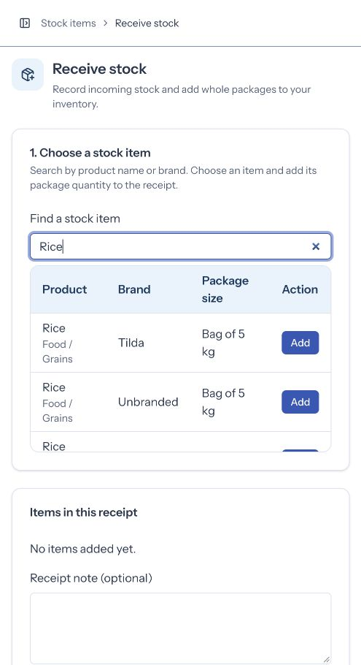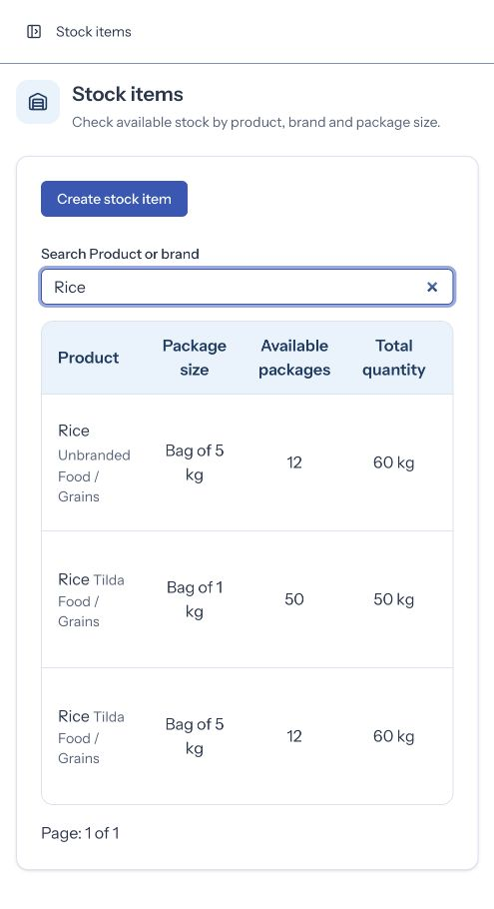
On the receiving screen Search for the product or brand, then check the package size before selecting Add.
On the stock list Available packages is the number of packages. Total quantity is the amount of food inside them. Scroll sideways on a narrow screen to reach the action buttons.

FOODBANK / USER GUIDE

Check and correct stock

Stock items
Open Stock items to see available packages for each product, brand and size. Search by product name or brand. Use the page controls to see more results.
Different package sizes appear separately. This helps you find the exact item on the shelf. The total quantity also shows how much food those packages contain.

Product totals
Open Product totals for one combined amount per product across its brands and package sizes. Search for a product, then expand its row to see the stock items making up the total.
Example: 3 bags of 1 kg rice and 2 bags of 2 kg rice give a combined total of 7 kg. There are 5 bags, but 7 kg of food. These are different ways to count the same stock.

Stock adjustment
Use an adjustment when the recorded stock needs correcting, such as damaged packages or a difference found during a shelf count. Use Receive stock for a delivery and Distribute food for food given to a household.
1 Open Stock adjustment and search for the exact stock item.
2 Choose whether to add or remove packages.
3 Enter the number of whole packages to change, not the final amount you want to see.
4 Read the preview of the new balance. Enter a clear reason for the change.
5 Select Save adjustment and wait for the success message.
Example: The app says 10 cans, but 2 cans are damaged. Remove 2 packages and explain why. The new balance will be 8. A removal cannot take stock below zero.

Stock history
Managers and Super Admins can open an item’s history from Stock items or the expanded Product totals view.
History shows receipts, distributions and adjustments. Each change shows when it was recorded, who recorded it, the packages added or removed, and the balance afterward. Depending on the task, it also shows receipt notes, the household, or the adjustment reason.
Saved changes remain in the history. They cannot be edited or deleted. If a saved entry is wrong, tell a manager so the correction can be recorded clearly. A zero balance does not erase the item’s history.

FOODBANK / USER GUIDE

Read totals and history
Real screens from the local demo. Your quantities will change as the team records stock. These examples show the app on a narrow screen.
Left Product totals | Right Stock history
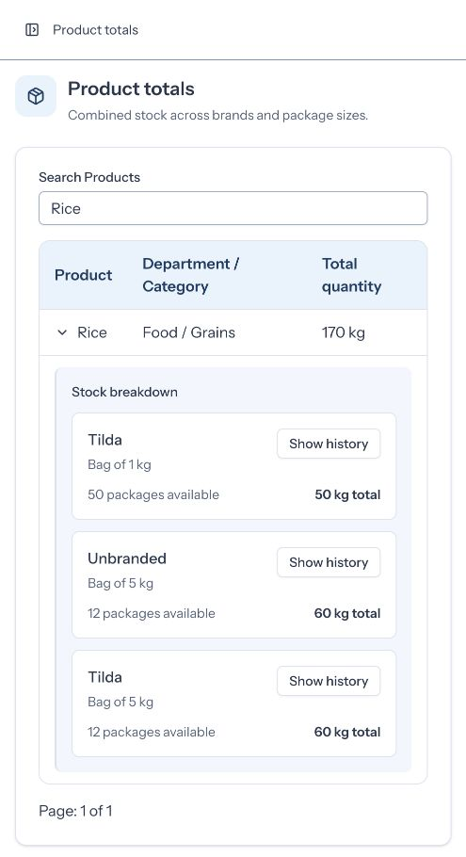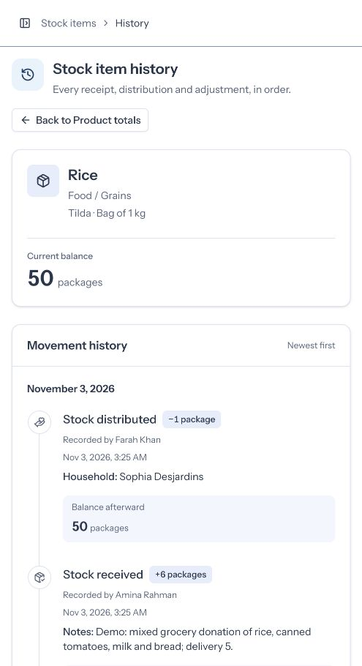
On Product totals Expand a product to see the brands and package sizes behind its combined amount.
On Stock history Read the item identity and current balance first. Below them, each saved change shows what happened and who recorded it. Newest changes appear first.

FOODBANK / USER GUIDE

Set up products and packages
This section is for Managers and Super Admins. Set up the choices before the team needs to record food arriving.

Organise the product catalogue
The catalogue has three levels: Department, Category and Product. For example: Food → Grains → Rice. Departments are broad groups. Categories are smaller groups inside them. Products are the individual kinds of goods.
1 Open Departments to create or rename a broad group.
2 Open Categories to create a category under a department. You can rename it or move it to another department.
3 Open Products to create a product under a category. You can edit its name or category.
4 Use search and the department or category filters on Products to find existing entries before adding a new one.
The app prevents a duplicate product name in the same category. If the same name exists elsewhere, read the warning and confirm only if the new entry is intended. Read any confirmation before moving a category or product.
The catalogue describes what the goods are. Creating a product does not add any food to stock. Departments, categories and products do not have a delete option in this version.

Create a package size
1 Open Package sizes and choose Create package size.
2 Choose the package type, such as bag, can or bottle.
3 Enter the contents of one package and its unit. For example: bag, 1, kg.
4 Save the package size. It can be reused for several products.
A package size cannot be changed or deleted once a stock item uses it. Create another size when you need a different package. Equivalent definitions of the same package type, such as 1 kg and 1,000 g, are treated as duplicates.

Create a stock item
1 Open Stock items and choose Create stock item.
2 Search for and select the product. Check its department and category to avoid choosing a same-name product from another group.
3 Enter the brand, or leave it blank for an unbranded item.
4 Choose the package size and save. Use Receive stock afterward to record the packages you actually have.
Package measurements for the same product must be compatible. For example, weight and liquid volume cannot be combined into one product total.
After an item has a saved stock change, its product and package size are locked. Brand spelling can still be corrected if it does not create a duplicate. A stock item can be deleted only if it has no saved stock changes; zero stock alone is not enough.

FOODBANK / USER GUIDE

Accounts and help

Find people and view your details
Open Users to search the team directory by name, email, phone or role. Use the page controls for more results. Open My details to see your own full account information, including your username and account status.

Create or update an account
Managers can create volunteer accounts. Super Admins can create manager and volunteer accounts. Only accounts you are allowed to manage have the relevant edit controls.
1 Open Create user. Enter the person’s name, email and phone, then choose an available role and account status.
2 Save the account. The app creates a username from the person’s name.
3 Give the person their username and the initial password supplied through your team’s account setup process.
4 The person signs in and chooses a personal password. They then sign in again with that password.
To update a permitted account, find the person in Users and choose Edit. Check any confirmation before saving a role or status change. A name change can also change the generated username, so tell the person their updated sign-in details.
An inactive account cannot use FoodBank. Making an account inactive also ends its current access. Reactivating it allows the person to sign in again. Accounts are kept rather than deleted.

Change your password or sign out
Open the menu beside your name and choose Settings. In Security, enter your current password, then enter and confirm your new password. Select Save. A successful password change signs you out of all sessions; sign in again with the new password.
To finish work, open the menu beside your name and choose Log out. Always sign out on a shared computer.

If something does not work
A message appears under a field: read it, correct the value, and save again. Wait while the button says it is saving.
An item is missing: try another search or clear the search. Ask a manager if the stock choice has not been set up.
A household is missing: check the name or household number and ask your team for help. This version has no screen for adding households.
A button or page is unavailable: your role may not have permission. Ask your manager rather than using another person’s account.
You cannot sign in: check your username or email and account status with your team. Administrator password resets and Super Admin recovery are not included in this version.

What this version does not cover
Appointment booking, full household management, wider volunteer management, and separate role dashboards are not included. Follow your team’s existing process for these tasks. Household selection is available for recording distributions, and appointments must be confirmed outside FoodBank.

