**Lab #2 (Lab Assignment):**

# WEB PAGE DEVELOPMENT USING HTML

|  |  |
| --- | --- |
| **Duration** | 2 hours |
| **Topic** | Web page development using HTML |
| **Domain of**  **Learning** | Psychomotor (P2: Set; P3: Guided Respond; P4: Mechanism) |
| **Learning objective** | 1. To evaluate the response to solve the problem as required. (P2) 2. To evaluate the skill of how the web page is developed whereas using the code/tags correctly. (P3) 3. To evaluate the value added of creativity/knowledge/skill in web page development. (P4) |
| **Lab activity objective** | To use the combination of HTML tags properly based on the suitable requirement of a case study. |
| **Instructions** | Provide possible solutions for the given task individually. |
| **Submission** | Author, GitHub |

|  |  |
| --- | --- |
| Name | matric |
| Arfat Elnour | Ai230244 |

**Task 1:-**

[**https://arafatalnoor.github.io/2/**](https://arafatalnoor.github.io/2/)

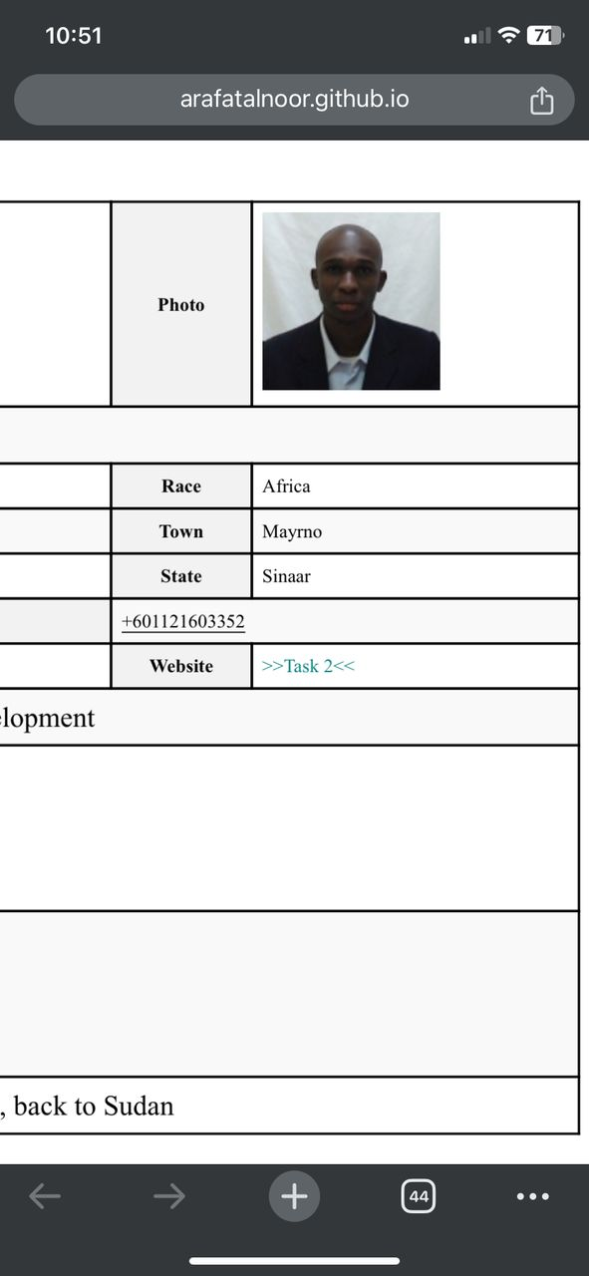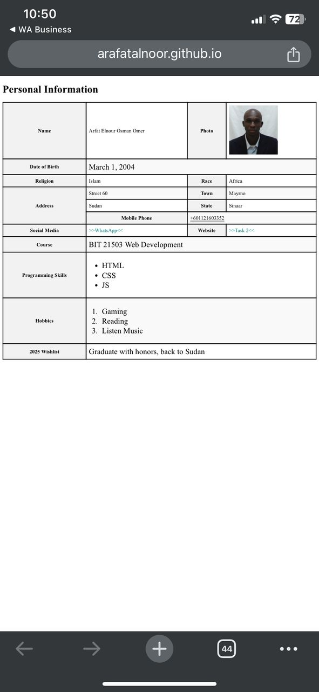

Task 2:-

<https://arafatalnoor.github.io/2/Task2.html>