Design Report
HTTP / TCP Session Hijacking Attack
Team Members | Samiul Hasan Nihal — 2105105
 | Arnab Sarker — 2105099
Course | CSE 406 — Sessional (Cybersecurity)
Submission Date | 13 September 2026

1. Overview of the Project Idea
TCP session hijacking is an attack in which an adversary takes over an already-established TCP connection between two hosts by observing or predicting the connection's sequence and acknowledgment numbers, then injecting forged segments that the receiving host accepts as legitimate. HTTP session hijacking exploits the fact that HTTP is stateless: web applications identify a logged-in user through a session token (usually a cookie) rather than re-checking credentials on every request. If that token is transmitted in the clear or can otherwise be observed, anyone who obtains it can impersonate the victim without ever knowing their password.
This project demonstrates both attacks in a single controlled lab scenario: a victim client authenticates to a web server over plain HTTP on a shared local network, and an attacker on the same network segment uses ARP cache poisoning to place itself on-path between the two, then (a) injects data into the live TCP stream, and (b) captures and replays the victim's session cookie.
Goals of the design phase:
- Establish an on-path (man-in-the-middle) position between a client and a server using ARP spoofing.
- Show that an attacker who can read live sequence/acknowledgment numbers can inject accepted data into an ongoing TCP connection, without brute-forcing or blindly guessing those numbers.
- Show that an unencrypted HTTP session's cookie is sufficient, on its own, to impersonate an authenticated user.
- Identify concrete, layered defenses that would have prevented or limited each attack.
Assumption used throughout this report: a small isolated lab (3 virtual machines on one bridged/internal network segment) is used, since a switched LAN is what makes ARP spoofing possible and is the standard, reproducible setup for this class of assignment. If the course's assigned lab environment differs (e.g. a specific VM image or tool is mandated), the same design carries over — only the exact commands in Section 4 would change.

2. Network Topology, Components, and Timing Diagram

2.1 Topology and Components
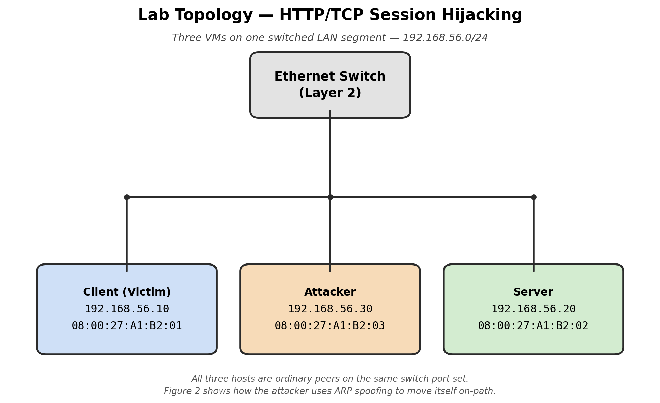
Figure 1. Lab topology — three hosts on a single switched segment.
Components:
- Client (victim) — 192.168.56.10. Runs a browser (or curl) that logs into the web app over HTTP.
- Server — 192.168.56.20. Runs a small login-protected web application (e.g. Flask/PHP) using a plaintext-HTTP, cookie-based session, plus a Telnet-style plaintext TCP service for the pure TCP-hijack demonstration.
- Attacker — 192.168.56.30. Runs Scapy (packet crafting/injection), Wireshark/tcpdump (capture and analysis), and an ARP-spoofing tool (arpspoof/ettercap, or a short custom Scapy script).
- Switch — an ordinary Layer-2 switch (or a VirtualBox/VMware internal network, which behaves the same way). This is what makes ARP spoofing meaningful — on a hub, all traffic would already be visible to everyone.

2.2 Attack Timing / Sequence Diagram
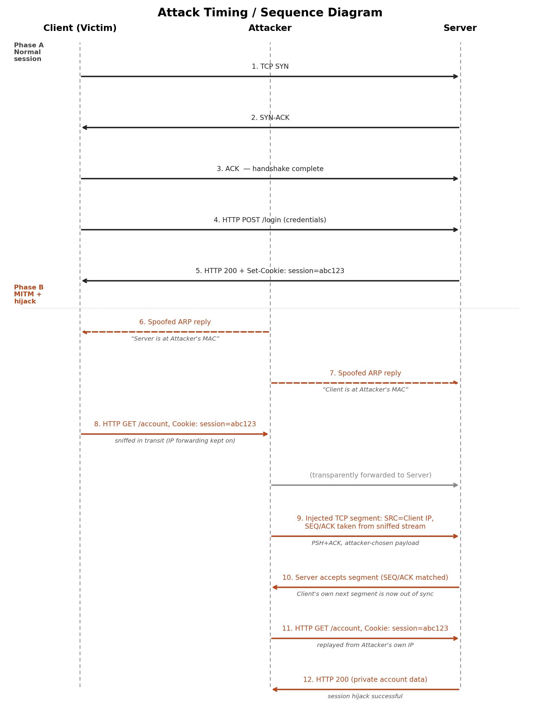
Figure 2. Message sequence: normal session (Phase A) followed by MITM setup and hijack (Phase B).
Phase A is an ordinary session: TCP three-way handshake, then an HTTP login that returns a session cookie. Phase B begins with the attacker sending unsolicited, forged ARP replies to both the client and the server so that each maps the other's IP address to the attacker's MAC address. With IP forwarding enabled on the attacker's machine, traffic keeps flowing (so the victim notices nothing) while the attacker reads it. The attacker then (i) crafts and sends a TCP segment with the client's source IP and the correct next sequence/acknowledgment numbers, which the server accepts as if it came from the client, and (ii) replays the sniffed session cookie from its own machine to access the victim's authenticated session directly.

3. Packet and Frame Structure
The tables below list only the header fields that matter for this attack (not every field defined by each protocol), and note what the attacker reads, forges, or relies on at each layer.

3.1 Ethernet II Frame
Field | Size | Relevance to the Attack
Destination MAC | 6 B | Set to the attacker's MAC during ARP poisoning replies, so the switch/host delivers traffic meant for the victim to the attacker instead.
Source MAC | 6 B | Attacker inserts its own MAC as the claimed owner of the spoofed IP.
EtherType | 2 B | 0x0806 for the forged ARP replies; 0x0800 for the IPv4 frames carrying the injected TCP segment / HTTP traffic.
Payload | 46–1500 B | Carries the ARP packet or IP datagram described below.
FCS (CRC) | 4 B | Recomputed automatically by the NIC/driver — not something the attack needs to forge by hand.

3.2 ARP Packet (spoofed reply)
Field | Size | Relevance to the Attack
Hardware Type | 2 B | 1 (Ethernet).
Protocol Type | 2 B | 0x0800 (IPv4).
Opcode | 2 B | Set to 2 (Reply) — the attacker sends unsolicited replies that no one requested, which real ARP does not forbid.
Sender MAC / IP | 6 B / 4 B | The core of the spoof: Sender IP is set to the victim's IP (client or server), Sender MAC is set to the attacker's real MAC.
Target MAC / IP | 6 B / 4 B | Address of the host being poisoned (whoever should now believe the false mapping).

3.3 IPv4 Header
Field | Size | Relevance to the Attack
Source IP Address | 4 B | Forged as the client's IP for the injected TCP segment, so the server treats it as part of the existing connection.
Destination IP Address | 4 B | Server's IP — unchanged, since the attacker is impersonating the sender, not the recipient.
Protocol | 1 B | 6 (TCP), so the segment is handed up to the TCP stack.
TTL | 1 B | Can betray the extra hop introduced by an on-path attacker if it differs from the victim's normal TTL — a possible detection signal, not something the attacker benefits from forging correctly.
Header Checksum | 2 B | Must be recalculated for the forged packet or it will be silently dropped.

3.4 TCP Header
Field | Size | Relevance to the Attack
Sequence Number | 4 B | The value the attacker most needs: it must match what the server currently expects from the client. Sniffed directly off the live stream (on-path), so no blind guessing is required.
Acknowledgment Number | 4 B | Likewise taken from the live stream; tells the server the injected segment continues the existing conversation.
Flags | 9 bits | PSH+ACK is used to push the injected payload; RST can optionally be sent to the real client afterward to tear down its now-desynchronized connection cleanly. (Relevant flags: SYN, ACK, PSH, RST, FIN.)
Window Size | 2 B | Kept consistent with the observed stream so the segment doesn't look anomalous.
Source / Destination Port | 2 B each | Identify the specific TCP connection being hijacked; taken directly from the sniffed traffic.

3.5 HTTP Request / Response (session cookie)
A generic authenticated request and the response it returns — the field the attack targets is the Cookie / Set-Cookie header:
GET /account HTTP/1.1
Host: server.local
Cookie: session=abc123xyz

HTTP/1.1 200 OK
Set-Cookie: session=abc123xyz; Path=/
Content-Type: text/html
Because the connection is plain HTTP (no TLS), this entire exchange — including the Cookie header — is visible to the on-path attacker in Section 2.2. Replaying the same Cookie value from a different machine is enough to be treated as the logged-in user; the server has no way to tell the two apart.

4. Implementation Plan
Phase 1 — Lab Setup
- Provision three VMs (client, server, attacker) on one isolated internal/host-only network segment so the attack cannot leak onto a production network.
- Deploy the login web app on the server with a plaintext-HTTP, cookie-based session, and a plaintext TCP service (e.g. a Telnet daemon) for the pure TCP-hijack demonstration.
- Install Scapy, Wireshark, and an ARP-spoofing tool on the attacker VM; confirm IP forwarding can be toggled on the attacker.
Phase 2 — MITM Positioning
- Run the ARP-spoofing script/tool to poison the client's and server's ARP caches simultaneously.
- Enable IP forwarding on the attacker so traffic continues to flow while it is being read (keeps the attack silent).
- Confirm interception in Wireshark by identifying the client–server TCP stream now visible on the attacker's interface.
Phase 3 — TCP Session Hijack
- From the sniffed stream, read the current sequence and acknowledgment numbers for the live connection.
- Use Scapy to craft a segment with the client's source IP, the correct SEQ/ACK, and an attacker-chosen payload; send it to the server.
- Observe in Wireshark whether the server accepts the segment (no RST, ACK advances) versus rejects it.
- Optionally send a spoofed RST to the legitimate client to remove it from the conversation.
Phase 4 — HTTP Session Hijack
- Extract the session cookie value from the sniffed post-login HTTP traffic.
- From the attacker machine, issue a request to a protected endpoint using only the stolen cookie (via curl or a browser cookie editor).
- Confirm the server serves the protected page without requesting credentials.
Phase 5 — Evidence Collection
- Save .pcap captures for the baseline session and for the attack.
- Screenshot the poisoned ARP tables, the accepted injected segment, and the unauthorized HTTP response, for the final report.

Tools and Technologies
Tool | Purpose
Scapy (Python) | Craft and send the forged ARP replies and the injected TCP segment with chosen SEQ/ACK values.
Wireshark / tcpdump | Capture and inspect traffic at each stage; read live SEQ/ACK numbers and the session cookie; verify the injected segment and the replayed HTTP request.
arpspoof / ettercap (or custom script) | Automate continuous ARP poisoning of both client and server.
Flask / small PHP app | Minimal login page issuing a cookie-based session over plain HTTP, to serve as the hijack target.
VirtualBox / VMware (internal network) or Mininet | Provide the isolated, switched lab network so the attack is contained and reproducible.

5. Expected Outcome of a Successful Attack
- TCP hijack: the server accepts and processes the attacker's injected segment as if it came from the legitimate client (e.g. a command is executed in the Telnet-style session with no authentication). The real client's next segment now carries a sequence number the server no longer expects, so its connection stalls, resets, or produces duplicate-ACK behavior visible in Wireshark.
- HTTP hijack: the attacker is served the victim's protected page/data using only the replayed cookie — no password is required, and the request is indistinguishable, at the server, from one made by the real client.
- Evidence recorded for the report: poisoned ARP tables on client and server, the injected TCP segment accepted without an RST, and the successful authenticated HTTP response returned to the attacker's replayed request.
Taken together, a successful run demonstrates that plaintext, cookie-based authentication and an unauthenticated ARP protocol are both sufficient, on their own, for a same-network attacker to fully impersonate a legitimate user — without ever learning their password.

6. Defense Ideas

Transport / network layer
- TLS (HTTPS) for all traffic — encrypts the cookie and payload, defeating passive sniffing even from an on-path position.
- TCP sequence-number randomization (standard on modern OSes) — raises the cost of blind/off-path hijacking, though it does not stop an attacker who is already on-path and can read numbers directly.
- IPsec or a VPN tunnel — authenticates and encrypts at the network layer, so injected/spoofed segments are rejected.

Session / cookie hardening
- Secure, HttpOnly, and SameSite cookie attributes; short session lifetimes; regenerate the session ID after login.
- Bind sessions to additional signals (IP address, User-Agent) as a speed bump — with the usability trade-off that this can break for genuinely mobile users.

Layer-2 / ARP defenses
- Static ARP entries for critical hosts, or Dynamic ARP Inspection (DAI) on managed switches.
- ARP-spoofing detection tools (e.g. arpwatch, XArp) to flag unsolicited or conflicting ARP replies.

Detection
- IDS/IPS rules for ARP anomalies (duplicate IP–MAC bindings), unexpected RSTs, and duplicate-ACK storms that often accompany hijack attempts.

Application layer
- Require step-up / re-authentication for sensitive actions even within an already-authenticated session, so a hijacked cookie alone isn't enough for high-value operations.

References
- RFC 793 — Transmission Control Protocol.
- RFC 826 — An Ethernet Address Resolution Protocol (ARP).
- RFC 7230 — HTTP/1.1: Message Syntax and Routing.
- OWASP Session Management Cheat Sheet.

