Uncertainty-Gated Fusion of EfficientNet-B3 and a Multi-Scale Graph Pyramid for Four-Class Brain Tumour MRI Classification: A Duplicate-Aware Cross-Validation Study
Arafat Rahman
Md Assaduzzaman
Department of Computer Science and Engineering, Daffodil International University, Dhaka, Bangladesh. Corresponding author: Arafat Rahman (arafat2001noor@gmail.com)
Abstract
Deep networks often report near-perfect accuracy on public brain tumour MRI collections, yet these collections contain offline-augmented copies and near-duplicate slices that can fall on both sides of an image-level split. We propose a dual-stream classifier that pairs an ImageNet-pretrained EfficientNet-B3 with a three-level graph pyramid of 336 regional nodes processed by parallel GCN, GAT and TransformerConv paths. The two 384-dimensional embeddings are refined by dynamic recalibration and a two-token cross-modal transformer, and fused by a gate driven by Monte Carlo (MC) dropout uncertainty. The model (19.35 M parameters) was evaluated on a public four-class dataset of 12,064 images with duplicate-aware five-fold cross-validation: offline-augmented copies and perceptual-hash near-duplicates were merged into 3,873 groups, and no group was shared between training, validation and test data. Accuracy was $96.54±1.71\%$ (range 94.34–98.16%) and macro-F1 $96.36±1.81\%$; pooled out-of-fold accuracy was 96.49% (95% group-bootstrap CI 95.50–97.37%), with a pooled expected calibration error of 0.012. The same architecture reached $99.15±0.39\%$ under an image-level split, so duplicate leakage inflated accuracy by about 2.6 percentage points; the error rate of the augmented-copy family rose from 0.85% to 5.89%. Errors were concentrated in a few source slices, whose copies were misclassified together, and in one public sub-collection with an 18.5% error rate. The audit also found 108 near-duplicate pairs with conflicting labels, four of them identical images filed under two classes. The image stream received most of the fusion weight (mean 0.73), and the three graph operators kept equal weights in every fold. A four-model ablation on the same folds showed that the EfficientNet-B3 stream alone was as accurate as the complete framework ($96.58±1.44\%$; McNemar $p=0.72$), whereas the graph stream alone reached only $87.48\%$. Patient identifiers are unavailable, so these remain slice-level estimates on one compiled dataset.
Index Terms— Brain tumour classification, magnetic resonance imaging, graph neural networks, EfficientNet, multimodal fusion, Monte Carlo dropout, calibration, data leakage, cross-validation.

I. Introduction
Gliomas, meningiomas and pituitary tumours differ in origin, treatment and prognosis, and their distinction on MRI shapes the first clinical decisions [1]. Contrast-enhanced T1-weighted images form the basis of the most widely used public datasets for this task [2]. Automated classification of these tumour types, with or without a tumour-free class, is a widely studied triage and second-reader task [2], [3], [4], [5], [6].
Convolutional neural networks (CNNs) with transfer learning dominate this task and typically report accuracies in the mid- to high-90 percent range on public collections [3], [4], [5]. Vision transformers report similar figures [6]. Two properties of these models remain under-examined. First, a CNN pools local evidence into one global vector, so explicit relations between distant regions are learned only implicitly. Graph formulations make such relations explicit, and hybrid CNN–graph models have recently been applied to brain tumour MRI [7]. Second, most systems output a single softmax vector without checking whether its confidence is trustworthy, although calibration is central to clinical use [8], [9].
Evaluation practice is a third, larger concern. Public brain tumour collections are often compiled from earlier datasets and can contain offline-augmented copies and near-duplicate slices. When images rather than patients or source slices are split, related images can fall on both sides of a split. Such leakage is a documented cause of over-optimistic results in medical machine learning [10], [11], [12], [13]. A near-perfect accuracy is only interpretable together with an account of how the data were split and what the split could not prevent.
This study addresses all three points. We combine an EfficientNet-B3 image stream [14] with a multi-scale graph stream and fuse them through recalibration, a cross-modal transformer and an uncertainty-guided gate based on MC dropout [9]. We then evaluate the model with a duplicate-aware protocol: augmented copies and near-duplicate slices are grouped before splitting, every metric is recomputed from saved per-image predictions, calibration is analysed bin by bin, and the same architecture is also evaluated under a conventional image-level split to measure how much leakage inflates accuracy. We ask three research questions:
- RQ1: How accurate is a dual-stream CNN–graph model with uncertainty-gated fusion on four-class brain tumour MRI classification when no near-duplicate group is shared between training and test data?
- RQ2: How well calibrated are its probability estimates, and which design choices shape that calibration?
- RQ3: How much of the dataset consists of duplicated slices, and how much does an image-level split that ignores them inflate accuracy?
The contributions of this paper are as follows:
- A dual-stream architecture that couples EfficientNet-B3 with a three-level graph pyramid processed by GCN, GAT and TransformerConv paths, fused by dynamic recalibration, a two-token transformer and an MC-dropout uncertainty gate (Section IV).
- A duplicate-aware five-fold evaluation, with groups formed from file-name stems and perceptual-hash near-duplicates: fold-wise and pooled out-of-fold metrics, group-bootstrap confidence intervals, per-class sensitivity and specificity, and a reliability analysis (Section VI).
- A direct measurement of duplicate leakage, by comparing the same architecture under image-level and grouped splits, and an audit that identifies label conflicts between near-duplicate images (Section VII-A).
- A four-model ablation on identical folds (image only, graph only, concatenation and the full framework), together with an analysis of the trained fusion parameters and gate weights, which shows how much each stream contributes in practice (Sections VI-G, VI-F and VII-D).
- Release of the training code, group and fold assignments and per-image out-of-fold predictions for independent re-analysis.

II. Related Work

A. CNNs and Transformers for Brain Tumour MRI
Cheng et al. released the 3,064-slice, 233-patient figshare collection and classified it with region augmentation and handcrafted features [2]. Transfer learning with pretrained CNNs became the standard approach on this and similar collections [3], [4], [5]. EfficientNet scales depth, width and resolution jointly and offers a strong accuracy-to-cost ratio [14]. Vision transformers [15] and their ensembles report about 98.7% accuracy on the three-class figshare data [6]. Results across papers are seldom comparable, because datasets, class sets and split protocols differ.

B. Graph Representations
Graph convolution aggregates neighbour features through a normalised adjacency [16], graph attention learns neighbour weights [17], and graph transformer convolution applies multi-head attention over neighbours [18]. Gürsoy and Kaya combined a graph network over image regions with a CNN and reported 93.68% accuracy on a 10,847-image collection [7]. Our graph stream differs in using a fixed three-level pyramid with explicit parent–child links and three operators in parallel.

C. Fusion and Gating
Squeeze-and-excitation gates rescale channels by learned importance [19], and transformer attention [20] lets tokens exchange information. Fusion of two streams is usually done by concatenation or attention, without regard to how reliable each stream is for a given input.

D. Uncertainty and Calibration
MC dropout approximates Bayesian inference by sampling dropout masks at test time [9]. Kendall and Gal distinguished epistemic from aleatoric uncertainty [21], and test-time augmentation is a simple estimate of the latter [22]. Modern networks are often over-confident; expected calibration error (ECE) and reliability diagrams are the standard diagnostics [8], [23], and the Brier score measures probabilistic accuracy [24]. Label smoothing improves generalisation [25] but changes the calibration and the geometry of the penultimate layer [26]. Uncertainty estimates can degrade under dataset shift [27].

E. Leakage in Medical Imaging Benchmarks
Data leakage is a pervasive source of irreproducible results in machine-learning-based science [12]. In a survey of 32 CNN studies on Alzheimer’s disease, data leakage was potentially present in half; in a controlled simulation, leakage raised validation balanced accuracy to 1.00 against 0.75–0.80 on independent test sets [13]. Reviews of medical imaging AI list improper splitting among the most common methodological failures, and warn that datasets assembled from other public datasets can contain duplicates that bias evaluation [10], [11]. Several public brain tumour collections are compilations of earlier sets [28], [29]. Users of a public mirror of one such compilation have reported that the glioma images of one of its sources appear mislabelled [30]. For this reason we treat dataset composition as part of the evaluation.

III. Dataset
We used Version 1 of the publicly available Brain Tumor MRI Dataset (Glioma, Meningioma, Pituitary, No Tumor) on Mendeley Data [31]. Its publishers describe it as 12,064 pre-processed T1-weighted contrast-enhanced slices in four classes, distributed in predefined Train and Test folders. The record describes the images as greyscale or RGB depending on the scan, distributes them as JPEG or PNG under a CC BY 4.0 licence, and does not document acquisition parameters. Visual inspection shows axial, coronal and sagittal slices; the plane is not recorded per image. Inspection of the misclassified images further showed that the collection is not uniformly T1-weighted: it includes T2-weighted slices and at least one slice that appears to be a computed tomography (CT) image (Fig. 9). The distributed archive is named “Epic and CSCR hospital Dataset”, and a later version of the record states that the images were sourced from Epic & CSCR Hospital, Bangladesh [32]. We merged both folders before cross-validation, so that every image is tested exactly once (Section V-B). No new images were acquired, and the data contain no patient identifiers.
TABLE I. Class Distribution of the 12,064 Images Used
Class | Images | Share
Glioma | 3,773 | 31.3%
Pituitary tumour | 3,130 | 25.9%
Meningioma | 2,729 | 22.6%
No tumour | 2,432 | 20.2%
Total | 12,064 | 100%
Table I reports the counts in the distributed files. The record’s description lists 2,809 meningioma and 3,050 pituitary images, because its per-class test counts for these two classes (626 and 546) are interchanged relative to the files, which contain 546 meningioma and 626 pituitary test images. Totals for glioma, no tumour and the whole dataset agree with the description. Representative slices are shown in Fig. 1.
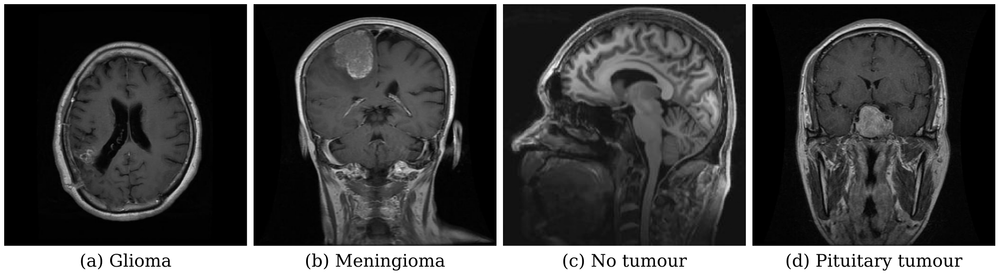
Fig. 1. Representative slices of the four classes from the dataset [31] (CC BY 4.0): (a) glioma, (b) meningioma, (c) no tumour and (d) pituitary tumour. The slices differ in imaging plane, as does the dataset.
Composition and duplicate structure: File names fall into distinct naming families, summarised in Table II. The largest family (G_###, M_###, N_###, P_###) contains 4,246 images. These are 620 source slices, of which 591 appear exactly seven times: the original plus six offline augmentations marked by the suffixes RO, VF, HF, BR, SP and DA (for example G_710.jpg, G_710_RO_.jpg). Of the remaining 7,818 images, 5,902 (75%) follow the naming conventions of public Kaggle collections [28], [29], [33]. Whether these files are identical to the images of those collections was not verified.
TABLE II. File-Name Families of the Dataset
File-name family | Images | Interpretation
G/M/P/N_### (+ six augmentation suffixes) | 4,246 | 620 source slices, typically seven copies each
Tr-xx_#### | 3,784 | naming of the training split of [28]
#.jpg (plain numbers) | 1,914 | origin not identified
gg (n), m (n), p (n) | 935 | naming of the training split of [29]
Te-xx_#### | 858 | naming of the test split of [28]
image(n) | 249 | naming of the test split of [29]
N#, # no | 76 | naming of [33]
other | 2 | –
A later release of the same Mendeley record (Version 7) states that exact and near-duplicate images were removed, leaving 5,941 images with a verified leakage-free split [32]. This independently confirms substantial duplication in Version 1. Section VII-A measures its effect on our results.

IV. Proposed Method
The classifier learns two complementary views of the same slice: dense appearance features from a CNN, and regional relations from a graph built over a multi-scale grid. Both streams map to 384-dimensional vectors, which are refined jointly, weighted by their estimated reliability and classified (Fig. 3). Exact layer settings follow the released code. The overall study workflow, from dataset preparation to evaluation, is summarised in Fig. 2.
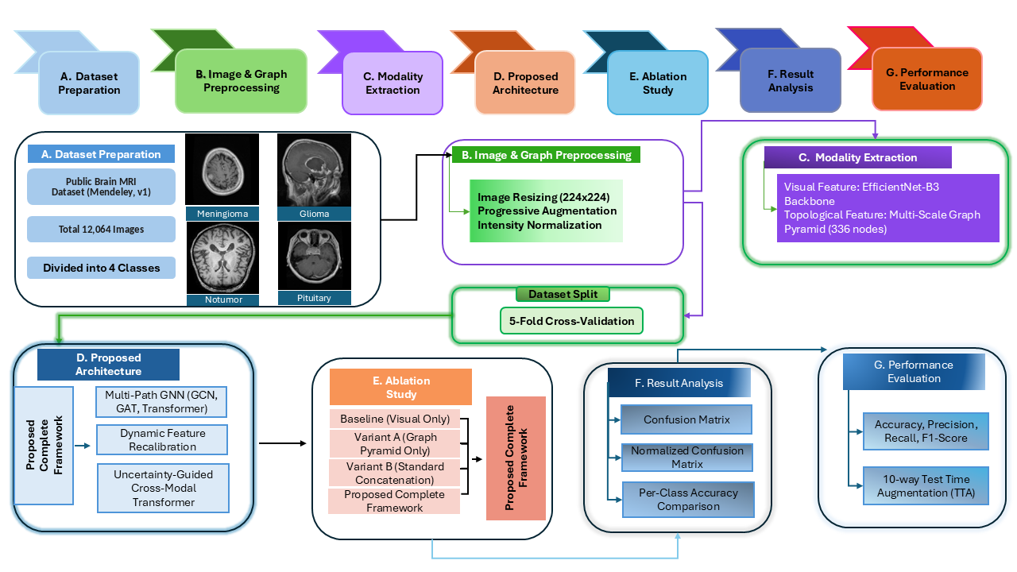
Fig. 2. Overview of the study workflow: (A) dataset preparation, (B) image and graph pre-processing, (C) extraction of the visual and topological modalities, (D) the proposed architecture (detailed in Fig. 3), (E) ablation study (Section VI-G), (F) result analysis and (G) performance evaluation with ten-view test-time augmentation.
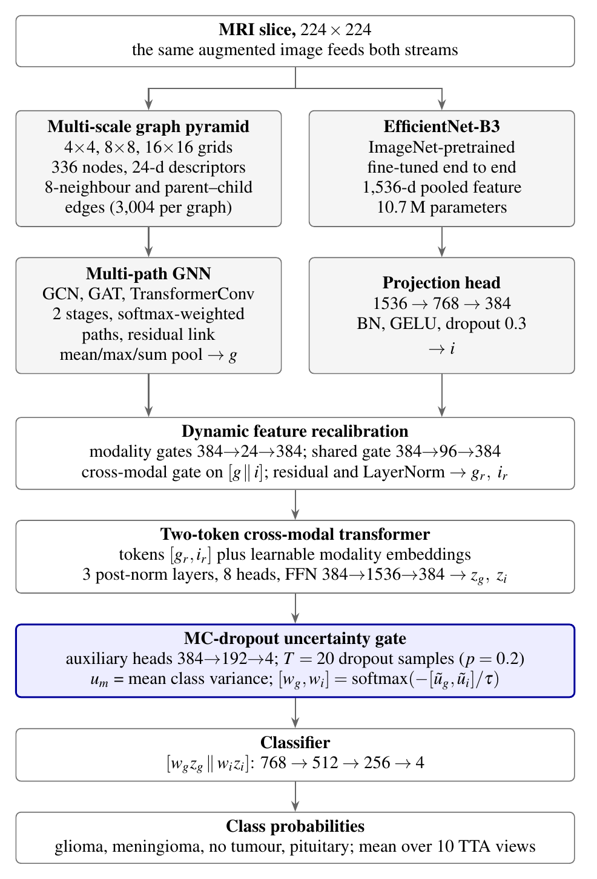
Fig. 3. Architecture of the dual-stream classifier, with layer sizes from the released code. $g$ and $i$ are the graph and image embeddings, $g_{r}$ and $i_{r}$ their recalibrated versions, $z_{g}$ and $z_{i}$ the transformer outputs and $w_{g}$, $w_{i}$ the uncertainty-based fusion weights.

A. Input Pre-Processing
Each image is read as three-channel RGB and resized to $224×224$ pixels. The CNN input is normalised with ImageNet channel means $\left(0.485,0.456,0.406\right)$ and standard deviations $\left(0.229,0.224,0.225\right)$. Training augmentation applies a horizontal flip ($p=0.5$) and brightness and contrast jitter whose strength grows linearly over the first 15 epochs, up to factors of $±0.35$. Saturation and hue jitter are not used, because they leave slices stored as greyscale (identical channels) unchanged. The same transformed image feeds both streams, so the two views stay spatially and photometrically aligned.

B. Multi-Scale Graph Pyramid
The greyscale image is divided into non-overlapping grids of $s×s$ patches for $s∈\{4,8,16\}$, giving patches of 56, 28 and 14 pixels (Fig. 4). Each patch is a node, so every image yields a graph of
N=s∈{4,8,16}​s2=16+64+256=336 nodes.
Each node carries a 24-dimensional descriptor computed on the 0–255 intensity scale:
- intensity statistics: mean, standard deviation, minimum, maximum, median, variance and the 25th, 50th, 75th and 90th percentiles (intensities divided by 255, variance by ${255}^{2}$);
- texture: mean absolute vertical and horizontal gradients and mean gradient magnitude;
- intensity proportions: pixels above 128, below 64, above the patch mean, between 64 and 192, and above 192;
- position and scale: the patch’s grid row and column divided by $s$, their distance from $\left(0.5,0.5\right)$, their normalised sum, $s/16$ and $1/s$.
Within each level, a node is linked to its eight spatial neighbours. Between consecutive levels, each fine node is linked in both directions to the coarse node that contains it, with parent index $\left(⌊i/2⌋,⌊j/2⌋\right)$. This gives 3,004 directed edges per graph: 2,364 within levels and 640 between them. The topology is identical for every image; only the node descriptors change.
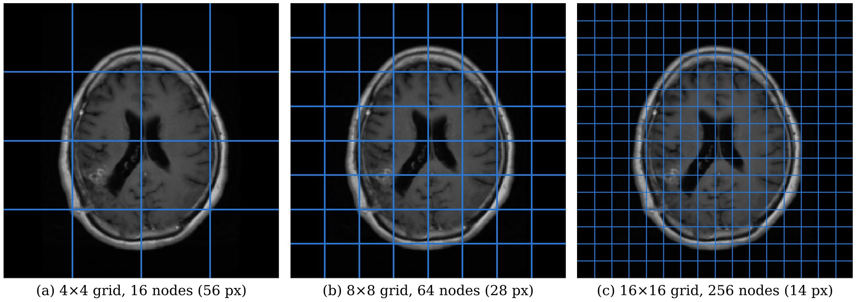
Fig. 4. Graph pyramid on the glioma slice of Fig. 1(a), resized to $224×224$: (a) $4×4$, (b) $8×8$ and (c) $16×16$ grids, whose patches form the 16, 64 and 256 graph nodes.

C. Multi-Path Graph Neural Network
Descriptors are projected to 128 dimensions by a linear layer, batch normalisation (BN) and GELU. Two stages follow. Each stage runs three operators in parallel on the same input: GCN [16], GAT [17] and TransformerConv [18]. The attention operators use four heads in stage 1 and two in stage 2, averaged rather than concatenated, with attention dropout 0.1. GCN and GAT add self-loops; TransformerConv does not. Each path is followed by BN and GELU, and the paths are mixed by softmax-normalised learnable weights:
h1=Drop0.20m​αm GELUBNfm1x,E,h2=Drop0.15(BN(h1 +m​βm GELUBNfm2h1,E)),
where $m∈\{GCN,GAT,TR\}$, $α=softmax\left(a\right)$ and $β=softmax\left(b\right)$. The logits $a$ and $b$ start at zero, so each path initially receives a weight of $1/3$. Mean, max and sum pooling over all nodes are concatenated ($3×128$; because every graph has 336 nodes, the sum-pooled vector is a fixed multiple of the mean-pooled one, and it is kept to match the trained models) and projected by a linear layer, BN, GELU and dropout (0.2) to the graph embedding $g∈R^{384}$.

D. EfficientNet-B3 Image Stream
The image stream is the torchvision EfficientNet-B3 [14] initialised with ImageNet weights, with its classifier removed. It is fine-tuned end to end, with no frozen layers, at $224×224$ input rather than the $300×300$ resolution used for B3 in [14]. The 1,536-dimensional pooled feature passes through a projection head: linear $1,536→768$, BN, GELU, dropout 0.3, linear $768→384$, BN, GELU. This gives the image embedding $i∈R^{384}$.

E. Dynamic Feature Recalibration
Three kinds of sigmoid gate rescale the embeddings, in the spirit of squeeze-and-excitation [19]. Modality gates ($384→24→384$ with GELU) rescale each embedding. A shared gate ($384→96→384$ with LayerNorm and GELU) applies to both. A cross-modal gate ($768→384→384$ with LayerNorm and GELU) produces one mask from the concatenated pair. With $⊙$ for element-wise multiplication and LN for layer normalisation:
$$\begin{matrix}g_{c}=g⊙σ\left(M_{g}\left(g\right)\right), i_{c}=i⊙σ\left(M_{i}\left(i\right)\right), \\ g_{s}=g_{c}⊙σ\left(M_{s}\left(g_{c}\right)\right), i_{s}=i_{c}⊙σ\left(M_{s}\left(i_{c}\right)\right), \\ m=σ\left(M_{c}\left(\left[ g_{s} ∥ i_{s} \right]\right)\right), \\ g_{r}=LN\left(g_{s}⊙m+g\right), i_{r}=LN\left(i_{s}⊙m+i\right).\end{matrix}$$

F. Two-Token Cross-Modal Transformer
The recalibrated vectors are stacked as a two-token sequence $X_{0}∈R^{2×384}$, and a learnable modality embedding (initialised from $N\left(0,{0.02}^{2}\right)$) is added. Three post-norm transformer blocks [20] follow, each with eight-head self-attention, a feed-forward network $384→1,536→384$ with GELU, and dropout 0.05:
$$\begin{matrix}{\tilde{X}}_{l}=LN\left(X_{l−1}+MHA\left(X_{l−1},X_{l−1},X_{l−1}\right)\right), \\ X_{l}=LN\left({\tilde{X}}_{l}+FFN\left({\tilde{X}}_{l}\right)\right).\end{matrix}$$
The first output token is the refined graph vector $z_{g}$ and the second the refined image vector $z_{i}$. With two tokens, each head’s attention is a $2×2$ weighting between the modalities.

G. MC-Dropout Uncertainty-Guided Gating
Each modality has an auxiliary head $H_{m}$ ($384→192→4$ with GELU). To estimate how stable each head’s prediction is, the embedding is replicated $T=20$ times and passed through dropout with $p=0.20$, which stays active at inference. The per-modality uncertainty is the class-averaged variance of the sampled probabilities [9]:
$$\begin{matrix}p_{m}^{\left(t\right)}=softmax\left(H_{m}\left({Drop}_{0.2}\left(z_{m}\right)\right)\right), \\ u_{m}=\frac{1}{C}\sum_{c=1}^{C}{{Var}_{t=1,…,T}}\left(p_{m,c}^{\left(t\right)}\right), C=4.\end{matrix}$$
The two scores are normalised by their mean and turned into fusion weights by a softmax with a learnable temperature $τ=softplus\left(ρ\right)+{10}^{−6}$, where $ρ$ is initialised at 0 (so $τ$ starts at 0.693):
$$\begin{matrix}{\tilde{u}}_{m}=\frac{u_{m}}{1/2\left(u_{g}+u_{i}\right)+{10}^{−8}}, \\ \left[w_{g},w_{i}\right]=softmax\left(−\left[{\tilde{u}}_{g},{\tilde{u}}_{i}\right]/τ\right).\end{matrix}$$
The weighted vectors $w_{g}z_{g}$ and $w_{i}z_{i}$ are passed on. Dropout is applied only in front of the auxiliary heads, so $u_{m}$ measures the stability of those heads rather than the full epistemic uncertainty of the network. Gradients flow through the uncertainty computation; it is not detached.

H. Classification Head and Objective
The concatenated vector $\left[w_{g}z_{g} ∥ w_{i}z_{i}\right]∈R^{768}$ passes through linear $768→512$, BN, GELU, dropout 0.4, linear $512→256$, BN, GELU, dropout 0.3 and linear $256→4$. The loss combines the main cross-entropy with the two auxiliary heads (applied to the non-dropped embeddings). All three terms use label smoothing $ε=0.03$ [25] on logits clipped to $\left[−20,20\right]$:
$$L=L_{main}+λ⋅1/2\left(L_{g}+L_{i}\right), λ=0.15.$$

I. Test-Time Augmentation
At test time, class probabilities are averaged over ten deterministic views [22]: identity, horizontal flip, rotations of $±5^{∘}$, brightness $×0.9$ and $×1.1$, contrast $×0.9$ and $×1.1$, a $1.05×$ centre zoom, and horizontal flip with brightness $×1.1$. Each view feeds both streams:
$$p_{final}\left(x\right)=\frac{1}{10}\sum_{a=1}^{10}{softmax}\left(f\left(T_{a}\left(x\right)\right)\right).$$
All views use the same resizing as training and validation.

V. Experimental Setup and Evaluation Protocol

A. Implementation
The model was implemented in PyTorch [34] with PyTorch Geometric [35] and the torchvision EfficientNet-B3. It was trained on single-GPU Kaggle notebook sessions with an NVIDIA Tesla T4 (PyTorch 2.11.0 with CUDA 12.8, PyTorch Geometric 2.8.1) and automatic mixed precision. Each fold ran as a separate session, with only the fold index changed; one fold took about 17 min per epoch and 6.8 h in total.

B. Cross-Validation and Test Isolation
Duplicate-aware groups: Before splitting, related images were merged into groups by union–find. First, all files sharing a source-slice stem and class (G_710.jpg, G_710_RO_.jpg, …) were joined. Second, a 64-bit perceptual hash (pHash) was computed for every image, and any two images whose hashes differed in at most 5 bits were joined, regardless of file name or class. This reduced the 12,064 images to 3,873 groups: 1,871 single images and 2,002 groups of two or more (largest 93 images).
Outer and inner splits: Stratified group five-fold cross-validation (scikit-learn StratifiedGroupKFold, shuffled, random state 42) was applied to the merged images, giving test folds of 2,310–2,539 images with near-identical class proportions. Within the remaining data of each fold, about 8% of the groups (a grouped split with random state $42+k$ for zero-based fold $k$; 718–1,030 images) served for validation and checkpoint selection. For every fold, it was verified in code that no group was shared between training, validation and test images. Test images were used only after the fold’s checkpoint had been selected and reloaded.
Grouping removes the leakage that file names and image similarity reveal. Patient identifiers are unavailable, so different slices of one patient can still fall on both sides of a split, and the estimates remain slice-level rather than patient-level.
Image-level reference: To measure leakage, the same architecture was also evaluated with an earlier version of the training script that used a conventional image-level stratified split (test folds of 2,412–2,413 images) and selected checkpoints on validation accuracy (Section VII-A).

C. Optimisation and Model Selection
The training configuration, identical for all folds, is listed in Table III. The checkpoint with the lowest validation cross-entropy was kept. Because the gate’s MC dropout also runs during validation, the random number generator was re-seeded before every validation pass, so that the dropout masks, and therefore the selection criterion, did not change randomly from epoch to epoch.
TABLE III. Training Configuration, Identical for All Folds
Setting | Value
Optimiser | AdamW [36], weight decay 0.01
Peak learning rate | $3×{10}^{−4}$; $6×{10}^{−5}$ for GAT, TransformerConv and cross-modal attention modules (with their normalisation layers)
Schedule | OneCycle [37] over 30 epochs, 10% warm-up, cosine annealing
Batch size | 36 (243–249 training batches per epoch)
Max. epochs / early stopping | 30 / patience 5 on validation cross-entropy
Loss | Section IV-H: label smoothing 0.03, auxiliary weight $λ=0.15$
Gradient clipping | global norm 1.0
MC-dropout samples / rate | $T=20$ / $p=0.20$
Test-time augmentation | 10 deterministic views (Section IV-I)
Random seed | 42 (Python, NumPy, PyTorch, CUDA; deterministic cuDNN)

D. Metrics
We report accuracy and macro-averaged precision, recall and F1, which weight the four classes equally. With $N$ test images, $C=4$ classes and per-class precision $P_{c}$ and recall $R_{c}$:
$$Acc=\frac{1}{N}\sum_{n=1}^{N}{1}\left[{\hat{y}}_{n}=y_{n}\right], {F1}_{macro}=\frac{1}{C}\sum_{c=1}^{C}{\frac{2P_{c}R_{c}}{P_{c}+R_{c}}}.$$
Class-wise sensitivity (recall) and specificity are computed one-vs-rest. Calibration is measured by top-label ECE with ten equal-width confidence bins $B_{b}$ [8], [23] and by the multiclass Brier score [24], summed over classes (range 0–2):
$$\begin{matrix}ECE=\sum_{b=1}^{10}{\frac{\left|B_{b}\right|}{N}} |acc\left(B_{b}\right)−conf\left(B_{b}\right)|, \\ Brier=\frac{1}{N}\sum_{n=1}^{N}{\sum_{c=1}^{C}{(}}p_{n,c}−1\left[y_{n}=c\right])^{2}.\end{matrix}$$
We also report the negative log-likelihood (NLL) of the true class.

E. Aggregation and Verification
Fold-level metrics are summarised as mean $±$ sample standard deviation ($n=5$). Each image is predicted only by the model of the fold in which it was held out. The five prediction files were concatenated into one set of 12,064 out-of-fold (OOF) predictions, used for the pooled confusion matrix, per-class analysis and reliability diagram. The five models are never ensembled on these data. Pooled 95% confidence intervals come from 2,000 bootstrap resamples [38] of whole duplicate groups, because errors are correlated within a group (Section VII-B).
Before analysis, every saved metric was recomputed independently from the per-image predictions. The five test folds were checked to be pairwise disjoint, to cover all 12,064 images exactly once and to share no group with their training data. All recomputed values matched the saved ones.

VI. Results
All results in this section come from the duplicate-aware split of Section V-B.

A. Fold-Wise Performance
Across the five folds, accuracy was $96.54±1.71\%$ and macro-F1 $96.36±1.81\%$ (Table IV). Folds 1, 2 and 4 reached 97.06–98.16%; folds 3 and 5 reached 95.16% and 94.34%, with 123 and 140 errors (see also Fig. 8). Early stopping selected checkpoints between epochs 8 and 16.
TABLE IV. Held-Out Performance per Fold Under the Duplicate-Aware Split (Macro-Averaged Precision, Recall and F1)
Fold | Images | Accuracy (%) | Prec. (%) | Recall (%) | F1 (%) | ECE | Brier | NLL | Errors | Best ep.
1 | 2,343 | 97.06 | 96.81 | 96.85 | 96.83 | 0.0140 | 0.0495 | 0.1281 | 69 | 16
2 | 2,310 | 97.97 | 97.68 | 98.03 | 97.84 | 0.0139 | 0.0374 | 0.1098 | 47 | 15
3 | 2,539 | 95.16 | 95.02 | 95.43 | 95.11 | 0.0131 | 0.0809 | 0.1890 | 123 | 8
4 | 2,397 | 98.16 | 98.15 | 98.09 | 98.11 | 0.0243 | 0.0301 | 0.0810 | 44 | 11
5 | 2,475 | 94.34 | 94.57 | 93.58 | 93.89 | 0.0248 | 0.0944 | 0.2064 | 140 | 11
Mean $±$ SD | – | 96.54 ± 1.71 | 96.45 ± 1.59 | 96.39 ± 1.91 | 96.36 ± 1.81 | 0.018 ± 0.006 | 0.058 ± 0.028 | 0.143 ± 0.053 | 423 | –

B. Pooled Out-of-Fold Performance
Pooling the 12,064 out-of-fold predictions gave 11,641 correct classifications: 96.49% accuracy (95% group-bootstrap CI 95.50–97.37%) and macro-F1 96.40% (95.36–97.29%). Pooled ECE was 0.012 (0.008–0.018), Brier 0.059 (0.044–0.076) and NLL 0.144. Resampling single images instead of groups would give a CI about half as wide (accuracy 96.17–96.83%), which overstates the precision because errors cluster within groups.

C. Per-Class Performance and Errors
Sensitivity ranged from 95.02% (no tumour) to 97.40% (meningioma), and specificity from 98.23% to 99.27% (Table V). Meningioma had the lowest precision, because glioma and pituitary images were often called meningioma.
TABLE V. Per-Class Results on the Pooled Out-of-Fold Predictions ($n=12,064$)
Class | Support | Prec. (%) | Sens. (%) | Spec. (%) | F1 (%)
Glioma | 3,773 | 97.30 | 96.58 | 98.78 | 96.94
Meningioma | 2,729 | 94.16 | 97.40 | 98.23 | 95.75
No tumour | 2,432 | 96.17 | 95.02 | 99.04 | 95.59
Pituitary | 3,130 | 97.90 | 96.74 | 99.27 | 97.32
The 423 errors are spread over several class pairs (Fig. 5): glioma–meningioma 112 (26%), glioma–no tumour 108 (26%), meningioma–pituitary 88 (21%), no tumour–pituitary 69, meningioma–no tumour 36 and glioma–pituitary 10. Ninety-two of 9,632 tumour images (0.96%) were called tumour-free, and 121 of 2,432 tumour-free images (4.98%) were called tumour, 69 of them glioma.
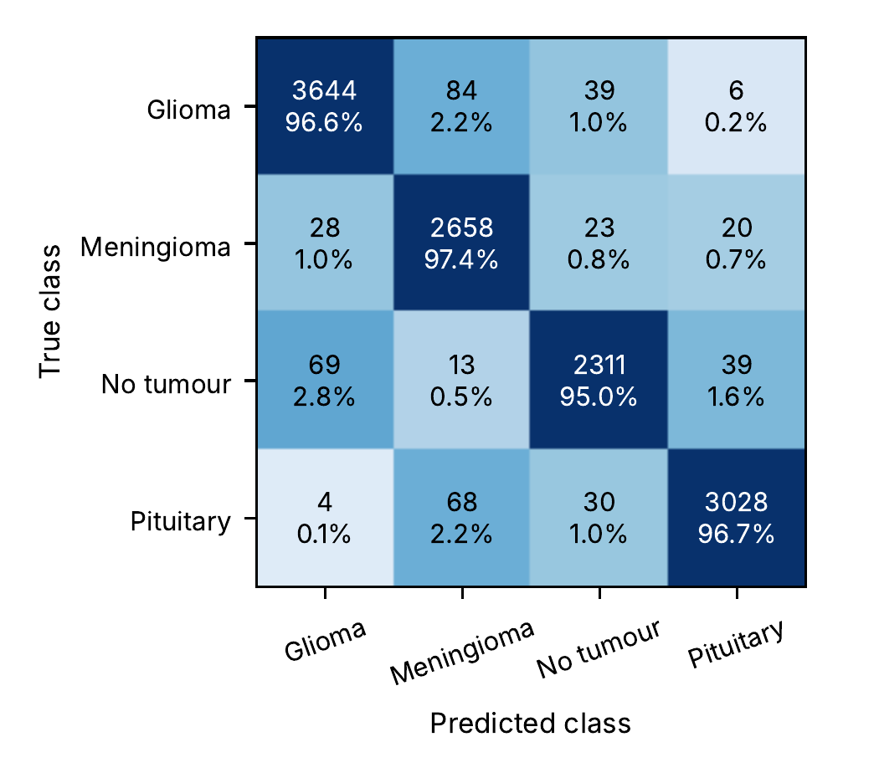
Fig. 5. Pooled out-of-fold confusion matrix of the duplicate-aware five-fold cross-validation ($n=12,064$). Each cell gives the image count and the row percentage; shading follows the row percentage on a logarithmic scale so that small error counts remain visible.

D. Calibration
The confidence of the top bin matched its accuracy closely: 11,577 images (96.0%) were predicted with confidence above 0.9, with 98.17% accuracy at 97.73% mean confidence (Fig. 6). Below 0.9 the model was over-confident; for example, the 206 images in the 0.8–0.9 bin had 64.1% accuracy at 86.0% mean confidence. The highest probability assigned to any image was 0.984.
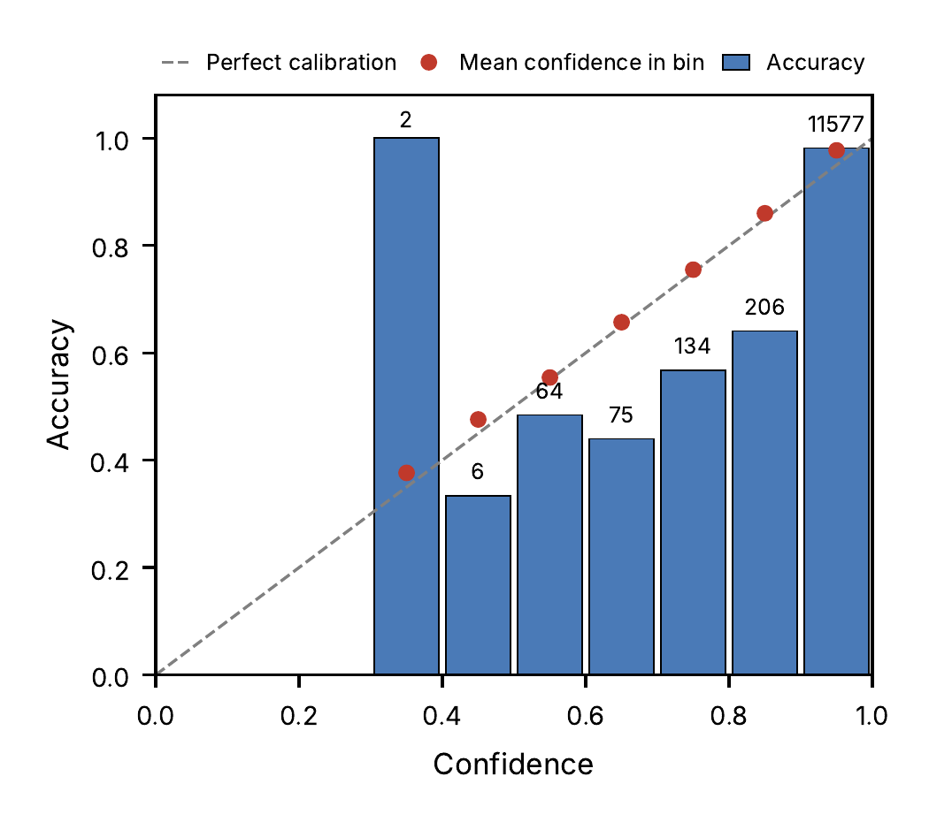
Fig. 6. Reliability diagram of the pooled out-of-fold predictions of the duplicate-aware cross-validation (12,064 images, ten equal-width bins; numbers above the bars give the images per bin).
Confidence is only partly informative for triage. The 487 images (4.0%) predicted with confidence below 0.9 had 56.7% accuracy and contained 211 of the 423 errors (50%). However, 199 errors (47%) were made at confidence of 0.95 or higher, and 175 of these belonged to groups in which at least half of the copies were misclassified (Section VII-B).

E. Model Size and Cost
The model has 19,350,155 trainable parameters (Table VI). A single forward pass costs about 2.26 GFLOPs of dense operations, measured with the PyTorch FLOP counter (torch.utils.flop_counter) at $224×224$ input; graph message passing is not included.
TABLE VI. Parameter Count per Module (Identical in All Five Checkpoints)
Module | Parameters | Share
EfficientNet-B3 features | 10,696,232 | 55.3%
Image projection head | 1,478,016 | 7.6%
Cross-modal transformer | 5,324,160 | 27.5%
Multi-path GNN (graph stream) | 617,222 | 3.2%
Dynamic recalibration | 557,520 | 2.9%
Classifier | 527,620 | 2.7%
Uncertainty heads and $τ$ | 149,385 | 0.8%
Total | 19,350,155 | 100%
On the Tesla T4, one forward pass, including the 20 MC-dropout samples of the gate, took 21.1 ms per image. Building one graph on the notebook’s CPU took 232 ms, and the complete ten-view TTA pipeline, which builds a graph for every view, took 2.63 s per image. Graph construction therefore dominates inference time.

F. Learned Fusion Parameters
The learned path weights stayed close to their initial value of $1/3$ in all five folds: every component of $softmax\left(a\right)$ and $softmax\left(b\right)$ lay between 0.327 and 0.341 (fold 1: $\left(0.329,0.330,0.341\right)$ and $\left(0.333,0.336,0.330\right)$ for GCN, GAT and TransformerConv). The gate temperature rose from its initial 0.693 to 0.743–0.768.
The uncertainty gate favoured the image stream. Averaged over the ten TTA views, the image weight $w_{i}$ had a mean of 0.731 and a median of 0.866, and it exceeded 0.5 for 79.5% of the test images (fold means 0.82, 0.69, 0.72, 0.69 and 0.73). Misclassified images had a higher mean image weight (0.806) than correctly classified ones (0.729).

G. Ablation Study: Four Models
The four variants of the workflow (Fig. 2, panel E) were trained on the same duplicate-aware folds with otherwise identical settings: the baseline uses only the EfficientNet-B3 stream (with its projection head and the same classifier); Variant A uses only the graph pyramid and multi-path GNN; Variant B concatenates the two embeddings without recalibration, transformer or gate; and the proposed model is the complete framework. Table VII summarises the results, Fig. 7 shows the pooled out-of-fold confusion matrix of each model, and Fig. 8 shows the fold-by-fold behaviour. Because every model is evaluated on the same images, the variants are compared with the full model by McNemar’s exact test on the paired out-of-fold predictions and, because errors cluster within groups, by a group-bootstrap 95% CI of the difference in pooled accuracy (4,000 resamples of whole groups).
The image stream alone matched the complete framework. The baseline reached $96.58±1.44\%$ accuracy (pooled 96.55%), against $96.54±1.71\%$ (pooled 96.49%) for the full model; 138 images were classified correctly only by the full model and 145 only by the baseline (McNemar $p=0.72$), and the difference in pooled accuracy was $−0.06$ percentage points (95% CI $−0.61$ to $+0.46$). The graph stream alone was much weaker, at $87.48±1.73\%$ (pooled 87.43%; difference $+9.06$ points in favour of the full model, CI $+7.76$ to $+10.48$, p < 10⁻²⁰⁰); it confused meningioma most, with 72.8% sensitivity (Fig. 7). Plain concatenation of the two streams reached $96.25±1.74\%$ (pooled 96.21%). The full model was 0.28 points more accurate; this difference was nominally significant by McNemar’s test ($p=0.049$), which treats images as independent, but its group-bootstrap CI included zero ($−0.16$ to $+0.72$). Across folds, the three models that contain the image stream moved together (Fig. 8): all were weakest in folds 3 and 5, the folds that contain the hard source slices of Section VII-B. The image-only model has 12.5 M parameters, against 19.35 M for the full model, and it needs no graph construction at inference.
TABLE VII. Ablation on the Same Duplicate-Aware Folds (Mean $±$ SD Over Five Folds; Pooled Out-of-Fold Accuracy in Parentheses)
Model | Accuracy (%) | Macro-F1 (%) | ECE | McNemar $p$ vs. full
Baseline: image stream only | 96.58 ± 1.44 (96.55) | 96.45 ± 1.51 | 0.015 ± 0.006 | 0.72
Variant A: graph stream only | 87.48 ± 1.73 (87.43) | 87.13 ± 1.79 | 0.030 ± 0.009 | < 10⁻²⁰⁰
Variant B: concatenation | 96.25 ± 1.74 (96.21) | 96.14 ± 1.85 | 0.019 ± 0.004 | 0.049
Proposed: complete framework | 96.54 ± 1.71 (96.49) | 96.36 ± 1.81 | 0.018 ± 0.006 | –
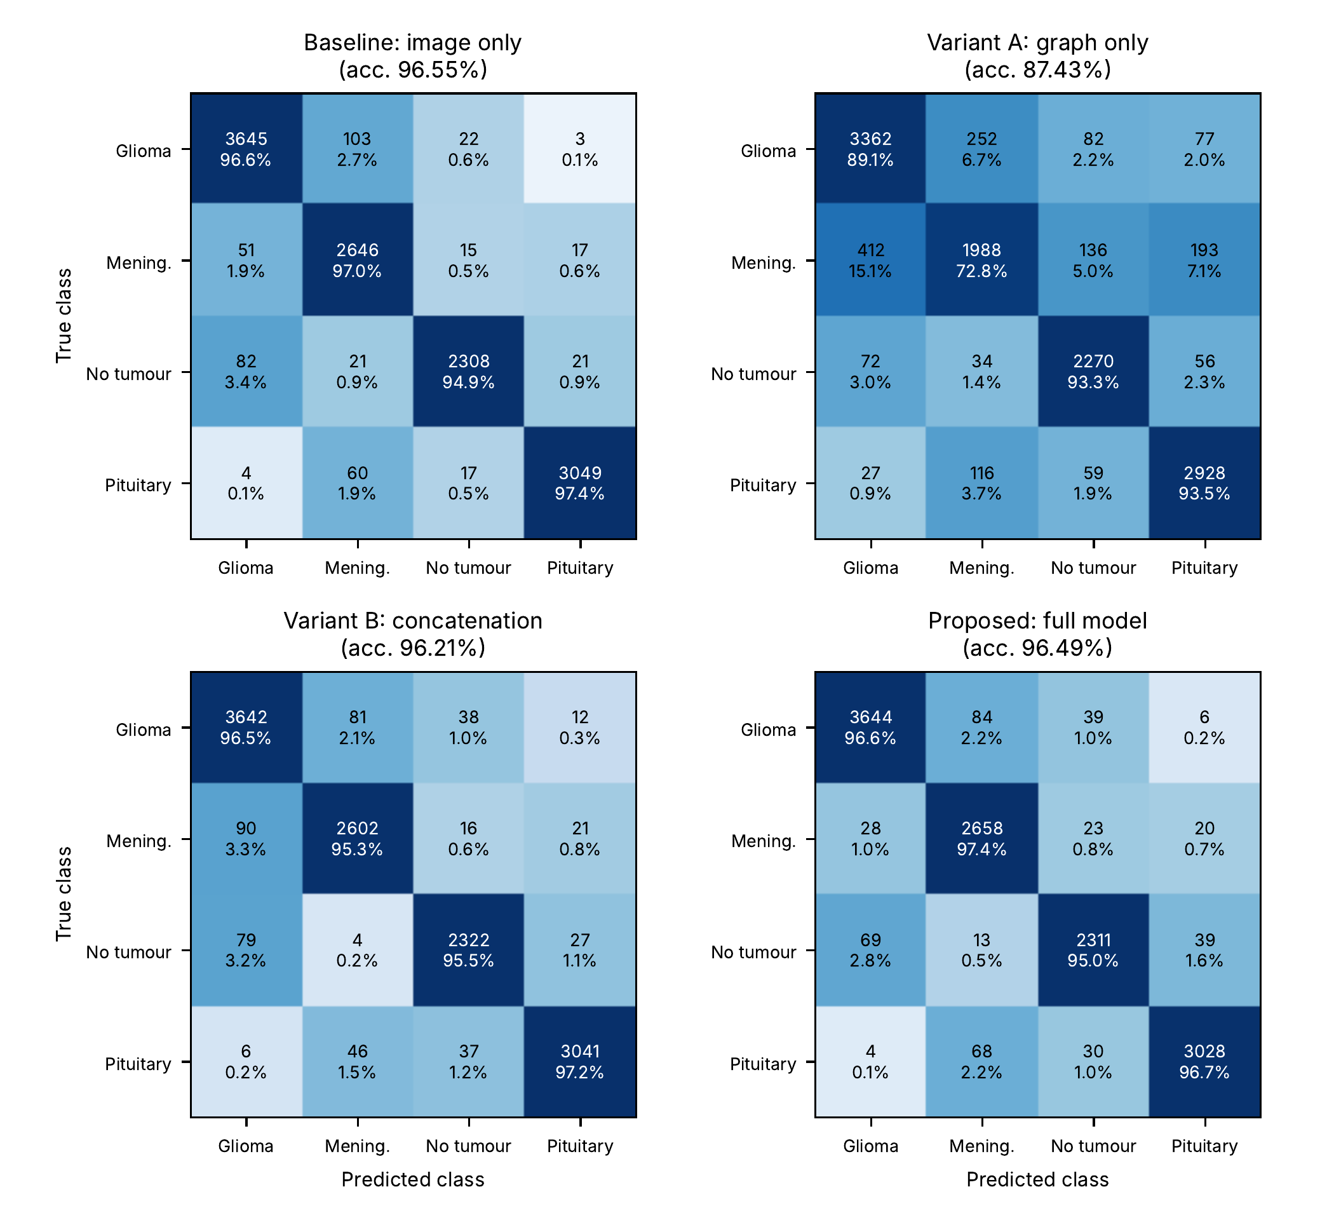
Fig. 7. Pooled out-of-fold confusion matrices of the four models on the duplicate-aware folds ($n=12,064$ each). Each cell gives the image count and the row percentage.
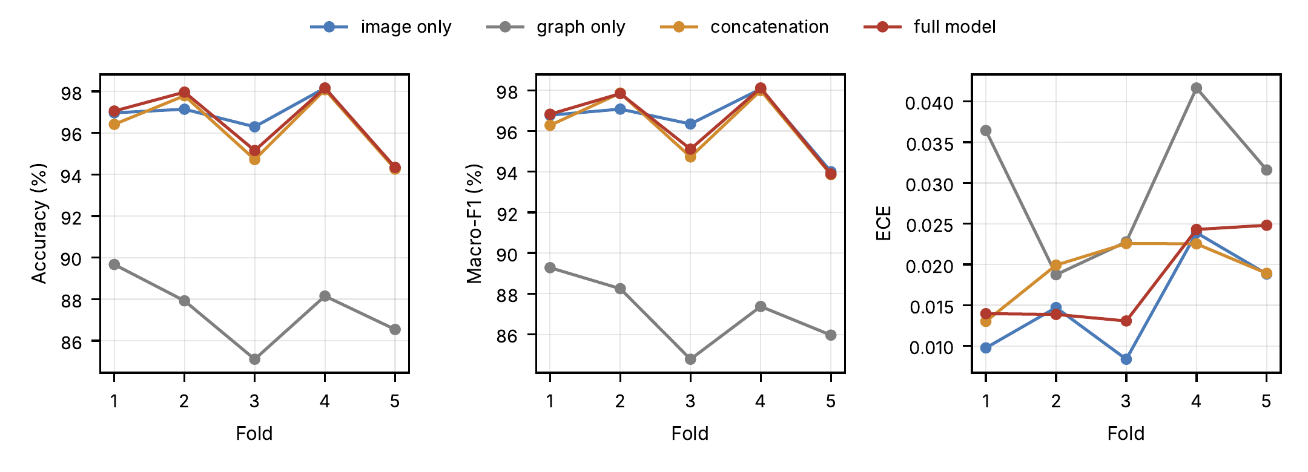
Fig. 8. Five-fold cross-validation results per fold for the four models; from left to right: accuracy, macro-F1 and expected calibration error. All models use the same duplicate-aware folds.

VII. Discussion

A. How Much Does Duplicate Leakage Inflate Accuracy?
The same architecture lost 2.6 percentage points of accuracy when near-duplicate groups were kept on one side of the split, and its error count rose fourfold (Table VIII). Under the image-level split, accuracy was $99.15±0.39\%$ with 103 errors; under the duplicate-aware split it was $96.54±1.71\%$ with 423 errors. Sensitivity fell for every class, most for no tumour (99.55% to 95.02%).
TABLE VIII. The Same Architecture Under an Image-Level and a Duplicate-Aware Five-Fold Split
Metric | Image-level split | Duplicate-aware split
Accuracy, mean $±$ SD (%) | 99.15 ± 0.39 | 96.54 ± 1.71
Pooled accuracy (%) | 99.15 | 96.49
Macro-F1, mean $±$ SD (%) | 99.15 ± 0.40 | 96.36 ± 1.81
ECE, mean $±$ SD | 0.021 ± 0.003 | 0.018 ± 0.006
Errors (of 12,064) | 103 | 423
Sensitivity, glioma (%) | 98.97 | 96.58
Sensitivity, meningioma (%) | 98.53 | 97.40
Sensitivity, no tumour (%) | 99.55 | 95.02
Sensitivity, pituitary (%) | 99.58 | 96.74
The increase was largest where duplication is greatest (Table IX). The error rate of the augmented-copy family (G/M/P/N_###), whose seven copies of each slice had almost always been split between training and test, rose sevenfold, from 0.85% to 5.89%. Error rates also rose in every other large family. This is consistent with the perceptual-hash grouping having removed near-duplicates across source collections, which file names do not reveal.
TABLE IX. Error Rate by File-Name Family Under the Two Splits (Pooled Out-of-Fold Predictions)
File-name family | Images | Image-level error (%) | Duplicate-aware error (%)
image(n) | 249 | 6.02 | 18.47
G/M/P/N_### (+ aug.) | 4,246 | 0.85 | 5.89
#.jpg | 1,914 | 0.31 | 2.09
Tr-xx_#### | 3,784 | 0.98 | 1.61
gg/m/p (n) | 935 | 0.64 | 1.50
Te-xx_#### | 858 | 0.23 | 1.40
N#, # no | 76 | 1.32 | 0.00
Within the image-level run, this leakage was invisible. Test images whose augmented siblings were in training had the same accuracy as the remaining images (99.15% against 99.14%), which suggested that leakage did not matter. The grouped split shows that it did. The “remaining” images were not leak-free either, because many had near-duplicates from other source collections in training. A within-run comparison cannot replace a grouped re-split. One caveat applies: the image-level run used an earlier version of the training script, which also selected checkpoints on validation accuracy, applied saturation and hue jitter, and used a saturation view instead of the zoom view in TTA. These differences are small and are unlikely to explain a fourfold increase in errors that is concentrated in the duplicated families, but the two runs do not differ in the split alone.
Label conflicts: The hash comparison also exposed inconsistent labels. Of the near-duplicate pairs, 108 carry different labels: glioma–meningioma 49, glioma–no tumour 45, meningioma–no tumour 10 and meningioma–pituitary 4. In total, 25 groups (538 images) contain more than one class. The four meningioma–pituitary pairs have identical hashes: four images named Tr-me_0828, 0829, 0831 and 0942 (meningioma) are, after a horizontal flip, the images P_834_HF_, P_836_HF_, P_843_HF_ and P_833_HF_ (pituitary). In the image-level run, all four meningiomas were predicted as pituitary, with confidence 0.95–0.97. They are label conflicts within the dataset, not model failures, and under the grouped split one image of each pair is necessarily counted as an error.

B. Where the Errors Come From
Errors cluster within source slices. The 423 errors fall in only 136 of the 3,873 groups; in 91 of these groups at least half of the images were misclassified, and these groups account for 338 errors (80%). The ten worst groups alone hold 151 errors. For example, 23 of 25 copies of the tumour-free slice N_378 were called glioma and 17 of 20 copies of N_375 were called pituitary (both in fold 5), and 19 of 20 copies of the pituitary slice P_818 were called tumour-free (fold 3). When the model fails on a source slice, it fails on most of its augmented copies, often with high confidence. Several of these groups also contain images from another naming family; the group of N_378, for instance, includes 1729.jpg, a cross-source duplicate that only the hash comparison revealed. Offline-augmented copies had a higher error rate than the remaining images (5.93% against 2.46%), because they come in large groups that succeed or fail together.
This clustering explains the fold-to-fold variation. In fold 3, 56% of the 123 errors came from five groups, and in fold 5, 78 of the 140 errors came from five source slices, four of them tumour-free. Which hard slices a fold happens to contain matters more than the number of test images, and the effective sample size is closer to the number of groups than to the number of images. This is why we report group-bootstrap intervals.
The second source of errors is the image(n) family, the test-split naming of one public source [29]. Its error rate was 18.5% (46 of 249), three times that of the next family. Users of a public mirror of a related compilation have reported mislabelled glioma images in this source [30], and its misclassified images include an apparent CT slice and a T2-weighted slice, modalities that the dataset description does not mention (Fig. 9). These errors point to label noise and modality heterogeneity rather than to model failure alone; expert re-reading is needed to confirm this.
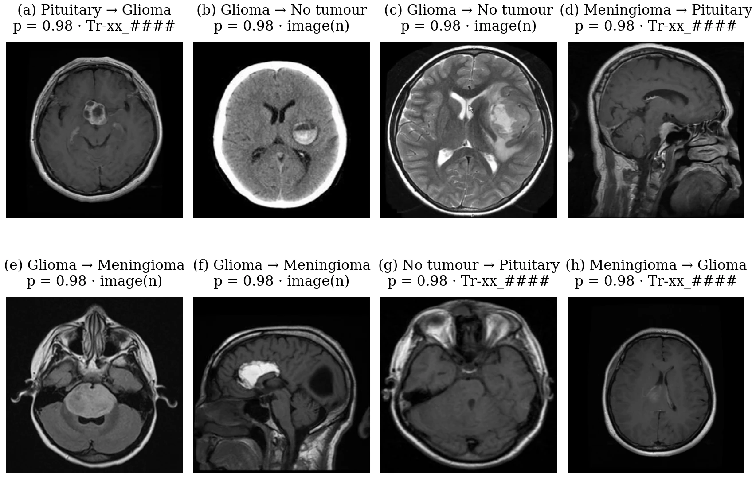
Fig. 9. The eight most confident out-of-fold errors of the image-level run, each labelled with true class $→$ predicted class, the predicted probability $p$ and the file-name family. Panel (b) appears to be a CT slice and panel (c) a T2-weighted MR slice, although the dataset is described as contrast-enhanced T1-weighted MRI.

C. Calibration and Fold-to-Fold Variability
In the top confidence bin, confidence and accuracy nearly coincided (97.7% and 98.2%). This agrees with the label-smoothing target: with $ε=0.03$ and four classes, the training target for the true class is $1−ε+ε/4=0.9775$, and the highest predicted probability was 0.984 [26]. Below 0.9 the model was over-confident, and almost half of the errors were made with confidence of at least 0.95, mostly in groups that were misclassified as a whole. Confidence thresholds catch hesitant predictions but not systematic failures on a source slice. Post-hoc temperature scaling fitted on the validation split [8] could reduce the mid-range over-confidence, but not these confident group-level errors.
The pooled ECE (0.012) is lower than the mean of the fold-wise values (0.018), because fold-specific deviations partly cancel when the folds are pooled. Checkpoint selection was deterministic in this run, so the remaining fold-to-fold variation reflects the data in each fold rather than random selection.

D. What the Trained Parameters Reveal
The parameter analysis tempers the architectural claims. The graph stream holds 3.2% of the parameters, while the two-token cross-modal transformer holds 27.5%; with two tokens, each attention head reduces to a $2×2$ weighting of the modalities. The learnable path weights of the multi-path GNN stayed within 0.008 of $1/3$ in all five folds, so the three operators act as an equal-weight average rather than an adaptively selected mixture. The gate gave the image stream most of the weight, and it gave it even more weight on misclassified images, so it did not route hard cases to the graph stream.
None of this shows that the components are useless. The four-model ablation (Section VI-G) tests what the graph stream adds to the image stream and what the fusion modules add to plain concatenation. It shows that, on this dataset, the graph stream and the fusion modules add no measurable accuracy: the image-only baseline matched the full model, and the full model’s advantage over plain concatenation (0.28 points) was within the uncertainty caused by clustered errors. The graph stream does carry class information (87.5% on its own), but it appears to be largely redundant with what EfficientNet-B3 already extracts, which is consistent with the gate’s preference for the image stream. The individual contributions of recalibration, the transformer, the uncertainty gate and the three GNN operators are not isolated separately.

E. Relation to Prior Results
Published accuracies are not directly comparable to ours. Tummala et al. reported 98.7% with a ViT ensemble on the three-class figshare data [6], and Gürsoy and Kaya 93.68% with a CNN–GCN hybrid on a 10,847-image collection [7]. Datasets, class sets and split units differ across these studies, and duplication levels are rarely reported. Our own image-level result of 99.15% would have ranked among the highest published figures, yet 2.6 points of it came from duplicate leakage. We make no state-of-the-art claim for this reason, and we recommend that accuracies on compiled brain tumour collections be reported under a duplicate-aware split.

VIII. Limitations and Future Work
- Slice-level, not patient-level, grouping: Patient identifiers are unavailable. Grouping by file-name stem and perceptual hash removes augmented copies and close near-duplicates, but different slices of one patient can still fall on both sides of a split, so patient-level accuracy may be lower. Next step: a parallel analysis on the de-duplicated Version 7 of the dataset [32] and on a collection with patient identifiers.
- Limited ablation and no external baselines: The ablation covers four models (image only, graph only, concatenation and the full framework). Fixed-gate, transformer-free and single-operator variants, and standard CNN and transformer baselines, remain to be compared on identical folds.
- Single dataset, no external test: All images come from one compiled collection, part of which overlaps by naming with other public sets. An independent test set must first be checked for overlap with the training data.
- Label quality and provenance: The dataset contains near-duplicate pairs with conflicting labels, mixes MR contrasts and includes at least one apparent CT image, and one source shows an error rate consistent with label noise. The origin of the images was inferred from file names. Expert re-reading of the misclassified images and of the conflicting pairs would separate label noise from model error.
- Single training run per fold and an imperfect leakage comparison: Each fold was trained once (seed 42). GPU graph operations are not bit-reproducible, and a repeated training of the full model on fold 1 gave 94.62% instead of 97.06%, so differences of one or two points between single runs should not be over-interpreted. The image-level and grouped runs also differ in checkpoint criterion and in two augmentation details (Section VII-A).
- Two-dimensional slices: The model sees single 2D slices and ignores volumetric context and other MRI sequences.
- Inference cost: With ten TTA views, inference takes about 2.6 s per image, dominated by CPU graph construction.
- Not a clinical device: The model has not been evaluated prospectively or against radiologists, and its outputs are not diagnoses.

IX. Conclusion
Under duplicate-aware five-fold cross-validation, in which no group of augmented copies or near-duplicate slices was shared between training and test data, the dual-stream EfficientNet-B3 and graph model classified four-class brain tumour MRI with $96.54±1.71\%$ accuracy and $96.36±1.81\%$ macro-F1 (pooled 96.49%, 95% CI 95.50–97.37%; RQ1). Its probabilities were well calibrated in the high-confidence range (pooled ECE 0.012), but almost half of the errors were made with high confidence, mostly on source slices whose copies were misclassified together (RQ2). An image-level split of the same data gave $99.15±0.39\%$: duplicate leakage inflated accuracy by 2.6 points and hid three quarters of the errors (RQ3). The audit also revealed near-duplicate images with conflicting labels.
The uncertainty gate relied mainly on the image stream, the graph operators kept equal weights, and a four-model ablation on the same folds showed that EfficientNet-B3 alone was as accurate as the complete framework ($96.58\%$ against $96.54\%$), with fewer parameters and no graph construction. On this dataset, the accuracy gained does not justify the added graph stream and fusion modules. Patient-level validation, further ablations, retrained baselines and an independent external test are the necessary next steps before any claim of clinical generalisation.

Data and Code Availability
The dataset is publicly available on Mendeley Data, Version 1 (doi:10.17632/zwr4ntf94j.1), under a CC BY 4.0 licence [31]. The unmodified copy used for training is mirrored at https://www.kaggle.com/datasets/arafatrahmann/my-data221. The training scripts, the duplicate groups and fold assignments, the per-image out-of-fold predictions of both splits and the audit scripts are available at https://github.com/arafatrahmannoor/Paper-of-brain.

Ethics Statement
This study used only a public, de-identified dataset. No new data were collected and no ethics approval was required.

Acknowledgment
Author contributions: A. Rahman designed and implemented the model, ran the experiments and wrote the manuscript. M. Assaduzzaman supervised the study. Use of AI tools: Claude (Anthropic) was used to help review the training code, write the analysis scripts and edit the language of the manuscript. The authors checked all code, results and text and take full responsibility for the content. [Confirm both statements before submission.]

References
[1] D. N. Louis, A. Perry, P. Wesseling, et al., “The 2021 WHO classification of tumors of the central nervous system: A summary,” Neuro-Oncology, vol. 23, no. 8, pp. 1231–1251, 2021, doi: 10.1093/neuonc/noab106.
[2] J. Cheng, W. Huang, S. Cao, et al., “Enhanced performance of brain tumor classification via tumor region augmentation and partition,” PLoS ONE, vol. 10, no. 10, p. e0140381, 2015, doi: 10.1371/journal.pone.0140381.
[3] S. Deepak and P. M. Ameer, “Brain tumor classification using deep CNN features via transfer learning,” Computers in Biology and Medicine, vol. 111, p. 103345, 2019, doi: 10.1016/j.compbiomed.2019.103345.
[4] Z. N. K. Swati, Q. Zhao, M. Kabir, et al., “Brain tumor classification for MR images using transfer learning and fine-tuning,” Computerized Medical Imaging and Graphics, vol. 75, pp. 34–46, 2019, doi: 10.1016/j.compmedimag.2019.05.001.
[5] M. M. Badža and M. Č. Barjaktarović, “Classification of brain tumors from MRI images using a convolutional neural network,” Applied Sciences, vol. 10, no. 6, p. 1999, 2020, doi: 10.3390/app10061999.
[6] S. Tummala, S. Kadry, S. A. C. Bukhari, and H. T. Rauf, “Classification of brain tumor from magnetic resonance imaging using vision transformers ensembling,” Current Oncology, vol. 29, no. 10, pp. 7498–7511, 2022, doi: 10.3390/curroncol29100590.
[7] E. Gürsoy and Y. Kaya, “Brain-GCN-Net: Graph-convolutional neural network for brain tumor identification,” Computers in Biology and Medicine, vol. 180, p. 108971, 2024, doi: 10.1016/j.compbiomed.2024.108971.
[8] C. Guo, G. Pleiss, Y. Sun, and K. Q. Weinberger, “On calibration of modern neural networks,” in Proc. 34th int. Conf. Mach. Learn. (ICML), in PMLR, vol. 70. 2017, pp. 1321–1330.
[9] Y. Gal and Z. Ghahramani, “Dropout as a Bayesian approximation: Representing model uncertainty in deep learning,” in Proc. 33rd int. Conf. Mach. Learn. (ICML), in PMLR, vol. 48. 2016, pp. 1050–1059.
[10] M. Roberts, D. Driggs, M. Thorpe, et al., “Common pitfalls and recommendations for using machine learning to detect and prognosticate for COVID-19 using chest radiographs and CT scans,” Nature Machine Intelligence, vol. 3, pp. 199–217, 2021, doi: 10.1038/s42256-021-00307-0.
[11] G. Varoquaux and V. Cheplygina, “Machine learning for medical imaging: Methodological failures and recommendations for the future,” npj Digital Medicine, vol. 5, p. 48, 2022, doi: 10.1038/s41746-022-00592-y.
[12] S. Kapoor and A. Narayanan, “Leakage and the reproducibility crisis in machine-learning-based science,” Patterns, vol. 4, no. 9, p. 100804, 2023, doi: 10.1016/j.patter.2023.100804.
[13] J. Wen, E. Thibeau-Sutre, M. Diaz-Melo, et al., “Convolutional neural networks for classification of Alzheimer’s disease: Overview and reproducible evaluation,” Medical Image Analysis, vol. 63, p. 101694, 2020, doi: 10.1016/j.media.2020.101694.
[14] M. Tan and Q. V. Le, “EfficientNet: Rethinking model scaling for convolutional neural networks,” in Proc. 36th int. Conf. Mach. Learn. (ICML), in PMLR, vol. 97. 2019, pp. 6105–6114.
[15] A. Dosovitskiy, L. Beyer, A. Kolesnikov, et al., “An image is worth 16x16 words: Transformers for image recognition at scale,” in Proc. Int. Conf. Learn. Represent. (ICLR), 2021.
[16] T. N. Kipf and M. Welling, “Semi-supervised classification with graph convolutional networks,” in Proc. Int. Conf. Learn. Represent. (ICLR), 2017.
[17] P. Veličković, G. Cucurull, A. Casanova, A. Romero, P. Liò, and Y. Bengio, “Graph attention networks,” in Proc. Int. Conf. Learn. Represent. (ICLR), 2018.
[18] Y. Shi, Z. Huang, S. Feng, H. Zhong, W. Wang, and Y. Sun, “Masked label prediction: Unified message passing model for semi-supervised classification,” in Proc. 30th int. Joint conf. Artif. Intell. (IJCAI), 2021, pp. 1548–1554.
[19] J. Hu, L. Shen, and G. Sun, “Squeeze-and-excitation networks,” in Proc. IEEE/CVF conf. Comput. Vis. Pattern recognit. (CVPR), 2018, pp. 7132–7141.
[20] A. Vaswani, N. Shazeer, N. Parmar, et al., “Attention is all you need,” in Adv. Neural inf. Process. Syst. (NeurIPS), 2017.
[21] A. Kendall and Y. Gal, “What uncertainties do we need in Bayesian deep learning for computer vision?” in Adv. Neural inf. Process. Syst. (NeurIPS), 2017.
[22] G. Wang, W. Li, M. Aertsen, J. Deprest, S. Ourselin, and T. Vercauteren, “Aleatoric uncertainty estimation with test-time augmentation for medical image segmentation with convolutional neural networks,” Neurocomputing, vol. 338, pp. 34–45, 2019, doi: 10.1016/j.neucom.2019.01.103.
[23] M. P. Naeini, G. F. Cooper, and M. Hauskrecht, “Obtaining well calibrated probabilities using Bayesian binning,” in Proc. 29th AAAI conf. Artif. intell., 2015, pp. 2901–2907.
[24] G. W. Brier, “Verification of forecasts expressed in terms of probability,” Monthly Weather Review, vol. 78, no. 1, pp. 1–3, 1950.
[25] C. Szegedy, V. Vanhoucke, S. Ioffe, J. Shlens, and Z. Wojna, “Rethinking the Inception architecture for computer vision,” in Proc. IEEE conf. Comput. Vis. Pattern recognit. (CVPR), 2016, pp. 2818–2826.
[26] R. Müller, S. Kornblith, and G. Hinton, “When does label smoothing help?” in Adv. Neural inf. Process. Syst. (NeurIPS), 2019.
[27] Y. Ovadia, E. Fertig, J. Ren, et al., “Can you trust your model’s uncertainty? Evaluating predictive uncertainty under dataset shift,” in Adv. Neural inf. Process. Syst. (NeurIPS), 2019.
[28] M. Nickparvar, “Brain tumor MRI dataset.” Kaggle, 2021. Available: https://www.kaggle.com/datasets/masoudnickparvar/brain-tumor-mri-dataset
[29] S. Bhuvaji, A. Kadam, P. Bhumkar, S. Dedge, and S. Kanchan, “Brain tumor classification (MRI).” Kaggle, 2020. doi: 10.34740/KAGGLE/DSV/1183165.
[30] J. Chaki, “Brain tumor MRI dataset.” IEEE DataPort (mirror of the Kaggle dataset by M. Nickparvar; see the user comments on the record page). doi: 10.21227/1jny-g144.
[31] M. I. K. Hira, M. S. Hossain, and M. M. A. Bithee, “Brain tumor MRI dataset (glioma, meningioma, pituitary, no tumor).” Mendeley Data, Version 1, 2025. doi: 10.17632/zwr4ntf94j.1.
[32] [Contributors], “BDNeuro-MRI: A Bangladeshi clinical brain tumor MRI dataset for four-class deep learning classification.” Mendeley Data, Version 7. doi: 10.17632/zwr4ntf94j.7.
[33] N. Chakrabarty, “Brain MRI images for brain tumor detection.” Kaggle, 2019. Available: https://www.kaggle.com/datasets/navoneel/brain-mri-images-for-brain-tumor-detection
[34] A. Paszke, S. Gross, F. Massa, et al., “PyTorch: An imperative style, high-performance deep learning library,” in Adv. Neural inf. Process. Syst. (NeurIPS), 2019.
[35] M. Fey and J. E. Lenssen, “Fast graph representation learning with PyTorch Geometric,” in Proc. ICLR workshop represent. Learn. Graphs manifolds, 2019.
[36] I. Loshchilov and F. Hutter, “Decoupled weight decay regularization,” in Proc. Int. Conf. Learn. Represent. (ICLR), 2019.
[37] L. N. Smith and N. Topin, “Super-convergence: Very fast training of neural networks using large learning rates,” in Proc. SPIE artif. Intell. Mach. Learn. Multi-domain oper. appl., 2019, p. 1100612. doi: 10.1117/12.2520589.
[38] B. Efron and R. J. Tibshirani, An introduction to the bootstrap. New York, NY, USA: Chapman & Hall/CRC, 1993.

