Maybe you don’t agree with this article that say: “[Owner Of WeRateDogs Twitter Has The Best Job In The World](https://www.unilad.co.uk/featured/owner-of-weratedogs-twitter-has-the-best-job-in-the-world/)” but this twitter user [@dog_rates](https://twitter.com/dog_rates), also known as [WeRateDogs](https://en.wikipedia.org/wiki/WeRateDogs), has 7.46M followers and some its post retweet and like more than 200k, like kind of celebrities, ha?! And Matt Nelson, a former student who dropped his college after successful of WeRateDogs acoount, now based on [time interview](http://time.com/money/5225272/weratedogs-matt-nelson-interview/), make 6 figures yearly and growing like logarithm chart. So, what is all about? This twitter account rates people's dogs with a humorous comment about their dogs. These ratings almost always have a denominator of 10 and the numerators almost greater than 10 like 11/10, 12/10, 13/10, etc.

I decided, beside core interesting activity of the account, to look on other facts and figures that help this success. They may useful for other people who are or consider a social network business model and make some interesting insides based on near 2 years tweets. (late 2015 to late 2017)

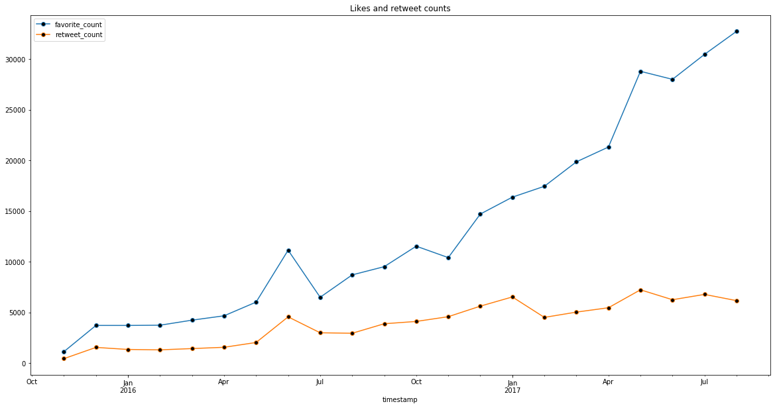For every successful twitter account, number of “likes” and “retweet” are vital measures. WeRateDogs has started 2015 and, as following diagram shows, at the late 2015, both were similar together but after that retweet” count has increased very smoothly and even can say at Jan 2017 reaches to a relatively steady situation, meanwhile “like” counts after Nov 2016 was a skyrocket date to increase sharply and continue this trend. So, hardworking, keep frequently posting and be diligent is the most important secret for social network business model to reach to exponential growth in followers. On other hand the difference between these two measures is by active social media followers, the followers who have active twitter accounts and prefer to share interesting tweets with their followers, and the rest of followers are less professional users of twitters and just make “like” tweets are funny for them.

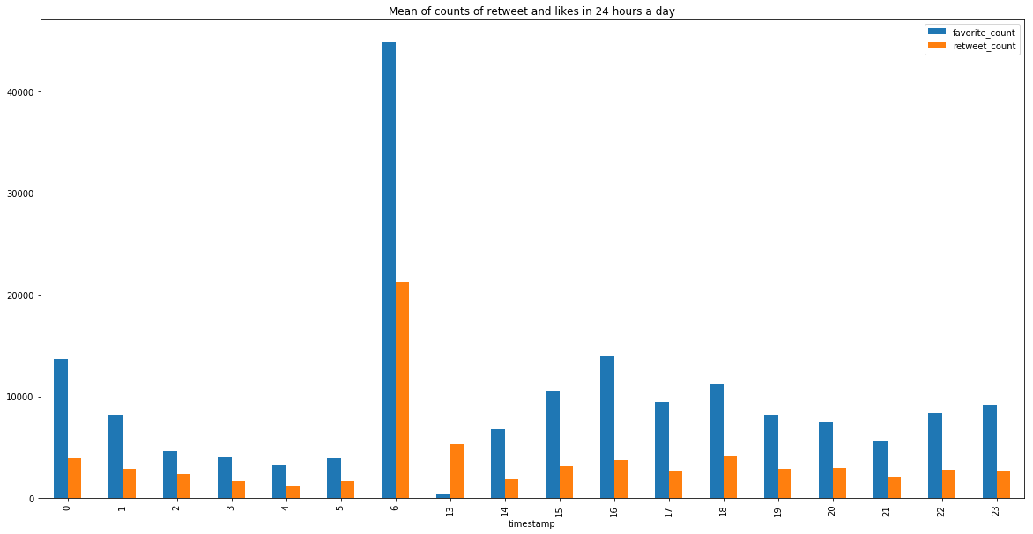I always wondering, is there any meaningful relation between tweet time and number of “like” and “retweet”? Digging inside data tells interesting story, the chance of getting more like and retweet for each tweet, during time from 6 a.m. to 1 p.m. is the most. So, if we use WeRateDogs experience as role models, do you think we can generalized it? I think so.

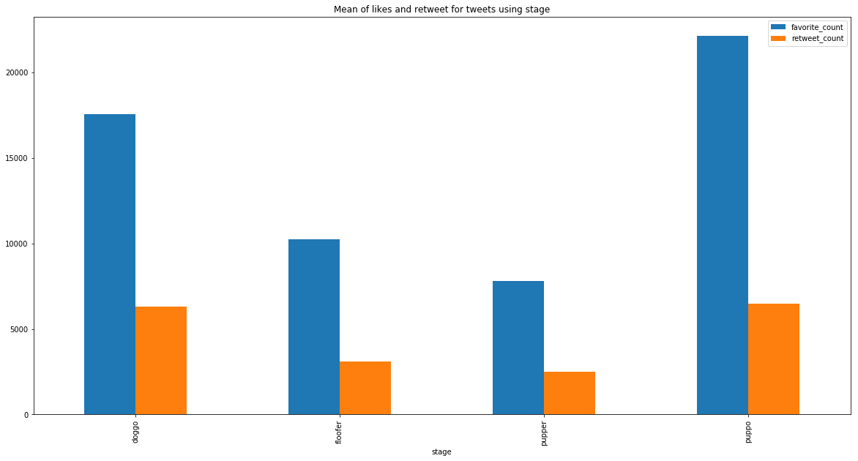One funny thing in this account is using a customized various stages of dogs. (The Dogtionary explains these stages: doggo, pupper, puppo, and floof(er) (via the [#WeRateDogs book](https://www.amazon.com/WeRateDogs-Most-Hilarious-Adorable-Youve/dp/1510717145) on Amazon). The most favorite of these stages between followers is puppo.

But in other hand, breeds of Bedlington Terrier and Afghan Hound get, respectively, havemost like and retweet, maybe they are more uncommon specially Afghan Hound and for that getting most retweet.

WeRateDogs is amazing account even for nonlover dogs and beside of all these analysis and success tips, the most successful items is gifted humorous comments of author.