# Business and system summery

Today’s time in this era computer and computers based technologies are holding a big part in all the sectors of our society. Computers have putted much influence in the hotel business sectors as well. Because day by day everything is getting better and modern and that’s why to cover-up with this development and keep moving with this flow hotel business sectors are also have to become developed and modern with the influence of computer technologies. Computers is used everywhere now a days and it has become efficient in the hotel business sectors also. As a result hotel business is incomplete without the help of computers today. In hotels previously they were using hand written or composed records or tally copies to record all the information and data of customers, room reservation, bills and all other things related to hotels activity. As it was so badly coordinated and harmonized and sometimes it became less effective with mistakes. This type of records were also lost sometimes. So hotel business sectors would need an electronic data storage system or management which is computerizes and well planned and organized by a management and it works or control under a systematic and automated way. It is only possible in a DATABASE MANAGEMENT SYSTEM (DBMS). Database management systems (DBMS) are specially designed applications that interact with the user, other applications, and the database itself to capture and analyze data. File system is also an electronic data storage system but database system is more friendly and efficient and sustaining plan. Database system is very effective in educational sectors to keep or store all kind of data or information’s provided from that particular institute or the elements of that institute.

Firstly we need to know what is database or database system. A database is an organized collection of data. The data are typically organized to model relevant aspects of reality in a way that supports processes requiring this information as we can say that basically a simple SQL file or card index containing related data is a database. Databases are created to operate large quantities of information by inputting, storing, retrieving, and managing that information. Databases are set up so that one set of software programs provides all users with access to all the data. In such a system the items data will be laid out as a table with related data items forming a row and a column.

# Business environment and project objectives

A useful database system has many advantages for hotels purposes and ensuring a better service. It can save more time it the solution is already exist. Researcher can see how others have solved similar problems or met similar requirements using it.

It’s very innovative and special to use a database system among the other hotels. If we use this system in a hotel we can get update in daily basis and very quickly without any delay. We can get an easy documents of our all hotel related works.

In this project we are showing that by using this hotel management database system authority can easily access any customers from the computer and at any time. We can also put as many as needed new data or new information in the database easily as we can modify this system any time. We can search each and every customer wise, room wise, package price wise, bill wise. As a example- if a customer wants to see his/her all bills or if a manager want to see which customer haven't payed their bill or which customer will cheaking out they can easily see by the database system. Otherwise if anyone want to see how many and who are the customers under a particular floor he/she can see or access this output by only database system. This project was made for the ease of searching such data or various information at a time. This project is for a computerize hotel to manage data, so that all that reservations and information become fast and there should remain no error in the information tables.

In the perspective of Bangladesh, our country is a developing country. It is developing in many sectors day by day such as hotel business sectors also. There are situating many hotels as well. Day by day there hugely increasing numbers of foreigners comes to this country. These increasing foreigners have stay somewhere, so those hotels needs a better database system to handle this increasing numbers of foreigners. Day by day these number are increasing not decreasing. So to keep the system organized and better on the go this database project will play an effective role in the hotel business. If we take a scenario of a manually controlled hotel records, suppose one wants to see a particular hotels details and the rooms and package price details definitely it would be a very lengthy, slow and complex process. But in a database system one can easily access to the database and see whatever he/she want to see by doing some DBMS based queries in computer software or in web. It decreases the time and process complexity and gives us accurate data. This project will also be effective for putting new colums or new rows as data in the database’s table in future. Those who will be in the management or sector that controls this database system will easily access and update it any time by just doing some queries. This database can provide or show data at 24 hours and 7 days as it is a computerized automated data storage system. DBMS also will provide better security as it will not be visible to anyone who wants. Its view level can be defined or controlled by the institutional management or authority. Management or the authority would be able to calculate many numerical data for example the customers by particular conditions and also be able to see calculated data in tables.

Some objectives of this projects given below-

* Computerized web or software based data storage system for all those inside information.
* Ensures lack of data complexity and avoiding data duplication.
* Ensures proper save of time to access or find any data or records.
* Authority gets access to every individual entities details 24/7.
* Customers would be able to view or access their reservation and bills at any time.
* Authorities would be able to access the details of customers under his/her own and also individual or all customers’s bills detail or results at any time.
* Ensures modification or update process for further use or purpose.
* Authorities can calculate total, average, maximum, minimum bills obtained by the customers in particular time.
* Provides better service to all.
* Decreasing the number of customer if they checks out from the hotel.

By fulfilling these objectives and system policies this project would be a proper and organized database system to run the system.

# Technical summary of Student-Exam record Database

The database system that prepared in this project can be accessed via a software program or a web-server based system using internet access or as an embedded data storage system. The database system and the project was made using Oracle SQL Express 11, Microsoft Word. All the tables of entity and attributes were made using Oracle SQL Express 11. The database system is very simple in design and to implement. This system requires very low system resources and this system will work in almost all configurations.

# List of Entities of the model:

* Customer
* Reserve
* Payment
* Account
* Room
* Relation1
* desRoom

Thus how the database system was created by following above pattern. The data types are shown in the table charts and all entities and attributes names as well. This database is following joining function of DBMS between the tables and the tables are linked with each other with the foreign keys. By these foreign keys these tables are connected with each other except the grade table. In those tables any suitable and eligible type of data and specially appropriate data can be stored or modify.

# Justifying objectives and the supportive role of the database

Our project object was developed as a database system for all hotel base program so that they can ensure better service gain satisfaction and privilege by using a high tech service or database. This project makes a database system for the records of customers, room, prices, bills etc. Using this database system one would be able to access or find any kind of details or information easily and within a short time and without any complexity. This system has various modules or features comes up from the records stored in those tables. First table helps by recording each hotels name and their hotel ID number which is unique and not null and that is why one can find any hotel as wanted using those unique IDs. Second table helps by recording all rooms name and also each room’s unique ID. Any customers would be able to find the particular room as they wanted and this makes the records very user friendly and ease which is everyone’s demand now a days. Third table is recording the package and price details and it helps to find any rooms hotel wise for the user. Fourth table is for the customers info And details including customers name, every customers unique ID which only marks of that particular customer. By this anyone can search many customer’s details at a time using their unique ID. And then there is an invoice table which records all rooms name and ID under a terminal bill of other type of bills. The table which is a relational table of customer and bill is the customer bill list table. It helps us to search customer bill wise. And lastly there is a bill table which holds the records of bills, amount, date and customer id obtained by the customers. This system provides better and relaxing facilities for users. This study has its primary objectives which is fully and properly justified, and the design of the system that will immense benefit to the customers and authorities or managements and also for the operators. It developed a cost effective, efficient in intelligent and user friendly graphic interface for the viewers. The project will involve researching into existing systems, user expectation and then drawing up the requirements of the project. Once we have the functional requirements have been decided upon the second stage will involve research into the non-functional requirements of the project for instance security and accessibility. Once the functional and non-functional requirements have been decided upon and the technologies to be used has been decided, the system will be design. Once the design process has been completed the implementation stage can begin, although there will be no formal test driven development for this project when new features are added or code is edited the system will be tested to ensure that no bugs have been introduced into the program. Once the implementation has been completed the entire system will be thoroughly tested. The  customers and the Administrators or operators are the two parties which interact with the database, who have different ‘view level schemas’ to the database information.

## Users Services-

1. Users firstly can create an account by registering, modify account details, De-register from the services
2. Doing customers, rooms, invoice, bills data entry, the users are provided to choose their data entry spots rather than being randomly allocated positions
3. View, modify or cancel past records
4. Users will be informed through emails, about updates in the system

## Administrator Services-

1. Add new tables or update the existing tables records
2. Add or update the records of subjects
3. Update information about the exam details, Add new exams
4. Access and modify users accounts or various data entry

All these result are in high client-satisfaction, hence, more and more business for the company that will scale the company business to new heights in the forthcoming future. The main importance of this project is to provide the better work efficiency, security, accuracy, reliability, feasibility. The error occurred could be reduced to nil and working conditions can be improved.

# C:\Users\(SHAWON)\AppData\Local\Temp\Rar$DR39.728\DatabaseProject\hotel.pngNormalization for a HOTEL MANAGEMENT SYSTEM

1NF:

|  |  |  |  |  |  |  |  |
| --- | --- | --- | --- | --- | --- | --- | --- |
| Cus_ID | Name | Address | PhoneNo | Email | ArrivalDate | Reservation_ID | Chekout |

|  |  |  |  |  |  |  |
| --- | --- | --- | --- | --- | --- | --- |
| Cus_ID | Name | Address | PhoneNo | Email | Amount | Payment_ID |

|  |  |  |  |  |  |  |  |  |  |  |  |
| --- | --- | --- | --- | --- | --- | --- | --- | --- | --- | --- | --- |
| Cus_ID | Name | Address | PhoneNo | Email | A_ID | Aname | Type | Rate/hr | In_time | Out_time |  |

|  |  |  |  |  |
| --- | --- | --- | --- | --- |
| Amount | Payment_ID | ArrivalDate | Reservation_ID | Chekout |

|  |  |  |  |  |
| --- | --- | --- | --- | --- |
| Availability | Room_ID | ArrivalDate | Reservation_ID | Chekout |

|  |  |  |  |  |  |
| --- | --- | --- | --- | --- | --- |
| Availability | Room_ID | Type_ID | R_Name | Description | Terrif |

2NF:

|  |  |  |  |  |  |  |  |
| --- | --- | --- | --- | --- | --- | --- | --- |
| **Cus_ID** | **Name** | **Address** | **PhoneNo** | **Email** | **ArrivalDate** | **Reservation_ID** | **Chekout** |

|  |  |  |  |  |
| --- | --- | --- | --- | --- |
| Cus_ID | Name | Address | PhoneNo | Email |

|  |  |  |
| --- | --- | --- |
| ArrivalDate | Reservation_ID | Chekout |

|  |  |  |  |
| --- | --- | --- | --- |
| ArrivalDate | Reservation_ID | Chekout | Cus_ID |

|  |  |  |  |  |  |  |
| --- | --- | --- | --- | --- | --- | --- |
| **Cus_ID** | **Name** | **Address** | **PhoneNo** | **Email** | **Amount** | **Payment_ID** |

|  |  |  |  |  |
| --- | --- | --- | --- | --- |
| Cus_ID | Name | Address | PhoneNo | Email |

|  |  |
| --- | --- |
| Amount | Payment_ID |

|  |  |  |
| --- | --- | --- |
| Amount | Payment_ID | Cus_ID |

|  |  |  |  |  |  |  |  |  |  |  |  |
| --- | --- | --- | --- | --- | --- | --- | --- | --- | --- | --- | --- |
| **Cus_ID** | **Name** | **Address** | **PhoneNo** | **Email** | **A_ID** | **Aname** | **Type** | **Rate/hr** | **In_time** | **Out_time** |  |

|  |  |  |  |  |
| --- | --- | --- | --- | --- |
| Cus_ID | Name | Address | PhoneNo | Email |

|  |  |  |  |  |
| --- | --- | --- | --- | --- |
| Amount | A_ID | Aname | Type | Rate/hr |

|  |  |  |  |  |
| --- | --- | --- | --- | --- |
| ac_id | A_ID | Cus_ID | In_time | Out_time |

|  |  |  |  |  |
| --- | --- | --- | --- | --- |
| **Amount** | **Payment_ID** | **ArrivalDate** | **Reservation_ID** | **Chekout** |

|  |  |
| --- | --- |
| Payment_ID | Amount |

|  |  |  |
| --- | --- | --- |
| Reservation_ID | ArrivalDate | Chekout |

|  |  |  |  |  |
| --- | --- | --- | --- | --- |
| Reservation_ID | ArrivalDate | Chekout | Cus_ID | Payment_ID |

|  |  |  |  |  |
| --- | --- | --- | --- | --- |
| **Availability** | **Room_ID** | **ArrivalDate** | **Reservation_ID** | **Chekout** |

|  |  |
| --- | --- |
| Room_ID | Availability |

|  |  |  |
| --- | --- | --- |
| Reservation_ID | ArrivalDate | Chekout |

|  |  |  |
| --- | --- | --- |
| rr_id | Room_ID | Reservation_ID |

|  |  |  |  |  |  |
| --- | --- | --- | --- | --- | --- |
| **Availability** | **Room_ID** | **Type_ID** | **R_Name** | **Description** | **Terrif** |

|  |  |
| --- | --- |
| Room_ID | Availability |

|  |  |  |  |
| --- | --- | --- | --- |
| Type_ID | R_Name | Description | Terrif |

|  |  |  |
| --- | --- | --- |
| Room_ID | Type_ID | Availability |

3NF:

There is no transitive dependency.

2NF is the final Normalization.

# Relation Model:

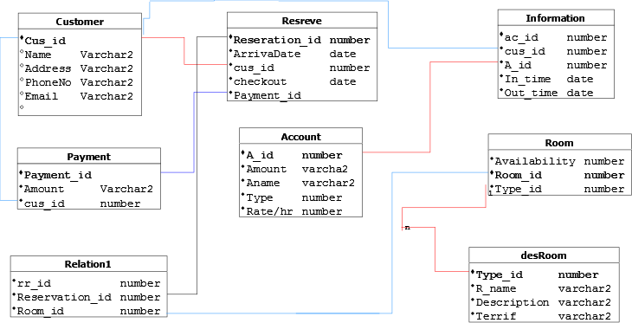

# Screenshots of the table with only data type of the attributes

Customer:

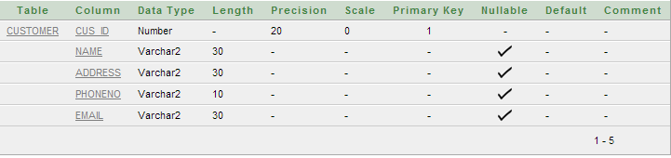

RESERVE:

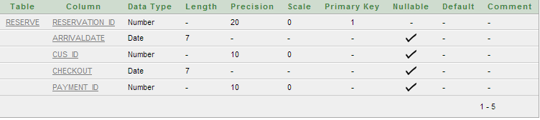

INFORMATION:

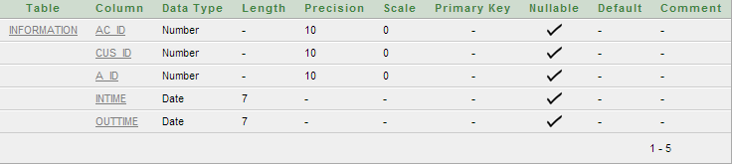

PAYMENT:

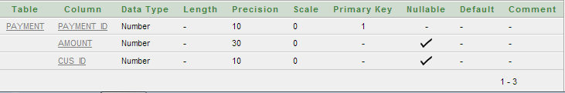

ACCOUNT:

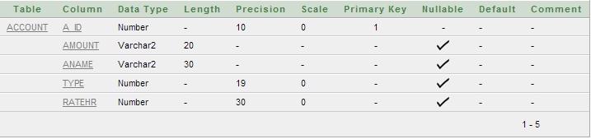

ROOM:

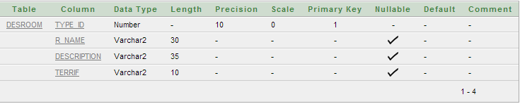

RELATION1:

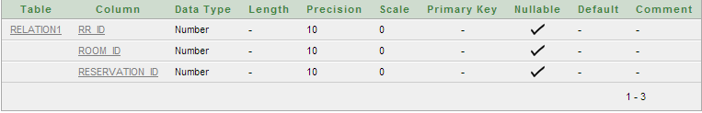

DESROOM:  


# Screenshots of the table with sample data records-

Customer

* insert into Customer values(1,'Arafin','Bangladesh','475','arafin@gmail.com');

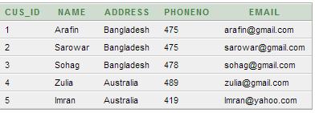

RESERVE:

* insert into Customer values(1,'Arafin','Bangladesh','475','arafin@gmail.com');

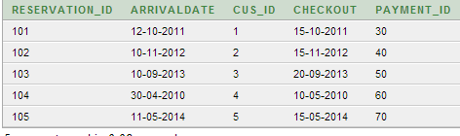

INFORMATION:

* insert into Information values(50,5,609,'17-07-2014','17-08-2014');

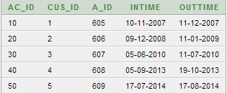

PAYMENT:

* insert into Payment values(30,3000,1);

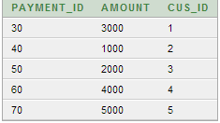

ACCOUNT:

* insert into Account values(605,3000,'A',1,20);

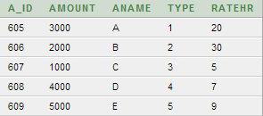

ROOM:

* insert into Room values(1,506,909);

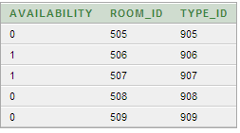

RELATION1:

* insert into Relation1 values(30,509,105);

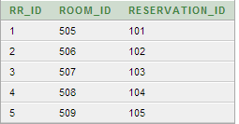

DESROOM:

* insert into desRoom values(905,'Deluxe','Single','Us-30$');

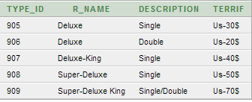

# Demonstration of some database query

## Simple query

1. select Cus_id,Name,Address,PhoneNo,Email from Customer;

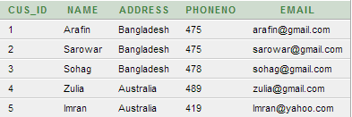

1. select Reservation_id,ArrivalDate,cus_id,checkout,Payment_id from Reserve;

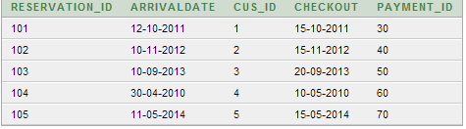

1. select Payment_id ,Amount,cus_id from Payment

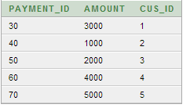

1. select A_id,Amount,Aname,Type,Ratehr from Account;

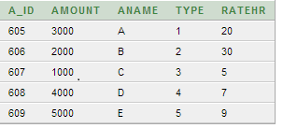

1. select Type_id,R_name,Description,Terrif from desRoom;

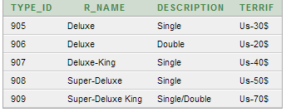

MultipleTable:

1.select c.name,r.Arrivaldate,r.cus_id from Customer c,Reserve r where c.cus_id=r.cus_id;

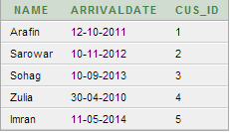

2.select c.Cus_id,c.name,c.Email,r.Reservation_id,r.checkout from Reserve r,Customer c where c.Cus_id=r.Cus_id Order by c.Cus_id;

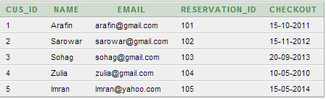

3.select s.Reservation_id,s.ArrivalDate,a.Room_id from Reserve s ,Relation1 a where s.Reservation_id=a.Reservation_id order by s.Reservation_id ;

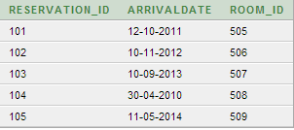

4.select c.Cus_id,c.Name,p.Payment_id,p.Amount From Customer c,Payment p where c.cus_id=p.cus_id ;

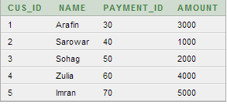

5.select r.Room_id,d.Description ,d.R_name From Room r,desRoom d where r.Type_id=d.Type_id;

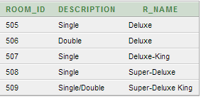

# PART- B

We have learned many lessons and hade valuable experience doing this project on database system. Though we had several problems doing this project but the achievements was more precious and efficient.

* This project would not be possible without the help of ORACLE SQL APPLICATION EXPRESS software.
* Companies or various institutes use databases because they can store a large number of records, ease of use when locating information, it is easy to add new data and to edit or delete old data, there is ease of storage Data can be imported into other applications
* The whole database model and specially the tables were created very carefully and the joining or linking among the table were done very carefully and also followed DBMS rules
* The constraints such as primary keys or foreign keys of the tables were assigned properly for linking among tables
* By fulfilling these objectives and system policies this project would be a proper and organized database system to run the system.
* The number of levels that the software is handling can be made unlimited in future from the current status of handling up to N levels as currently laid down by the software.
* Efficiency can be further enhanced and boosted up to a great extent by normalizing  and de-normalizing the database tables used in the project as well as taking the kind of the alternative set of data structures and advanced calculation algorithms available.
* We can in future generalize the application from its current customized status wherein other vendors developing and working on similar applications can utilize this system and make changes to it according to their client’s needs.
* Our main outcome would be faster processing of information as compared to the current system with high accuracy and reliability.
* Automatic and error free report generation as per the specified format with ease.

In case there be any additions or deletion of the services, addition or deletion of any individual in any type of modification in future can be implemented easily. The data collected by the system will be useful for some other purposes also.