TITLE : AH-Country-Level Provisional COVID-19 Deaths Counts

BRIEF INTRODUCTION: Provisional count of deaths involving coronavirus disease 2019(COVID-19) by United States County, From week ending February 1, 2020

through week ending August 1, 2020

YOUR GOAL : My goal is to count the deaths of the country I choose. I'll graph and compare it if the covid from the start till the end will breakdown.

TABLE OF CONTENTS:……………………………….. Page 1. Title Brief Introduction

Your Goal

Dataset Description

………………………………….. Page 2- 8.Output (Screenshot)

………………………………….. .Page 9. Conclusion

Citation Resources

DATASET DESCRIPTION:

This Dataset is intended for public access and use. The purpose of this data collection is to gather Federally-managed datasets relevant to the health of older adults in and outside the context of the coronavirus pandemic (COVID-19). Older adults reside at the intersection of key demographic and health challenges, including those resulting from the pandemic. Insights from data on the older adult population – before, during, and after COVID-19 – is also needed to better understand the impact of the pandemic on the health of this growing population segment.

OUTPUT (SCREENSHOT):

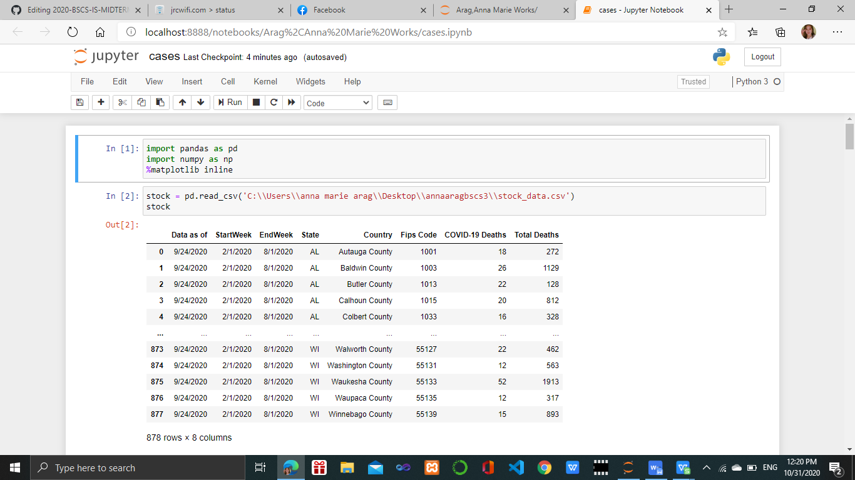

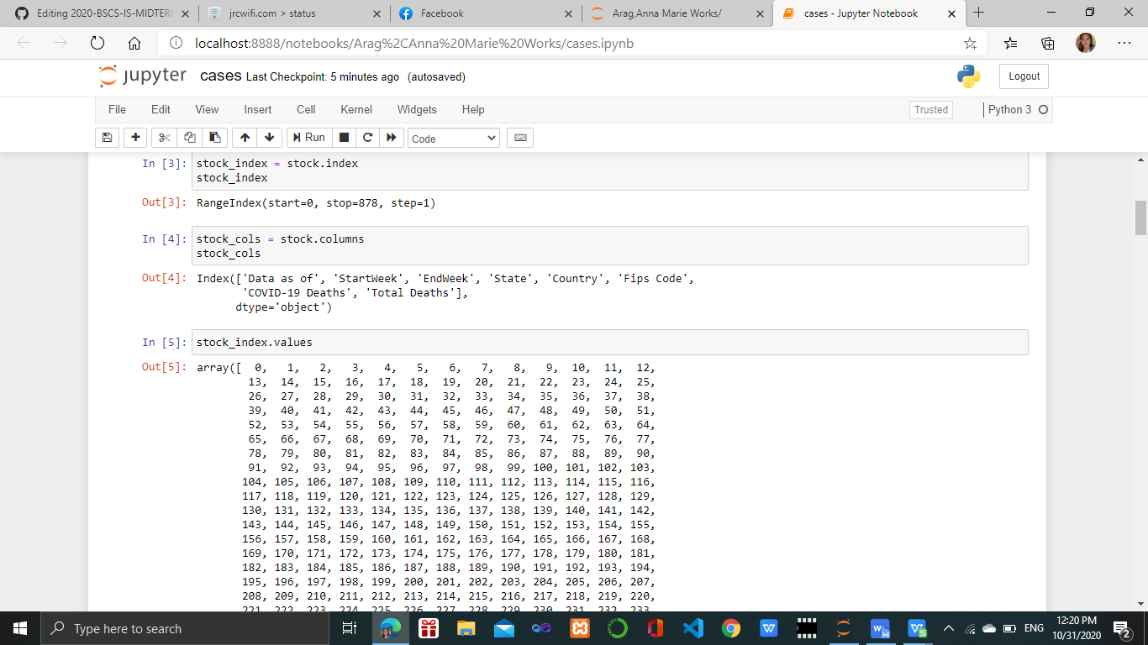

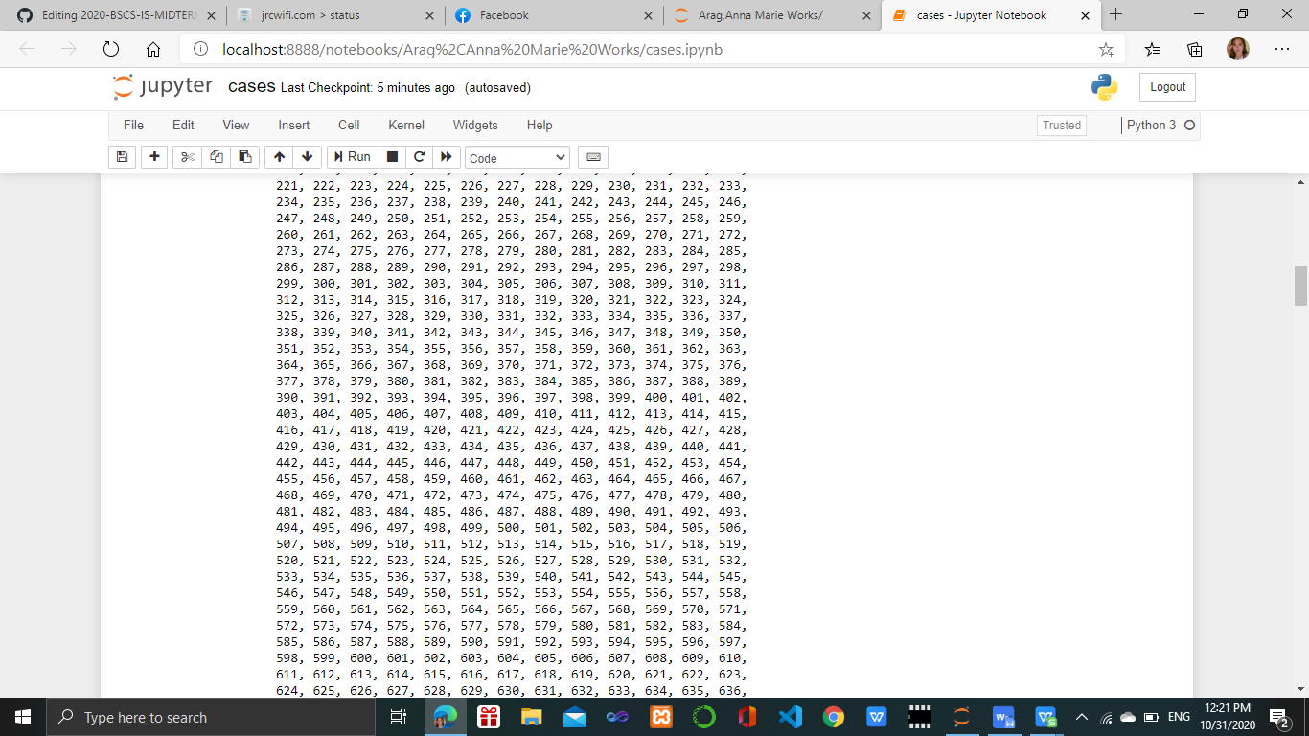

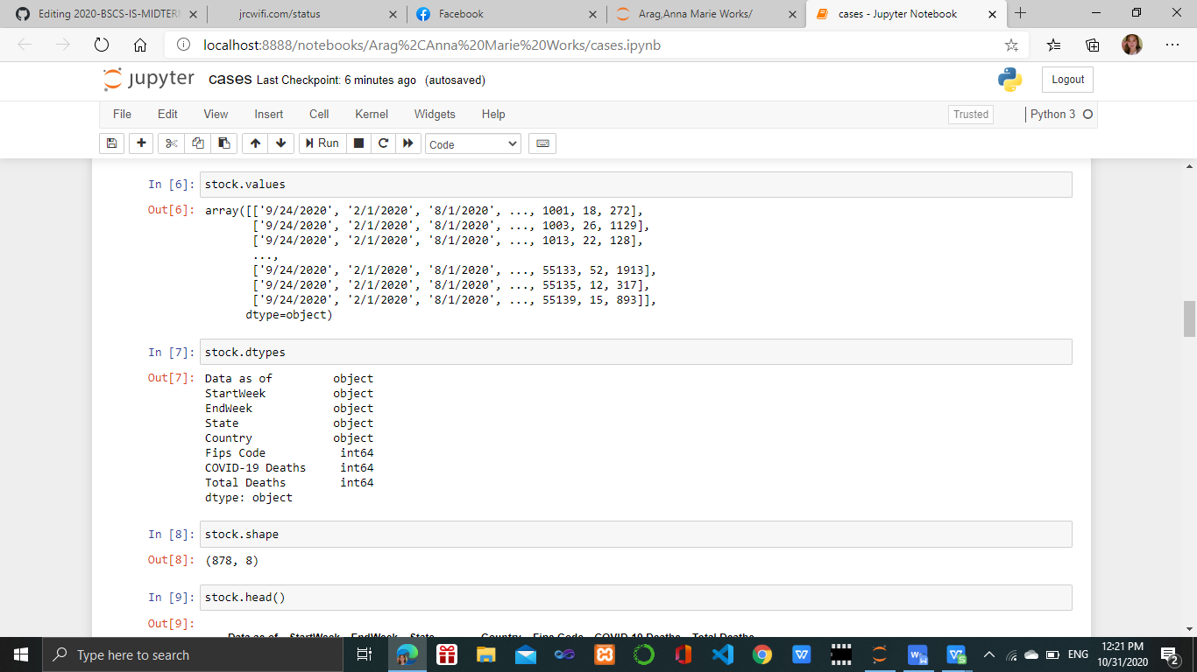

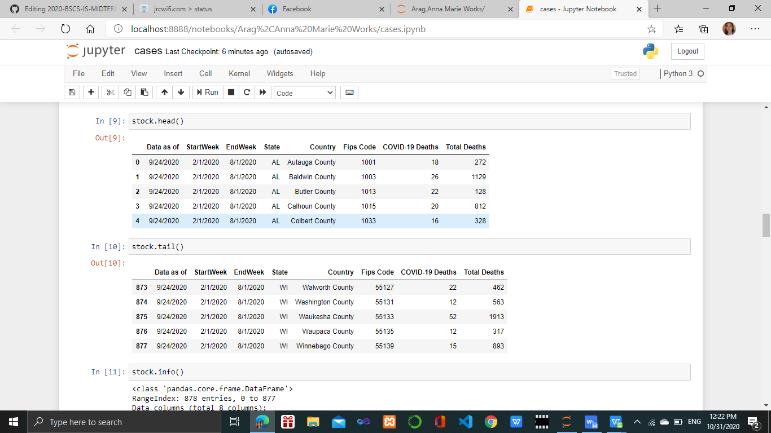

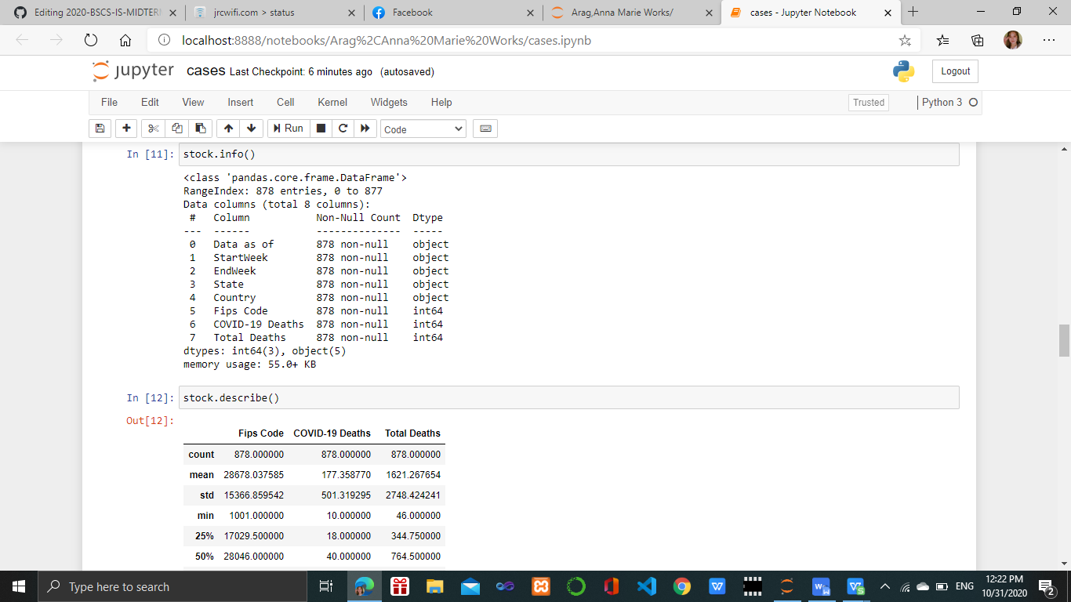

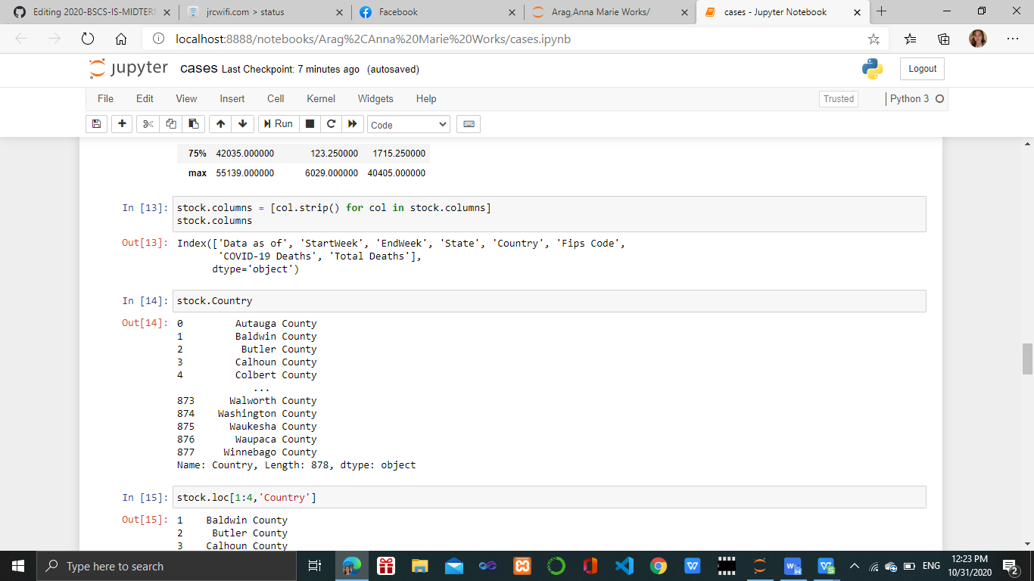

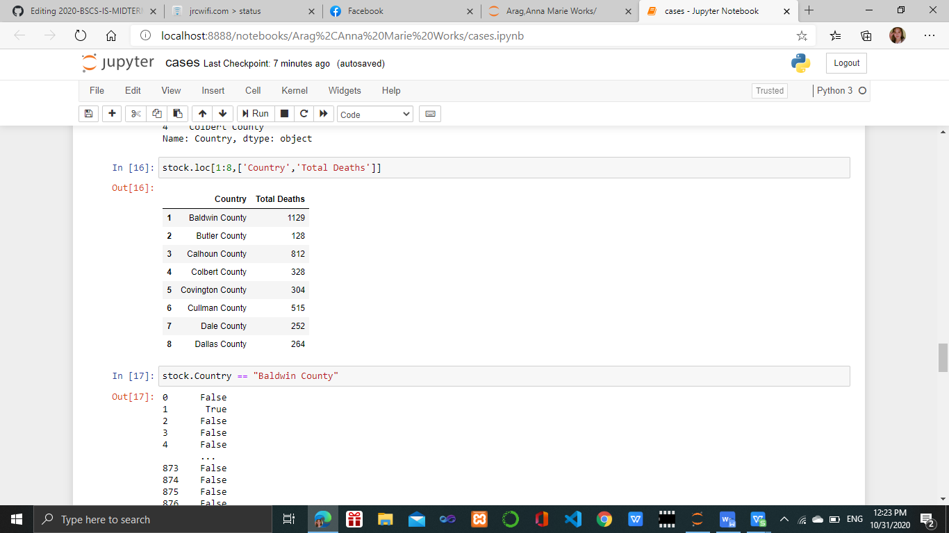

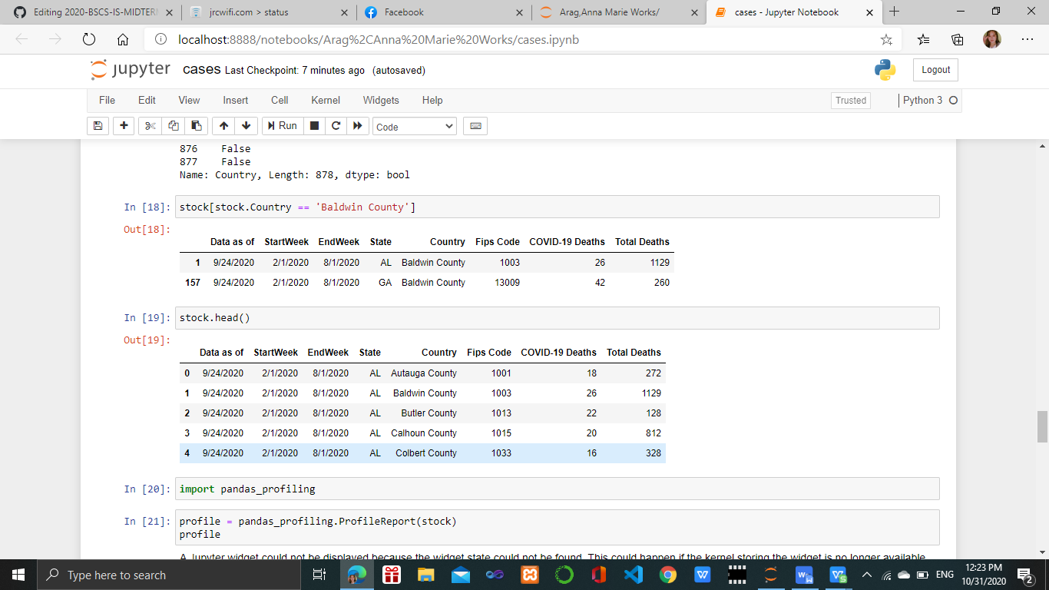

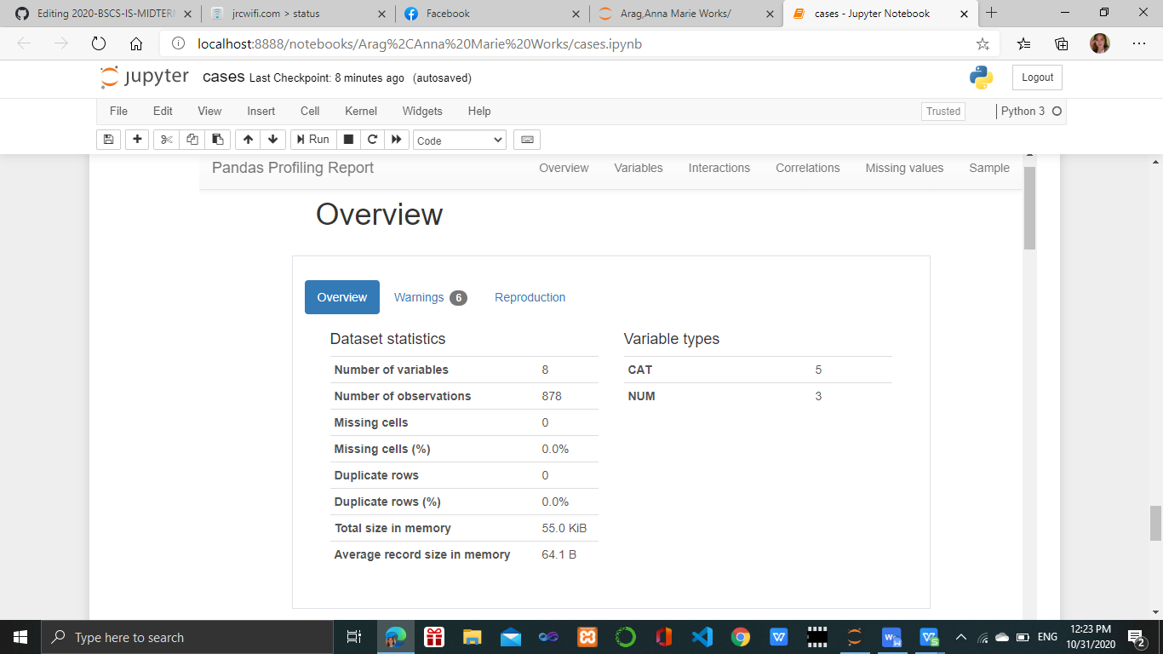

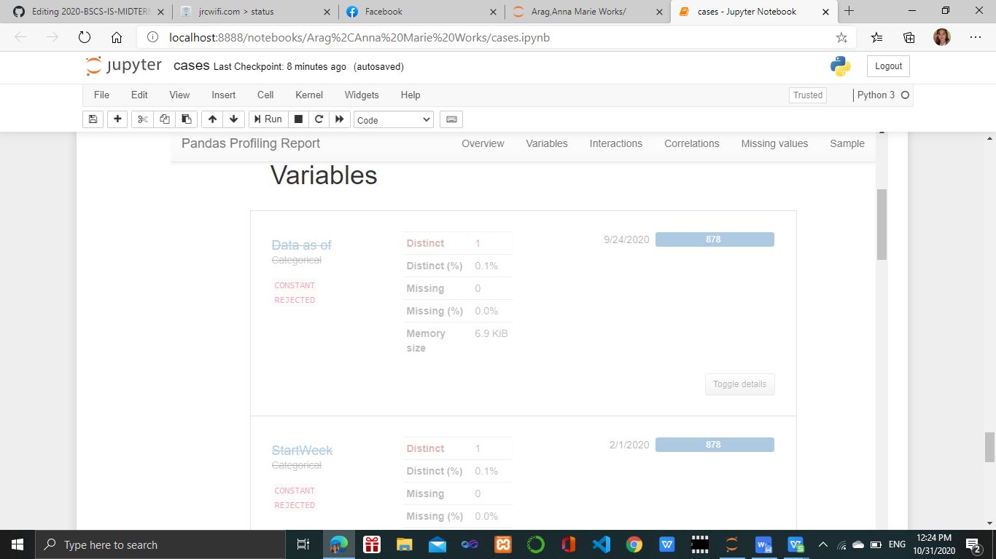

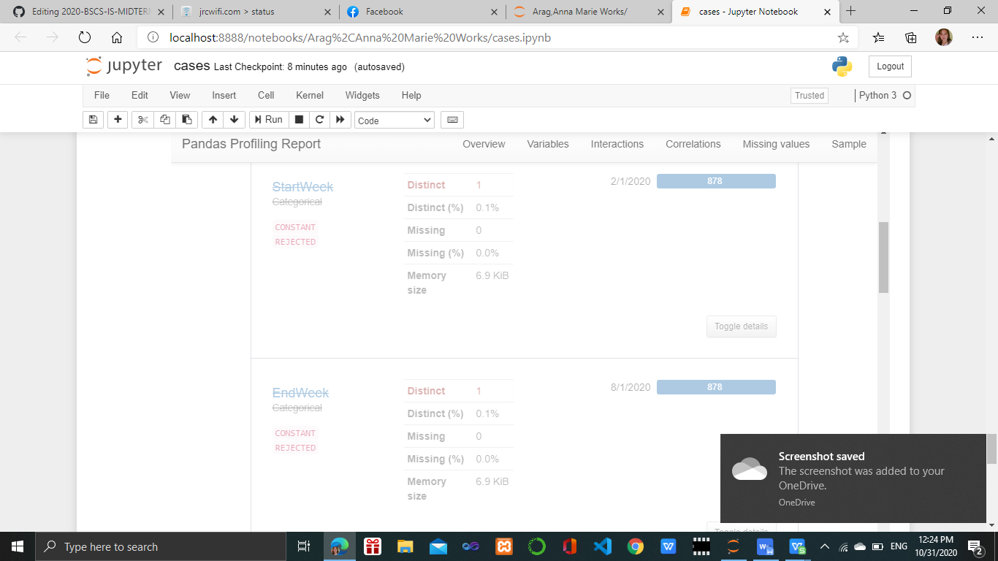

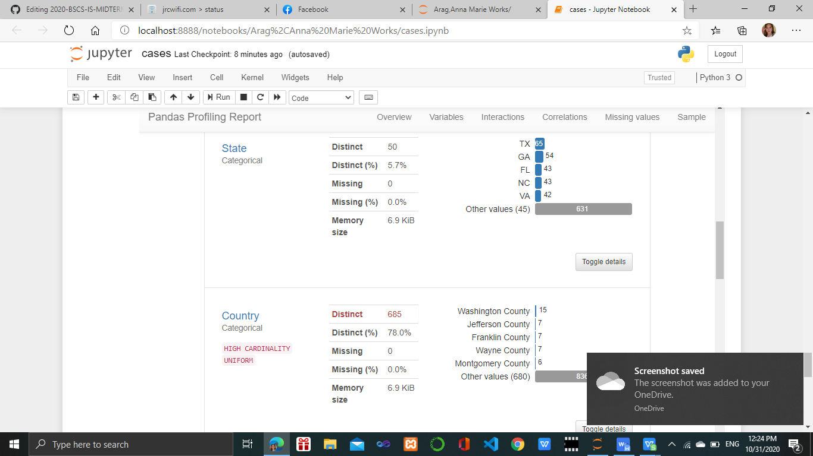

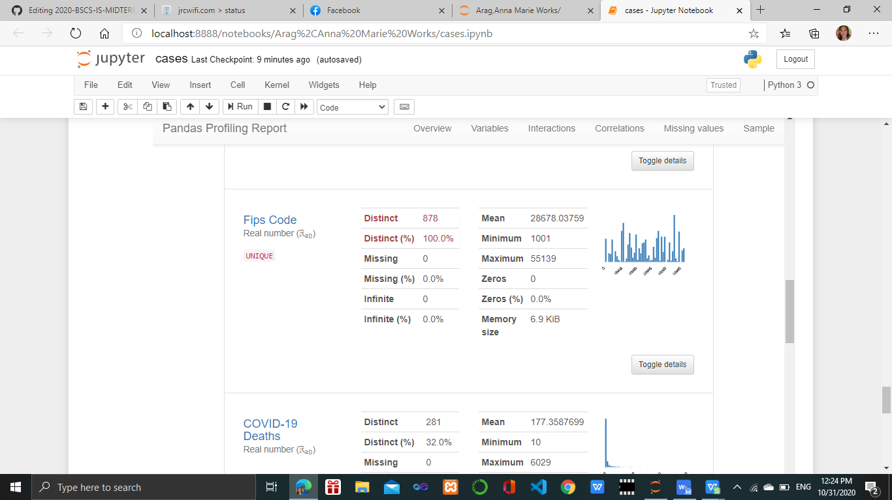

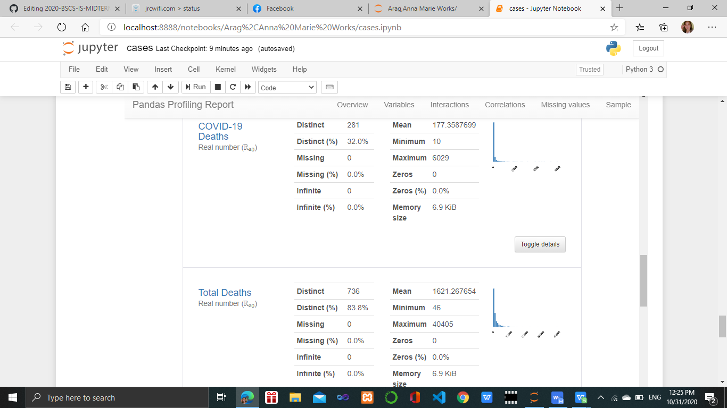

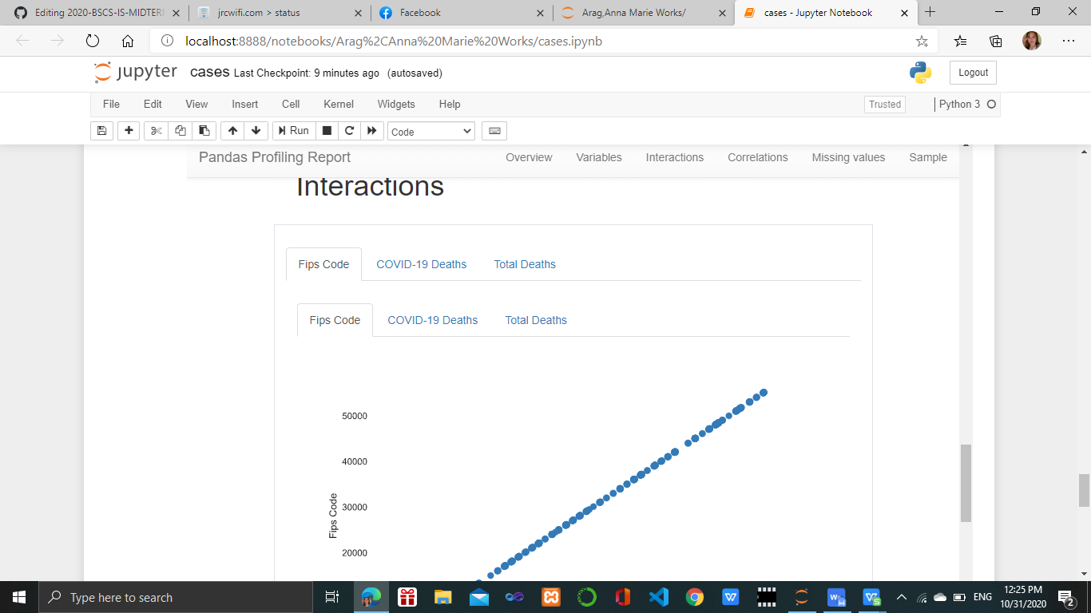

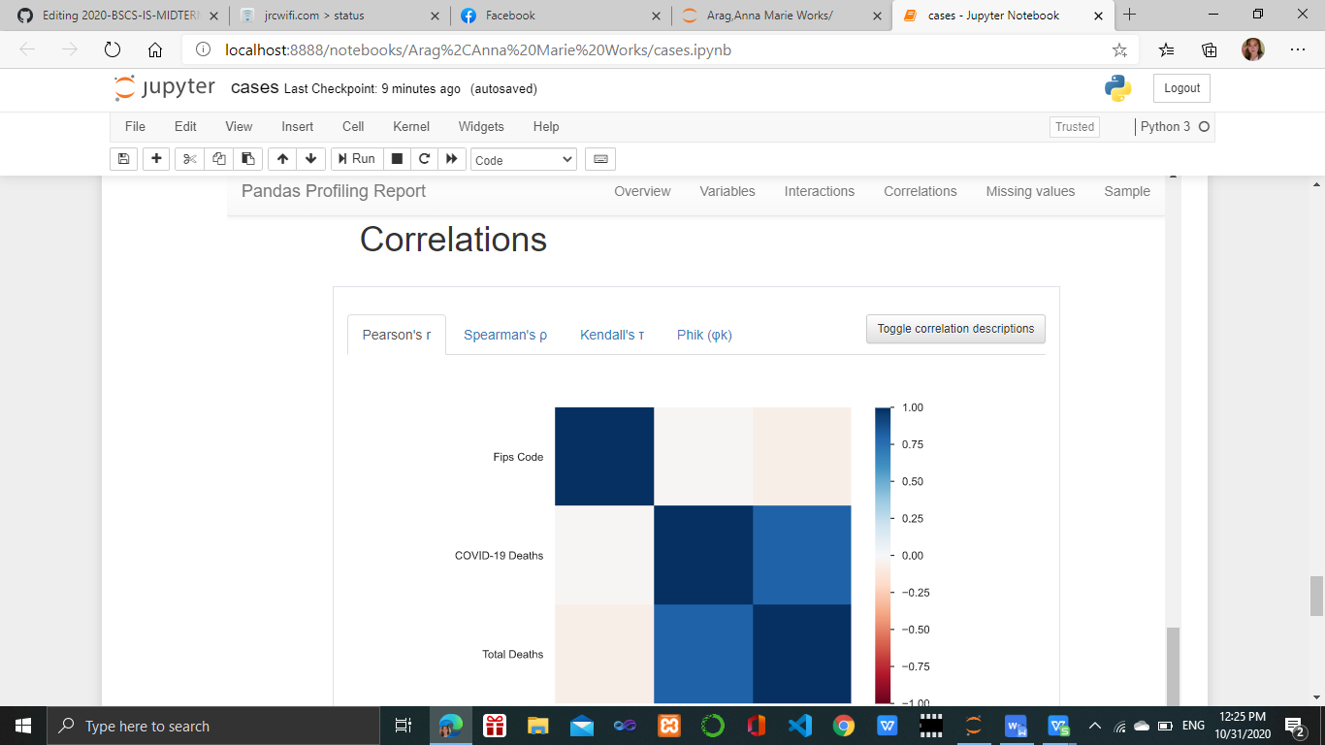

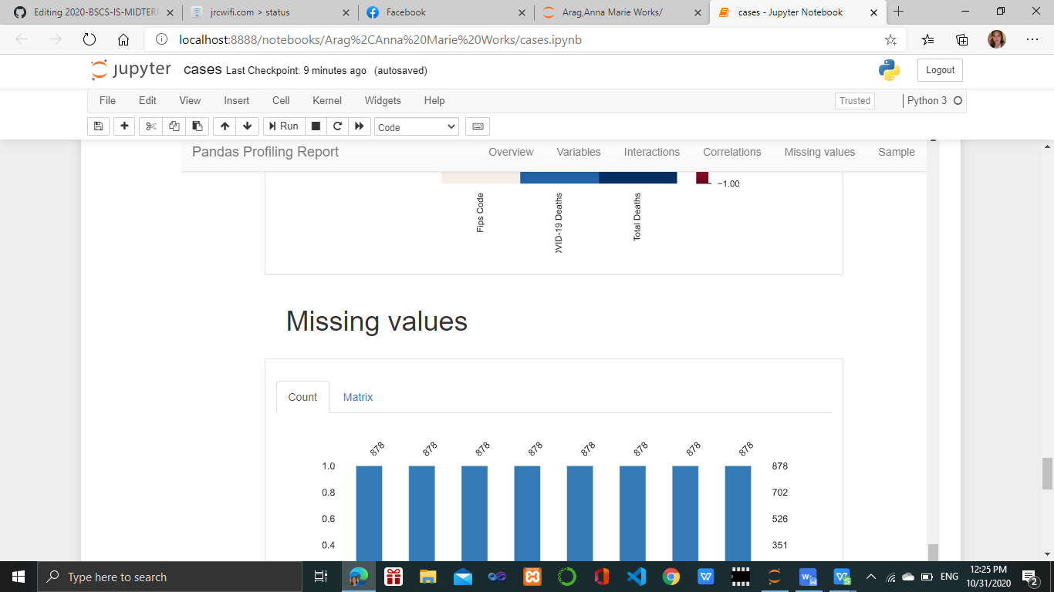

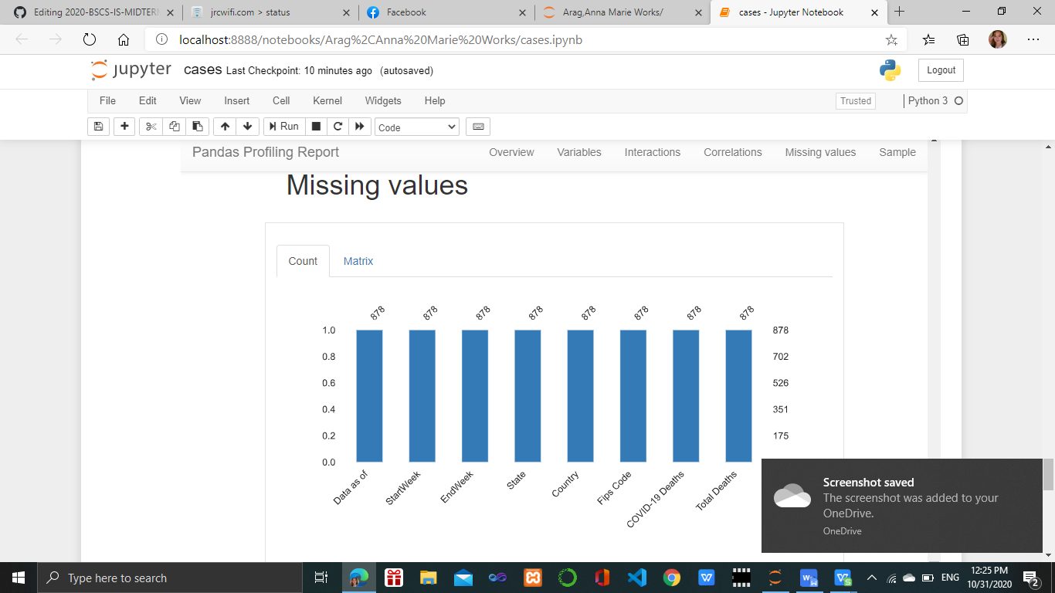

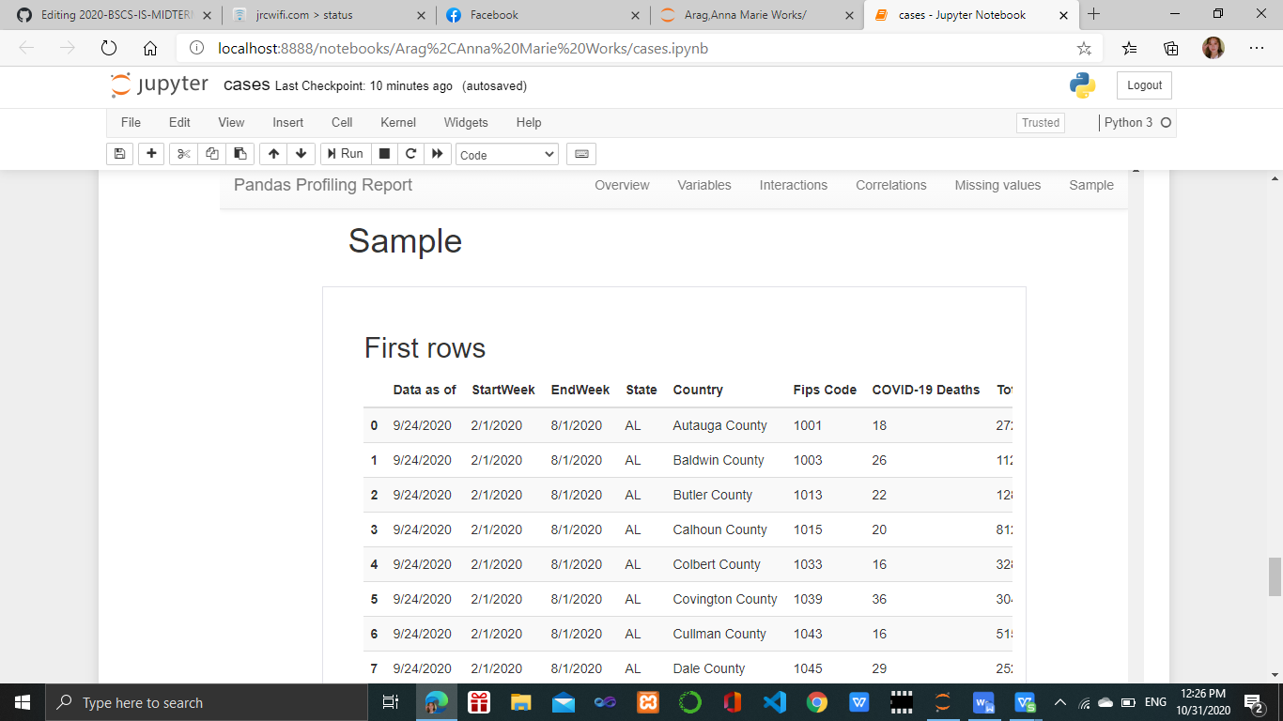

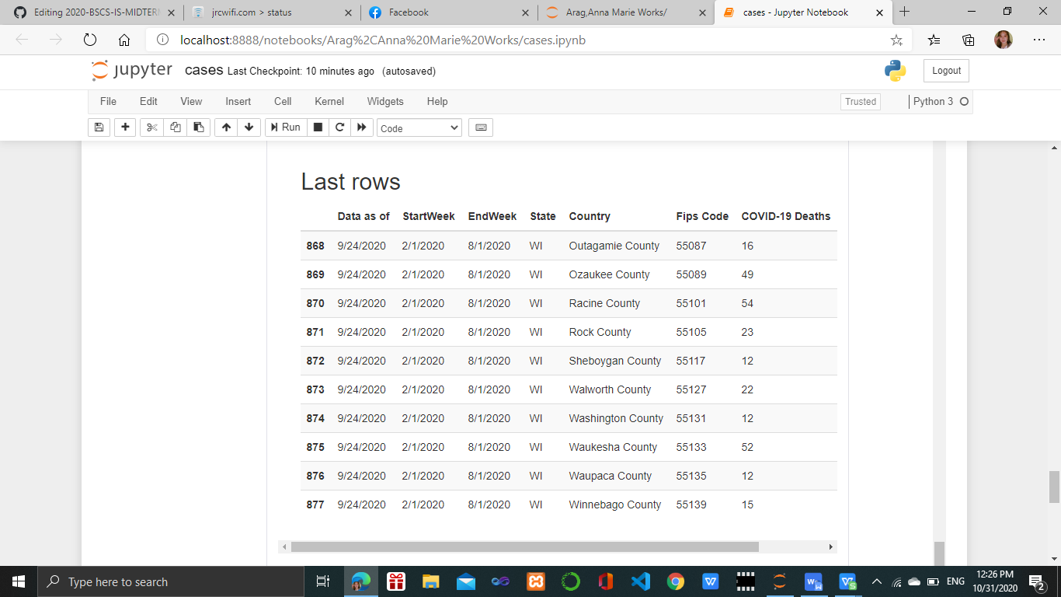

CONCLUSION:

In the topic, I'd chosen entitled “AH- Country-Level Provisional COVID-19 Deaths Counts. “ I generated in pandas profiling the numbers of deaths in Coronavirus Diseases 2019(COVID-19) in the United States of America (USA). The graph is shown that the number of deaths from the week ending February 1 through the week ending august 1, 2020, is slowly decreased.

CITATION SOURCES : [https://catalog.data.gov/group/older-adults-health-data](https://catalog.data.gov/group/older-adults-health-data?fbclid=IwAR3qSwAUJH-rzcOUInU5F5JDC2Hkf6GvQIqcuvt1BNbWXaj67pg5yzC5kP0" \t "https://www.facebook.com/_blank)