* At Brgy. Badas, near Sunrise Beach Resort, approx. 15m from the shoreline a High Tide

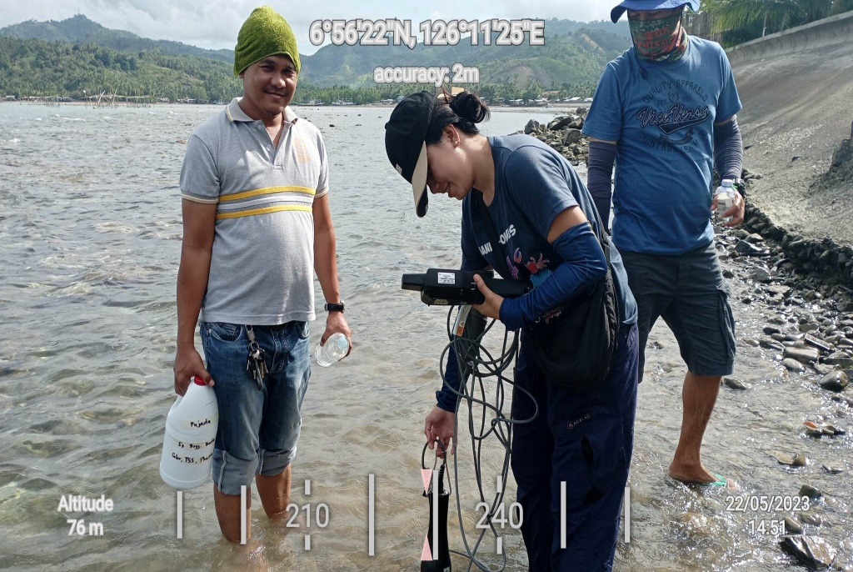

* At Brgy. Tamisan, approx. 37m from the shoreline at low Tide

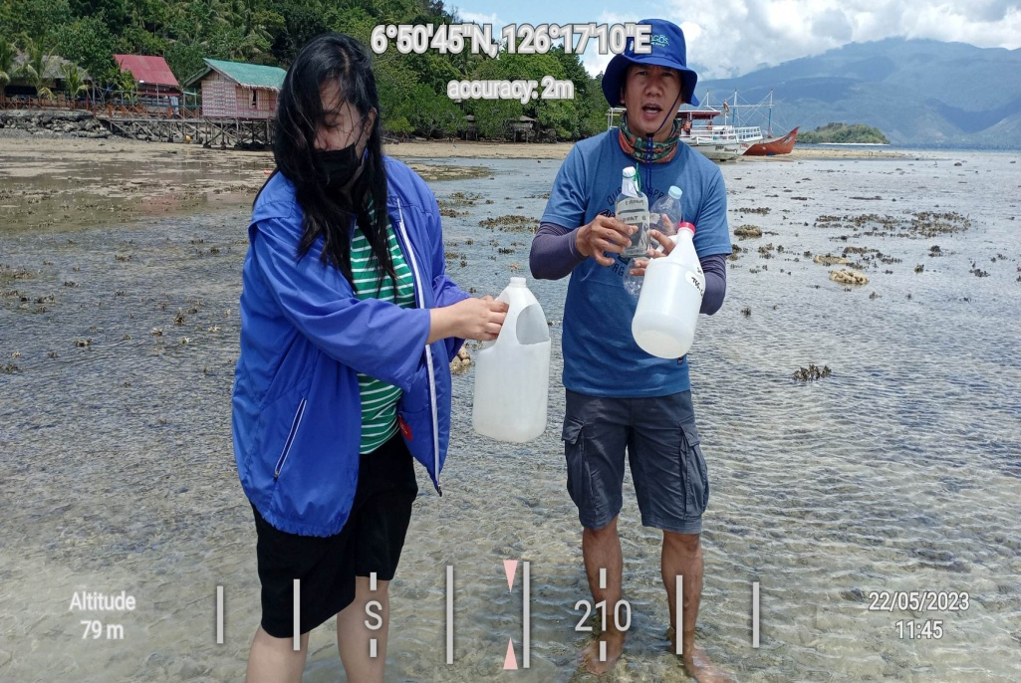

* At Brgy. Maitom, approx. 15m from the shoreline at low tide.

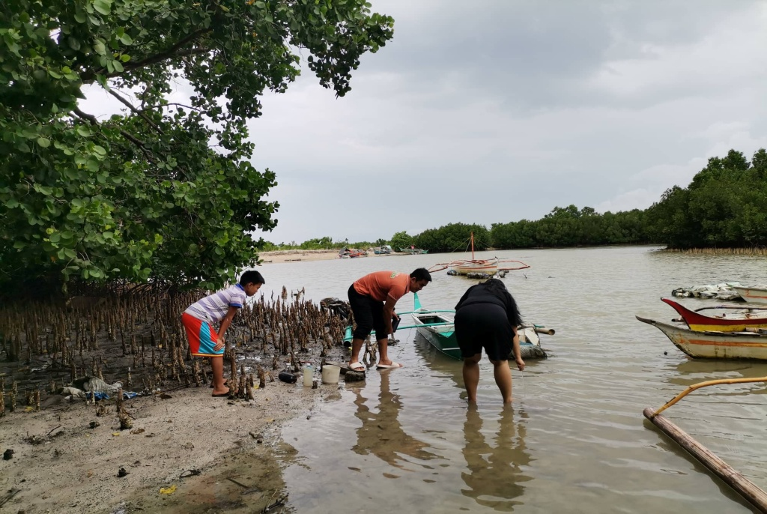

* At Brgy. Matiao near Interco, approx. 40m from the shoreline at low tide.

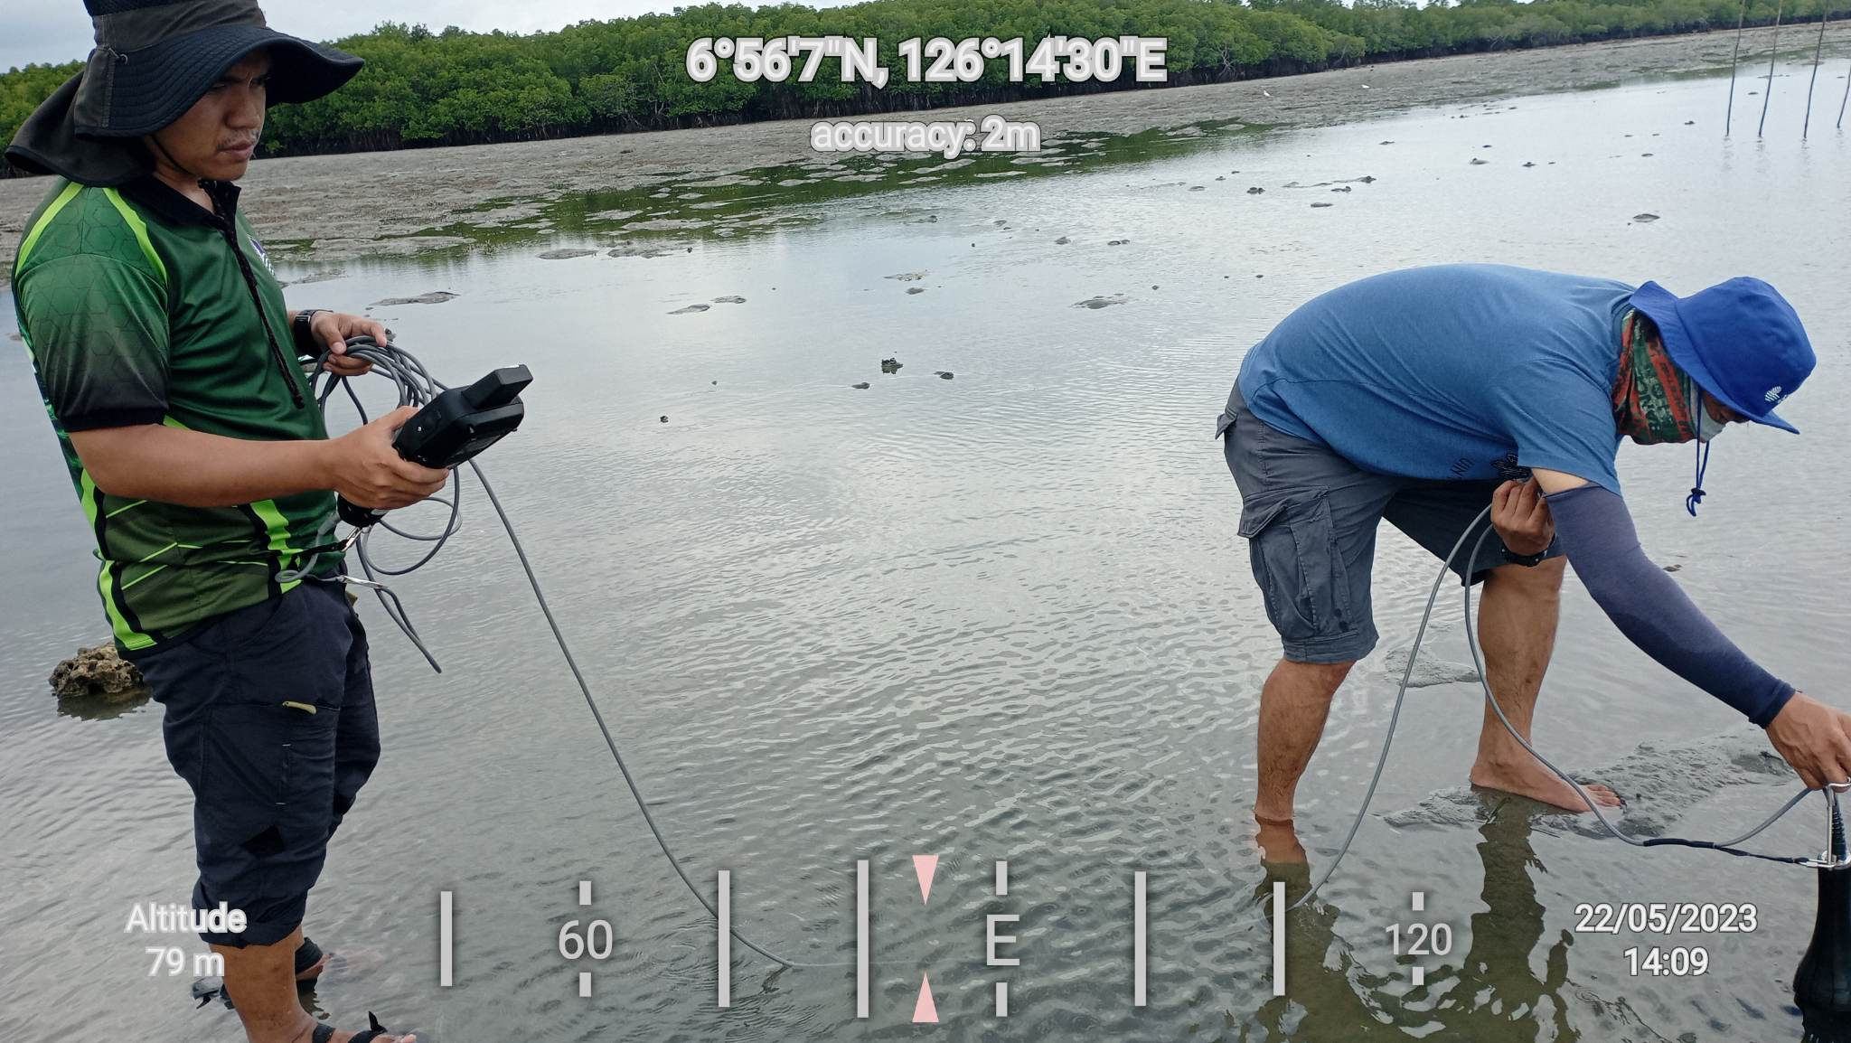

* At Gregorio Beach Resort, Brgy. Bobon, approx. 80m from the shoreline at low tide.

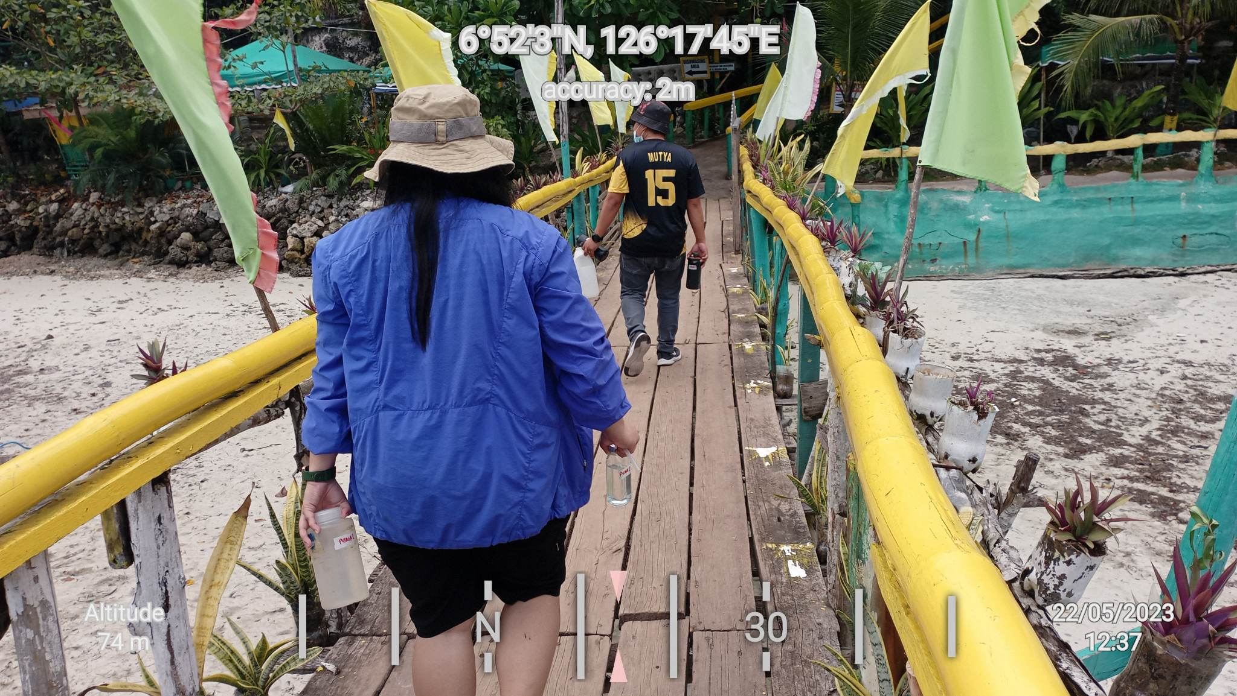

* At Brgy. Lawigan

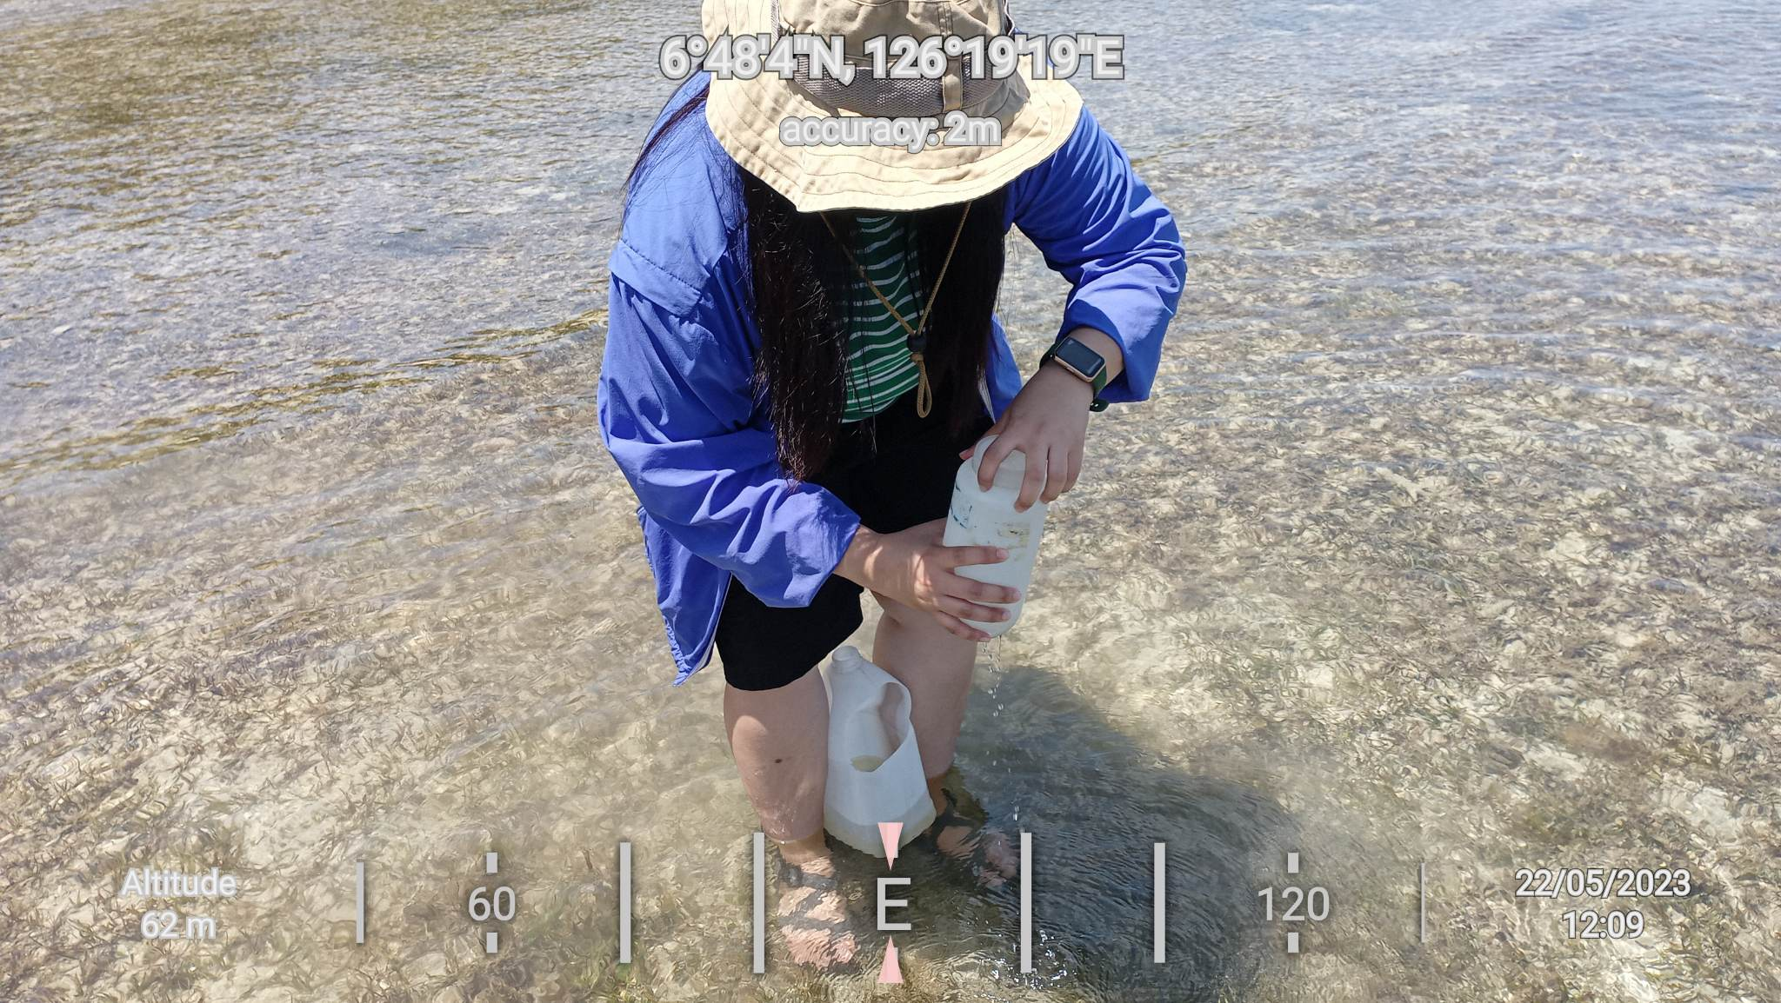

* At Bahia Beach Resort, Brgy. Dahican, approx. 37m from the shoreline at low tide.

