**NOVACARD FINANCIAL - Credit Card Complaints Analysis**

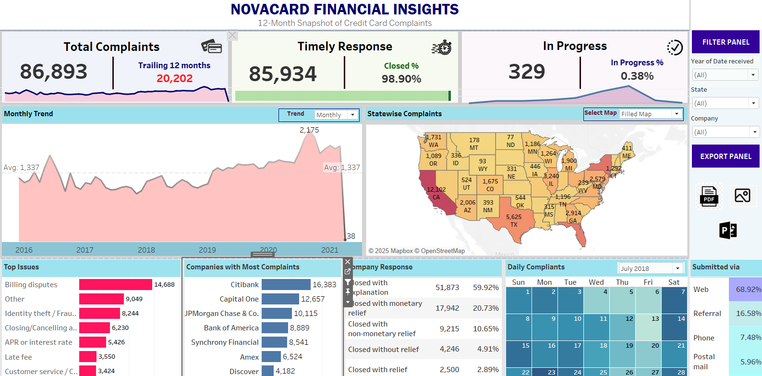[**VIEW PROJECT ON GITHUB!**](https://github.com/araghavan22/Credit_Card_Complaints_Analysis_using_Tableau)

This dashboard is based on a dummy dataset from a fictitious company, Novacard Financial, which compiles reports on credit card companies. My analysis of the trailing 12 months reveals some interesting trends in customer complaints:

**Total Complaints, Timely Responses and In Progress Sections**

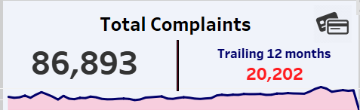

The total complaints generated throughout the time was 86,893 with 20,202 being generated in the last 12 months within the date ranges in the dataset. Also, the spark line at the bottom shows the trend of complaints over time.

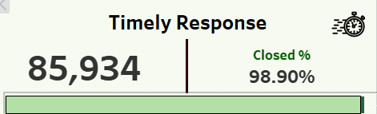

All credit card companies are fast to react upon complaints. 85,934 which is 98.9% of the complaints were closed on time. The progress bar towards the bottom shows the number of closed complaints (98.9%) out of total (100%).

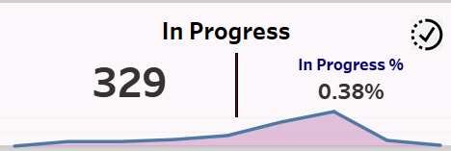

All credit card companies have only 329 complaint cases pending, which is .38%. Also, the spark line at the bottom shows the trned of in progress complaints over time.

**Overall Trend**

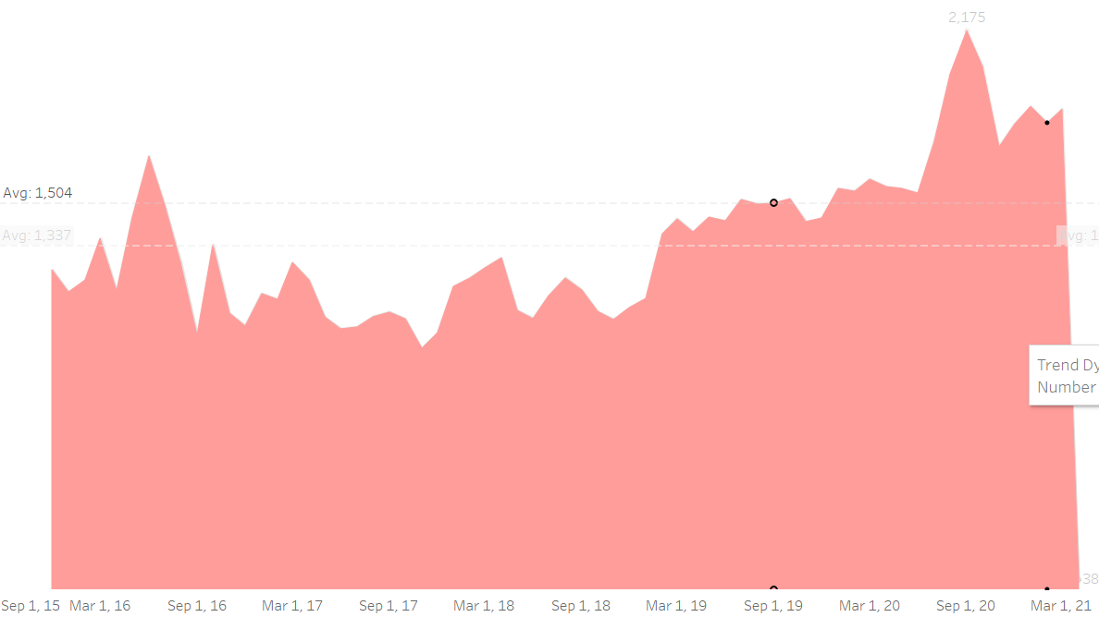

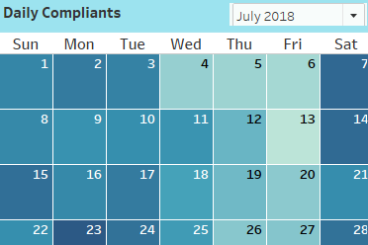

**✅ Key Dates & Trends**

September 9, 2020, saw the highest number of complaints filed in a single day.

There has been a consistent increase in complaints over the years, indicating growing consumer awareness or potential service issues.In the last 12 months alone, complaints have surged by over 20%, highlighting the need for better customer service and dispute resolution mechanisms.

The trend graph has a filter to depict the trend daily, weekly, monthly, quarterly or yearly. The calendar can be filtered to view the number of complaints on a specific day.

**Statewise Compliants**

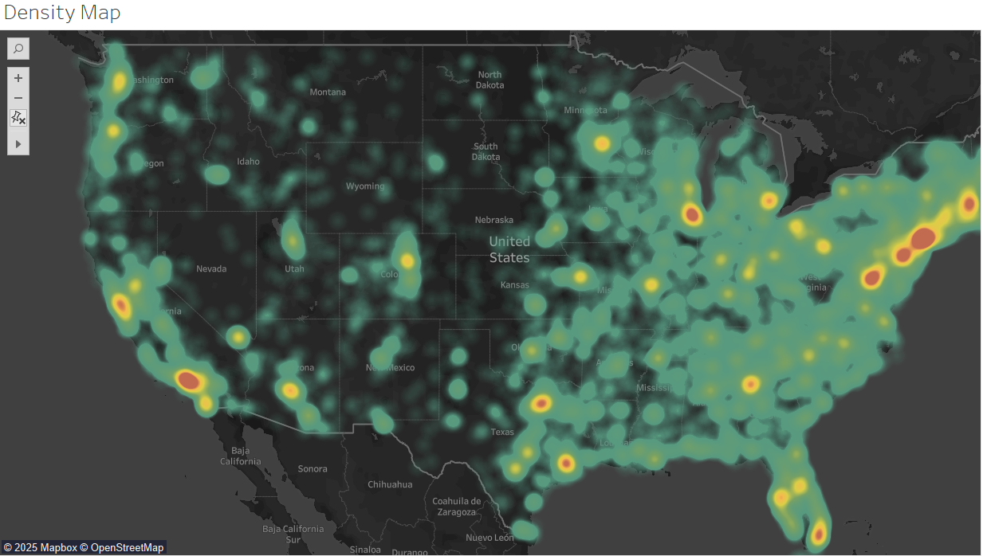

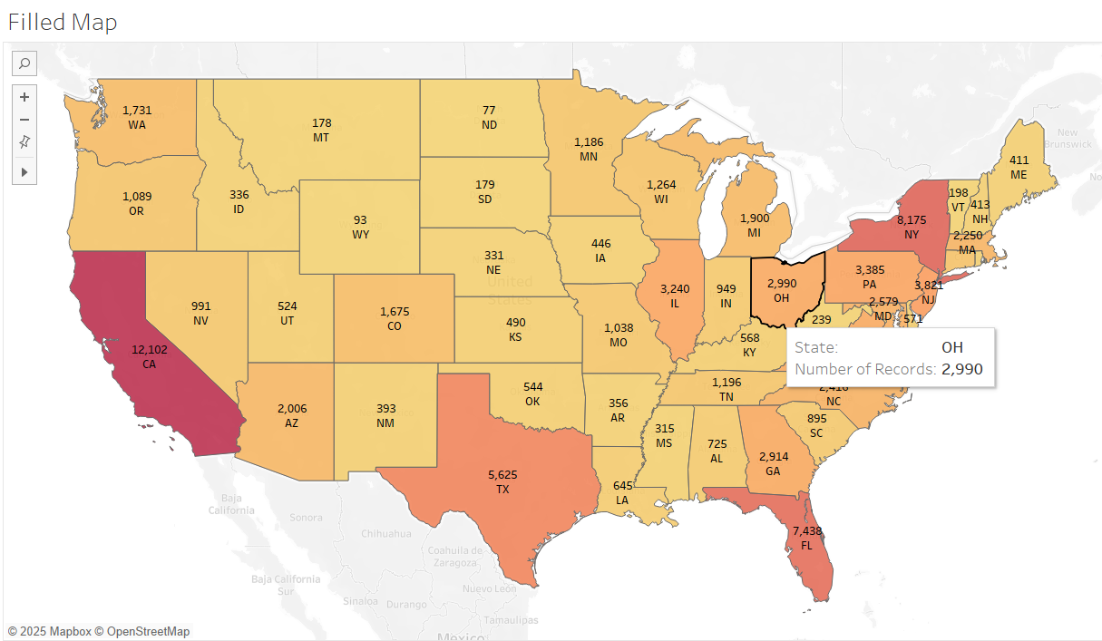

The highest number of complaints come from California, New York, Florida, and Texas—which aligns with their large populations.However, the most populated states are ranked as California, Texas, Florida, and New York, meaning complaint volumes do not always match population sizes exactly.

North Dakota recorded the least number of complaints, while Wyoming, despite having a smaller population, registered 93 complaints.

The maps can be toggled between one another to show either the density and filled map which depicts the number of complaints by state/region.

**Top Issues and Top Companies with the Most Complaints**

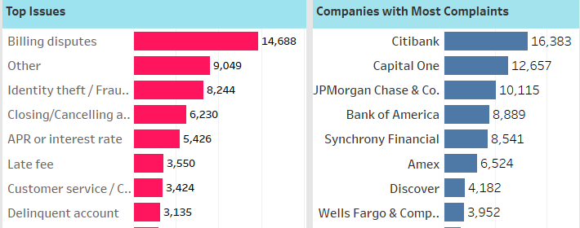

Citibank leads the way, followed by Capital One and JPMorgan Chase & Co.

Most complaints are about billing disputes.

The good news? These companies have resolved over 99% of complaints on time, mainly with an explanation or monetary relief.

**Company Response**

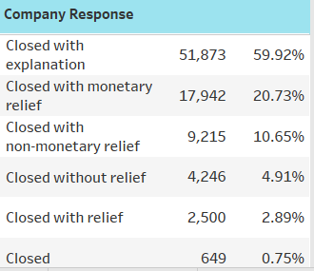

The majority of the complaints were closed with explanation, with monetary relief or some type of non-monetary relief.

**How were complaints submitted?**

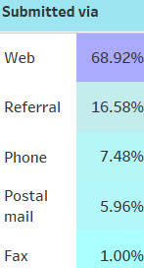

The web and referrals are the top channels—digital platforms are clearly the go-to for raising disputes.