**Medicaid - Business Problems with Solutions**

1. **What is the distribution of the number of active patients across different states and plan categories?**

WITH RankedMCOs AS (

SELECT

State,

MCO_Name,

Number_of_active_patients,

ROW_NUMBER() OVER(PARTITION BY State ORDER BY Number_of_active_patients DESC) as rn

FROM

managed_care

WHERE

Number_of_active_patients IS NOT NULL

AND County <> 'AllCountiesinState'

AND MCO_Name <> 'All'

)

SELECT

State,

MCO_Name,

Number_of_active_patients

FROM

RankedMCOs

WHERE

rn = 1

ORDER BY Number_of_active_patients DESC;

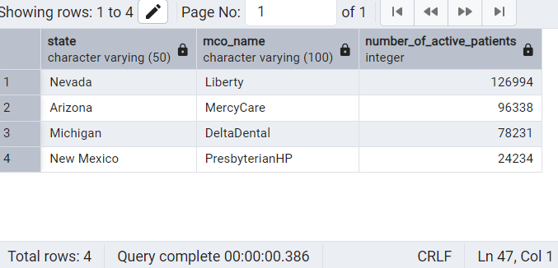

1. **How does the average number of eligible MCO patients vary by state and county?**

SELECT

State,

County,

AVG(Number_of_Eligible_MCO_Patients) AS Average_Eligible_Patients

FROM

managed_care

WHERE

Number_of_active_patients IS NOT NULL

AND County <> 'AllCountiesinState'

AND MCO_Name <> 'All'

GROUP BY

State,

County

ORDER BY

State,

County;

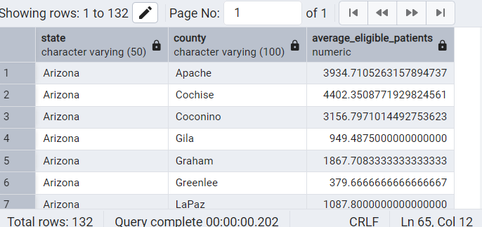

1. **What are the top 10 service categories that consistently have a higher number of active patients across different MCOs?**

SELECT

Service_Category, MCO_Name,

AVG(Number_of_active_patients) AS Average_Active_Patients

FROM

managed_care

WHERE

Number_of_active_patients IS NOT NULL

AND MCO_Name <> 'All'

AND County <> 'AllCountiesinState'

GROUP BY

Service_Category, MCO_Name

ORDER BY

Average_Active_Patients DESC

LIMIT 10;

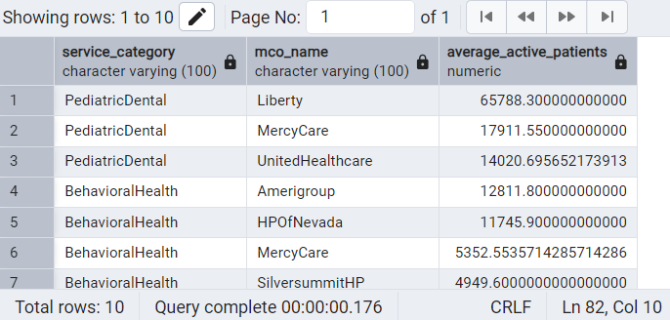

1. **What is the trend of the total number of active patients over the different calendar years present in the data?**

SELECT

Calendar_Year,

SUM(Number_of_active_patients) AS Total_Active_Patients

FROM

managed_care

WHERE

Number_of_active_patients IS NOT NULL

AND MCO_Name <> 'All'

AND County <> 'AllCountiesinState'

GROUP BY

Calendar_Year

ORDER BY

Calendar_Year;

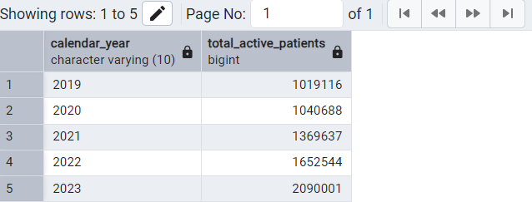

1. **How does the number of providers vary across different states and service categories?**

SELECT

State, Service_Category, AVG(Number_of_Providers) AS Average_Providers

FROM

managed_care

WHERE

Number_of_Providers IS NOT NULL

AND MCO_Name <> 'All'

AND County <> 'AllCountiesinState'

GROUP BY

State, Service_Category

ORDER BY

State, Service_Category;

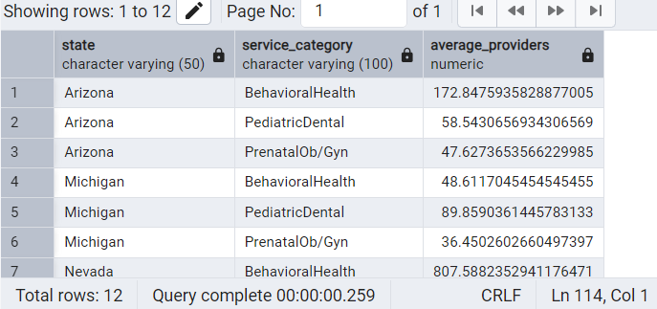

1. **Is there a correlation between the number of eligible patients and the number of providers within each county?**

SELECT

County, CORR(Number_of_Eligible_MCO_Patients, Number_of_Providers) AS Correlation

FROM

managed_care

WHERE

Number_of_Eligible_MCO_Patients IS NOT NULL

AND Number_of_Providers IS NOT NULL

AND MCO_Name <> 'All'

AND County <> 'AllCountiesinState'

GROUP BY

County

ORDER BY

Correlation DESC;

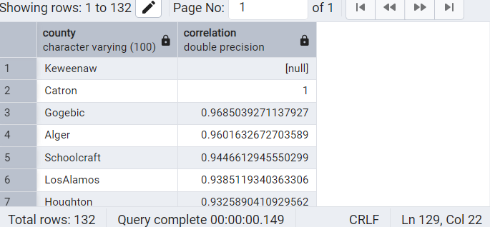

1. **Which are the top 10 MCOs that have the highest average number of active patients per provider?**

SELECT

MCO_Name,

AVG(

CASE

WHEN POSITION(':' IN Number_of_Active_Patients_per_Provider) > 0 THEN

CASE

WHEN CAST(SPLIT_PART(Number_of_Active_Patients_per_Provider, ':', 2) AS NUMERIC) = 0 THEN

NULL -- Handle division by zero

ELSE

CAST(SPLIT_PART(Number_of_Active_Patients_per_Provider, ':', 1) AS NUMERIC) /

CAST(SPLIT_PART(Number_of_Active_Patients_per_Provider, ':', 2) AS NUMERIC)

END

END

) AS Average_Patients_Per_Provider_Ratio

FROM

managed_care

WHERE

Number_of_Active_Patients_per_Provider IS NOT NULL

AND MCO_Name <> 'All'

AND County <> 'AllCountiesinState'

GROUP BY

MCO_Name

HAVING AVG(

CASE

WHEN POSITION(':' IN Number_of_Active_Patients_per_Provider) > 0 THEN

CASE

WHEN CAST(SPLIT_PART(Number_of_Active_Patients_per_Provider, ':', 2) AS NUMERIC) = 0 THEN

NULL -- Handle division by zero

ELSE

CAST(SPLIT_PART(Number_of_Active_Patients_per_Provider, ':', 1) AS NUMERIC) /

CAST(SPLIT_PART(Number_of_Active_Patients_per_Provider, ':', 2) AS NUMERIC)

END

END

) IS NOT NULL

ORDER BY

Average_Patients_Per_Provider_Ratio DESC

LIMIT 10;

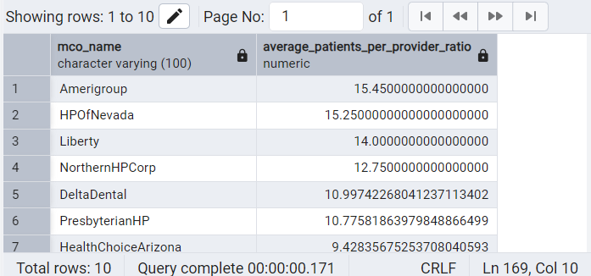

1. **Which are the top 10 MCOs that have the lowest average number of active patients per provider?**

SELECT

MCO_Name,

AVG(

CASE

WHEN POSITION(':' IN Number_of_Active_Patients_per_Provider) > 0 THEN

CASE

WHEN CAST(SPLIT_PART(Number_of_Active_Patients_per_Provider, ':', 2) AS NUMERIC) = 0 THEN

NULL -- Handle division by zero

ELSE

CAST(SPLIT_PART(Number_of_Active_Patients_per_Provider, ':', 1) AS NUMERIC) /

CAST(SPLIT_PART(Number_of_Active_Patients_per_Provider, ':', 2) AS NUMERIC)

END

END

) AS Average_Patients_Per_Provider_Ratio

FROM

managed_care

WHERE

Number_of_Active_Patients_per_Provider IS NOT NULL

AND MCO_Name <> 'All'

AND County <> 'AllCountiesinState'

GROUP BY

MCO_Name

HAVING AVG(

CASE

WHEN POSITION(':' IN Number_of_Active_Patients_per_Provider) > 0 THEN

CASE

WHEN CAST(SPLIT_PART(Number_of_Active_Patients_per_Provider, ':', 2) AS NUMERIC) = 0 THEN

NULL -- Handle division by zero

ELSE

CAST(SPLIT_PART(Number_of_Active_Patients_per_Provider, ':', 1) AS NUMERIC) /

CAST(SPLIT_PART(Number_of_Active_Patients_per_Provider, ':', 2) AS NUMERIC)

END

END

) IS NOT NULL

ORDER BY

Average_Patients_Per_Provider_Ratio ASC

LIMIT 10;

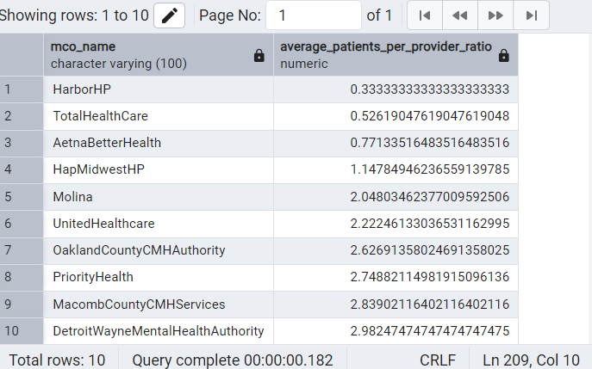

1. **Has the average number of active patients per provider changed significantly over the different calendar years?**

WITH YearlyAvgRatio AS (

SELECT

Calendar_Year,

AVG(

CASE

WHEN POSITION(':' IN Number_of_Active_Patients_per_Provider) > 0 THEN

CASE

WHEN CAST(SPLIT_PART(Number_of_Active_Patients_per_Provider, ':', 2) AS NUMERIC) = 0 THEN

NULL

ELSE

CAST(SPLIT_PART(Number_of_Active_Patients_per_Provider, ':', 1) AS NUMERIC) /

CAST(SPLIT_PART(Number_of_Active_Patients_per_Provider, ':', 2) AS NUMERIC)

END

ELSE

NULL

END

) AS Average_Patients_Per_Provider_Ratio_Raw

FROM

managed_care

WHERE

Number_of_Active_Patients_per_Provider IS NOT NULL

AND MCO_Name <> 'All'

AND County <> 'AllCountiesinState'

GROUP BY

Calendar_Year

)

SELECT

Calendar_Year,

ROUND(Average_Patients_Per_Provider_Ratio_Raw, 2) AS Average_Patients_Per_Provider

FROM

YearlyAvgRatio

WHERE

Average_Patients_Per_Provider_Ratio_Raw IS NOT NULL

ORDER BY

Calendar_Year;

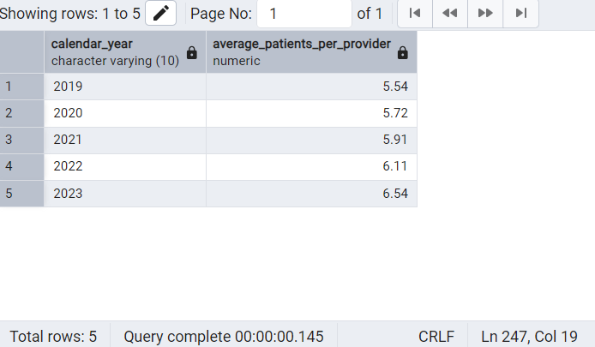

1. **What is the average number of services per active patient for each service category?**

SELECT

Service_Category,

ROUND(AVG(Number_of_Services_per_Active_Patient),2) AS Average_Services_Per_Active_Patient

FROM

managed_care

WHERE

Number_of_Services_per_Active_Patient IS NOT NULL

AND MCO_Name <> 'All'

AND County <> 'AllCountiesinState'

GROUP BY

Service_Category

ORDER BY

Service_Category;

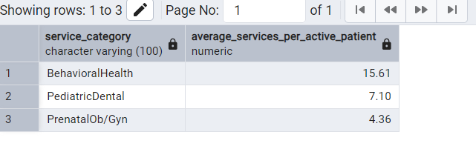

1. **Are there significant differences in the average number of services per active patient across different states or plan categories?**

-- Average services per active patient by State

SELECT

State,

ROUND(AVG(Number_of_Services_per_Active_Patient),2) AS Average_Services

FROM

managed_care

WHERE

Number_of_Services_per_Active_Patient IS NOT NULL

AND MCO_Name <> 'All'

AND County <> 'AllCountiesinState'

GROUP BY

State

ORDER BY

State;

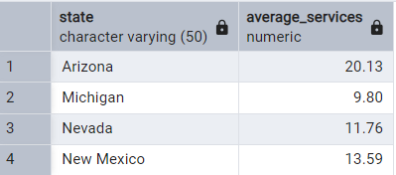

-- Average services per active patient by Plan Category

SELECT

Plan_Category,

ROUND(AVG(Number_of_Services_per_Active_Patient),2) AS Average_Services

FROM

managed_care

WHERE

Number_of_Services_per_Active_Patient IS NOT NULL

AND MCO_Name <> 'All'

AND County <> 'AllCountiesinState'

GROUP BY

Plan_Category

ORDER BY

Plan_Category;

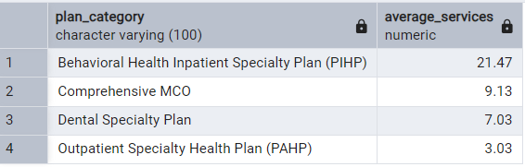

-- Average services per active patient by State and Plan Category

SELECT

State,

Plan_Category,

ROUND(AVG(Number_of_Services_per_Active_Patient),2) AS Average_Services

FROM

managed_care

WHERE

Number_of_Services_per_Active_Patient IS NOT NULL

AND MCO_Name <> 'All'

AND County <> 'AllCountiesinState'

GROUP BY

State,

Plan_Category

ORDER BY

State,

Plan_Category;

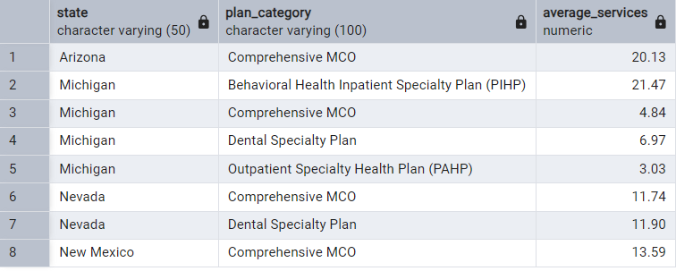

1. **How does the "Percent_Of_Eligible_Patients_Receiving_Services" vary across different MCOs and service categories?**

SELECT

MCO_Name,

Service_Category,

ROUND(AVG(CAST(REPLACE(Percent_Of_Eligible_Patients_Receiving_Services, '%', '') AS DECIMAL(10, 4))),2) AS average_eligible_percent_receiving_services

FROM

managed_care

WHERE

Percent_Of_Eligible_Patients_Receiving_Services IS NOT NULL

AND MCO_Name <> 'All'

AND County <> 'AllCountiesinState'

GROUP BY

MCO_Name,

Service_Category

ORDER BY

MCO_Name,

Service_Category;

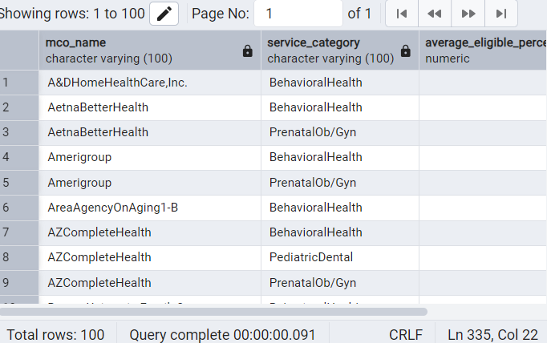

1. **Is there a relationship between the number of providers and the "Percent_Of_Eligible_Patients_Receiving_Services" within a given area?**

SELECT

State,

County,

CORR(Number_of_Providers,

ROUND(CAST(REPLACE(Percent_Of_Eligible_Patients_Receiving_Services, '%', '') AS DECIMAL(10, 4)),2)

) AS Correlation_Providers_vs_ServicePercent

FROM

managed_care

WHERE

Number_of_Providers IS NOT NULL

AND Percent_Of_Eligible_Patients_Receiving_Services IS NOT NULL

AND MCO_Name <> 'All'

AND County <> 'AllCountiesinState'

GROUP BY

State,

County

ORDER BY

State,

County;

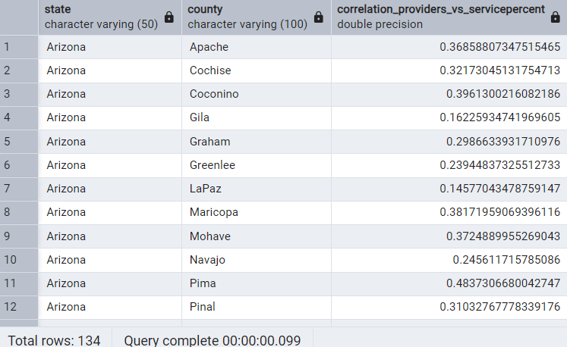

1. **Which MCOs consistently have a high "Percent_Of_Eligible_Patients_Receiving_Services" across different service categories and years?**

WITH MCOAvgPercent AS (

SELECT

MCO_Name,

AVG(

(CAST(REPLACE(Percent_Of_Eligible_Patients_Receiving_Services, '%', '') AS DECIMAL(10, 4)))/ 100.0

) AS Avg_Percent_Across_Services_Years,

COUNT(DISTINCT EXTRACT(YEAR FROM TO_DATE(Calendar_Year, 'YYYY'))) AS Number_Of_Years,

COUNT(DISTINCT Service_Category) AS Number_Of_Service_Categories

FROM

managed_care

WHERE

Percent_Of_Eligible_Patients_Receiving_Services IS NOT NULL

AND MCO_Name <> 'All'

AND County <> 'AllCountiesinState'

GROUP BY

MCO_Name

HAVING

COUNT(DISTINCT EXTRACT(YEAR FROM TO_DATE(Calendar_Year, 'YYYY'))) > 1

AND COUNT(DISTINCT Service_Category) > 1

)

SELECT

MCO_Name,

Avg_Percent_Across_Services_Years

FROM

MCOAvgPercent

WHERE

Avg_Percent_Across_Services_Years >= (SELECT AVG(Avg_Percent_Across_Services_Years) FROM MCOAvgPercent) -- Adjust threshold as needed

ORDER BY

Avg_Percent_Across_Services_Years DESC;

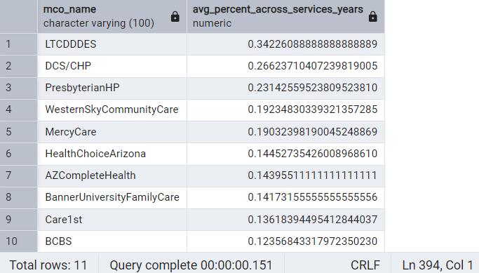

1. **What is the trend of the total number of active patients within each state over the available calendar years?**

-- Trend in the number of active patients by State and Year

SELECT

EXTRACT(YEAR FROM TO_DATE(Calendar_Year, 'YYYY')) AS Year,

State,

SUM(Number_of_active_patients) AS Total_Active_Patients

FROM

managed_care

WHERE

Number_of_active_patients IS NOT NULL

AND MCO_Name <> 'All'

AND County <> 'AllCountiesinState'

GROUP BY

EXTRACT(YEAR FROM TO_DATE(Calendar_Year, 'YYYY')),

State

ORDER BY

State,

Year;

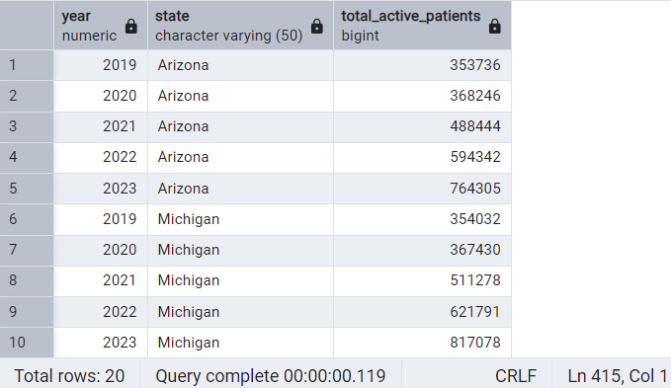

1. **What is the trend of the total number of active patients within each county over the available calendar years?**

-- Trend in the number of active patients by County and Year

SELECT

EXTRACT(YEAR FROM TO_DATE(Calendar_Year, 'YYYY')) AS Year,

County,

SUM(Number_of_active_patients) AS Total_Active_Patients

FROM

managed_care

WHERE

Number_of_active_patients IS NOT NULL

AND MCO_Name <> 'All'

AND County <> 'AllCountiesinState'

GROUP BY

EXTRACT(YEAR FROM TO_DATE(Calendar_Year, 'YYYY')),

County

ORDER BY

County,

Year;

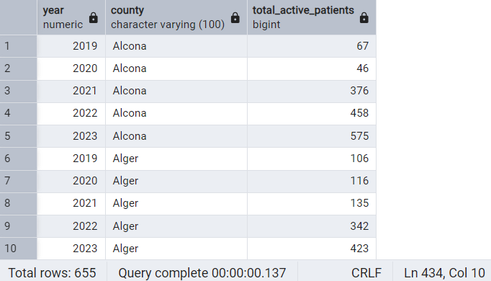

1. **What is the trend of the average number of providers within each state over the available calendar years?**

-- Trend in the number of providers by State and Year

SELECT

EXTRACT(YEAR FROM TO_DATE(Calendar_Year, 'YYYY')) AS Year,

State,

ROUND( AVG(Number_of_Providers),2) AS Average_Providers

FROM

managed_care

WHERE

Number_of_Providers IS NOT NULL

AND MCO_Name <> 'All'

AND County <> 'AllCountiesinState'

GROUP BY

EXTRACT(YEAR FROM TO_DATE(Calendar_Year, 'YYYY')),

State

ORDER BY

State,

Year;

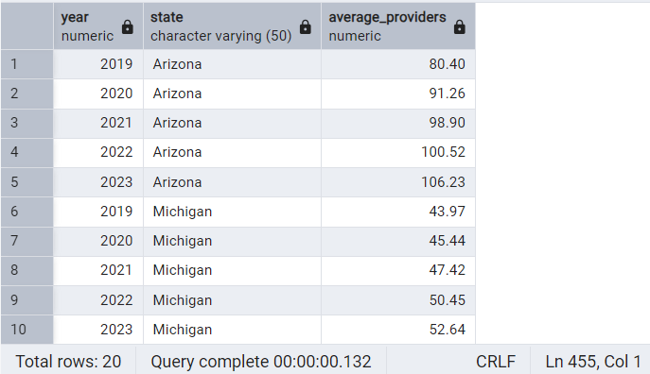

1. **What is the trend of the average number of providers within each county over the available calendar years?**

-- Trend in the number of providers by County and Year

SELECT

EXTRACT(YEAR FROM TO_DATE(Calendar_Year, 'YYYY')) AS Year,

County,

ROUND(AVG(Number_of_Providers),2) AS Average_Providers

FROM

managed_care

WHERE

Number_of_Providers IS NOT NULL

AND MCO_Name <> 'All'

AND County <> 'AllCountiesinState'

GROUP BY

EXTRACT(YEAR FROM TO_DATE(Calendar_Year, 'YYYY')),

County

ORDER BY

County,

Year;

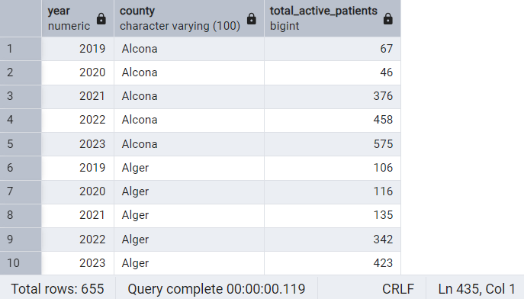

1. **What is the trend of the average number of services per active patient within each state over the available calendar years?**

-- Trend in service utilization (average services per active patient) by State and Year

SELECT

EXTRACT(YEAR FROM TO_DATE(Calendar_Year, 'YYYY')) AS Year,

State,

ROUND(AVG(Number_of_Services_per_Active_Patient),2) AS Average_Services_Per_Patient

FROM

managed_care

WHERE

Number_of_Services_per_Active_Patient IS NOT NULL

AND MCO_Name <> 'All'

AND County <> 'AllCountiesinState'

GROUP BY

EXTRACT(YEAR FROM TO_DATE(Calendar_Year, 'YYYY')),

State

ORDER BY

State,

Year;

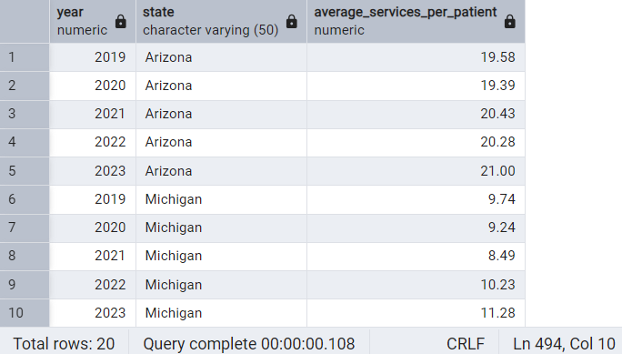

1. **What is the trend of the average number of services per active patient within each county over the available calendar years?**

-- Trend in service utilization (average services per active patient) by County and Year

SELECT

EXTRACT(YEAR FROM TO_DATE(Calendar_Year, 'YYYY')) AS Year,

County,

ROUND(AVG(Number_of_Services_per_Active_Patient),2) AS Average_Services_Per_Patient

FROM

managed_care

WHERE

Number_of_Services_per_Active_Patient IS NOT NULL

AND MCO_Name <> 'All'

AND County <> 'AllCountiesinState'

GROUP BY

EXTRACT(YEAR FROM TO_DATE(Calendar_Year, 'YYYY')),

County

ORDER BY

County,

Year;

