DICOM Image Storage Abstraction

Revision History

Date | Who | Description of What Was Changed
2009–04-02 | Lin Yang | Initial draft version
2009-04-07 | Lin Yang | Added description of configuration items
2009-04-14 | Lin Yang | Added SQL script of creating table
2009-07-01 | Lin Yang | Modified configuration description

Abstract:

In the original Dcm4chee project (Homepage) DICOM image is supposed to be stored in file system. However, an abstraction of storage layer has been developed so that alternative storage medium could be applied. Although the current storage options confines to file system and Oracle 11g database, it is easy to extend the new feature to have more options.

Here you will be instructed how to install and configure the new feature so you can switch storage of DICOM images between file system and database.

- Download source code from AragonCG GitHub account

To download the source code, install a Git client first and then use the following clone url: git://github.com/aragoncg/dicom-storage-abastraction.git to get a copy of the source code.

The modified source code is based on version 2.14.2 of Dcm4chee.

- Compile source code, package binary distribution

These steps are totally same as those of the original Dcm4chee project, so please refer to the detailed installation instruction of Dcm4chee.

- Database Script Download and Installation

After finishing building and packaging, unzip one binary distribution package according to which database you decide to use.

Besides the source code there is a directory named “extra-resource” which contains some extra necessary resource. Download it as well.

Copy the Crt-TabSpc-Tab.sql file in it to dcm4chee - *** - 2.14.2 \ sql dir. Then execute this sql script under SqlPlus. This will set up default table space and table used to store DICOM images in Oracle 11g database.

Here is the script:

PROMPT Do you want to create the default table for DICOM image?

PAUSE Press OK to create default table.

-- Create tablespace
create tablespace dicomdata datafile 'dicomdata' size 100m
EXTENT MANAGEMENT LOCAL SEGMENT SPACE MANAGEMENT AUTO;

-- The standard process for creating fully instantiated ORDDicom objects
-- has several steps:
--
-- 1. insert an empty initialized ORDDicom object
-- 2. load binary DICOM data into the underlying BLOB
-- 3. select ORDDicom object from table for update
-- 4. call obj.setProperties() method to extract metadata and populate object attributes
-- 5. update table with modified object
--
-- Step 4 will increase the size of the ORDDicom object. Thus it will require more
-- space in the database page when it is written back to the table in step 5. Oracle
-- reserves space on every database page to accomodate the grow of data items. The
-- amount of space is determined by the PCTFREE attribute (default value 10) which
-- is specified in the CREATE TABLE statement.
--
-- To determine a suitable value for PCTFREE perform the following:
--
-- 1. create a test table and load it with data
-- 2. execute the command "ANALYZE TABLE <table_name> COMPUTE STATISTICS"
-- 3. execute the query "SELECT AVG_ROW_LEN, CHAIN_CNT
-- FROM USER_TABLES WHERE TABLE_NAME='<table_name>'"
-- 4. initialize the ORDDicom objects in the table using the setProperties() method
-- 5. perform steps 2 and 3 again.
-- 6. compute a value for PCTFREE as 100*(1-X/Y) where X is the AVG_ROW_LEN
-- from step 3 and Y is the AVG_ROW_LEN from step 5
--
-- NOTE this discussion assume that AVG_ROW_LEN < the database block size
-- You should ensure the your AVG_ROW_LEN is less than your database block size
-- so that row chaining does not occur automatically for every row.
--
-- The table definition below uses a value of 60 for the PCTFREE attribute.
-- Note that each LOB attribute of the ORDDicom object has a storage clause that
-- disables in row storage for that LOB data. This increases the predictablity of
-- row length and reduces row chaining.

create table dicom_image
(
i_id integer primary key , -- image id
i_date date ,
i_image ordsys.orddicom -- dicom image
)
--
-- table storage
--
-- metadata extraction expands the orddicom image considerably
--
pctfree 60
--
-- lob storage
--
lob(i_image.source.localdata) store as SecureFile
( tablespace dicomdata
nocache filesystem_like_logging
),
-- disable in row storage for the extension
-- so that it does not consume page space
-- it is usually < 4k in size
lob(i_image.extension) store as SecureFile
( tablespace dicomdata
nocache filesystem_like_logging
disable storage in row
),
-- store the metadata as a CLOB,
-- disable storage in row
xmltype i_image.metadata store as SecureFile clob
( tablespace dicomdata
nocache
disable storage in row
)
;

- Libraries Import

Copy ojdbc6.jar, orddicom.jar and ucp.jar in “extra-resource” dir to dcm4chee - *** - 2.14.2 \ server \ default \ lib dir. These three jars are necessary for DICOM storage in Oracle 11g database and connection pool management.

Since Oracle JDBC Driver 6 and universal connection pool are used here, the version of JDK should be updated to 6.0.

- Storage Configuration

Copy dcm4chee-storage-opt.xml in “extra-resource” dir to dcm4chee - *** - 2.14.2 \ server \ default \ deploy dir.

Configure the items in dcm4chee-storage-opt.xml according to your database connection information and table definition.

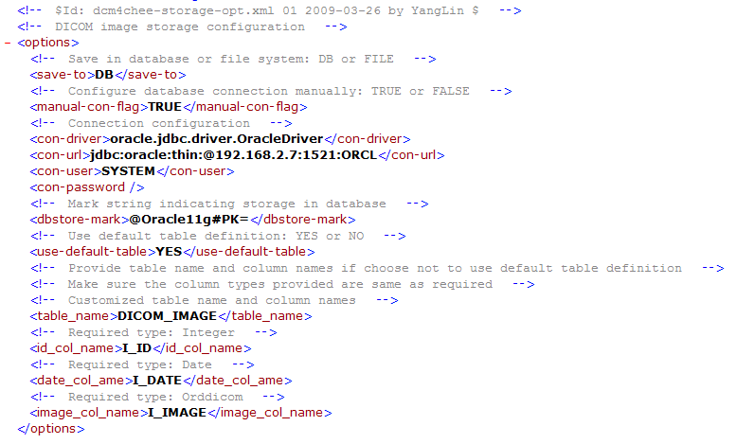

The value of <save-to> node determines where to save DICOM images. If it is configured as “FILE” then you don’t need to care the rest items.

If the <save-to> is configured as “DB” and the <manual-con-flag> is set to “TRUE”, then you need to provide JDBC connection information.

For security reason you can leave the <con-password> item blank and the server will prompt for the password when it starts; Or if you don’t care, you can fill in it here as plain text.

The <dbstore-mark> node indicates a mark string that will be appended to the storage path of each DICOM image inserted into the database.

If you decide to use default table and columns defined by the Crt-TabSpc-Tab.sql script, keep the <use-default-table> as “YES”; otherwise, you have to provide names of table and columns that accord to the required types. Once the table/columns you provide can not be found in database, or the types of columns are detected not same as the required, Dcm4chee will choose to save DICOM image in file system by default.

Now the new feature has been installed and configured. You can startup the project and test the new feature.

NOTE:
Keep in mind that each time before switching the storage medium, delete all DICOM images the Dcm4chee system currently works on, otherwise the system will be messed.

