Incident Investigation Report
Identity-Based Attack Chain Against Active Directory
A SOC Detection & Response Investigation
SOC Detection & Response Lab — Investigation #1
Analyst: Andres Aragon Molina
Date: October 2026
Classification: TLP:AMBER

1. Classification & Privacy Notice
Traffic Light Protocol (TLP): TLP:AMBER — Limited disclosure. This report is intended for the author's professional portfolio and prospective employers only; it describes a fully isolated, consent-based lab environment with no real victims.
All screenshots in this report were reviewed before inclusion. Browser and virtualization-window chrome was cropped out; all IP addresses shown fall within the lab's isolated 10.10.10.0/24 range; no personal file paths, real credentials, or identifying information appear in any figure.
Note on methodology: the attack activity described in this report was generated in a controlled lab under my own authorization, using known offensive tools (Kerbrute, Impacket), for the explicit purpose of producing realistic telemetry to analyze, detect, and respond to as a defender. This report is written from the perspective of a SOC analyst investigating the resulting alerts, not as an offensive engagement report.

2. Executive Summary
This report documents my investigation of a simulated attack chain against soclab.local, an Active Directory environment built to replicate the identity infrastructure of a medium-sized enterprise. Over the course of this investigation, I identified and analyzed 5 distinct alerts covering the full lifecycle of an identity-based attack: reconnaissance, credential compromise, privilege escalation, remote code execution, and large-scale credential theft. My analysis traced the attacker's movement from an unauthenticated enumeration of domain accounts to full domain compromise, including extraction of the krbtgt hash — a finding that would allow an adversary to forge valid Kerberos tickets for any user indefinitely, even after a full password reset. I built, validated, and deployed 5 custom Sigma/SPL detection rules covering this entire attack chain, each confirmed to fire correctly against the real attack traffic analyzed in this investigation.
Field | Value
Environment | soclab.local — isolated VirtualBox NAT Network (10.10.10.0/24)
Affected Asset | DC01 (Windows Server 2022, Domain Controller)
Alerts Investigated | 5 (see Section 4)
Detection Platform | Splunk Enterprise 10.6
Highest Severity | Critical (Privilege Escalation, DCSync)
Outcome | Full attack chain reconstructed and detected; krbtgt hash exposure identified as the critical finding requiring immediate remediation

3. Environment & Scope

3.1 Monitored Environment
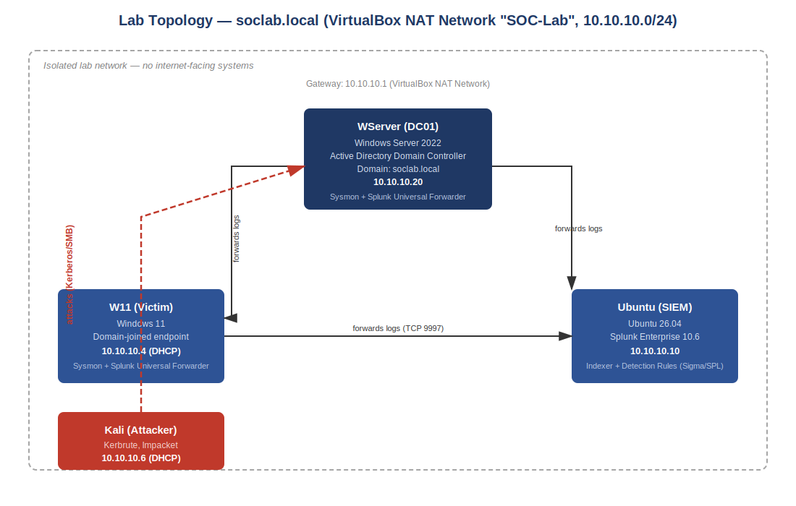
Figure 0. Monitored network topology — soclab.local Active Directory domain, isolated VirtualBox NAT Network (10.10.10.0/24).
The monitored environment consists of a Windows Server 2022 Domain Controller (WServer / DC01, 10.10.10.20) running Active Directory for the soclab.local domain, and a domain-joined Windows 11 workstation (W11, 10.10.10.4). Both systems forward Windows Event Logs and Sysmon telemetry to a centralized Splunk instance (Ubuntu, 10.10.10.10), which hosts the detection rules referenced throughout this report. The host at 10.10.10.6 / 10.10.10.4 (Kali Linux) represents the external source from which the attack traffic analyzed below originated.

3.2 Detection Stack
- Splunk Enterprise 10.6 (SIEM) — centralized log indexing, correlation searches, and alerting
- Sysmon + Windows Event Logs, forwarded via Splunk Universal Forwarder
- 5 custom Sigma rules, translated to SPL and deployed as scheduled Splunk alerts (see Section 7)

4. Attack Chain Overview (MITRE ATT&CK Mapping)
The following table summarizes the techniques identified during this investigation, mapped to the MITRE ATT&CK framework, in the order the attacker executed them.
# | Technique | MITRE ID | Severity | Analyst Finding
1 | Kerberos User Enumeration | T1589.002 | Medium | 2 valid domain accounts identified via unauthenticated Kerberos requests
2 | Kerberos Password Brute Force | T1110.003 | High | Valid credentials obtained for a standard domain user
3 | Domain Admin Privilege Escalation | T1136.001 / T1098.007 | Critical | Rogue account created and added to Domain Admins in 6 seconds
4 | Remote Command Execution via Task Scheduler | T1053.005 | High | SYSTEM-level remote code execution confirmed on the Domain Controller
5 | DCSync Credential Extraction | T1003.006 | Critical | Full domain credential database exfiltrated, including krbtgt

5. Investigation Timeline
Correlating timestamps across all 5 alerts reconstructs the attacker's full path through the environment, from first contact to complete domain compromise in under 70 minutes of active attack time.
Time (UTC) | Observed Activity | Technique | Supporting Evidence
13:14:56 | Unauthenticated Kerberos requests enumerate valid domain accounts | T1589.002 | Kerbrute output — "2 valid"
21:12-21:28 | Successful authentication for a previously enumerated account | T1110.003 | Splunk 4768, Result_Code 0x0, src 10.10.10.4
21:52:54 | New domain account created, immediately added to Domain Admins | T1136.001 / T1098.007 | Splunk 4720 (21:52:54) / 4728 (21:53:00)
22:10:03 | SYSTEM-level command execution observed on the Domain Controller | T1053.005 | Sysmon EventID 1, cmd.exe via svchost.exe
22:15:33 | Non-DC account observed exercising Directory Replication rights | T1003.006 | Splunk 4662, replication rights GUID

6. Alert-by-Alert Analysis

Alert 1 — Kerberos User Enumeration (T1589.002)
SEVERITY: MEDIUM
Trigger: Multiple Kerberos AS-REQ (Event 4768) requests for different account names, originating from the same source address within a one-minute window.
Investigation: I correlated the AS-REQ events in Splunk and found 8 distinct authentication attempts from 10.10.10.4 within seconds of each other, each testing a different username against the Domain Controller. Of these, 2 returned a successful Kerberos pre-authentication response — confirming jperez and administrator as valid domain accounts — while the remaining 6 produced no corresponding event, consistent with Kerberos silently rejecting requests for non-existent accounts.
Attacker Pattern: This activity is consistent with the Kerbrute user-enumeration technique: querying Kerberos pre-authentication without ever submitting a password. Because no authentication is actually attempted, the technique does not trigger account lockout policies and produces no failed-logon events — making it a quiet reconnaissance step attackers use to build a target list before a credential attack.
Analyst Note: This finding matters because enumeration is the first opportunity to detect an attacker before any credentials are at risk. A SOC that only alerts on failed logons will miss this technique entirely, since it never generates one.
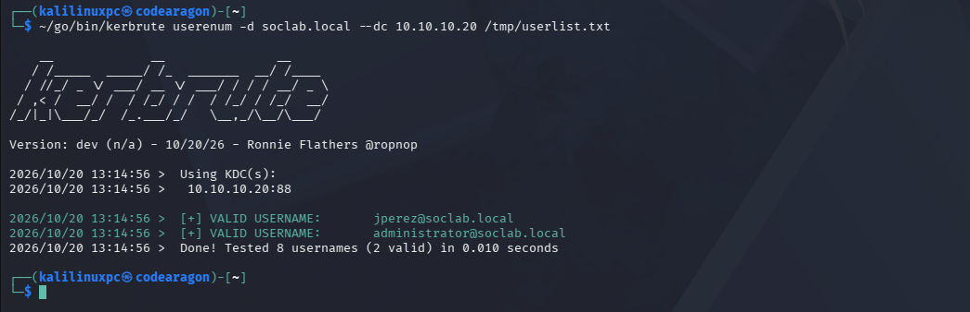
Figure 1. Evidence of Kerberos user enumeration — two valid domain accounts (jperez, administrator) confirmed via unauthenticated AS-REQ, without triggering account lockout.

Alert 2 — Kerberos Password Brute Force (T1110.003)
SEVERITY: HIGH
Trigger: Three or more Kerberos pre-authentication failures (Event 4771, Failure_Code 0x18) for the same account and source, followed by a successful AS-REQ (Event 4768) within a 5-minute window.
Investigation: Following up on the account identified in Alert 1, I found a sequence of 4771 events against jperez, each failing with code 0x18 (incorrect password), immediately followed by a single 4768 event with Result_Code 0x0 — a successful authentication — from the same source address, 10.10.10.4.
Attacker Pattern: This is a short, targeted password-guessing attack following directly from the enumeration in Alert 1 — the attacker did not spray passwords broadly across many accounts, but focused a small password list against one confirmed-valid username. This is a far quieter and more efficient approach than a traditional brute force, and highlights why enumeration (Alert 1) is the critical point to intercept this attack chain.
Analyst Note: The short gap between failures and success (seconds) combined with the small number of attempts shows this was not a guessing exercise but a targeted attack using a curated password list — a pattern worth flagging even below typical lockout thresholds.
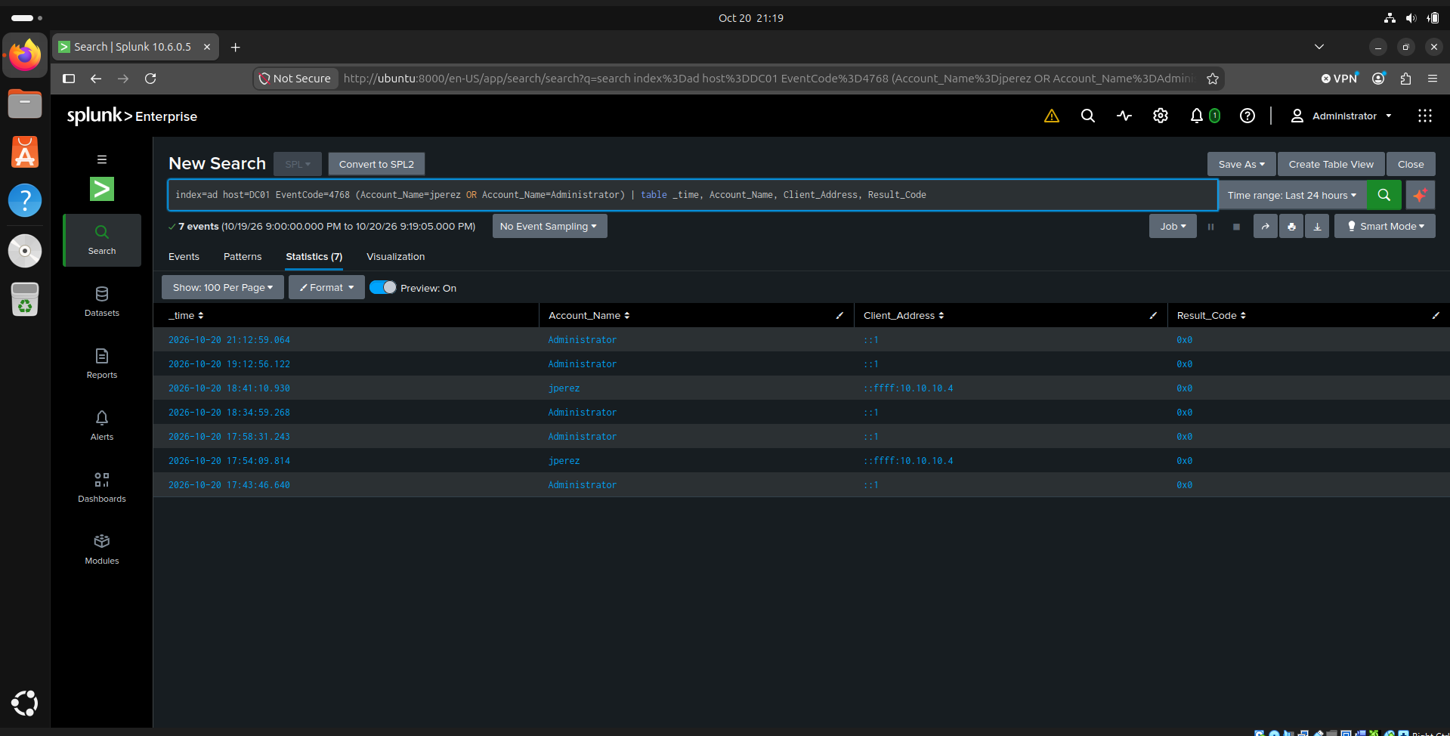
Figure 2. Correlated Kerberos AS-REQ (4768) events for jperez and Administrator, isolating the successful authentication (Result_Code 0x0) from source 10.10.10.4.

Alert 3 — Domain Admin Privilege Escalation (T1136.001 / T1098.007)
SEVERITY: CRITICAL
Trigger: A new account creation event (4720) followed by that same account being added to the Domain Admins group (4728) within a 5-minute window.
Investigation: Splunk correlation showed account attacker01 was created at 21:52:54 and added to Domain Admins just 6 seconds later, at 21:53:00 — both actions performed under the Administrator account. This pairing is highly anomalous: legitimate account provisioning in a managed environment virtually never results in immediate Domain Admin membership without an intermediate approval step.
Attacker Pattern: This behavior is consistent with an attacker who has already compromised a privileged credential (Administrator) and is establishing a secondary, self-controlled foothold — a common technique to avoid relying solely on a single stolen account, which the legitimate owner might notice or have reset. Creating a new, less conspicuous account reduces the attacker's dependency on the original compromised identity.
Analyst Note: The 6-second gap between the two actions is the most important signal here: no human admin workflow operates at that speed. This is precisely the kind of pattern that requires automated, real-time detection, since by the time a human reviews an audit log, the damage is already done.
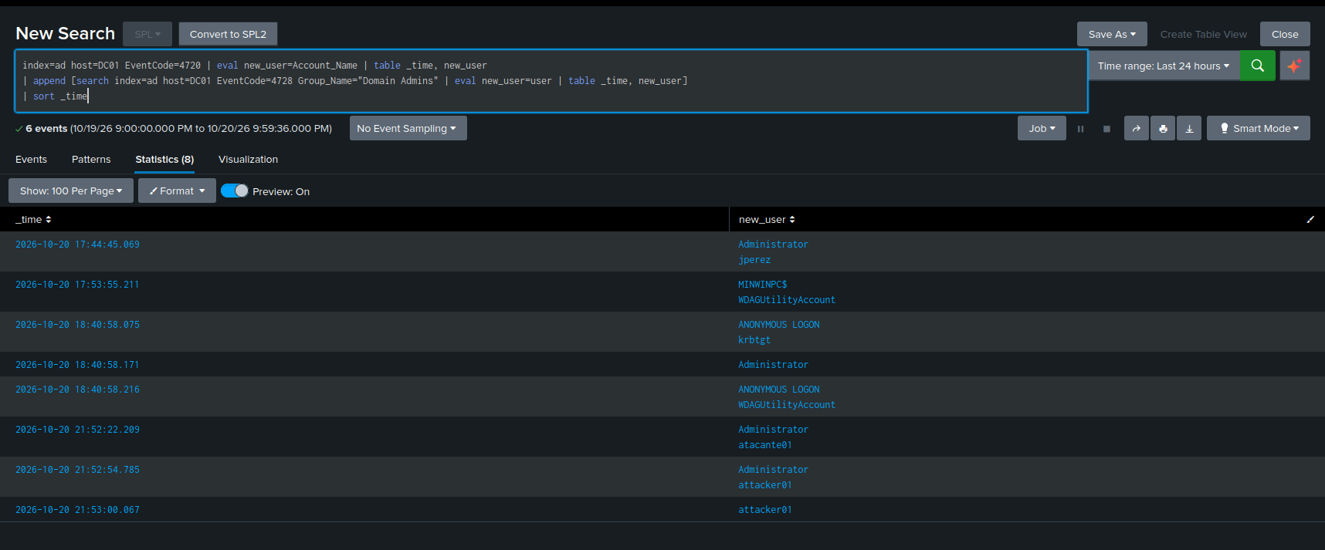
Figure 3. Correlated timeline showing attacker01 account creation (4720) immediately followed by addition to the Domain Admins group (4728), 6 seconds apart.

Alert 4 — Remote Command Execution via Task Scheduler (T1053.005)
SEVERITY: HIGH
Trigger: cmd.exe spawned by svchost.exe (Task Scheduler service), running as NT AUTHORITY\SYSTEM, with output redirected to a file under C:\Windows\Temp.
Investigation: Sysmon process-creation telemetry showed cmd.exe executing ‘whoami > C:\Windows\Temp\GqPpMBmJ.tmp 2>&1’, with ParentImage svchost.exe and ParentCommandLine referencing the Schedule service, running under the SYSTEM account — the highest privilege level available on Windows.
Attacker Pattern: This matches the signature of remote task-based execution tooling (such as Impacket's atexec), which abuses the Windows Task Scheduler RPC interface to run arbitrary commands on a remote host using only a valid set of credentials — in this case, the attacker01 account already elevated to Domain Admin in Alert 3. The attacker is using their newly escalated privileges to confirm remote code execution capability on the Domain Controller itself.
Analyst Note: A normal user process is almost never the direct child of svchost.exe. This parent-child relationship, combined with SYSTEM-level execution and a Temp-directory output path, is a high-confidence detection signature regardless of the specific command executed.

Alert 5 — DCSync Credential Extraction (T1003.006)
SEVERITY: CRITICAL
Trigger: A non-Domain-Controller account exercising Active Directory Replicating Directory Changes / Replicating Directory Changes All rights (Event 4662 with the corresponding GUIDs).
Investigation: I identified Event 4662 entries where attacker01 — a standard domain account, not a Domain Controller computer account — exercised directory replication rights normally reserved exclusively for Domain Controllers replicating with one another. This is the technical basis of a DCSync attack: by impersonating a DC's replication request, an attacker can ask the real Domain Controller to hand over the full password hash database for every account in the domain.
Attacker Pattern: This is the final and most damaging stage of the observed attack chain. With Domain Admin rights obtained in Alert 3, the attacker requested a full replication of domain secrets, including the krbtgt account hash. krbtgt is the account Active Directory uses to cryptographically sign every Kerberos ticket issued in the domain.
Critical Impact: Possession of the krbtgt hash allows an attacker to forge valid Kerberos tickets for any account in the domain — including Domain Admins — without needing that account's actual password. These forged tickets (commonly called Golden Tickets) remain valid even after every user password in the domain is reset, because they do not depend on any individual password. The only way to invalidate them is to reset the krbtgt password twice in sequence, due to how Kerberos ticket versioning works. This single finding elevates the entire incident from 'privilege escalation' to 'full domain compromise requiring a krbtgt reset as part of remediation.'

7. Detection Coverage & Response
Five Sigma/SPL detection rules were built and validated against this attack chain, providing coverage across the full progression from reconnaissance to domain compromise. Full rule definitions are maintained in /detections/sigma/ in the project repository.
Rule | Severity | Detects
Kerberos User Enumeration | Medium | Multiple AS-REQ (4768) for different accounts, same source, <1min
Kerberos Password Brute Force | High | 3+ failed pre-auth (4771, 0x18) followed by success (4768)
New Domain Admin Shortly After Creation | Critical | 4720 (account created) + 4728 (added to Domain Admins), <5min
Remote Command Execution via Task Scheduler | High | cmd.exe via svchost.exe as SYSTEM, writing to Temp
Potential DCSync Attack | Critical | Non-DC account using Directory Replication rights (4662)

7.1 Incident Response Actions
If this were a live incident, the first three containment actions would be: (1) disable the attacker01 account, to immediately cut off access regardless of which machine the attacker tries to log in from; (2) force a logout of all active domain sessions, to close any session that may already be active; and (3) isolate the attacking host from the network, to contain the compromised machine for forensic analysis and prevent further lateral movement.
Given the confirmed krbtgt exposure (Alert 5), remediation cannot stop at account containment alone: the krbtgt password must be reset twice in sequence to invalidate any Golden Tickets that may already have been forged, and all Domain Admin group memberships should be audited for any additional unauthorized changes made during the window of compromise.

8. Threat Hunting — Follow-On Investigation

Hypothesis 1 — Lateral Movement
Hypothesis: Having obtained Domain Admin privileges via attacker01, the adversary may have attempted lateral movement to other domain-joined hosts, such as W11, to expand their foothold beyond the Domain Controller.
Investigation: I searched Splunk for any authentication events involving attacker01 on W11 using the query ‘index=ad host=W11 Account_Name=attacker01 earliest=-30d’.
Conclusion: No matching events were found. This hypothesis was not confirmed — within the scope of this attack chain, attacker01 was never used to authenticate against W11, indicating the observed activity remained confined to the Domain Controller.

Hypothesis 2 — Additional Targeted Accounts
Hypothesis: Beyond the two accounts confirmed valid in Alert 1 (jperez, administrator), the adversary may have also attempted direct authentication against the six invalid usernames from the enumeration wordlist, potentially using a different tool, generating additional failed-logon telemetry.
Investigation: I searched Splunk for all failed logon (4625) and Kerberos pre-authentication failure (4771) events on the Domain Controller over the past 30 days using ‘index=ad host=DC01 (EventCode=4625 OR EventCode=4771) earliest=-30d | stats count by Account_Name | sort -count’.
Conclusion: This hypothesis was not confirmed. Only four accounts appear in the failed-logon telemetry — Administrator, jperez, the DC01$ machine account, and a small number of events with no resolved account name — all consistent with normal lab activity and the documented attack chain. None of the six invalid usernames from the enumeration wordlist showed any authentication attempts.

9. Lessons Learned & Hardening Recommendations
Based on this investigation, three concrete improvements would significantly reduce this attack surface in a production environment:
1. DCSync monitoring as a standing control: I built and validated a detection rule for this exact attack, confirming it fires correctly against non-DC accounts exercising replication rights. This control should run continuously, not just during active investigations.
2. Tiered administration: the Administrator account should never be used for routine tasks; a single compromised privileged credential enabled this entire attack chain, from account creation through krbtgt extraction.
3. Periodic review of Domain Admins group membership: automated alerts can fail or be missed, so a periodic manual audit of this group serves as a second layer of defense, independent of real-time alerting.

10. How to Reproduce This Investigation
Full environment build steps, attack traffic generation commands, and detection queries are documented in the project repository:
https://github.com/aragonofficialaam-glitch/soc-detection-lab
At a high level, the monitored environment and attack traffic can be reproduced as follows: (1) build the soclab.local Active Directory lab and forward logs to Splunk; (2) generate reconnaissance traffic via Kerberos user enumeration; (3) generate a credential-compromise event via targeted password brute-force; (4) generate a privilege-escalation event via account creation and Domain Admins group modification; (5) generate remote-execution and DCSync events using the newly privileged account.

Appendix A: Raw Evidence References
Figures referenced in this report:
- Figure 0: Monitored environment topology (Section 3.1)
- Figure 1: Kerberos user enumeration evidence (Alert 1, Section 6)
- Figure 2: Correlated Kerberos AS-REQ (4768) events (Alert 2, Section 6)
- Figure 3: Correlated account creation / Domain Admins addition timeline (Alert 3, Section 6)

Splunk SPL queries referenced throughout this report:
index=ad host=DC01 EventCode=4768 (Account_Name=jperez OR Account_Name=Administrator) | table _time, Account_Name, Client_Address, Result_Code
index=ad host=DC01 EventCode=4720 | eval new_user=Account_Name | table _time, new_user | append [search index=ad host=DC01 EventCode=4728 Group_Name="Domain Admins" | eval new_user=user | table _time, new_user] | sort _time
index=sysmon host=W11 OR host=DC01 Image="*cmd.exe*" CommandLine="*whoami*" earliest=-30d
index=ad host=DC01 EventCode=4662 ("1131f6ad-9c07-11d1-f79f-00c04fc2dcd2" OR "1131f6aa-9c07-11d1-f79f-00c04fc2dcd2") Account_Name=attacker01 earliest=-30d
index=ad host=W11 Account_Name=attacker01 earliest=-30d | table _time, EventCode, Account_Name, Logon_Type
index=ad host=DC01 (EventCode=4625 OR EventCode=4771) earliest=-30d | stats count by Account_Name | sort -count

Full detection rule definitions (Sigma + SPL) are maintained in the project repository under /detections/sigma/ and /detections/spl/.

