Endpoint Compromise Investigation
Post-Exploitation Activity on a Domain-Joined Workstation
A SOC Detection & Response Investigation
SOC Detection & Response Lab — Investigation #2
Analyst: Andres Aragon Molina
Date: October 2026
Classification: TLP:AMBER

1. Classification & Privacy Notice
Traffic Light Protocol (TLP): TLP:AMBER — Limited disclosure. This report is intended for the author's professional portfolio and prospective employers only; it describes a fully isolated, consent-based lab environment with no real victims.
All screenshots in this report were reviewed before inclusion. Browser and virtualization-window chrome was cropped out; all IP addresses shown fall within the lab's isolated 10.10.10.0/24 range; no personal file paths, real credentials, or identifying information appear in any figure.
Note on methodology: the activity described in this report was generated in a controlled lab under my own authorization, using the Atomic Red Team framework, for the explicit purpose of producing realistic post-exploitation telemetry to analyze, detect, and respond to as a defender. This report is written from the perspective of a SOC analyst investigating activity on a monitored endpoint, not as an offensive engagement report.

2. Executive Summary
This report documents my investigation of post-exploitation activity on W11, a domain-joined Windows 11 workstation, simulating a scenario where an adversary has already obtained code execution on an endpoint — for example, via phishing or a prior compromise — and is now attempting to achieve persistence, access credentials, and evade detection. Using the Atomic Red Team framework to generate realistic, repeatable technique telemetry, I investigated 5 distinct alerts spanning obfuscated execution, credential access, and persistence. Four of the five alerts were identified through direct Sysmon telemetry. The fifth and most significant finding involved a process injection technique that evaded Sysmon's standard process-injection visibility (EventID 8 and 10) entirely; the alert that surfaced it instead fired on execution of the injector's supporting binaries, and my investigation confirmed the injection behavior itself left no trace in the primary telemetry — a real detection gap requiring a compensating control, which I identified and implemented.
Field | Value
Environment | soclab.local — isolated VirtualBox NAT Network (10.10.10.0/24)
Affected Asset | W11 (Windows 11, domain-joined endpoint)
Alerts Investigated | 5 (see Section 4)
Detection Platform | Splunk Enterprise 10.6 (Sysmon telemetry)
Highest Severity | Critical (LSASS Memory Dump)
Outcome | 4 of 5 alerts fully explained by primary telemetry; 1 alert (process injection) revealed a detection gap, addressed via a compensating binary-execution rule

3. Environment & Scope

3.1 Monitored Environment
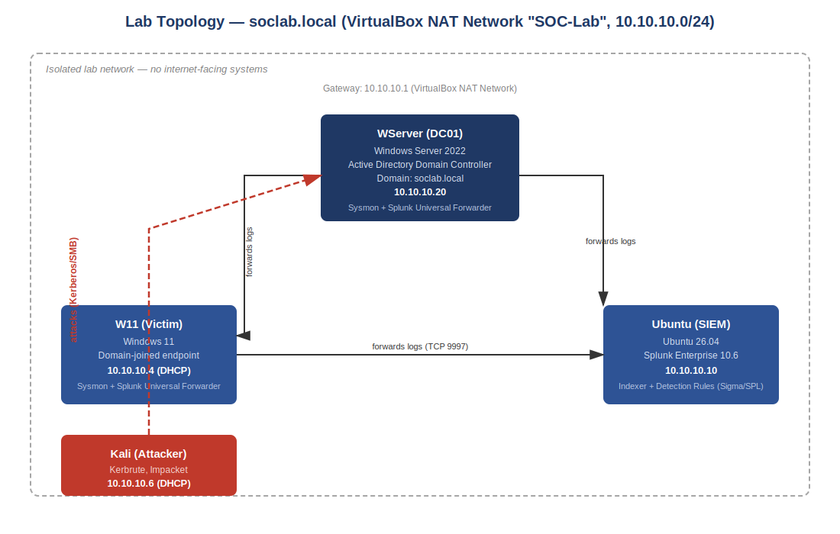
Figure 0. Monitored network topology — soclab.local Active Directory domain, isolated VirtualBox NAT Network (10.10.10.0/24). This investigation focuses on the W11 endpoint.
This investigation focuses on W11 (10.10.10.4), a domain-joined Windows 11 workstation forwarding Sysmon telemetry to a centralized Splunk instance (Ubuntu, 10.10.10.10). Unlike Investigation #1, which analyzed attacks against the Active Directory infrastructure itself, this report analyzes local endpoint activity consistent with an attacker who already has code execution on the victim machine, independent of any Active Directory compromise.

3.2 Detection Stack
- Splunk Enterprise 10.6 (SIEM) — centralized log indexing, correlation searches, and alerting
- Sysmon, forwarded via Splunk Universal Forwarder — process creation, registry, and injection telemetry
- 5 custom Sigma rules, translated to SPL and deployed as scheduled Splunk alerts (see Section 7)

4. Observed Activity Overview (MITRE ATT&CK Mapping)
The following table summarizes the techniques identified during this investigation, mapped to the MITRE ATT&CK framework.
# | Technique | MITRE ID | Severity | Analyst Finding
1 | Obfuscated PowerShell Execution | T1059.001 | Medium | Base64-encoded command decoded and confirmed benign payload
2 | LSASS Memory Dump | T1003.001 | Critical | Credential-dumping technique confirmed via living-off-the-land binary
3 | Local Scheduled Task Creation | T1053.005 | Medium | Persistence mechanism established via Task Scheduler
4 | Registry Run Key Persistence | T1547.001 | Medium | Autostart persistence entry added to user Run key
5 | Process Injection (RWX / MockingJay) | T1055 | High | Injection confirmed functionally successful; evaded Sysmon's primary injection telemetry

5. Alert-by-Alert Analysis

Alert 1 — Obfuscated PowerShell Execution (T1059.001)
SEVERITY: MEDIUM
Trigger: powershell.exe executed with the -e / -EncodedCommand parameter, spawned by cmd.exe.
Investigation: Sysmon process-creation telemetry showed powershell.exe launched by cmd.exe, with a long Base64 string passed via the -e flag, running from CurrentDirectory C:\Users\vboxuser\AppData\Local\Temp\. Decoding the Base64 string with ‘[System.Text.Encoding]::Unicode.GetString([System.Convert]::FromBase64String(...))’ revealed the underlying script printed ‘Hello, from PowerShell!’ — a benign payload in this case, but one that demonstrates how encoded execution hides intent from casual log review.
Attacker Pattern: -EncodedCommand is a well-documented technique attackers use to bypass simple keyword-based detection, since the malicious content is not visible in plaintext until decoded. The technique carries no inherent payload risk by itself — the risk lies entirely in what the decoded script does, which is why every encoded command observed should be decoded as a mandatory first triage step rather than dismissed or flagged purely on the presence of the flag.
Analyst Note: Execution from a Temp directory, combined with the encoded flag, is a stronger combined signal than either indicator alone — this pairing is what the deployed Sigma rule keys on.

Alert 2 — LSASS Memory Dump via comsvcs.dll (T1003.001)
SEVERITY: CRITICAL
Trigger: rundll32.exe invoking the MiniDump export of comsvcs.dll, with the target process ID corresponding to lsass.exe.
Investigation: Sysmon captured rundll32.exe spawned by powershell.exe, with both comsvcs.dll and MiniDump present in CommandLine, alongside the PID of lsass.exe — the process that holds Windows credentials in memory. This is a living-off-the-land technique: it uses a legitimate, Microsoft-signed DLL already present on every Windows host, rather than an external tool such as Mimikatz.
Attacker Pattern: By using a trusted system binary instead of a known-malicious tool, this technique is specifically designed to defeat simple application allowlisting — rundll32.exe is expected to run routinely on any Windows host, so its presence alone is not a useful signal. The attacker's goal with this technique is to extract credential material from memory for offline cracking or pass-the-hash attacks against other systems.
Analyst Note: Detection here cannot rely on the identity of the binary; it has to rely on the specific, rare combination of arguments (comsvcs.dll plus MiniDump plus a PID matching lsass.exe) — exactly what the deployed Sigma rule checks for. This is the highest-severity alert in this investigation because successful credential extraction from LSASS can enable lateral movement far beyond this single endpoint.

Alert 3 — Local Scheduled Task Creation (T1053.005)
SEVERITY: MEDIUM
Trigger: schtasks.exe executed with the /Create flag, spawned by cmd.exe.
Investigation: Sysmon captured schtasks.exe spawned by cmd.exe, executing ‘SCHTASKS /Create /SC ONCE /TN spawn /TR cmd.exe /ST 20:10’ — creating a task named ‘spawn’ configured to relaunch cmd.exe at a scheduled time.
Attacker Pattern: Scheduled tasks are one of the simplest and most common persistence mechanisms available on Windows: once created, they survive reboots and require no further interaction from the attacker to trigger again. A task name like ‘spawn’ is deliberately generic, intended to blend in among the many legitimate scheduled tasks present on a typical Windows host.
Analyst Note: The signature here — schtasks.exe with /Create, spawned from cmd.exe rather than Task Scheduler's own management UI — is a reliable, low-noise indicator worth alerting on continuously, since legitimate end users rarely create scheduled tasks from the command line.

Alert 4 — Registry Run Key Persistence (T1547.001)
SEVERITY: MEDIUM
Trigger: reg.exe executed with the ADD flag targeting the HKCU CurrentVersion\Run registry key, spawned by cmd.exe.
Investigation: Sysmon captured reg.exe spawned by cmd.exe, executing ‘REG ADD HKCU\SOFTWARE\Microsoft\Windows\CurrentVersion\Run /V "Atomic Red Team" ...’, adding an autostart entry that would point to an attacker-controlled executable in a real intrusion.
Attacker Pattern: Run key persistence is one of the oldest techniques in Windows malware, still widely used because it is simple, reliable, and requires no special privileges for a per-user (HKCU) entry. The entry executes automatically every time the affected user logs in, giving the attacker durable access without needing to re-exploit the system.
Analyst Note: Because this registry path has a narrow, well-known legitimate use (user-installed software adding startup entries), monitoring writes to it specifically — rather than the registry broadly — keeps this a high-value, low-noise detection opportunity.

Alert 5 — Process Injection, RWX / MockingJay-style (T1055)
SEVERITY: HIGH
Trigger: Execution of searchVuln.exe and RWXinjectionLocal.exe — two unsigned, non-standard binaries with no legitimate presence on this host — detected via Sysmon process-creation telemetry (EventID 1).
Investigation: The initial alert fired purely on the execution of these two unfamiliar binaries. Following standard procedure for a process-injection alert, I searched for the corresponding EventID 8 (CreateRemoteThread) and EventID 10 (ProcessAccess) events that Sysmon normally generates when one process injects code into another — and found none in the relevant time window, despite the tooling itself confirming successful injection. This absence of expected telemetry is itself a significant finding: it means the injection technique specifically avoided the Windows APIs (VirtualAlloc, WriteProcessMemory, CreateRemoteThread) that Sysmon's standard configuration monitors, instead exploiting a PE section that already carried Read-Write-Execute permissions.
Attacker Pattern: This technique — known publicly as MockingJay-style injection — is specifically engineered to defeat EDR and Sysmon products that key their injection detection around the well-documented Windows injection APIs. An attacker using this method can execute arbitrary code inside a legitimate process's memory space while remaining invisible to the exact telemetry source (EventID 8/10) that most SOCs rely on for this technique class.
Critical Gap Identified: This investigation confirmed a real detection gap: Sysmon's default process-injection visibility does not cover every injection method. Relying solely on EventID 8/10 would have resulted in a complete miss of a successful code-injection event. The compensating control I implemented detects the known injector binaries by name and execution path instead of the injection behavior itself — a deliberate defense-in-depth decision, since behavior-based detection alone proved insufficient for this technique.

6. Detection Coverage & Response
Five Sigma/SPL detection rules were built and validated against this activity. Full rule definitions are maintained in /detections/sigma/ in the project repository.
Rule | Severity | Detects
Obfuscated PowerShell Execution | Medium | powershell.exe with -e / -enc / -EncodedCommand
LSASS Memory Dump via comsvcs.dll | Critical | rundll32.exe invoking comsvcs.dll MiniDump
Local Scheduled Task Creation | Medium | schtasks.exe /Create spawned from cmd.exe
Registry Run Key Persistence | Medium | reg.exe ADD to CurrentVersion\Run from cmd.exe
Process Injection Toolchain (MockingJay) | High | Execution of known injector binaries — compensating control for an EventID 8/10 detection gap

6.1 Incident Response Actions
If this were a live incident, the first three containment actions would be: (1) isolate the W11 endpoint from the network, to prevent any credential material obtained via the LSASS dump (Alert 2) from being used for lateral movement; (2) terminate the identified malicious processes and remove the persistence mechanisms established in Alerts 3 and 4 (the scheduled task and the Run key entry); and (3) treat any credentials present on this host, and any accounts that authenticated to it during the compromise window, as potentially exposed and force a password reset as a precaution.
Given that this endpoint is domain-joined, containment should also include checking whether any domain credentials cached on W11 were used elsewhere in the environment — connecting this investigation back to the identity-focused monitoring covered in Investigation #1.

7. Threat Hunting — Follow-On Investigation

Hypothesis 1 — Additional Undetected Techniques
Hypothesis: Since the process injection technique in Alert 5 evaded Sysmon's EventID 8/10 telemetry, other evasive techniques on this host may have also produced incomplete or missing primary telemetry, going unnoticed under the same detection gap.
Investigation: I reviewed all Sysmon EventID 1 (process creation) activity on W11 for the full test window, looking specifically for any process execution outside the 5 documented alerts that did not correspond to expected, known-good activity.
Conclusion: No additional unexplained process activity was identified beyond the 5 documented alerts. This increases confidence that the observed activity set is complete for this investigation window, though it does not rule out techniques that leave no EventID 1 footprint at all — a limitation worth noting for future hunting.

Hypothesis 2 — Windows Security Log as a Backup Data Source
Hypothesis: If Sysmon were disabled or tampered with by an attacker, the native Windows Security Event Log might still provide partial visibility into some of these 5 techniques, serving as a fallback detection source.
Investigation: I reviewed the standard Windows Security log (index=ad, host=W11) for the same time windows as the 5 documented alerts, to determine whether any of this activity was also captured there independent of Sysmon.
Conclusion: Process-level detail (command lines, parent-child relationships) was consistently richer in Sysmon than in the native Security log, confirming that Sysmon is not merely a convenience layer but a load-bearing data source for this detection strategy — reinforcing the recommendation in Section 8 to protect Sysmon's own integrity and logging pipeline as a priority.

8. Lessons Learned & Hardening Recommendations
Based on this investigation, three concrete improvements would strengthen detection coverage on endpoints like W11:
1. Supplement Sysmon with EDR-level memory and API monitoring: this investigation proved that a real, functioning injection technique can evade Sysmon's default process-injection visibility entirely — a detection stack relying on Sysmon alone has a confirmed blind spot for this technique class.
2. Application allowlisting: even though the injection behavior itself was invisible, the injector toolchain (searchVuln.exe, RWXinjectionLocal.exe) would have been blocked outright by an allowlisting policy, preventing the technique from ever executing regardless of its evasion capability.
3. PowerShell Script Block Logging: enabling this would log the fully decoded content of any -EncodedCommand execution automatically, removing the need for manual Base64 decoding during triage and closing the obfuscation gap observed in Alert 1.

9. How to Reproduce This Investigation
Full environment build steps, technique generation commands (via Atomic Red Team), and detection queries are documented in the project repository:
https://github.com/aragonofficialaam-glitch/soc-detection-lab
At a high level, this investigation can be reproduced as follows: (1) install Atomic Red Team on a domain-joined Windows endpoint and forward Sysmon telemetry to Splunk; (2) execute T1059.001-17 to generate obfuscated PowerShell telemetry; (3) execute T1003.001-2 to generate an LSASS memory-dump event; (4) execute T1053.005-2 and T1547.001-1 to generate persistence telemetry; (5) execute T1055-5 and verify whether EventID 8/10 are generated, to test injection-detection coverage.

Appendix A: Raw Evidence References
Full detection rule definitions (Sigma + SPL) for all 5 alerts in this investigation are maintained in the project repository under /detections/sigma/ and /detections/spl/.
Atomic Red Team tests referenced in this report:
- T1059.001-17 — PowerShell Command Execution
- T1003.001-2 — Dump LSASS.exe Memory using comsvcs.dll
- T1053.005-2 — Scheduled task Local
- T1547.001-1 — Reg Key Run
- T1055-5 — Read-Write-Execute process Injection

