http://www.unitrends.com.
Scope of work

# 1. Reconnaissance & Information Gathering

* Identify the IP address(es) associated with each target website
* Discover subdomains, directories, and exposed endpoints
* Identify underlying technologies (web server, framework, CMS, hosting details)
* Map all possible entry points (forms, APIs, login panels, parameters)

- Found 2 IP addresses from NS Lookup site.
Below is the screen shot of the proof.
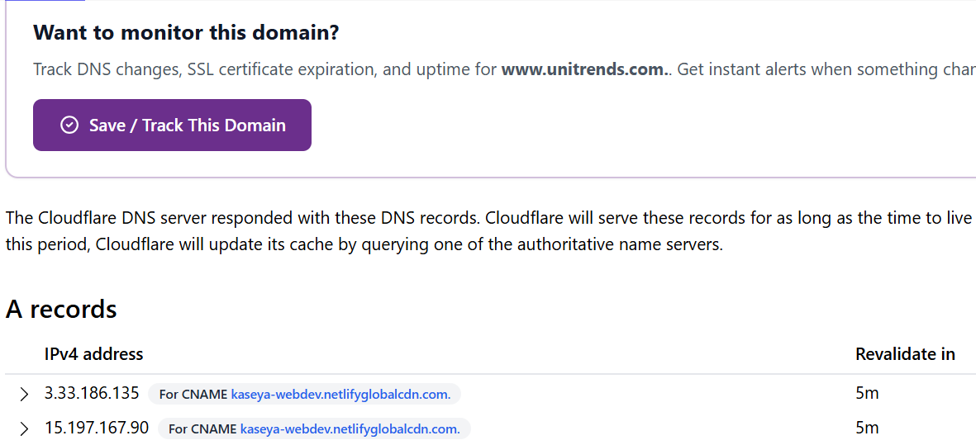

Used ping tools in Linux to verify and validate IP address.

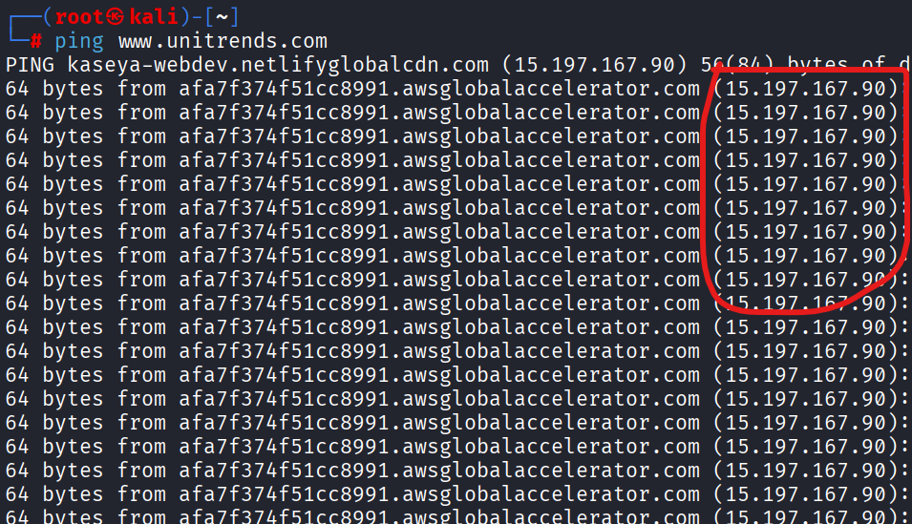

- To find subdomains

Discovered 13 Live subdomains out of 57 subdomains using subfinder and httpx tools in Kali-Linux

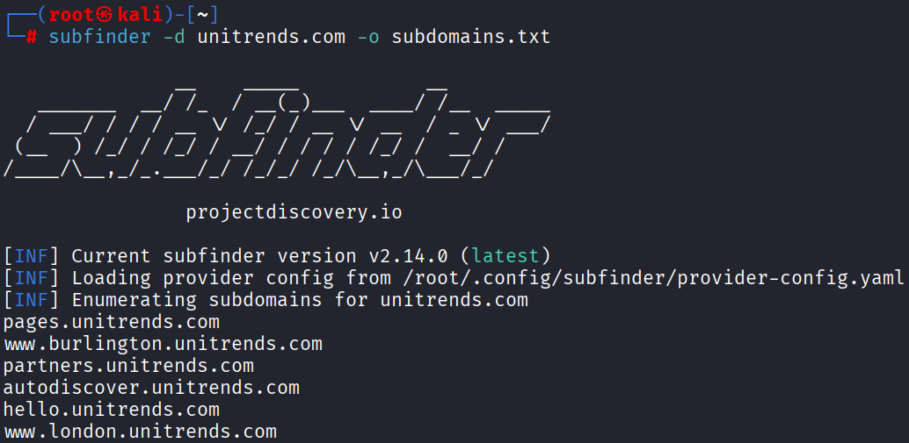

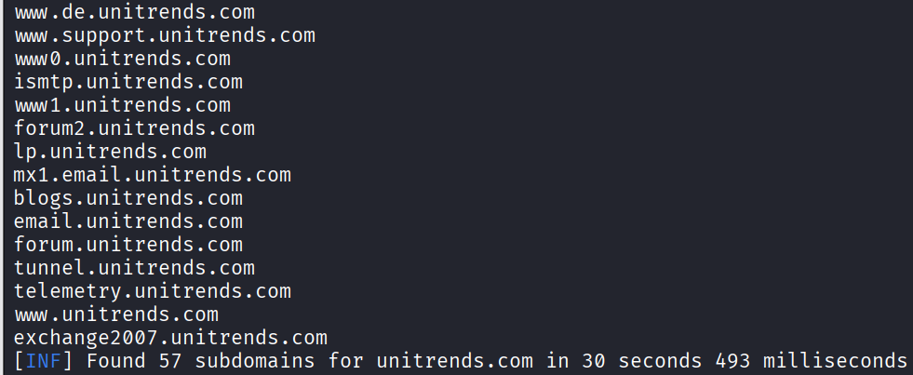

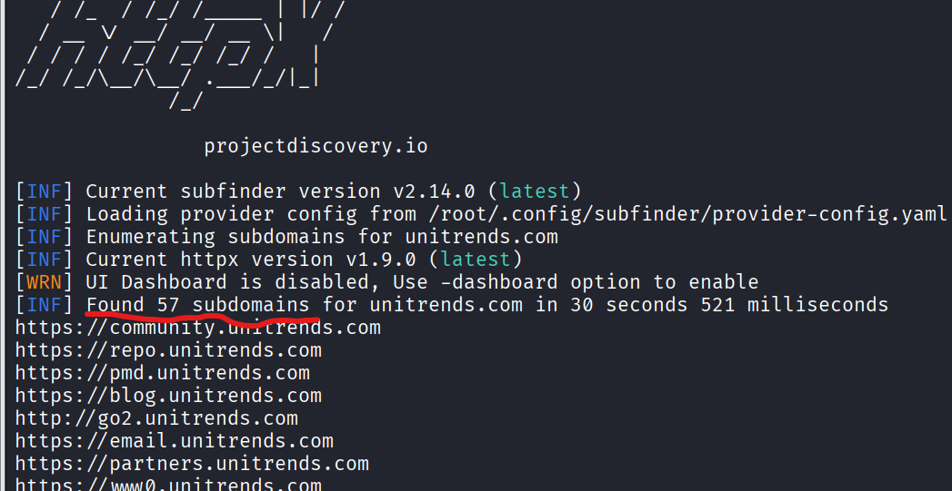

- To find directory I used gobuster tools in Kali Linux

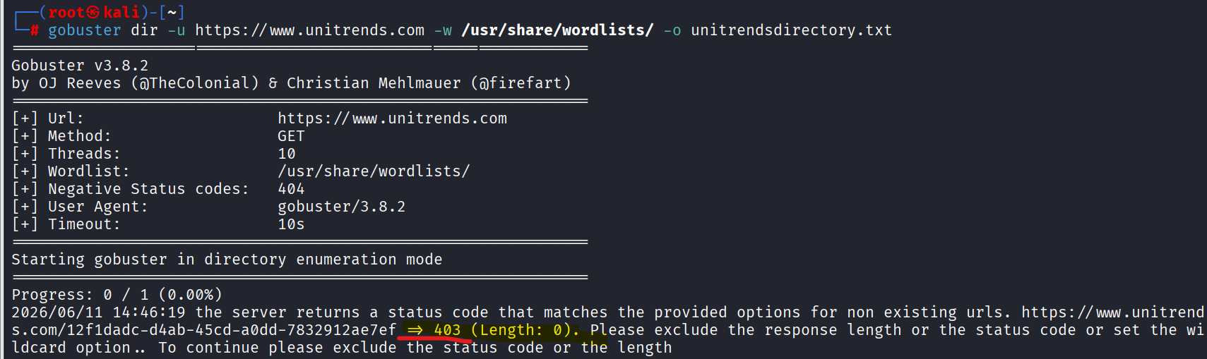

- Couldn’t find any Login Pannels

